# Lab: Login and Register

# Pythons Wiki (with Login and Register Forms)

**Extend** the pythons wiki project, so you have pages for **registration** and **login** with **forms**.

## Registration Form

For the **registration view**, you can use the form [UserCreationForm](https://docs.djangoproject.com/en/1.8/_modules/django/contrib/auth/forms/) **'from django.contrib.auth.forms import UserCreationForm'**. For the **form in the template**, you can use bootstrap4 (**pip install django-bootstrap4**)

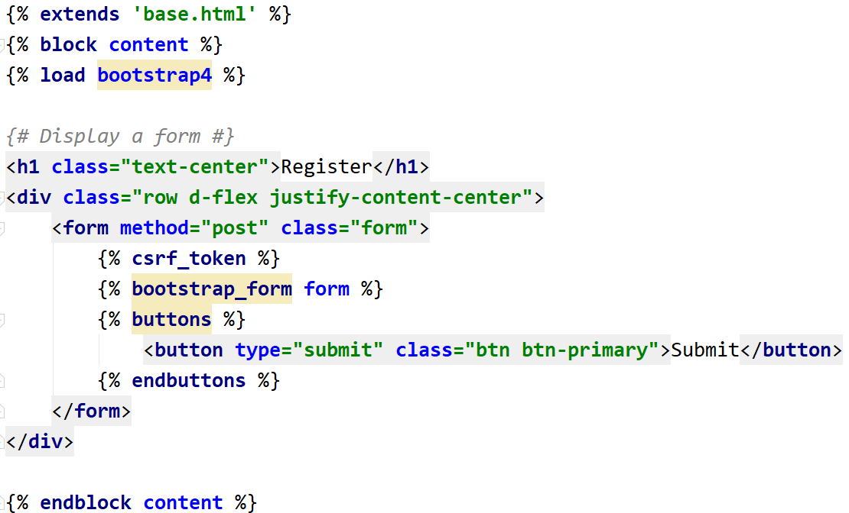

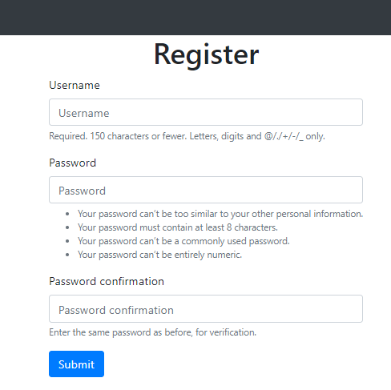

Upon registration, you should **add** the user to the **group 'User'**, so he can **create pythons**

## Login

**Create** a **login form** with **username** and **password** and use it in your **view**. You can again use **bootstrap4** to add styling to you form in the **template**

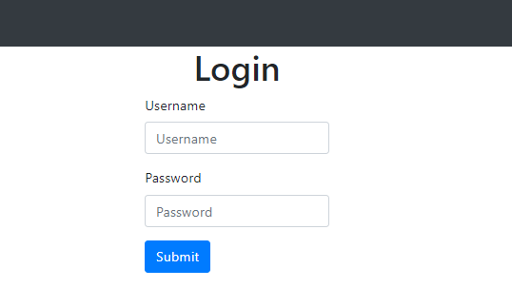

## Extending the User Model

Create a **Profile Model**, which should **extend** the **User Profile** (add **pictureUrl**, **description** and **website**).