# Workshop: Petstagram

## Part V – Users

### Creating 'accounts' app

Create a new **app** called **'accounts'**, where the **registration**, **login**, **logout** and **user profiles** will be handled

### UserProfile model

In the new app create an **UserProfile** model with the following **fields**:

* **user** – foreign key to the user
* **profile_picture** – picture upload

### New url's

Add the following **urls**:

* **GET** **'localhost:8000/accounts/'** – include the **django.contrib.auth.urls**
* **GET** **'localhost:8000/accounts/profile/<int:pk>'** – create a view that will **render** the provided **'user_profile.html'** with the needed information
* **POST** **'localhost:8000/accounts/profile/<int:pk>'** – **update** the **profile picture** of the user
* **GET** **'localhost:8000/accounts/signup'** – render the provided **'signup.html'** with the **register form**
* **POST** **'localhost:8000/accounts/signup'** – register the user and **create a user profile** (with the **default.png** as profile picture)

### Modifying old models

* **Pet** model – add a new **field** called **user** which is linked to an **UserProfile**
* **Comment** model – add a new **field** called **user** which is linked to an **UserProfile**
* **Like** model - add a new **field** called user which is linked to an **UserProfile**

### Modifying old templates

* Add **login/logout/register** links in the navbar and implement the needed **template logic**
* In the **pet_detail** template, implement the logic, so the **edit** and **delete** buttons are **visible only** in the pet **belongs** to the **user**. If not, display the **'heart'** button (**filled** if the user **has liked** the pet **already**, **not filled** if the user has **not yet liked** this pet). Display the **comment form** if the pet does **not belong** to the user.

### Restrictions

Only **logged** in users can view and **create pet photos**.

### Results

**Current user** is **not an owner** and has **not yet liked** this photo. The **user can** also **comment** the photo

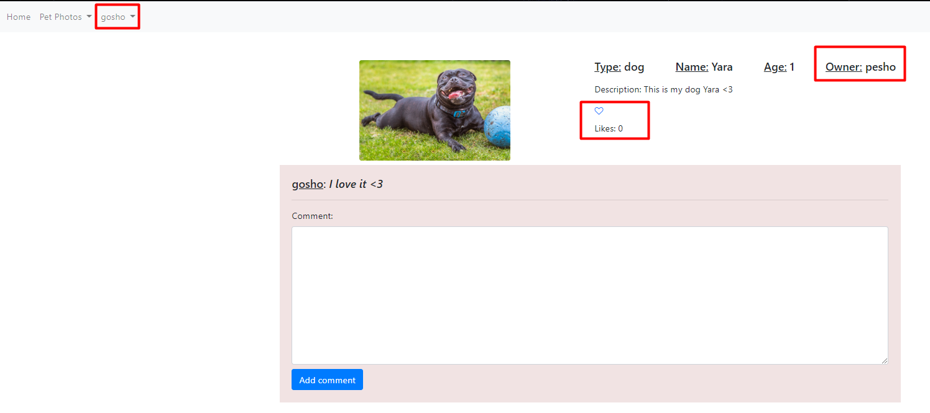

After the user **has liked** the photo:

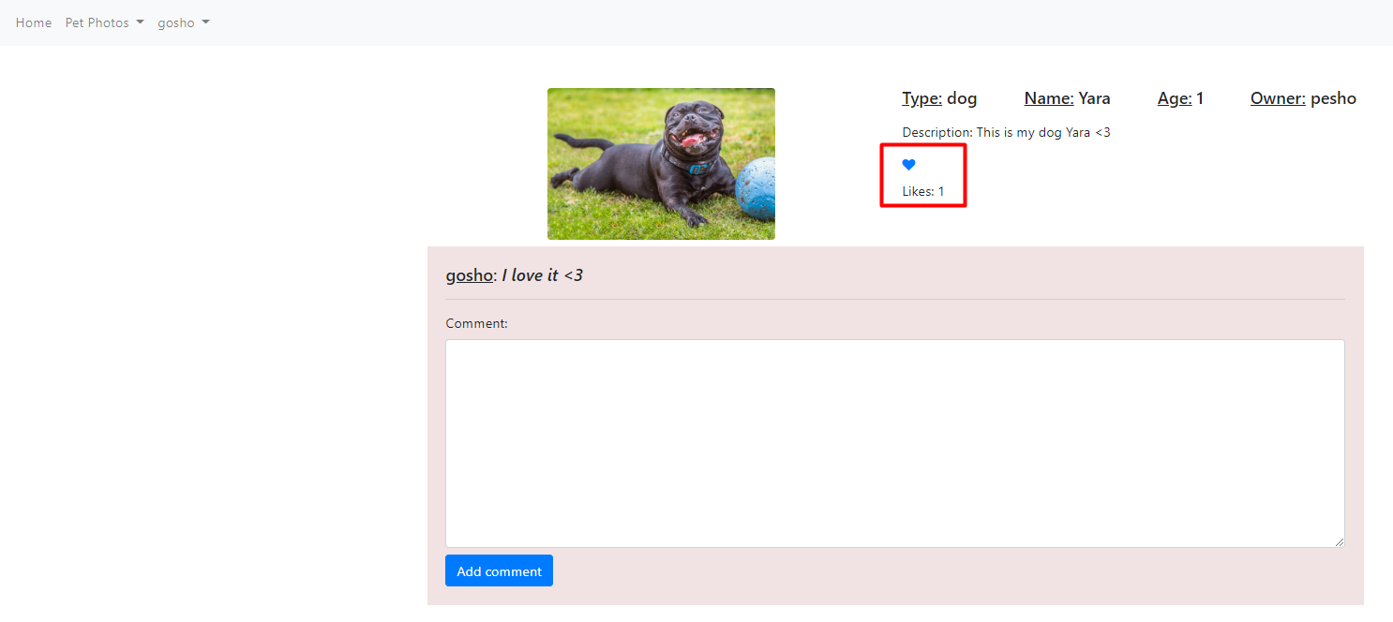

The owner **cannot like his photo** and **cannot post comments**. He can **edit/delete** his pet photo

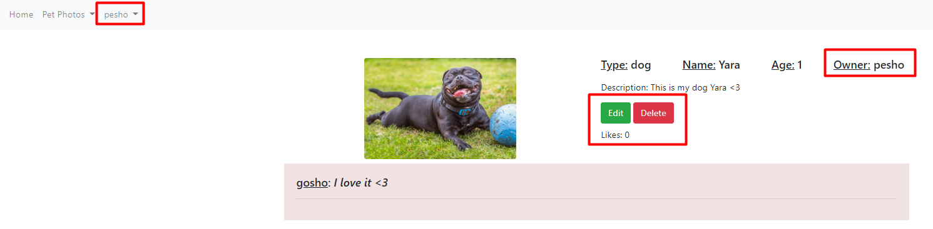

User profile

