# Lab: Intro to Class-Based-Views

# Pythons Wiki (refactoring)

**Refactor** some of your views to be **class based** as shown below

## Index View

**Refactor** the index view by using the propriate CBV (for example **ListView**, since we are going to display all the pythons)

***views.py***

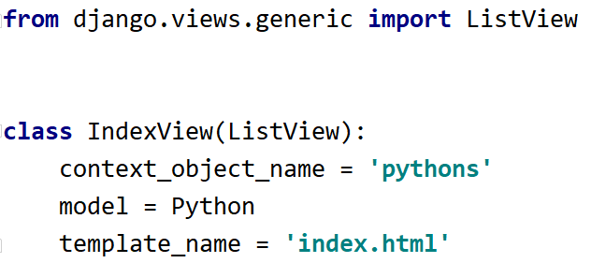

***urls.py***



## Create Python View

For the **create python view** we can use the **FormView** and since we also need to allow only **users** of the **group** **'User'**, we can implement a **special mixin**

***mixins.py***

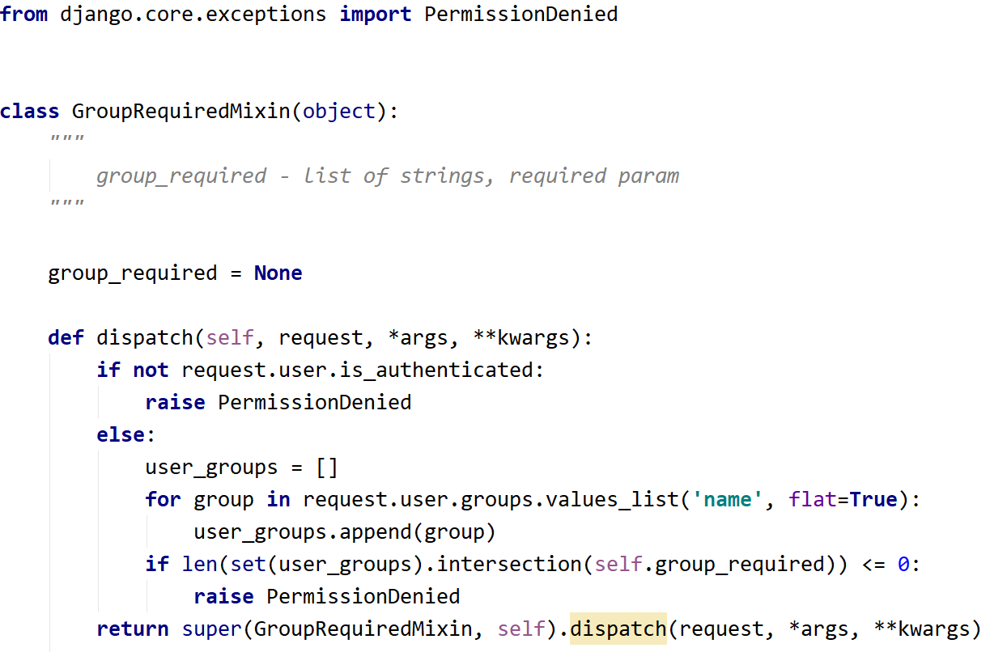

***views.py***

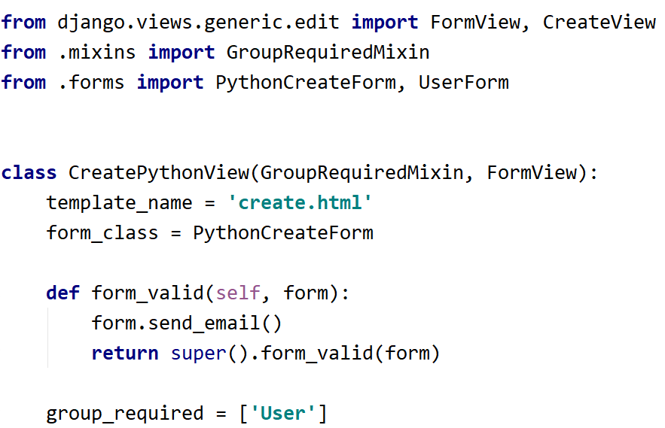

***urls.py***



## Register View

For the **register view** we can use the **CreateView**

***views.py***

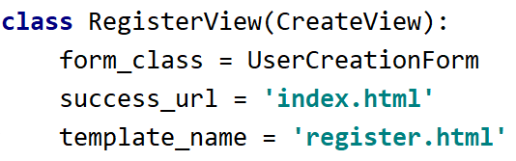

***urls.py***

