**Simulate VM CPU Throughput Test Report**

**Test objective:**

Test the maximum through put number of the GRE tunnel between AP(initiate) and CVGasAP(terminator), Pkts size from 64 to 1518, and random, and check if the CPU usage is in normal range.

**Test Topo:**

Topo1:

IXIA port7+++SW1+++Blade server1(Virtual HiveOS)+++SW2+++Blade server2(1 Core CVG)

                                                                                                    +

                                                                                                     +

                                                                                            IXIA port10

Topo2:

IXIA port7+++SW1+++Blade server1(Virtual HiveOS)+++SW2+++Blade server2(4 Core CVG)

                                                                                                    +

                                                                                                     +

                                                                                            IXIA port10

**Test Preconditions:**

**Configure on Virtual HiveOS:**

hive wcaitest

hive wcaitest password ***

interface eth1 mode bridge-access user-profile-attribute 1

interface eth1 mac-learning enable

interface mgt0 hive wcaitest

no report statistic enable

mobility-policy inxptest inxp gre-tunnel to 192.168.85.11 password ***

user-profile inxp-cw qos-policy def-user-qos vlan-id 1 mobility-policy inxptest attribute 1

**Configure on CVG:**

hive wcaitest

hive wcaitest password ***

interface mgt0 hive wcaitest

no report statistic enable

mobility-policy inxptest inxp gre-tunnel from 192.168.85.1/24 password ***

user-profile inxp-cw qos-policy def-user-qos vlan-id 1 mobility-policy inxptest attribute 1

**Configure on SW:**

All interfaces are in the same vlan

**Test Procedure:**

1. IXIA port 7 send pkts to IXIA port 10 via topo1, look up the CVG CPU utilization and through put maximum

2. IXIA port 7 send pkts to IXIA port 10 via topo2, look up the CVG CPU utilization and through put maximum

**Test Result:**

1. One core CPU, maximum through put is about 670Mbps, CPU use is about 3121MHz

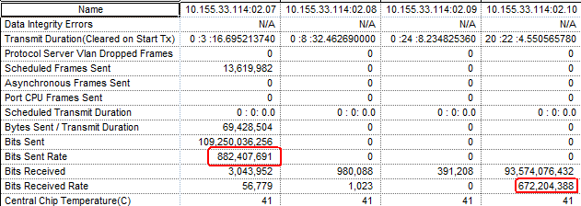

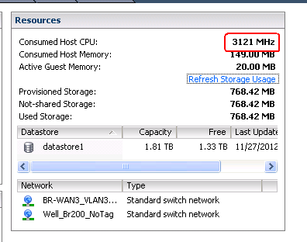

1. Four core CPU, maximum through put is about 940Mbps, CPU use is about **2300MHz**

