# Simulate VM Test

**Test objective:**

Establish CVG stability test when has 200 real tunnels and clients.

(Due to a Blade server cannot simulate 200 clients last long time, We will test total 200 real clients here)

Test the packets loss status when all tunnels are up and last long time.

**Test Topo:**



**Test Preconditions:**

CVG(Terminate)

AH-b78bb4#show running-config

hive wcaitest

hive wcaitest password ***

interface mgt0 hive wcaitest

no report statistic enable

mobility-policy inxptest inxp gre-tunnel from 10.68.123.1/24 password ***

mobility-policy inxptest inxp gre-tunnel from 10.68.133.1/24 password ***

mobility-policy inxptest inxp gre-tunnel from 10.68.134.1/24 password ***

mobility-policy inxptest inxp gre-tunnel from 10.68.135.1/24 password ***

no bonjour-gateway enable

no capwap client enable

capwap client server name 10.155.31.206

capwap client HTTP proxy name 10.155.60.114 port 808

user-profile inxp-cw qos-policy def-user-qos vlan-id 1 mobility-policy inxptest attribute 1

AH-b78bb4#show version

Aerohive Networks Inc.

Copyright (C) 2006-2013

Version: HiveOS 5.1r5 Dakar buildE1043

Build time: Tue Jan 29 04:18:07 UTC 2013

Build cookie: 51scale-precommit

Platform: HiveOS-VA

Uptime: 0 weeks, 0 days, 1 hours, 58 minutes, 4 seconds

CVGasAP(Originate)

AH-749cda#show running-config

hive wcaitest

hive wcaitest password ***

interface eth1 mode bridge-access user-profile-attribute 1

interface eth1 mac-learning enable

interface mgt0 hive wcaitest

no report statistic enable

mobility-policy inxptest inxp gre-tunnel to 10.68.122.2 password ***

no capwap client enable

capwap client server name 10.155.32.143

capwap client HTTP proxy name 10.155.60.114 port 808

user-profile inxp-cw qos-policy def-user-qos vlan-id 1 mobility-policy inxptest attribute 1

no bonjour-gateway enable

AH-749cda#show version

Aerohive Networks Inc.

Copyright (C) 2006-2013

Version: HiveOS 6.0r2 Firenze buildE1041

Build time: Tue Jan 29 04:42:33 UTC 2013

Build cookie: newhead

Platform: HiveOS-VA

Uptime: 0 weeks, 0 days, 5 hours, 7 minutes, 12 seconds

**Test Procedure:**

1. Blade server 2&3 use Mu’s support auth image create 100 virtual APs per Blade server, Blade2’s Virtual APs eth1 bind to vlan 1001-1100 and Blade3’s Virtual APs eth1 bind to vlan 1100-1200.

2. IXIA port 1&2 send increment src mac(0001 – 00c8) and vlan(1001-1200) pkts to IXIA port 4, IXIA port 4 send increment dst mac(0001 – 00c8) pkts to IXIA port 1&2. (pkt size 1400 and the total rate is about 1Mbps )

3. Keep sending more than 1h+, look up pkts receive tunnel status

4. Keep sending more than 12h+, look up pkts receive tunnel status

**Test Result:**

3.Upload direction is no pkts loss but download direction is few pkts loss(I cannot clearly locate which tunnel cause the pkts loss, about 15 pkts per hour)

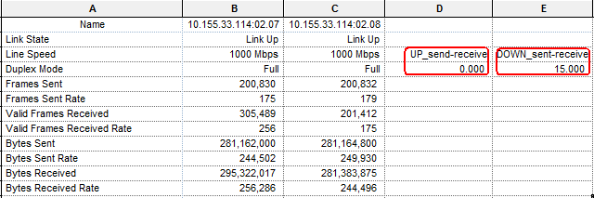

No tunnel interrupt can be show on AP’s display

The total rate cannot more than 1M per Blade server, if not, may generate **default route lost** phenomenon even the CPU is not use up.

CVG(Terminate) usage

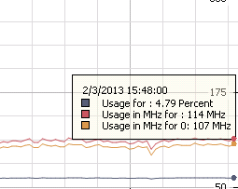

Blade server2 usage

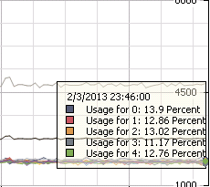

Blade server3 usage

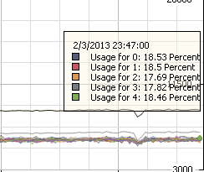

4. Both upload and download directions lost few pkts, and we can get the pkts loss proportion from below, upload is about 0.001% and download is about 0.008%

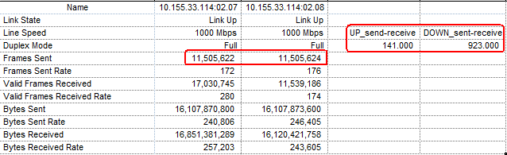

CVG

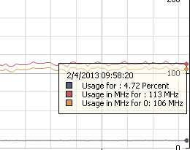

Blade server2

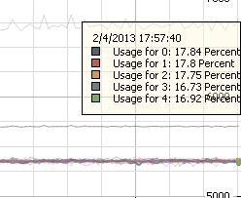

Blade server3

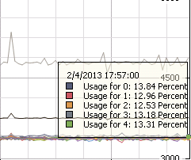

**Match issue:**

1. **Both upload and download directions lost few pkts, and we can get the pkts loss proportion from below, upload’s lost is about 0.001% and download’s is about 0.008%.**



2. **The total rate cannot more than 1M per Blade server, if not, may generate default route lost phenomenon even the CPU is not use up. This cause I cannot test high speed transmit situation**

3. **CVG tunnels duration is not match requirement, about 70% interrupt during transmitting. Based on pkts lost status on issue 1(loss 141 pkts), we can conclude that about 140 tunnels had been interrupted when the traffic run about 17.5 (21-3.5) hours, and lost 1 or 2 pkts. The tunnels can be recovered soon when the VirtualAP received next pkt, and no pkts lost again. My traffic rate is about 1 pkt per second on a virtual machine.**

**CVG tunnel status,**

AH-b78bb4#show amrp tunnel

Total 200 tunnels

DA - DNXP Access, DB - DNXP Backhaul

IA - INXP Access, IB - INXP Backhaul

VA - VPN Access, VB - VPN Backhaul

No. Peer Type client age TTL

-------------------------------------------------------------------------------

1 10.68.123.13 IB 1 21:02:13 -

2 10.68.133.40 IB 1 21:01:01 -

3 10.68.133.28 IB 1 21:00:59 -

4 10.68.133.24 IB 1 21:00:59 -

5 10.68.133.58 IB 1 21:00:58 -

6 10.68.133.19 IB 1 21:00:53 -

7 10.68.133.20 IB 1 21:00:48 -

8 10.68.133.42 IB 1 21:00:45 -

9 10.68.133.54 IB 1 21:00:43 -

10 10.68.133.80 IB 1 21:00:40 -

11 10.68.133.52 IB 1 21:00:40 -

12 10.68.133.56 IB 1 21:00:34 -

13 10.68.133.64 IB 1 21:00:29 -

14 10.68.133.76 IB 1 21:00:26 -

15 10.68.133.41 IB 1 21:00:19 -

16 10.68.133.61 IB 1 21:00:18 -

17 10.68.133.68 IB 1 21:00:15 -

18 10.68.133.39 IB 1 21:00:08 -

19 10.68.133.94 IB 1 21:00:06 -

20 10.68.133.13 IB 1 21:00:02 -

21 10.68.133.48 IB 1 20:54:40 -

22 10.68.133.92 IB 1 20:54:40 -

23 10.68.133.4 IB 1 20:54:40 -

24 10.68.133.9 IB 1 20:54:40 -

25 10.68.133.14 IB 1 20:54:40 -

26 10.68.133.17 IB 1 20:54:40 -

27 10.68.133.21 IB 1 20:54:39 -

28 10.68.133.22 IB 1 20:54:39 -

29 10.68.133.23 IB 1 20:54:39 -

30 10.68.133.25 IB 1 20:54:39 -

31 10.68.133.27 IB 1 20:54:39 -

32 10.68.133.32 IB 1 20:54:39 -

33 10.68.133.36 IB 1 20:54:39 -

34 10.68.133.43 IB 1 20:54:39 -

35 10.68.133.46 IB 1 20:54:39 -

36 10.68.133.55 IB 1 20:54:39 -

37 10.68.133.57 IB 1 20:54:39 -

38 10.68.133.63 IB 1 20:54:39 -

39 10.68.133.65 IB 1 20:54:39 -

40 10.68.133.71 IB 1 20:54:39 -

41 10.68.133.72 IB 1 20:54:39 -

42 10.68.133.74 IB 1 20:54:39 -

43 10.68.133.78 IB 1 20:54:39 -

44 10.68.133.79 IB 1 20:54:39 -

45 10.68.133.82 IB 1 20:54:39 -

46 10.68.133.84 IB 1 20:54:39 -

47 10.68.133.85 IB 1 20:54:39 -

48 10.68.133.87 IB 1 20:54:39 -

49 10.68.133.89 IB 1 20:54:39 -

50 10.68.133.93 IB 1 20:54:39 -

51 10.68.133.96 IB 1 20:54:39 -

52 10.68.123.64 IB 1 20:50:21 -

53 10.68.123.70 IB 1 19:29:21 -

54 10.68.133.69 IB 1 19:21:36 -

55 10.68.133.98 IB 1 19:21:36 -

56 10.68.133.97 IB 1 19:21:13 -

57 10.68.133.73 IB 1 19:21:06 -

58 10.68.133.34 IB 1 19:19:42 -

59 10.68.133.59 IB 1 19:17:33 -

60 10.68.133.26 IB 1 19:17:12 -

61 10.68.133.103 IB 1 04:40:36 -

62 10.68.133.7 IB 1 03:36:24 -

63 10.68.133.83 IB 1 03:36:19 -

64 10.68.123.60 IB 1 03:35:53 -

65 10.68.123.77 IB 1 03:35:47 -

66 10.68.123.62 IB 1 03:35:46 -

67 10.68.133.38 IB 1 03:35:45 -

68 10.68.123.61 IB 1 03:35:39 -

69 10.68.123.58 IB 1 03:35:38 -

70 10.68.133.1 IB 1 03:35:30 -

71 10.68.123.76 IB 1 03:35:29 -

72 10.68.133.29 IB 1 03:35:29 -

73 10.68.123.6 IB 1 03:35:27 -

74 10.68.133.12 IB 1 03:35:26 -

75 10.68.133.45 IB 1 03:35:26 -

76 10.68.133.37 IB 1 03:35:25 -

77 10.68.123.10 IB 1 03:35:25 -

78 10.68.133.15 IB 1 03:35:24 -

79 10.68.133.77 IB 1 03:35:23 -

80 10.68.133.44 IB 1 03:35:21 -

81 10.68.133.88 IB 1 03:35:21 -

82 10.68.123.5 IB 1 03:35:13 -

83 10.68.123.91 IB 1 03:35:11 -

84 10.68.133.16 IB 1 03:35:11 -

85 10.68.123.20 IB 1 03:35:09 -

86 10.68.133.101 IB 1 03:35:08 -

87 10.68.123.106 IB 1 03:35:08 -

88 10.68.123.23 IB 1 03:35:08 -

89 10.68.123.41 IB 1 03:35:08 -

90 10.68.123.49 IB 1 03:35:08 -

91 10.68.123.101 IB 1 03:35:07 -

92 10.68.123.105 IB 1 03:35:06 -

93 10.68.133.11 IB 1 03:35:06 -

94 10.68.123.53 IB 1 03:35:06 -

95 10.68.133.47 IB 1 03:35:06 -

96 10.68.123.81 IB 1 03:35:05 -

97 10.68.123.88 IB 1 03:35:04 -

98 10.68.123.90 IB 1 03:35:04 -

99 10.68.123.93 IB 1 03:35:04 -

100 10.68.123.45 IB 1 03:35:03 -

101 10.68.123.87 IB 1 03:35:01 -

102 10.68.123.19 IB 1 03:35:01 -

103 10.68.133.86 IB 1 03:35:00 -

104 10.68.123.28 IB 1 03:35:00 -

105 10.68.123.32 IB 1 03:35:00 -

106 10.68.123.35 IB 1 03:34:59 -

107 10.68.123.99 IB 1 03:34:59 -

108 10.68.123.17 IB 1 03:34:58 -

109 10.68.123.9 IB 1 03:34:58 -

110 10.68.123.80 IB 1 03:34:58 -

111 10.68.123.39 IB 1 03:34:56 -

112 10.68.133.66 IB 1 03:34:54 -

113 10.68.123.34 IB 1 03:34:53 -

114 10.68.123.43 IB 1 03:34:52 -

115 10.68.123.4 IB 1 03:34:51 -

116 10.68.123.46 IB 1 03:34:51 -

117 10.68.123.47 IB 1 03:34:51 -

118 10.68.133.5 IB 1 03:34:50 -

119 10.68.123.82 IB 1 03:34:49 -

120 10.68.123.92 IB 1 03:34:49 -

121 10.68.123.24 IB 1 03:34:49 -

122 10.68.123.48 IB 1 03:34:49 -

123 10.68.123.59 IB 1 03:34:48 -

124 10.68.123.86 IB 1 03:34:48 -

125 10.68.123.56 IB 1 03:34:47 -

126 10.68.123.97 IB 1 03:34:47 -

127 10.68.123.16 IB 1 03:34:47 -

128 10.68.123.18 IB 1 03:34:47 -

129 10.68.123.26 IB 1 03:34:46 -

130 10.68.123.30 IB 1 03:34:46 -

131 10.68.133.49 IB 1 03:34:46 -

132 10.68.123.79 IB 1 03:34:46 -

133 10.68.123.94 IB 1 03:34:46 -

134 10.68.123.54 IB 1 03:34:45 -

135 10.68.133.51 IB 1 03:34:45 -

136 10.68.123.73 IB 1 03:34:45 -

137 10.68.123.78 IB 1 03:34:45 -

138 10.68.123.102 IB 1 03:34:44 -

139 10.68.133.33 IB 1 03:34:44 -

140 10.68.123.95 IB 1 03:34:43 -

141 10.68.123.72 IB 1 03:34:42 -

142 10.68.123.50 IB 1 03:34:42 -

143 10.68.123.89 IB 1 03:34:41 -

144 10.68.123.96 IB 1 03:34:41 -

145 10.68.133.95 IB 1 03:34:41 -

146 10.68.133.30 IB 1 03:34:41 -

147 10.68.123.37 IB 1 03:34:39 -

148 10.68.123.40 IB 1 03:34:39 -

149 10.68.133.81 IB 1 03:34:38 -

150 10.68.123.100 IB 1 03:34:38 -

151 10.68.133.10 IB 1 03:34:37 -

152 10.68.123.36 IB 1 03:34:37 -

153 10.68.123.63 IB 1 03:34:37 -

154 10.68.123.69 IB 1 03:34:37 -

155 10.68.133.67 IB 1 03:34:37 -

156 10.68.123.83 IB 1 03:34:37 -

157 10.68.123.104 IB 1 03:34:36 -

158 10.68.123.12 IB 1 03:34:36 -

159 10.68.133.53 IB 1 03:34:36 -

160 10.68.123.67 IB 1 03:34:36 -

161 10.68.133.6 IB 1 03:34:35 -

162 10.68.123.33 IB 1 03:34:35 -

163 10.68.123.21 IB 1 03:34:34 -

164 10.68.133.75 IB 1 03:34:33 -

165 10.68.123.84 IB 1 03:34:33 -

166 10.68.133.91 IB 1 03:34:33 -

167 10.68.123.98 IB 1 03:34:33 -

168 10.68.133.102 IB 1 03:34:33 -

169 10.68.133.18 IB 1 03:34:33 -

170 10.68.123.51 IB 1 03:34:32 -

171 10.68.123.38 IB 1 03:34:30 -

172 10.68.133.31 IB 1 03:34:30 -

173 10.68.133.99 IB 1 03:34:29 -

174 10.68.123.103 IB 1 03:34:29 -

175 10.68.123.15 IB 1 03:34:29 -

176 10.68.123.65 IB 1 03:34:26 -

177 10.68.133.60 IB 1 03:34:26 -

178 10.68.123.42 IB 1 03:34:26 -

179 10.68.123.52 IB 1 03:34:24 -

180 10.68.123.74 IB 1 03:34:23 -

181 10.68.123.66 IB 1 03:34:22 -

182 10.68.123.25 IB 1 03:34:19 -

183 10.68.123.85 IB 1 03:34:16 -

184 10.68.123.31 IB 1 03:34:14 -

185 10.68.133.62 IB 1 03:34:14 -

186 10.68.123.22 IB 1 03:34:13 -

187 10.68.133.100 IB 1 03:34:09 -

188 10.68.133.8 IB 1 03:34:09 -

189 10.68.123.29 IB 1 03:34:07 -

190 10.68.123.44 IB 1 03:34:03 -

191 10.68.133.50 IB 1 03:33:59 -

192 10.68.123.57 IB 1 03:33:55 -

193 10.68.123.68 IB 1 03:33:54 -

194 10.68.123.55 IB 1 03:33:51 -

195 10.68.123.14 IB 1 03:33:51 -

196 10.68.123.75 IB 1 03:33:48 -

197 10.68.123.27 IB 1 03:33:37 -

198 10.68.133.70 IB 1 03:33:23 -

199 10.68.123.71 IB 1 03:33:21 -

200 10.68.133.35 IB 1 03:33:13 -