**Test objective:**

Test the maximum through put per client when the CVG has 1k tunnels and 4k/8k/16k clients, check if the CPU usage is in normal range.

**Test Topo:**

Blade server1(Virtual AP1&2)++++++(g1/0/1)SW1(g1/0/4)++++++Blade server2(1 Core CVG)

                                                                 (g1/0/13) (g1/0/14)

+ +

                                                                   + +

                                                    IXIAport7 IXIAport8

**Test Preconditions:**

**Configure on Virtual HiveOS1:**

no interface mgt0 dhcp client

interface mgt0 ip 10.69.0.1/16

ip route default gateway 10.69.255.254

hive wcaitest

hive wcaitest password aerohive

interface mgt0 hive wcaitest

mobility-policy inxptest inxp gre-tunnel to 10.68.131.1 password aerohive

user-profile inxp-cw qos-policy def-user-qos vlan-id 1 mobility-policy inxptest attribute 1

interface eth1 mode bridge-access user-profile-attribute 1

interface eth1 mac-learning enable

**Configure on Virtual HiveOS2:**

no interface mgt0 dhcp client

interface mgt0 ip 10.69.2.2/16

ip route default gateway 10.69.255.254

hive wcaitest

hive wcaitest password aerohive

interface mgt0 hive wcaitest

mobility-policy inxptest inxp gre-tunnel to 10.68.131.1 password aerohive

user-profile inxp-cw qos-policy def-user-qos vlan-id 1 mobility-policy inxptest attribute 1

interface eth1 mode bridge-access user-profile-attribute 1

interface eth1 mac-learning enable

**Configure on CVG:**

hive wcaitest

hive wcaitest password aerohive

interface mgt0 hive wcaitest

no report statistic enable

mobility-policy inxptest inxp gre-tunnel from 10.69.0.1/16 password aerohive

user-profile inxp-cw qos-policy def-user-qos vlan-id 1 mobility-policy inxptest attribute 1

**Configure on SW:**

G1/0/1 is in vlan 131(10.68.131.0/24)

G1/0/4 is in vlan 1000(10.69.0.0/16)

G1/0/13 is in vlan 1000

G1/0/14 is in vlan 1000

Monitor session 1 from interface G1/0/4 egress

Monitor session 1 to interface G1/0/13(IXIA 1/7 is used to capture the GRE pkts processed via CVG)

**Test Procedure:**

1. Virtual AP1&2 use Mu’s newest image and simulate 512 tunnels to CVG(Terminate) each.

2. Simulate 4 clients per tunnel(total 4096 clients)

2.1. Test the max through(1400bytes) put per client(upload/download/both) when oversubscription ration is 1:7(**585** clients are transmitting traffic), CPU and Memory utilization and tunnel status

3. Simulate 8 clients per tunnel(total 8192 clients)

3.1. Test the max through(1400bytes) put per client(upload/download/both) when oversubscription ration is 1:7(**1170** clients are transmitting traffic), CPU and Memory utilization and tunnel status

4. Simulate 16 clients per tunnel(total 16384 clients)

4.1. Test the max through(1400bytes) put per client(upload/download/both) when oversubscription ration is 1:7(**2340** clients are transmitting traffic), CPU and Memory utilization and tunnel status

**Test Result:**

**2. CPU and Memory status without traffic**

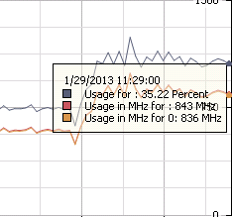

AH-0172a6#show cpu

CPU total utilization: 64.000%

CPU user utilization: 60.000%

CPU system utilization: 1.000%

AH-0172a6#show memory

Total Memory: 513096 KB

Free Memory: 411124 KB

Used Memory: 101972 KB

**2.1. 4 clients per tunnel, oversubscription ration is 1:7(585 clients are transmitting traffic)**

AH-0172a6#show amrp client | include total

Total 4096 INXP backhaul client

AH-0172a6#show amrp tunnel | include total

Total 1024 tunnels

**GRE to LLC(Upload)**

Max Upload rate can reach 910Mbps, and it is stable enough for 5 min+, so the clients’ rate is 1.55Mbps/client (pkt size 1400)

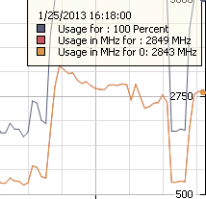

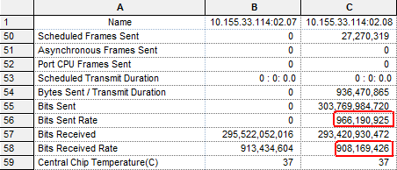

CPU total utilization: 78.000%

CPU user utilization: 7.000%

CPU system utilization: 1.000%

AH-0172a6#show memory

Total Memory: 513096 KB

Free Memory: 405316 KB

Used Memory: 107780 KB

AH-0172a6#

AH-0172a6#show logging flash | include err

AH-0172a6#

**LLC to GRE(Download)**

Max Download rate can reach 900Mbps, but the stable upload rate is about 190Mbps(CPU 100%), so the clients’ rate is 0.34Mbps/client (pkt size 1400)

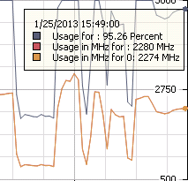

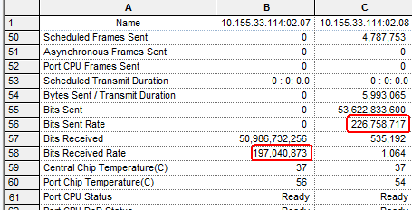

AH-0172a6#show cpu

CPU total utilization: 88.888%

CPU user utilization: 42.424%

CPU system utilization: 2.020%

AH-0172a6#show memory

Total Memory: 513096 KB

Free Memory: 406364 KB

Used Memory: 106732 KB

AH-0172a6#

AH-0172a6#show logging flash | include err

AH-0172a6#

**3. CPU and Memory status without traffic**

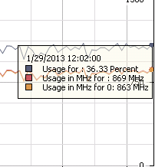

AH-0172a6#show cpu

CPU total utilization: 42.424%

CPU user utilization: 40.404%

CPU system utilization: 0.000%

AH-0172a6#show memory

Total Memory: 513096 KB

Free Memory: 409684 KB

Used Memory: 103412 KB

**3.1 8 clients per tunnel, oversubscription ration is 1:7(1170 clients are transmitting traffic)**

AH-0172a6#show amrp client | include total

Total 8192 INXP backhaul client

AH-0172a6#show amrp tunnel | include total

Total 1024 tunnels

**GRE to LLC(Upload)**

Max Upload rate can reach 860Mbps, and it is stable enough for 5 min+, so the clients’ rate is 0.74Mbps/client (pkt size 1400)

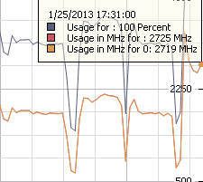

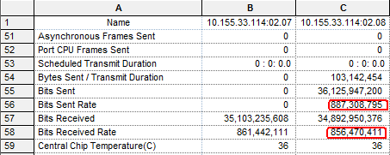

AH-0172a6#show cpu

CPU total utilization: 76.237%

CPU user utilization: 13.861%

CPU system utilization: 0.000%

AH-0172a6#show memory

Total Memory: 513096 KB

Free Memory: 402508 KB

Used Memory: 110588 KB

AH-0172a6#show logging flash | include err

AH-0172a6#

**LLC to GRE(Download)**

Max Download rate can reach 900Mbps, but the stable upload rate is about 190Mbps(CPU 100%), so the clients’ rate is 0.16Mbps/client (pkt size 1400)

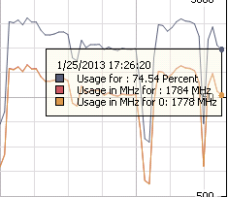

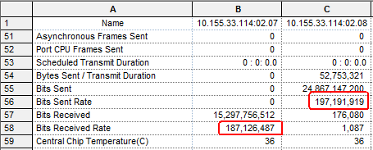

AH-0172a6#show cpu

CPU total utilization: 77.000%

CPU user utilization: 43.000%

CPU system utilization: 3.000%

AH-0172a6#show memory

Total Memory: 513096 KB

Free Memory: 402912 KB

Used Memory: 110184 KB

AH-0172a6#show logging flash | include err

AH-0172a6#

**4. CPU and Memory status without traffic**

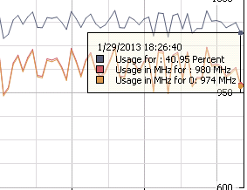

AH-0172a6#show cpu

CPU total utilization: 78.217%

CPU user utilization: 76.237%

CPU system utilization: 1.980%

AH-0172a6#show me

AH-0172a6#show memory

Total Memory: 513096 KB

Free Memory: 406932 KB

Used Memory: 106164 KB

**4.1 16 clients per tunnel, oversubscription ration is 1:7(2340 clients are transmitting traffic)**

AH-0172a6#show amrp client | include total

Total 16384 INXP backhaul client

AH-0172a6#show amrp tunnel | include total

Total 1024 tunnels

AH-0172a6#

**GRE to LLC(Upload)**

Max Upload rate can reach 850Mbps, and it is stable enough for 5 min+, so the clients’ rate is 0.36Mbps/client (pkt size 1400)

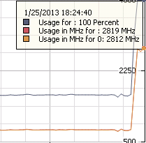

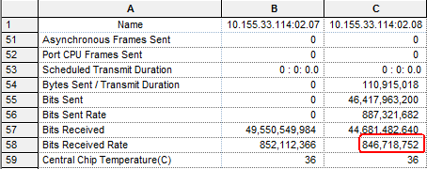

AH-0172a6#show cpu

CPU total utilization: 80.198%

CPU user utilization: 20.792%

CPU system utilization: 0.990%

AH-0172a6#show me

AH-0172a6#show memory

Total Memory: 513096 KB

Free Memory: 399840 KB

Used Memory: 113256 KB

AH-0172a6#sh

AH-0172a6#show logging fl

AH-0172a6#show logging flash | in

AH-0172a6#show logging flash | include err

AH-0172a6#

**LLC to GRE(Download)**

Max Download rate can reach 900Mbps, but the stable upload rate is about 190Mbps(CPU 100%), so the clients’ rate is 0.16Mbps/client (pkt size 1400)

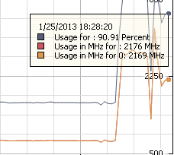

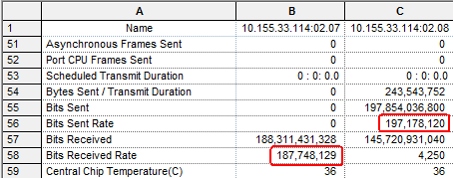

AH-0172a6#show cpu

CPU total utilization: 72.000%

CPU user utilization: 14.000%

CPU system utilization: 2.000%

AH-0172a6#show memory

Total Memory: 513096 KB

Free Memory: 398304 KB

Used Memory: 114792 KB

AH-0172a6#show logging flash | include err

AH-0172a6#

**Due to download rate is abnormal, I have tested one tunnel case**

Topo:

IXIAport9+++++SW1++++++CVGasAP++++++SW2++++++CVG(Terminate)

+

+

IXIAport8

**Test Procedure:**

1. IXIAport8 send LLC pkts destination MAC is IXIAport9’s source MAC, look up the IXIAport9’s receive status to get CVG(Terminate)’s Download rate

**Test result**

1. The maximum receive rate can reach 900M, but the stable rate is about **200M** too

