## 9.4.

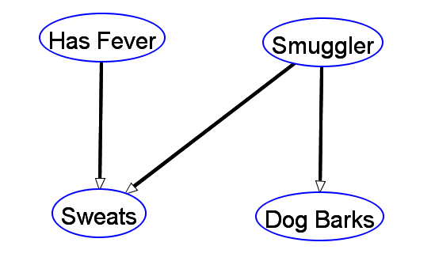

P(Smuggler) = 0.01 ; !P(Smuggler) = 0.99

P(Dog Barks | Smuggler) = 0.8 ; !P(Dog Barks | Smuggler) = 0.2

P(Dog Bark | -Smuggler) = 0.05 ; !P(Dog Barks | -Smuggler) = 0.95

P(Sweats | -Smuggler, - Fever) = 0 ; !P(Sweats | -Smuggler, - Fever) = 1

P(Sweats | Smuggler, - Fever) = 0.4 ; !P(Sweats | Smuggler, - Fever) = 0.6

P(Sweats | Smuggler, Fever) = 0.8 ; !P(Sweats | Smuggler, Fever) = 0.2

P(Sweats | -Smuggler, Fever) = 0.6 ; !P(Sweats | -Smuggler, Fever) = 0.4

P(Fever) = 0.013 ; !P(Fever) = 0.987

The probability that a person is a smuggler given the observation that the drug dog is barking: 0.13913

The probability that a suspect is sweating (without any prior observation): 0.01177

The probability that a person is a smuggler given both the observations that

that person is sweating and that the drug dog barked at him or her: 0.89357