Tensorboard
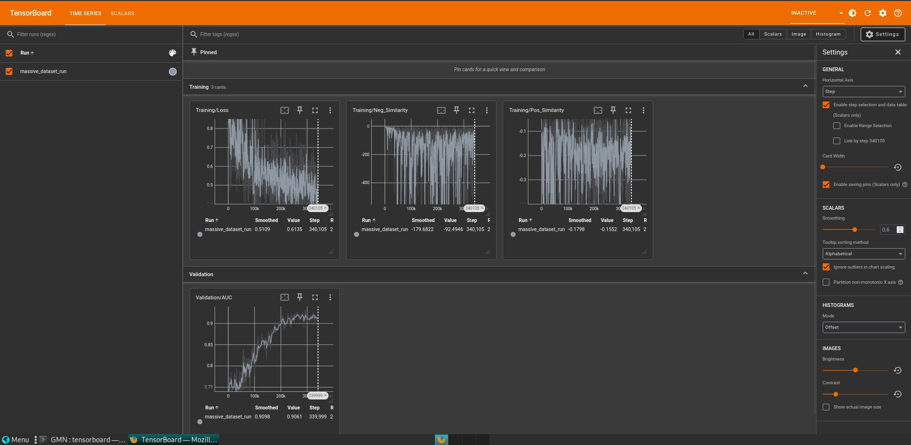

Training best AUC:
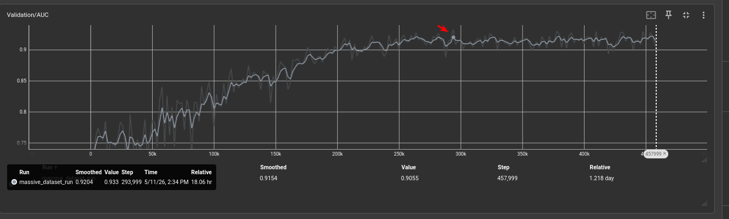

AUC on test set
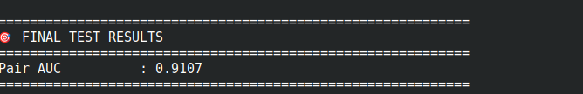
It didn’t memorize just the training data (overfitting); it generalized beautifully to unseen data.

Testing with big functions
Examples:
curl_curl_easy_setopt (gcc_O1)
wget_main (clang_02)
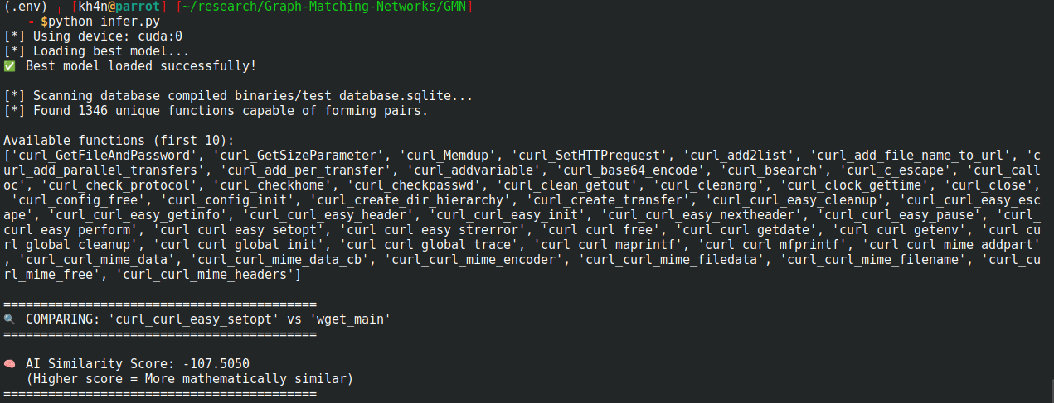
curl_curl_easy_setopt gcc_01
curl_curl_easy_setopt clang_02
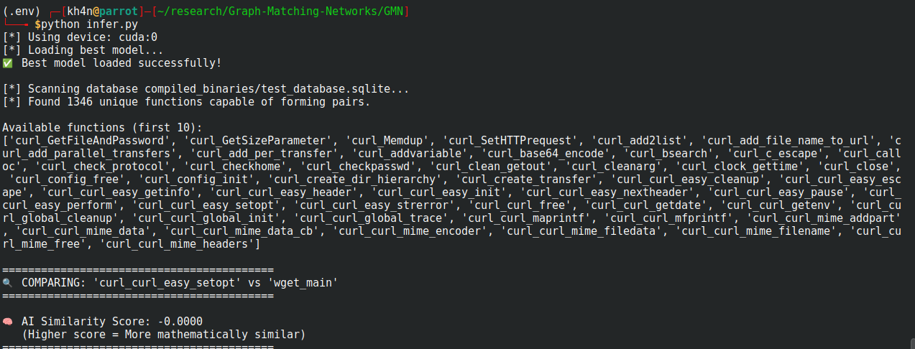
wget_main gcc_01
wget_main clang_02

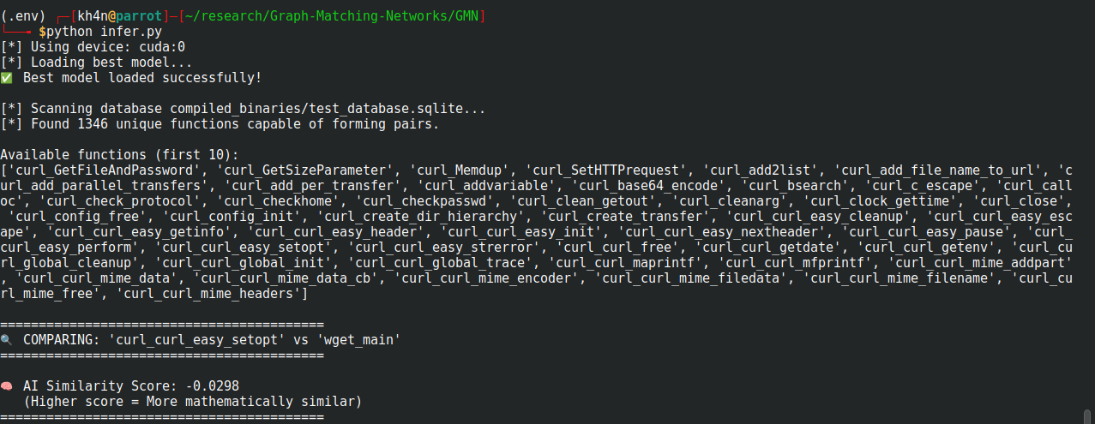
curl_main gcc01
Wget_http clang_02
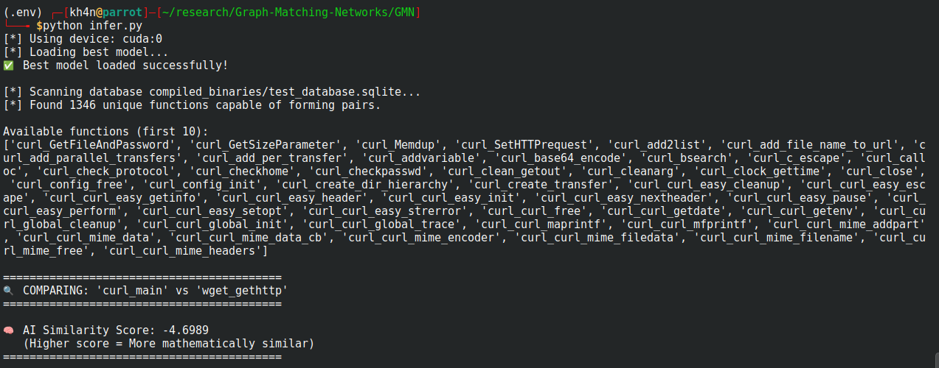
curl_single_transfer gcc_01
wget_ftp_retrieve_glob clang_02

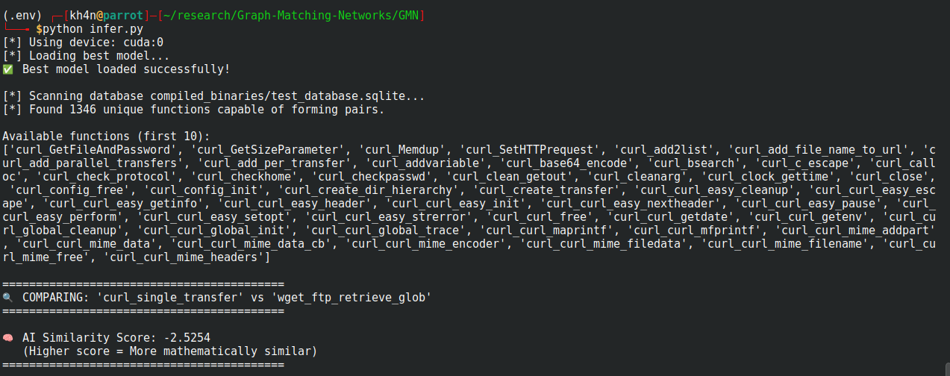
wget_ftp_retrieve_glob gcc_01
wget_ftp_retrieve_glob clang_02
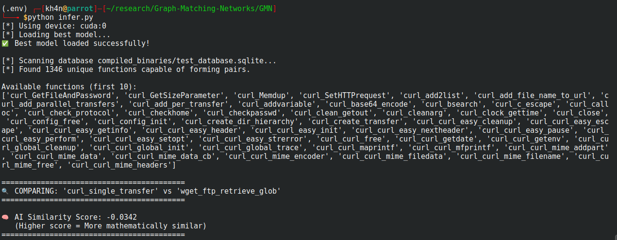
Stripped binaries
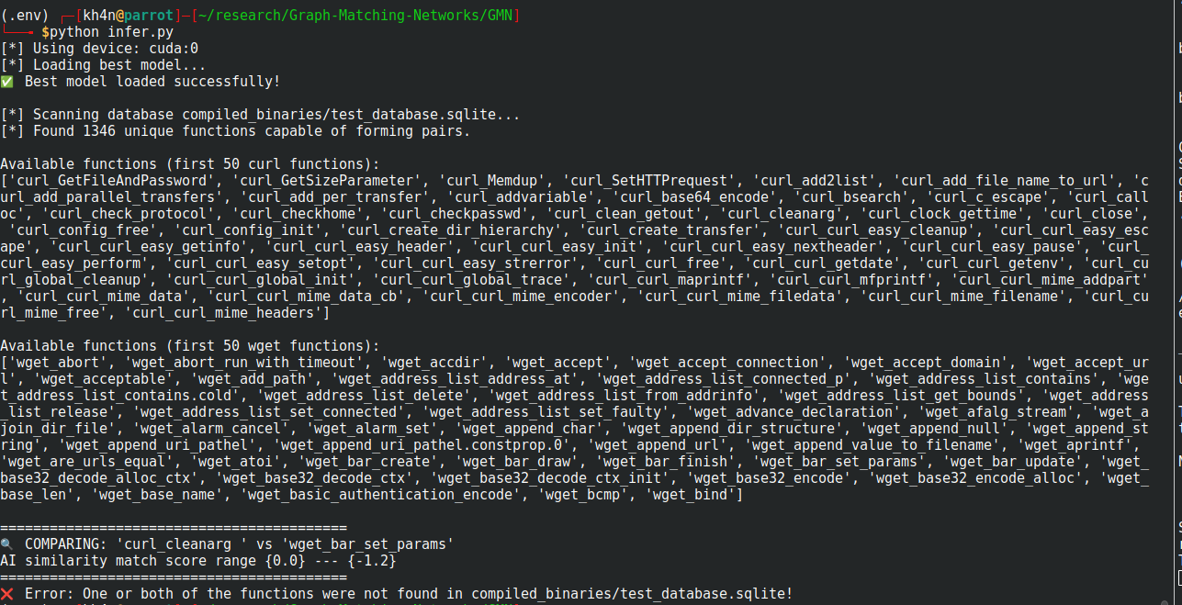

False Positives
curl_ipfs_url_rewrite gcc_01
Wget_url_parse clang_02
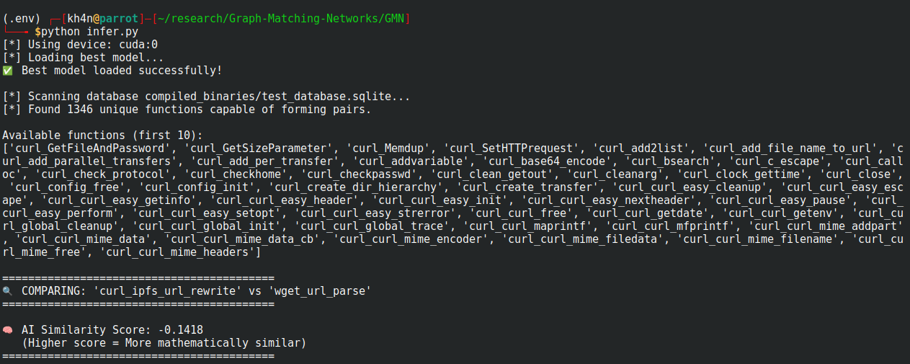
curl_curl_mime_filedata gcc_01
wget_bind clang_02
