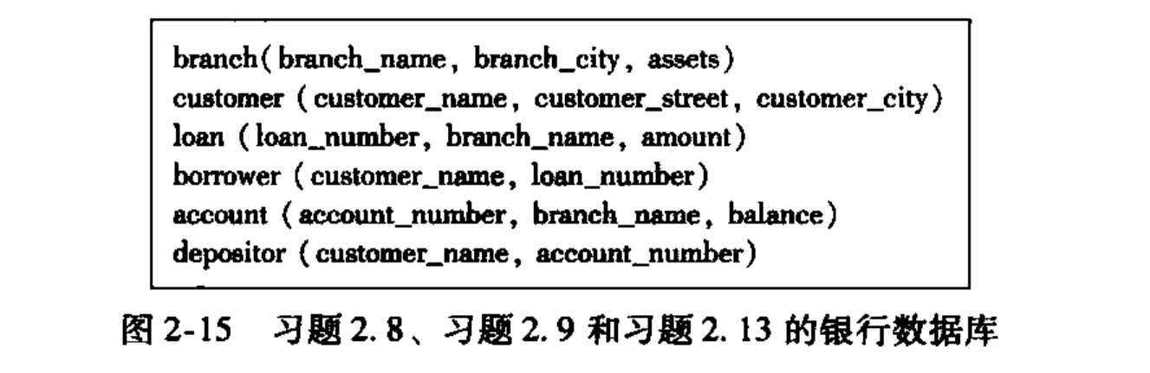



a. ∏loan_number(σamount>10000(loan))

b. ∏customer_name(σbalance>6000(account⋈depositor))

c.∏customer_name(σbalance>6000

(account⋈depositor)∪σbranch_name="Uptown"(account⋈depositor))





SELECT DISTINCT dept_name

FROM instructor i1

WHERE

(SELECT SUM(salary)

FROM instructor i2

WHERE i2.dept_name = i1.dept_name)

>=

(SELECT AVG(s)

FROM

(SELECT SUM(salary) AS s

FROM instructor

GROUP BY dept_name))

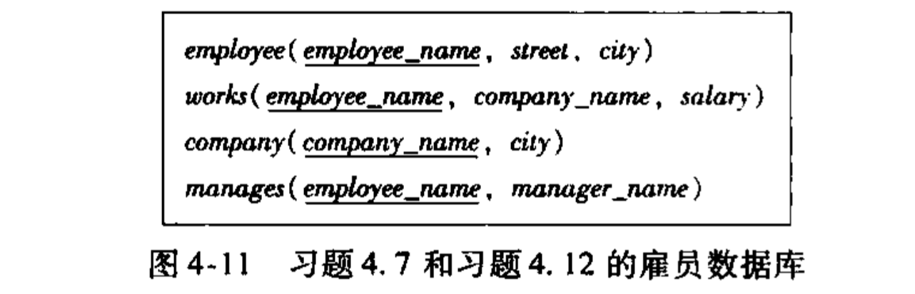



SELECT employee_name

FROM employee NATURAL LEFT OUTER JOIN manages

WHERE manager_name is NULL;