

WITH d_count(num, dept_name) AS

(SELECT COUNT(*), dept_name

FROM instructor

GROUP BY dept_name)

SELECT dept_name, budget

FROM department

WHERE d_count.num > 12 AND d_count.dept_name = department.dept_name



因为程序员在写触发器时，运行期间一个触发器的错误不仅仅会导致该触发器语句失败，而且该触发器的动作还可能影响另一个触发器，甚至于导致一个无线的触发连。因此有些数据库中会限制这种触发器链的长度（例如16或者32），把超过这种长度的触发器看成一种错误。从而可以减少开销，提高执行效率。

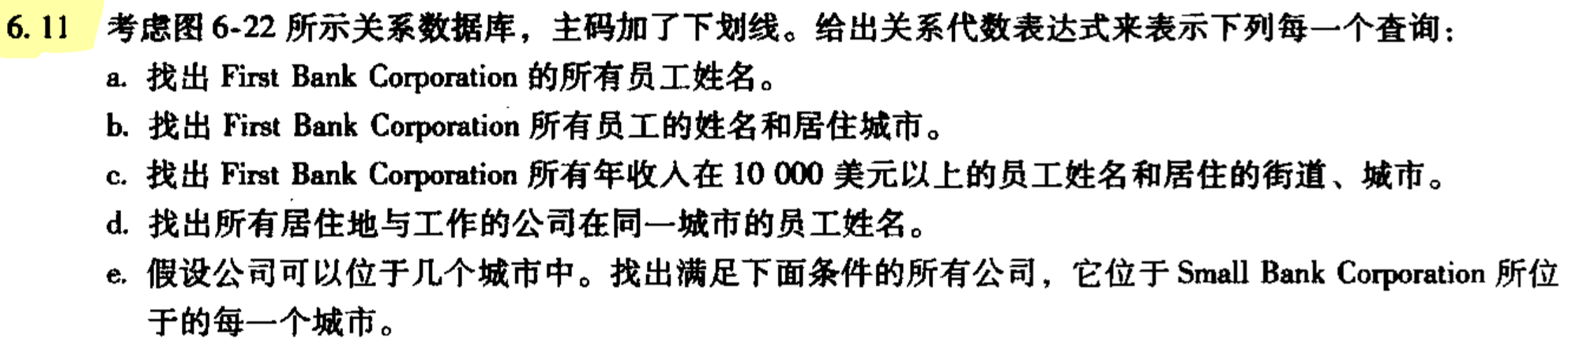

a.

∏​person_name(σcompany_name=“FirstBankCorporation”​(works))

b.

∏​person_name,city(employee⋈(σcompany_name=“FirstBankCorporation”​(works)))

c.

∏​person_name,street,city(σ(company_name=“FirstBankCorporation”∧salary>10000)​works⋈employee)

d.

∏​person_name(employee⋈works⋈company)

e.

∏​company_name(company÷(∏​city(σcompany_name=“SmallBankCorporation”​(company))))