**Eagleslist**

**Software Requirements Specification**

**CEN 3031, Fall, 2015**

**Modification history:**

|  |  |  |  |
| --- | --- | --- | --- |
| **Version** | **Date** | **Who** | **Comment** |
| **v1.0** | **October 5, 2015** | **Mostofa Ansary, Hermilo Calderon, Michael MacCallum,**  **Andrew Owen,**  **John Zachariah** | **Initial update to our Software Requirements Specification for the Eagleslist Application.** |
| **...** |  |  |  |

**Team Name:** 5Bit Studio

**Team Members:**

* Mostofa Ansary – msansary6258@eagle.fgcu.edu
* Hermilo Calderon – hcalder@eagle.fgcu.edu
* Michael MacCallum – msmaccallum5438@eagle.fgcu.edu
* Andrew Owen – adowen5642@eagle.fgcu.edu
* John Zachariah – jfzachariah3593@eagle.fgcu.edu

5-bit.github.io

**Contents of this Document**

(1) Introduction

* Software to be Produced
* Definition, Acronyms, and Abbreviations

(2) Product Overview

* Assumptions
* Use Case Diagram
* Use Case Descriptions

(3) Specific Requirements

**SECTION 1: Introduction**

Software to be Produced:

* Eagleslist is a textbook focused trading program for FGCU students that will allow users to make accounts, verify their student email addresses and post used textbooks and other goods that they’re looking to buy or sell. We plan on adding special features for textbooks, like the ability to lookup books by CRN, or ISBN. Professors will also be able to verify their faculty email addresses and have the ability to supply the ISBNs for books that they will require for specific classes. Students will be allowed to comment and/or review course books to rate them by relevance/necessity/etc. We will not be handling money, all transactions will be determined by the students who buy and sell products on our service.

Definitions, Acronyms, and Abbreviations:

* GUI - graphical user interface
* IDE - integrated development environment
* SQL - Structured Query Language (“sequel”)
* DB - database

**SECTION 2: Product Overview**

Assumptions:

The desktop application will require:

* Windows 7+ to run.
* Communication with a web service, and will therefore require an internet connection to operate.
* A system will at least 1GB of RAM, and at least a 1 GHz processor.
* C# and .NET 4.5
* Google Books API
* Web Service
* PostgreSQL
* Go
* Ubuntu 14.04
* Digital Ocean
* Journal Website
* HTML
* CSS
* Javascript
* Jekyll
* Liquid

Use Case Diagram: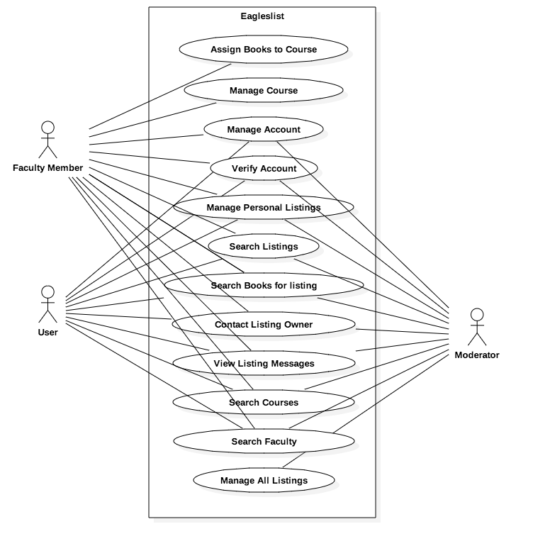

Use Case Descriptions:

* Assign Books to Course
  + A faculty member will be able to add books to a course (with an assigned CRN) so that students will be able to search a CRN to find all the books assigned to a course.
* Manage Course

Faculty members will be able to add, remove and edit their courses, including course titles, the CRN for a course, and a course description.

* Manage Account
  + Users will be able to adjust their username, ask for password resets, and set an avatar image for their profiles.
* Verify Account
  + Upon signup, users will have to confirm that they are a FGCU student by clicking a verification link that will automatically be sent to their EagleMail account. Users will not be allow to post or buy books on Eagleslist until this verification is complete. The procedure for faculty members to verify their email addresses will be exactly the same from a user interaction standpoint. The only difference internally, will be that the system will be checking for a “[someone@fgcu.edu](mailto:someone@fgcu.edu)” address, instead of a “[someone@eagle.fgcu.edu](mailto:someone@eagle.fgcu.edu)” address.
* Manage Personal Listings
  + Users will be able to view all of their listings. They will be able edit each listing’s description, title, and book list. The will also be able to mark a listing as sold, so that it do not show up in general searches.
* Search Listings
  + A search feature will be available for all users with a verified email address. This feature filters other user’s available listings based on the search parameters entered by the user.
* Search Books for Listing
  + Sellers will able to find books by using book name, author name, or ISBNs, and then add books from the results to a listing. This will enable users to search for listings for a specific book.
* Contact Listing Owner
  + The application will provide facilities that allow users that are interested in buying books to contact the seller directly to discuss the purchase. This will be done via direct messages that can not be seen by anyone other than the seller, and the user who contacted them.
* View Listing Messages
  + A notification will be sent to a user’s account when an offer is made on one of their listings.
* Search Courses
  + By entering the CRN of a class into the search field, users are able to find their professors and related textbooks.
* Search Faculty
  + Users are able to search professors by name and view faculty member’s current active courses and books related to the professor’s classes.
* Manage All Listings
  + Moderators are able to remove posts that are irrelevant or offensive. Continued misuse of the Eagleslist service will result in account removal or suspension.

**SECTION 3: Specific Requirements**

|  |
| --- |
| **No: 1** |
| **Statement:** Users shall be able to verify their account via Eaglemail. |

|  |
| --- |
| **No: 2** |
| **Statement:** Users shall be able to manage their account details (delete account, edit contact information, etc.). |

|  |
| --- |
| **No: 3** |
| **Statement:** Users shall be able to create a new listing as well as edit and remove previously created listings. |

|  |
| --- |
| **No: 4** |
| **Statement:** Passwords shall be stored using a one-way hashing algorithm, and never in plaintext. |

|  |
| --- |
| **No: 5** |
| **Statement:** Users shall be able to search for listings created by other users. |

|  |
| --- |
| **No: 6** |
| **Statement:** Users shall be able to contact the owner of a listing while browsing. |

|  |
| --- |
| **No: 7** |
| **Statement:** Users shall be able to view account messages related to offers other users have made for their posted listings. |

|  |
| --- |
| **No: 8** |
| **Statement:** Users shall be able to look up faculty members and view the classes they are currently offering to find relevant books for their classes. |

|  |
| --- |
| **No: 9** |
| **Statement:** Users shall be able to search required/recommended books using the CRN of their class. |

|  |
| --- |
| **No: 10** |
| **Statement:** Users shall be able to search for books to add to their listing to help others find it. |

|  |
| --- |
| **No: 11** |
| **Statement:** Moderators shall be able to manage all listings on the website in case of misuse of our service. |

|  |
| --- |
| **No: 12** |
| **Statement:** Faculty members shall be able to assign books to their related courses. |

|  |
| --- |
| **No: 13** |
| **Statement:** Faculty members shall be able to manage their courses (add, remove, edit). |

Template created by G. Walton (GWalton@mail.ucf.edu) on Aug 30, 1999 and last updated Aug 15, 2000; updated by A. Koufakou, Aug 2014

This page last modified by 5Bit Studio (msmaccallum5438@eagle.fgcu.edu) on 10/5/15