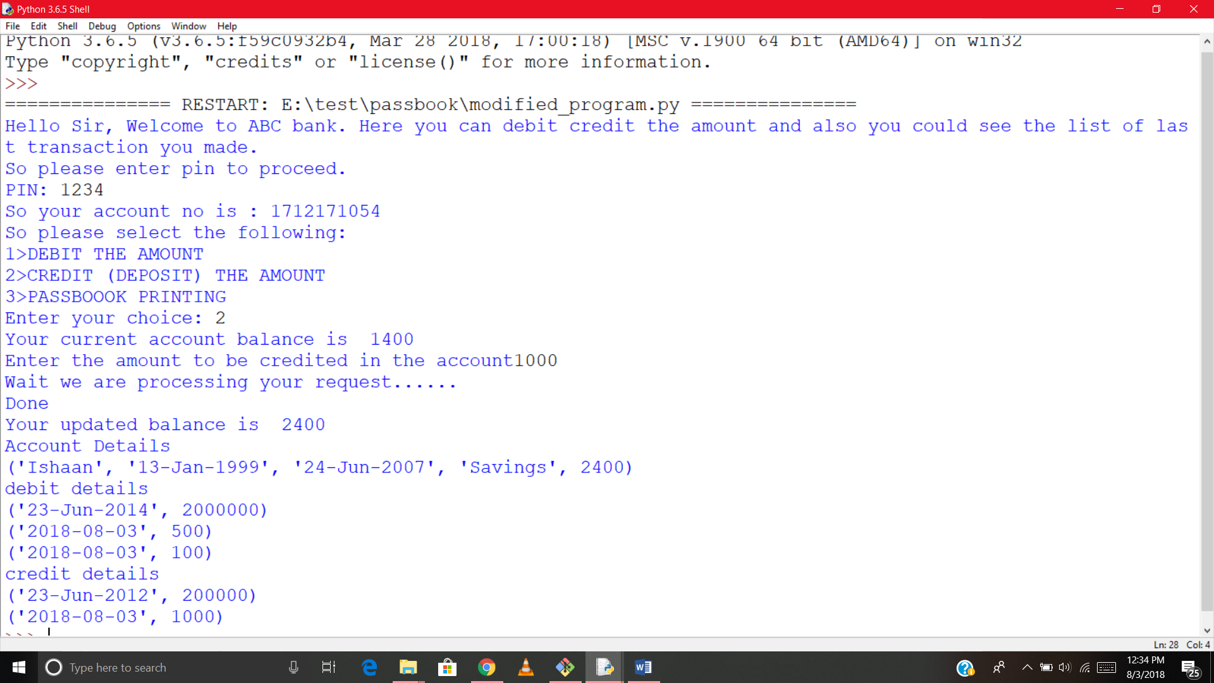

Initially the user was logging in to his own account by only entering PIN of account which is not safe for security reasons.

Functionality has been added so that user will only able to login to his account when both account number and pin exist in database and particular account number should have it’s matched PIN.

CASE1:Correct account number wrong pin

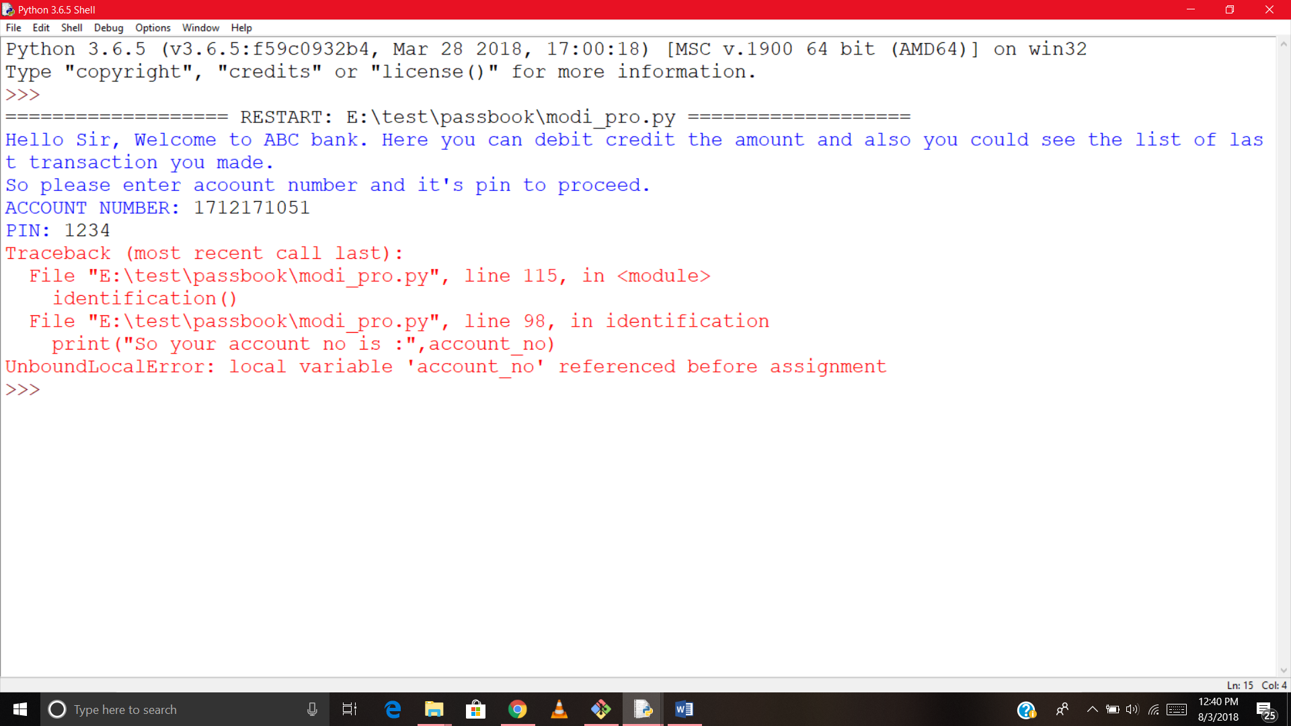

Login error

CASE2:wrong account number currect pin

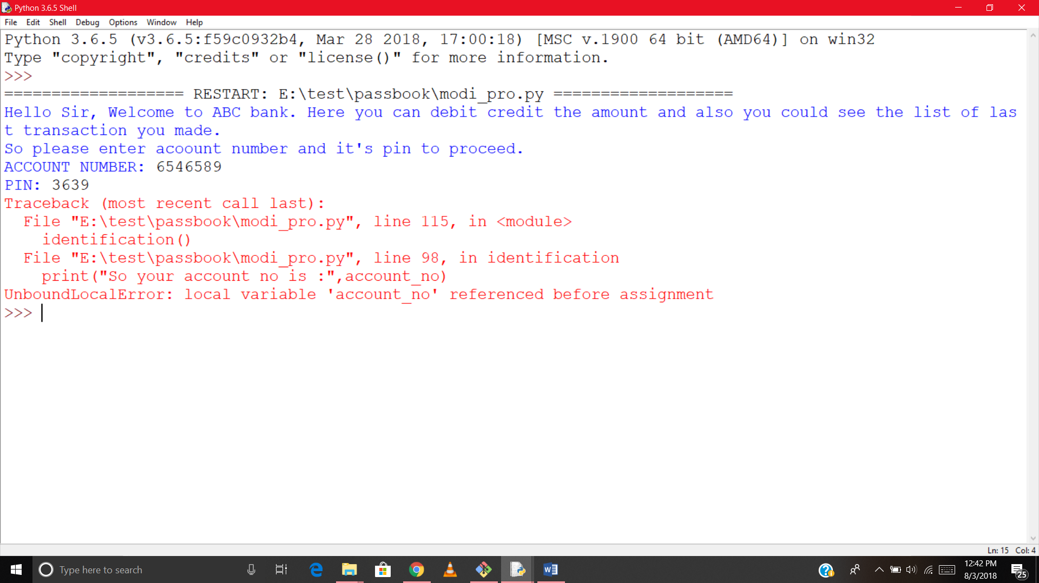

Login error

CASE3:Correct account number with it’s matching pin

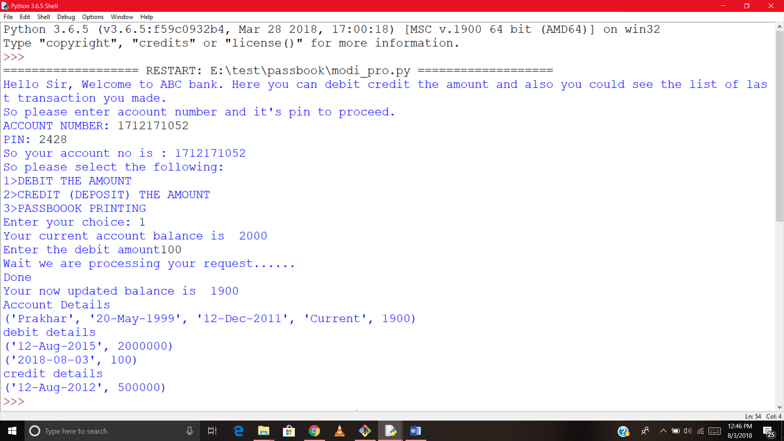

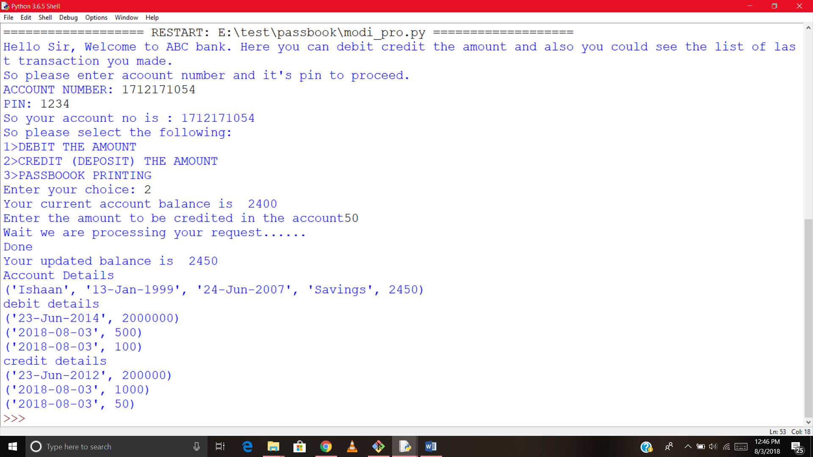

Login successful