Passbook printing functionality test

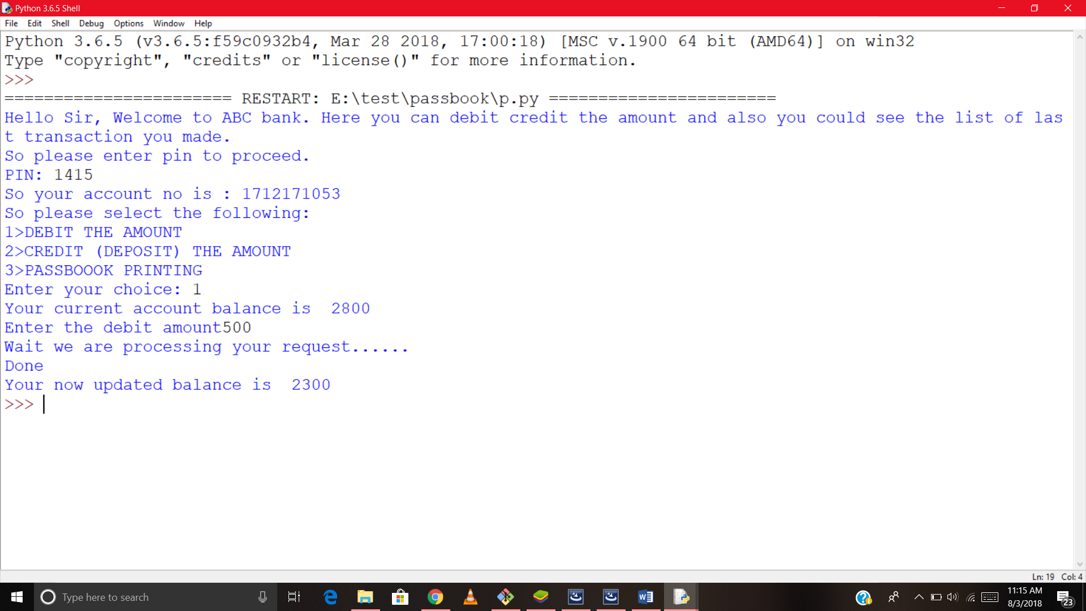

Account details prompt added

The code was note printing the account details after performing any credit or debit operation.

Functinality modified to display account details after every credit or debit operation.

