**ASSIGNMENT 2**

1. Calculate the average of three numbers. If average is greater than or equal to 75, print "Pass", else print "Fail".

Ans:

**Print “Fail”**

**Print ”Pass”**

**d=(a+b+c)/3**

**INPUT a,b,c**

**Is d>75 ?**

YES

NO

1. Calculate and print the factorial of a number

Ans:

NO

YES

**C=1**

**C=C*a  
a=a-1**

**INPUT a**

**Is a>0 ?**

**DISPLAY C**

1. Accept the lengths of three sides of a triangle as input from the user. Based on the input, print if the given triangle is "Equilateral", "Isosceles" or "Scalene".

Ans:

**PRINT “Isosceles Triangle”**

**PRINT “Equilateral Triangle”**

YES

YES

NO

NO

NO

**Is b=c ?**

YES

**Is a=b?**

**INPUT a,b,c**

**Is b=c ?**

**PRINT “Scalene Triangle”**

Accept the values of principal amount, rate of interest and number of years as an input from the user. Calculate and print the simple interest.

Ans:

**DISPLAY S.I.**

**S.I.=(P*R*T)/100**

**INPUT P,R,T**

**ASSIGNMENT 3**

In previous section, you have created the ﬂowcharts for the following problems. Now, use Raptor tool to create and execute ﬂowcharts for these problems. Observe the output for diﬀerent set of inputs.

1. Calculate the average of three numbers. If average is greater than or equal to 75, print "Pass", else print "Fail".

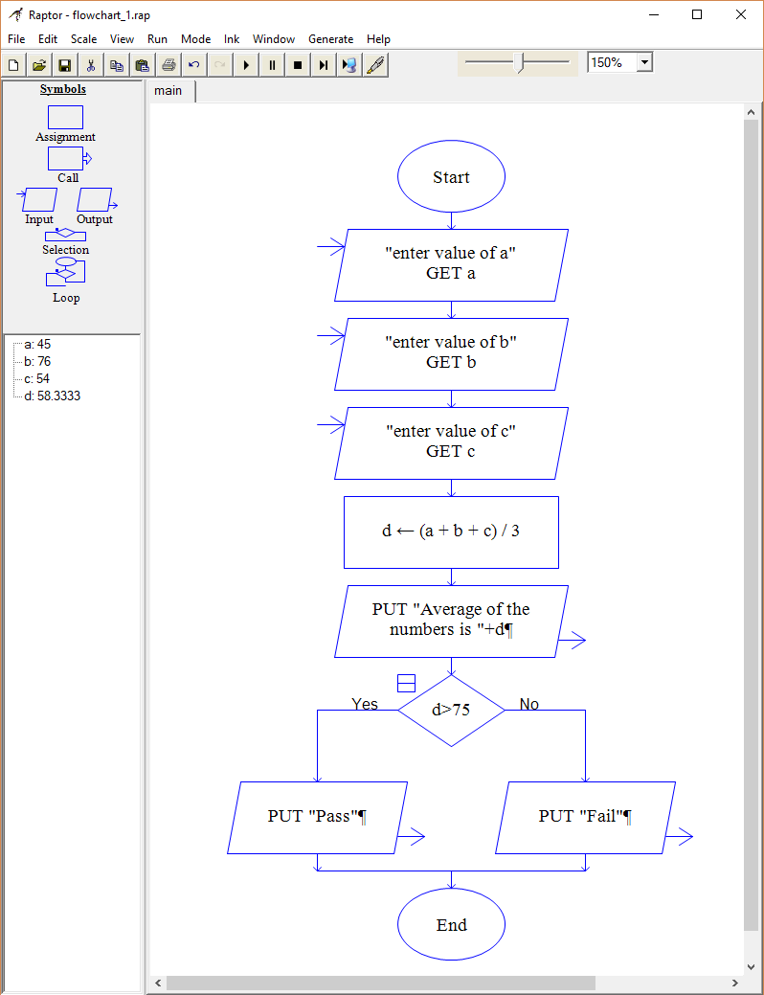 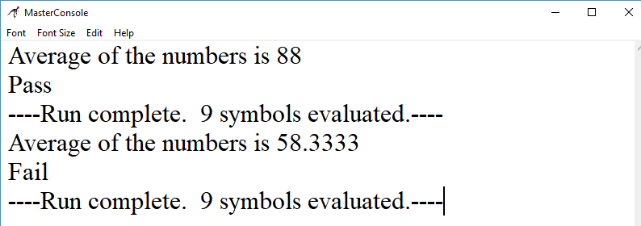

1. Calculate and print the factorial of a number

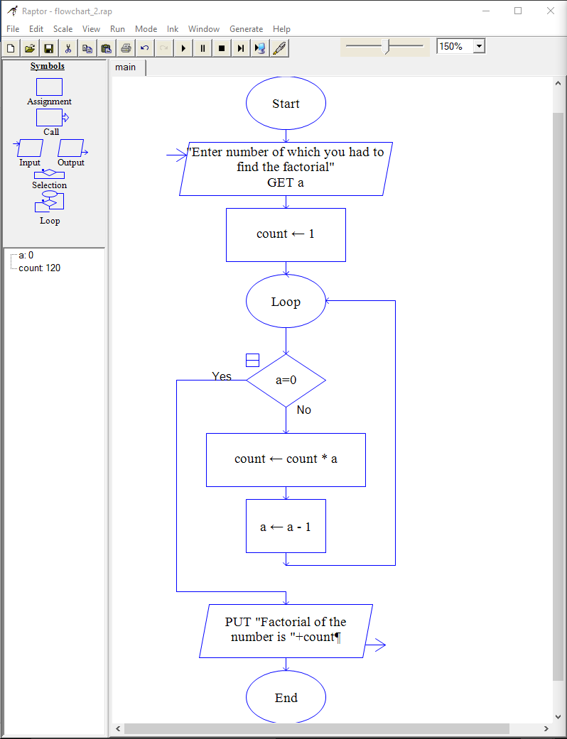

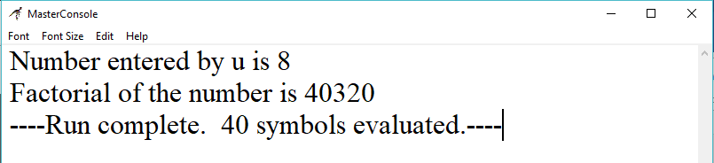

1. Accept the lengths of three sides of a triangle as input from the user. Based on the input, print if the given triangle is "Equilateral", "Isosceles" or "Scalene".

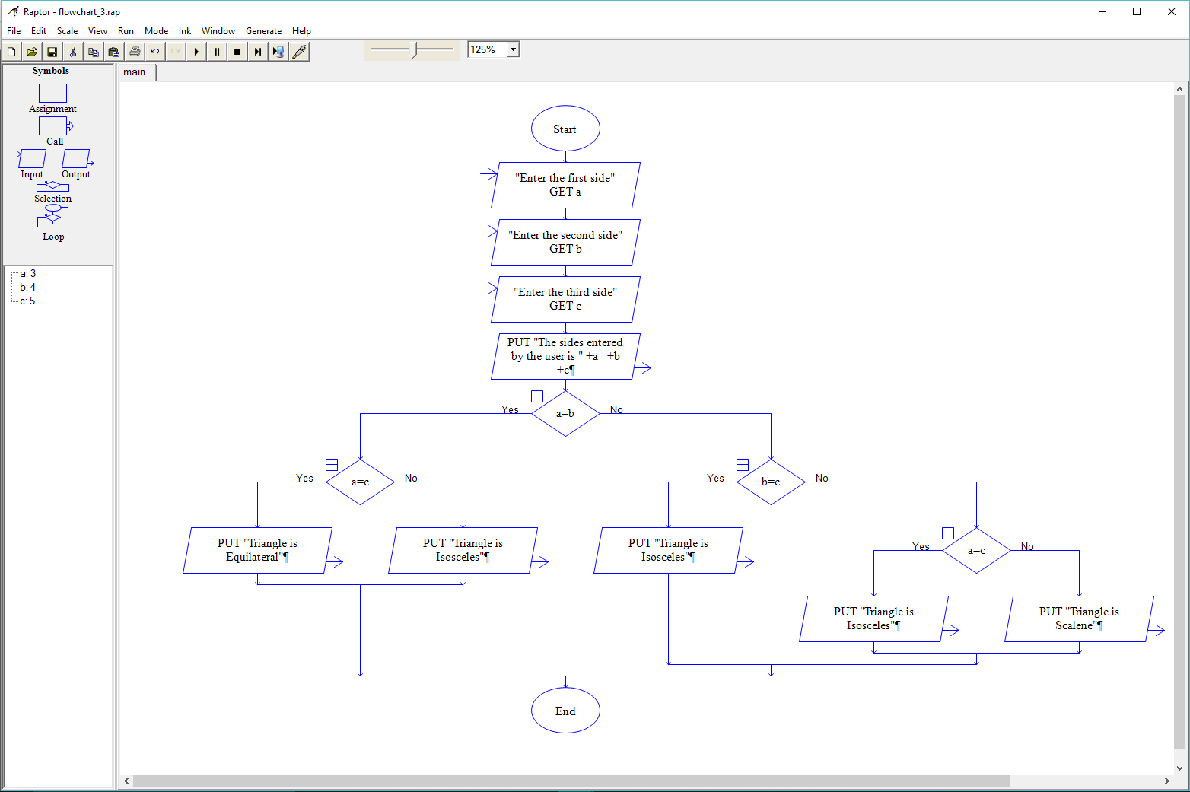

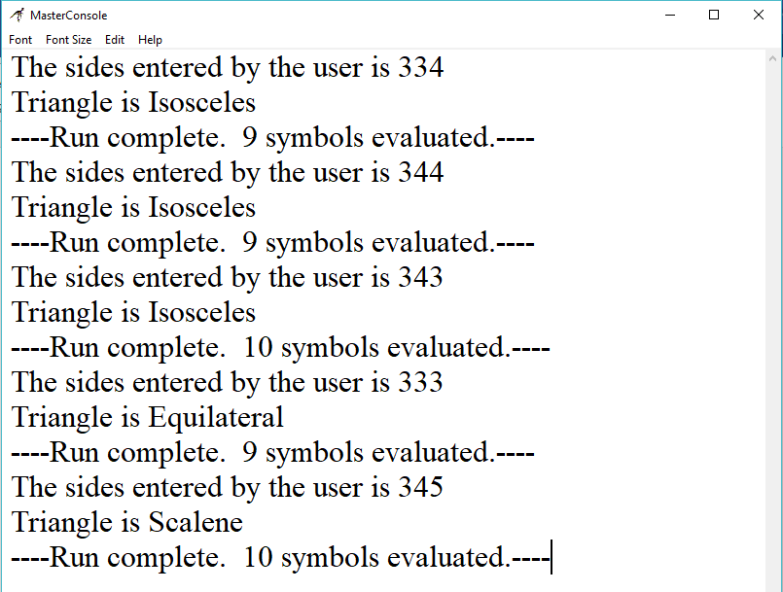

1. Accept the values of principal amount, rate of interest and number of years as an input from the user. Calculate and print the simple interest.

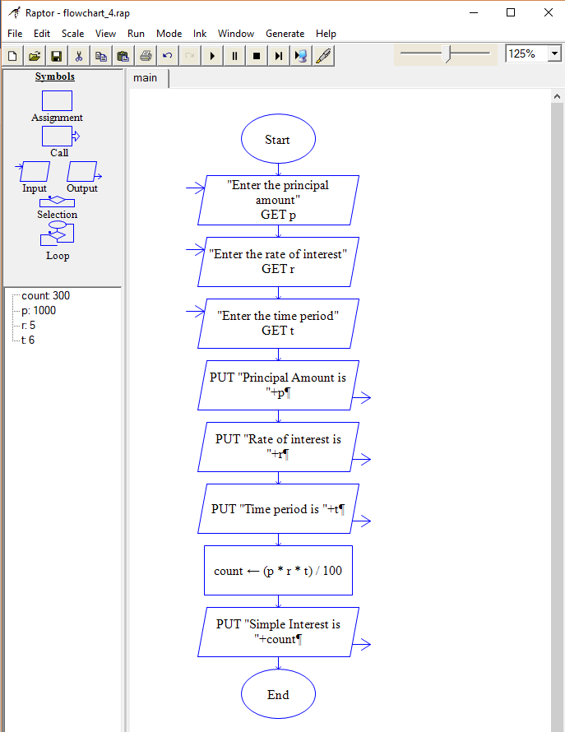

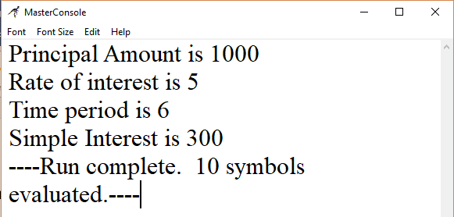

**ASSIGNMENT 4**

Q1: Write Pseudo Code:

1. To check whether a given number is even or odd.

Ans: **Step 1:** Start

**Step 2:** [Take Input] Read: N

**Step 3:** Check: If N%2 == 0 Then

Print : N is an Even Number.

Else

Print : N is an Odd Number.

**Step 4:** Exit

1. To ﬁnd factorial of a given number.

Ans: To calculate n!, given n

**Step 1**: Input integer number n

**Step 2**: If n< 0 , Output “error”, stop,

Else, Initialise Product to 1

**Step 3**: If n=0 or n=1, Output Product,Stop

Else, Initialise Multiplier to 2

**Step 4**: Redefine Product=Product* Multiplier

**Step 5**: Increment Multiplier by 1

**Step 6**: If Multiplier is less than or equal to n , go to 6

Else, Output Product

1. To calculate ‘x’ to the power of ‘n’ using a while loop.

Ans: **Step 1:** Input integer number n and x.

**Step 2:** Initialize a function **double** pow(**double** x, **int** n) {

**Step 3: if** (n < 0) **return** pow(1.0 / x, -n)

**Step 4**: **if** (n == 0) **return** 1.0

**Step 5:** **if** (n == 1) **return** x

**Step 6:** **if** (n % 2 == 0) **return** pow(x * x, n / 2)

**Step 7:** Default it will **return** x * pow(x * x, (n - 1) / 2)

1. To print the multiples of 3 between 1 to 20.

Ans**: Step 1:** Initialize a variable i and j. Make j static with a value equal to 3.

**Step 2:** Initialize a variable n=20 or define a limit variable.

**Step 3:** Design a for loop as for(i=1;i<=n/3;i++)

**Step 4:** Return 3*i

**Step 5:** Print the values received by the function and close the program

**ASSIGNMENT 5**

Open the Python IDLE and execute the following commands. Observe the output.

1. 10 + 15

“It will display the sum of 10 and 15 that is 25 after the clicking of enter key.”

1. Print(“Hello World”)

“It will print hello world after we press enter key”

1. 45-34

“It will give us difference of 45 and 34 after we press enter key.”

1. 8*2

“It will display the products of 8 and 2 after we press enter key”

1. Print(“Rahul’s age is”,45)

It will give us the output as follows: “Rahul’s age is 45”

1. Print(“I have”,10,”mangoes and”,12,”bananas”)

I will give us the output as follows: “I have 10 mangoes and 12 bananas”

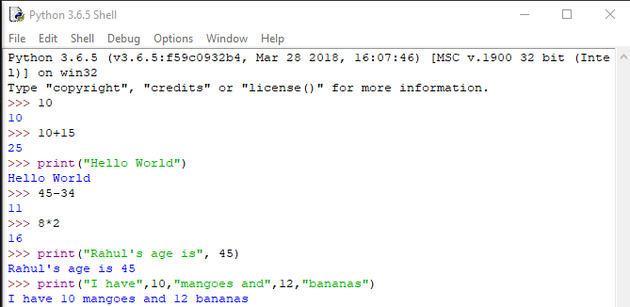

**ASSIGNMENT 6**

Open Python IDLE and execute the following commands. Observe the output.

1. emp_number = 1233

Assign the value to the emp_number variable.

1. print(“Emoployee Number:”, emp_number)

It will print the output as follows:

Employee Number: 1233

1. emp_salary = 16745.50

It will assign value to “emp_salary” variable.

1. emp_name = “Jerry Squaris”

It will assign string value to the “emp_name” variable.

1. print(“Employee Salary and Name:”,emp_salary,emp_number)

It will print the output as follows:

Employee Salary and Name: 16745.5 Jerry Squaris

1. emp_salary = 23450.34

It will assign new value to same “emp_salary” variable.

1. print(“Upadted Employee Salary:”,emp_salary)

It will print the output as follows:  
“Updated Employee Salary: 23450.34”

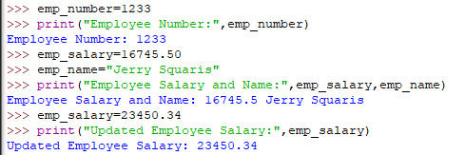

**ASSIGNMENT 7**

Execute the following Python statements in IDLE and observe the output:

1. customer_id=101

Assign the value to a variable named as customer_id.

1. type(customer_id)

Give the datatype of the variable taken as an argument.

1. customer_name="John"

Assign the value to a variable named as customer_name.

1. type(customer_name)

Give the datatype of the variable taken as an argument.

1. bill_amount=675.45

Assign the value to a variable named as bill_amount.

1. type(bill_amount)

Give the datatype of the variable taken as an argument.

1. x=5.3+0.9j

Assign the value to a variable named as x

1. type(x)

Give the datatype of the variable taken as an argument.

1. print(customer_id,customer_name,bill_amount)

It will give output as follows:

1. print(x.real)

“It will print the real part of the complex number”

1. print(x.imag+3)

“It will increase the imaginary part by 3 and print it”

1. Flag=True

“It will store boolean variable in the Flag”

1. Type(Flag)

“It will give us the name of the datatype of the variable to which it belongs”

1. Y=”Flag”

“It will store the string variable in the variable named as y”.

1. Type(y)

“It will give us the name of the datatype to which it will belong”

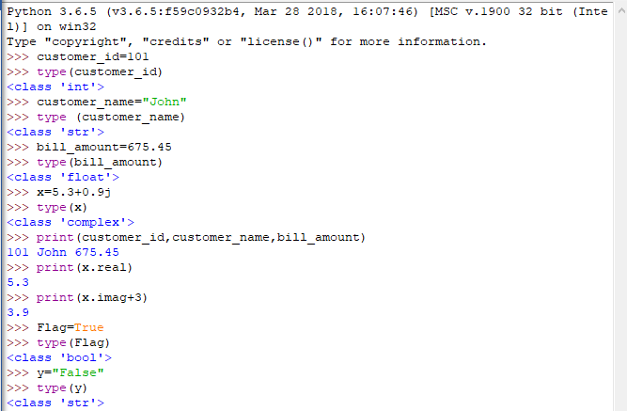

**ASSIGNMENT 8**

In a retail application, shopkeeper wants to keep a track of following details of a customer. Sample values are

provided.

•bill_id = 101

•customer_id = 1001

•customer_name = "Rahul"

•if_minor = False

•bill_amount = 2000.50

Write a python program to store the details and display them

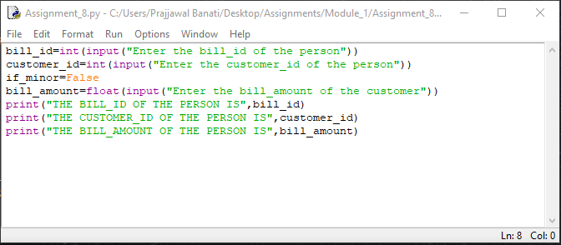

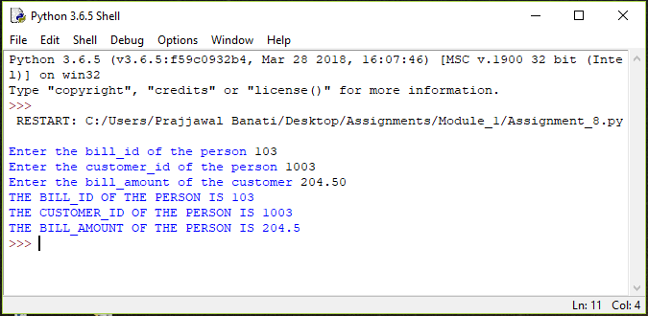

**ASSIGNMENT 9**

Execute the following commands and observe the usage of diﬀerent types of commenting styles.

i = 10

# creates an integer variable. This is a single line comment.

print("i =", i)

# prints 10

'''

Below code creates a Boolean variable in Python

(This is a multiple line comment)

'''

s = True

print("s =", s)

#prints True, Here, s is a Boolean variable with value True

"""

Below code assigns string data to variable 's'. Data type of variable can change during execution,

Hence, Python supports Dynamic Semantics.

(This is multi-line comment used for documentation)

"""

s = 24

print("s =", s)

#prints 24, Here, s is changed to integer data type with value 24

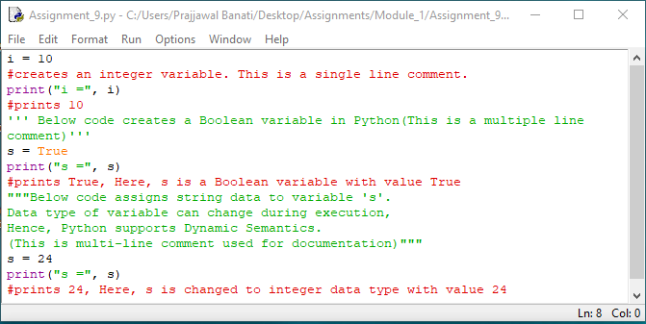

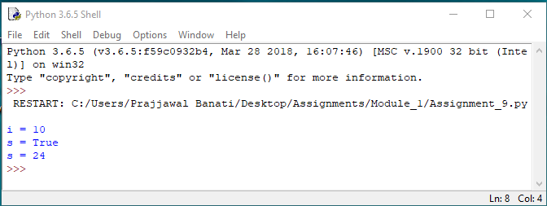

**ASSIGNEMENT 10**

Write a Python program for the following requirements:

• Prompt the user to input two numbers num1 and num2

• Increment num1 by 4 and num2 by 6

• Find and print the sum of new values of num1 and num2

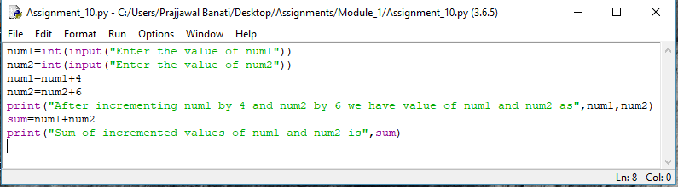

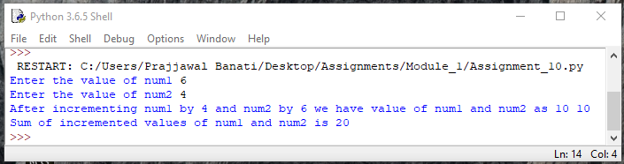

**ASSIGNMENT 11**

1. Consider two variables 'a' and 'b' in Python such that a = 4 and b = 5. Swap the values of 'a' and 'b' without using a temporary variable. Print the values of 'a' and 'b' before and after swapping

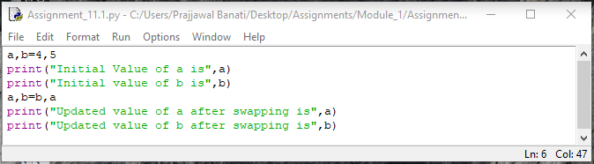

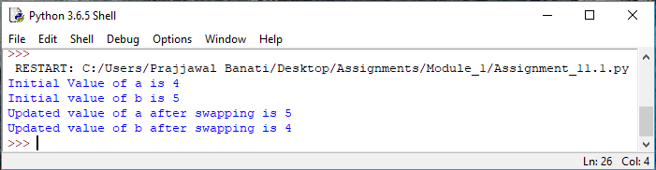

1. Consider the scenario of processing marks of a student in ABC Training Institute. John, the student of ﬁfth grade takes exams in three diﬀerent subjects. Create three variables to store the marks obtained by John in three

subjects. Find and display the average marks scored by John.

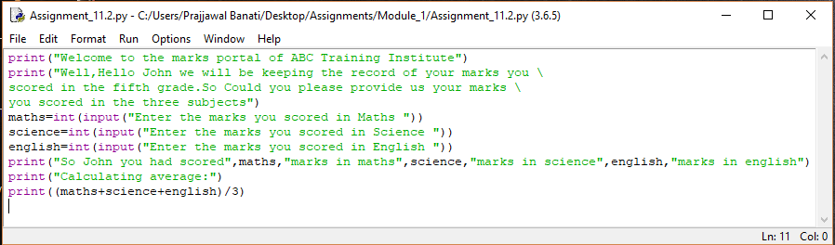

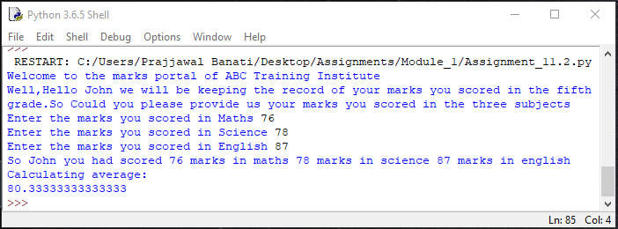

Now change the marks in one of the subjects and observe the output. Did the value of average change?

Ans: YES, AS NOW NEW VALUES WILL BE ASSIGNED TO SAME VARIABLES.

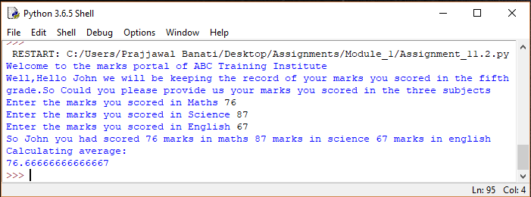

1. Given the value of radius of a circle, write a Python program to calculate the area and perimeter of the circle. Display both the values.

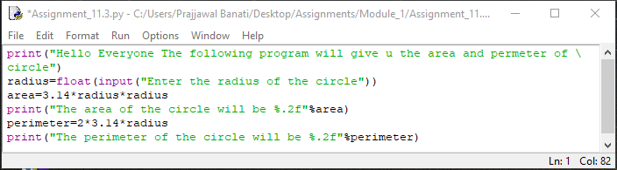

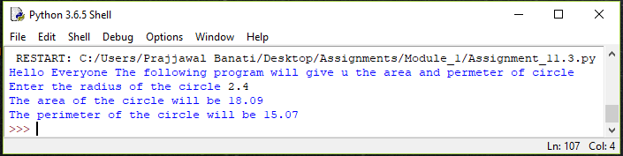

1. The ﬁnance department of a company wants to compute the monthly pay of its employees. Monthly pay should be calculated as mentioned in the formula below. Display all the employee details.

Monthly Pay = Number of hours worked in a week * Pay rate per hour * No. of weeks in a month

• The number of hours worked by the employee in a week should be considered as 40

• Pay rate per hour should be considered as Rs.400

• Number of weeks in a month should be considered as 4

Write a Python program to implement the above real world problem.

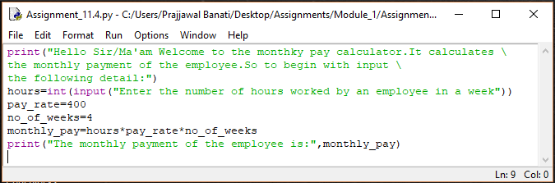

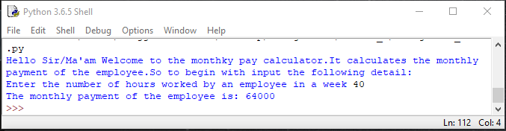

**ASSIGNEMENT 12**

Identify the sections of the given program where the coding standards are not followed and correct them.

1. itemNo= 1005

Ans: Firstly, all the letters should be in lowercase and secondly a combination of two words should be separated by _ mark. And also there must be spaces between the binary operators. So the right representation of the variable is:

item_no = 1005

1. unitprice = 250

Ans: Firstly we need underscore mark to separate the two words, So the right representation is

unit_price = 250

1. quantity=2

Ans: Space between the binary operators

quantity = 2

1. amount=quantity*unitprice

Ans: amount = quantity * unit_price

1. print(“Item No:”itemNo)

Ans: Firstly there must be space after the “Item No: ” so that it makes easy for the user to read the item no. and does not mix anything and one more thing itemNo should be all in lowercase and also spaced by underscore mark (‘_’) , So the correct representation is

Print(“Item No: ”item_no)

1. print(“Bill Amount:”,amount)

Ans: The correct representation is:

Print(“Bill Amount: ”,amount)

**ASSIGNMENT**

1. Create a file in PYTHON Idle named as triangle.py

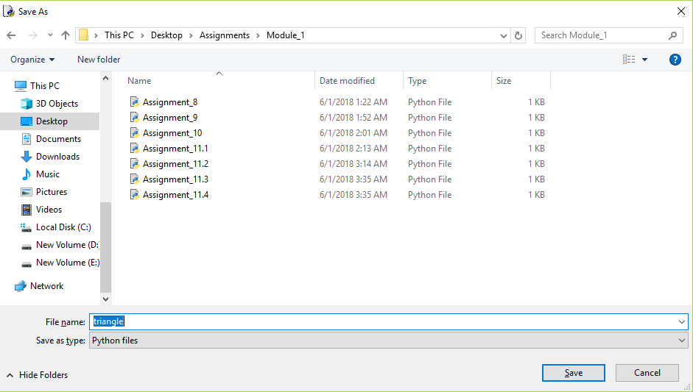

1. Write a Python program to calculate and print the area of the triangle. Prompt the user to input the values for base and height of the triangle.

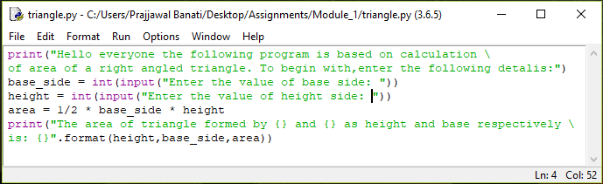

1. Execute the program(use 'Run Module' under 'Run' tab) and observe the output.

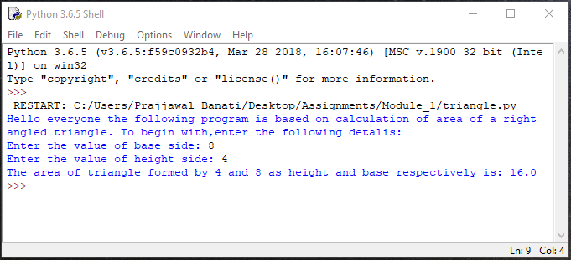

1. Close the ﬁle, open it again and execute it once more with diﬀerent values. Observe the output.

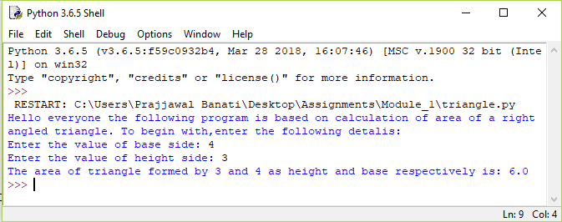

**ASSIGNMENT 13**

1. Consider the scenario of retail store management again. The store provides discount for all bill amounts based on the criteria below:

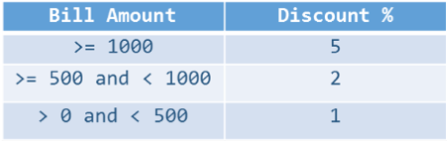

Write a Python program to ﬁnd the net bill amount after discount. Observe the output with diﬀerent values of bill amount. Assume that bill amount will be always greater than zero:

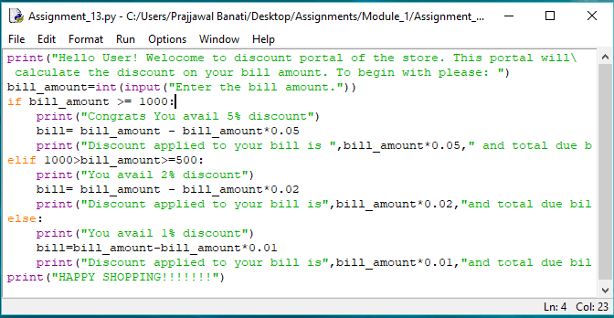

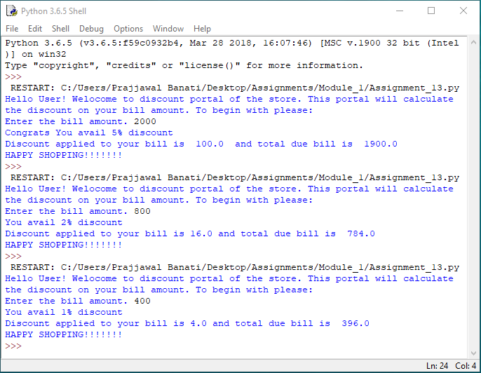

1. Extend the above program to validate the customer id. Customer ids in the range of 101 and 1000 (both inclusive) should only be considered valid.

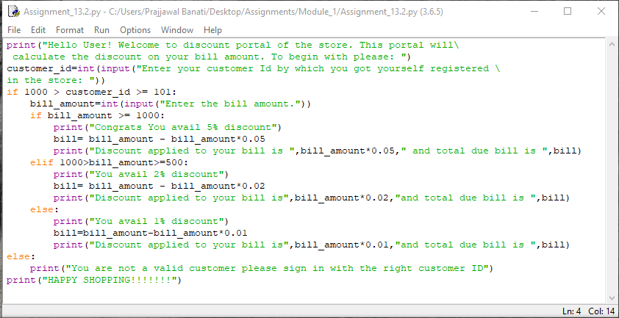

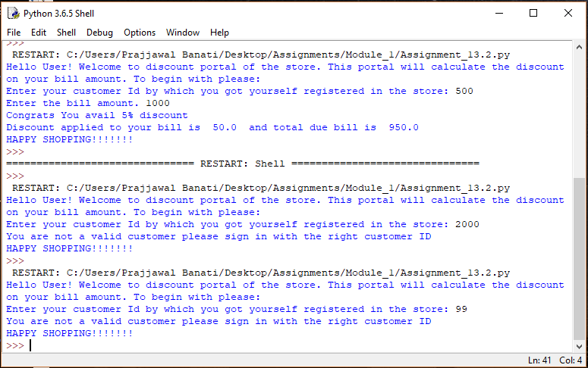

**ASSIGNMENT 14**

Implement the following in Python:

1. Display all even numbers between 50 and 80 (both inclusive) using "for" loop.

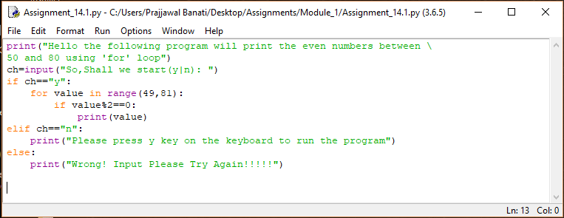

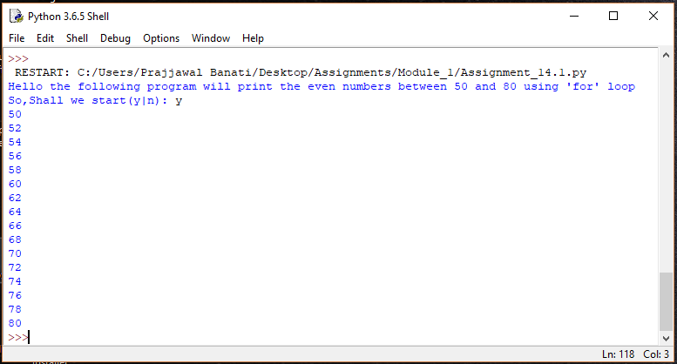

1. Add natural numbers up to n where n is taken as an input from user. Print the sum.

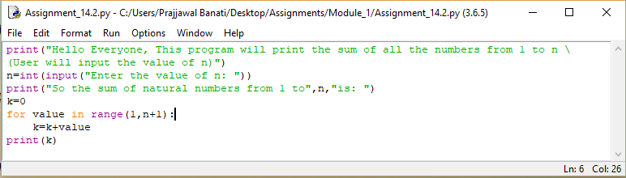

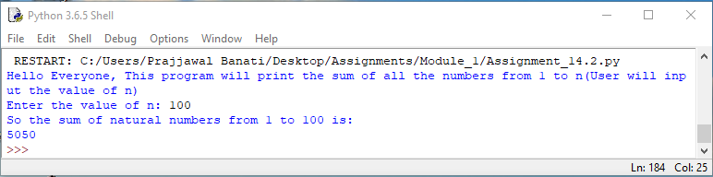

1. Prompt the user to enter a number. Print whether the number is prime or not.

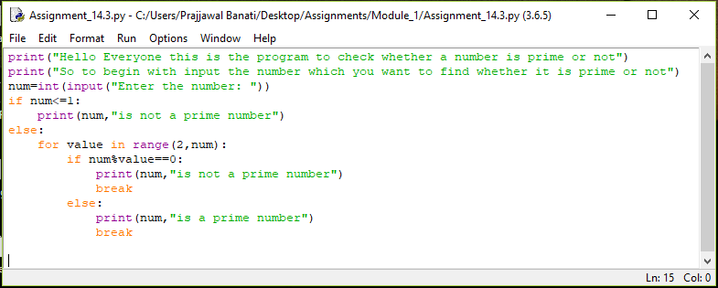

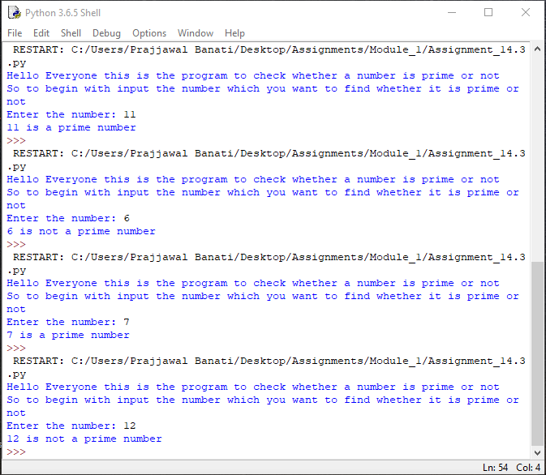

1. Print Fibonacci series till nth term where n is taken as an input from user.

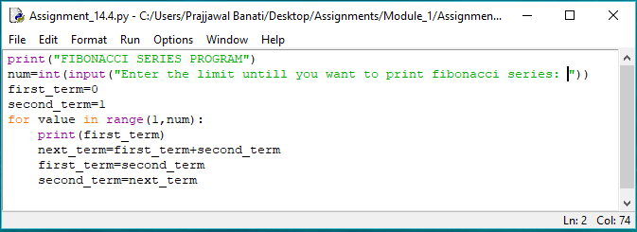

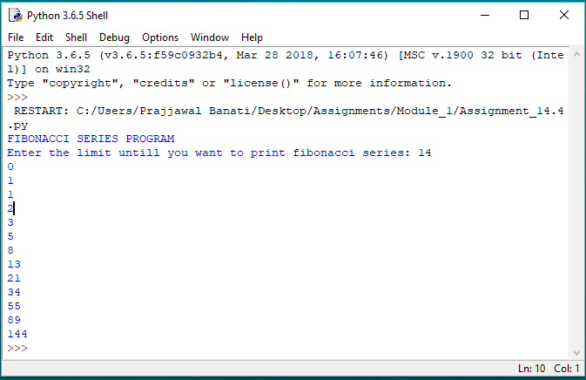

**ASSIGNMENT 15**

Create four string variables a, b, c, d

to store the following values and display them:

• My city is Mexico

• Raghu is my friend's brother

• My favorite programming language is "Python"

• Python is a widely used high-level, general-purpose, interpreted, dynamic programming language. It's design philosophy emphasizes code readability, and it's syntax allows programmers to express concepts in fewer lines of code than possible in languages such as "C++" or "Java".

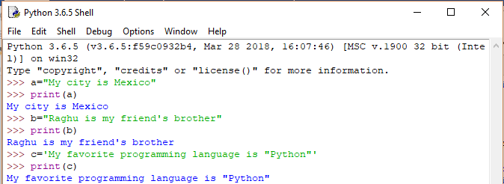

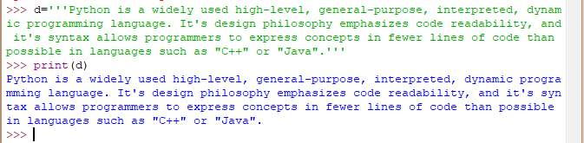

**ASSIGNMENT 16**

Accept a string as an input from the user. Check if the accepted string is palindrome or not.

• If the string is palindrome, print "String is palindrome", otherwise print "String is not palindrome".

• Also print the actual and the reversed strings.

Note – Ignore the case of characters.

Hint – A palindrome string remains the same if the characters of the string are reversed.

Ans:

print("Hello Everyone! This is the program of checking whether \

the strings are palindrome or not")

string=input("Input the string: ")

print("The original string is:",string)

#using an empty string to concatenate it while reversing

reverse_string=""

a=len(string)

#Reversing the string using a for loop

for i in range(-1,-a-1,-1):

#See here "b" will start storing the reverse string

reverse_string=reverse_string+string[i]

print("The string after reversing will be:",reverse_string)

if string==reverse_string:

print("The string is in palindrome")

else:

print("The strings is not in palindrome")

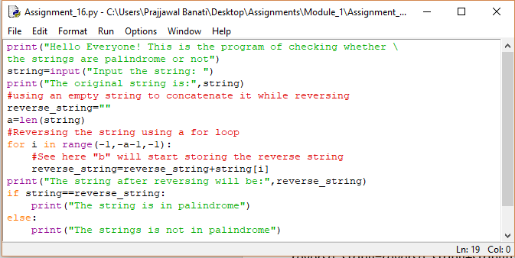

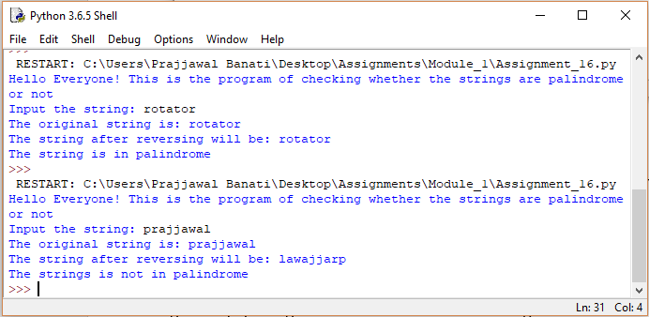

**ASSIGNMENT 17**

Accept two strings 'string1' and 'string2' as an input from the user. Generate a resultant string, such that it is a concatenated string of all upper case alphabets from both the strings in the order they appear. Print the actual and the resultant strings.

Note: Each character should be checked if it is a upper case alphabet and then it should be concatenated to the

resultant string.

Sample Input: string1: I Like C

string2: Mary Likes Python

Output: ILCMLP

print("Hello Everyone! The following program will take two string as an input \

from your and will concatenate all the capital letters from both the strings")

#Storing a string of capital letters in compiler to compare it with strings 1 and 2

default="ABCDEFGHIJKLMNOPQRSTUVWXYZ"

#Storing two Empty strings in which we insert the capital letter string

capital_string_1=""

capital_string_2=""

#Store length

a=len(default)

string_1 = input("Enter string 1: ")

b=len(string_1)

#Comparing each letter of string with the alphabet string

for i in range(0,b,1):

for j in range(0,a,1):

if string_1[i]==default[j]:

capital_string_1 = capital_string_1 + string_1[i]

print("The capital string in string_1 is",capital_string_1)

string_2 = input("Enter string 2: ")

b=len(string_2)

for i in range(0,b,1):

for j in range (0,a,1):

'''If the element gets equal to any alphabet in default string it will get

stored in the empty capital_string_2'''

if string_2[i]==default[j]:

capital_string_2 = capital_string_2 + string_2[i]

print("The capital string in string_2 is:",capital_string_2)

print("So the concatenated string is:",capital_string_1 + capital_string_2)

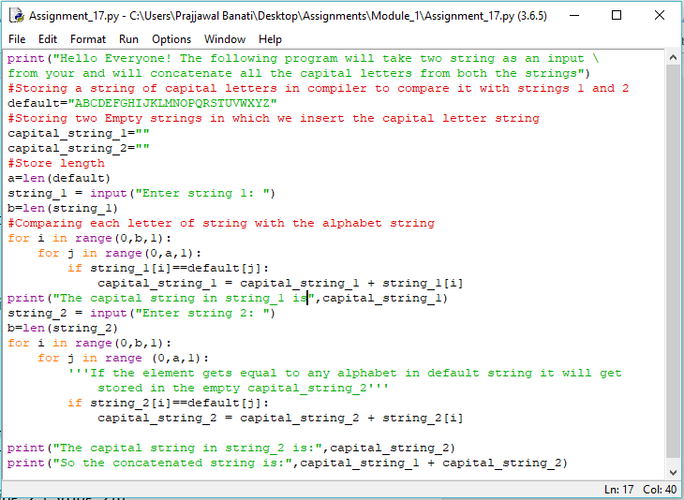

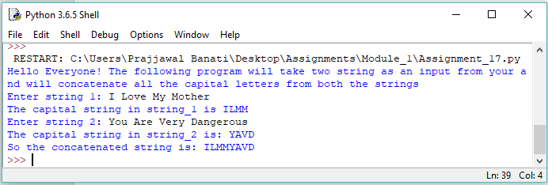

**ASSIGNMENT 19**

1. Write a Python program to accept a string 'accepted_string'. Generate a resultant string 'resultant_string' such that 'resultant_string' should contain all characters at the even position of 'accepted_string'(ignoring blank spaces). Display “resultant_string' in reverse order.

accepted_string: An apple a day keeps the doctor away

resultant_string: Aapedyepteotrwy

expected_output: ywrtoetpeydepaA

Code:

print("Hello Everyone the following program will take a string from you \

then it would select only the even places of the string ignoring the spaces \

and will give you a string in the reversed order")

resultant_string=""

expected_output=""

accepted_string = input("Write a string: ")

print(accepted_string)

#replace funtion is used to replace any variable or a space in the string

#So here we replaced the spaces to get the correct position of string

accepted_string=accepted_string.replace(" ","")

a=len(accepted_string)

for i in range(0,a,1):

if (i%2==0):

resultant_string=resultant_string+accepted_string[i]

print("The resultant_string of the accepted_string will be:",resultant_string)

b=len(resultant_string)

for i in range(b-1,-1,-1):

expected_output=expected_output+resultant_string[i]

print("The expected_output of the string will be:",expected_output)

