**Batch Name:** Infosys FP5.0 Summer 2018

**Enrollment No:** R171217044

**SAPID:** 500060722

**Name:** PRAJJAWAL BANATI

**Sem:** SEM-II

**Branch:** CSE-DEVOPS

**MODULE 1-Project**

**Word Scrambling**

**Algorithim:**

1. **Firstly open the file which you want to scramble in read mode.**
2. **Then define functions of checking the length, punctuation marks and scramble in a main.py file.**
3. **Import all those functions into your code for simplicity and to make the code short.**
4. **Then display the scrambled string.**

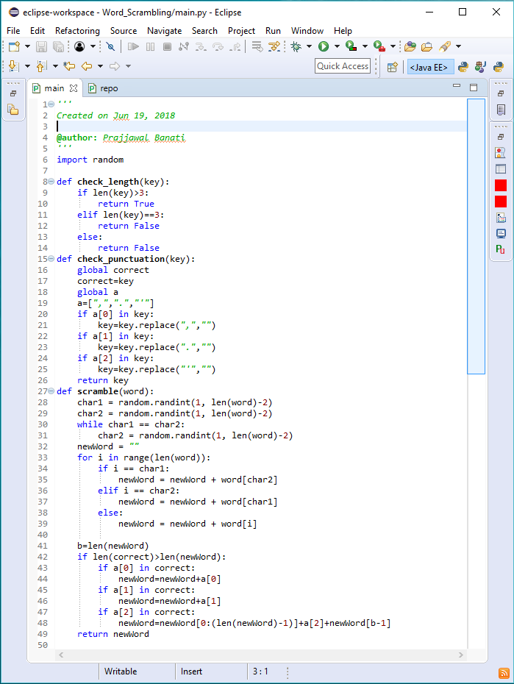

**This is the screenshot of the main.py file. You can see that we have defined three functions here which will do there respective work mentioned above in the algorithim**

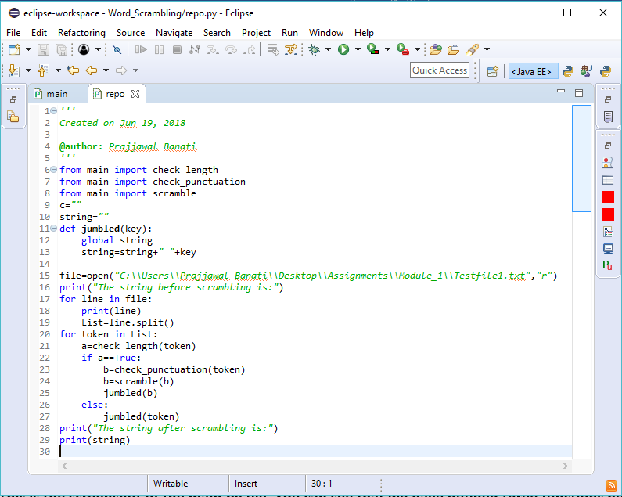

**This is the code which will read the file and will scramble the words and will give us the output**

**NOW LET’S SEE THE OUTPUT RESULTS**

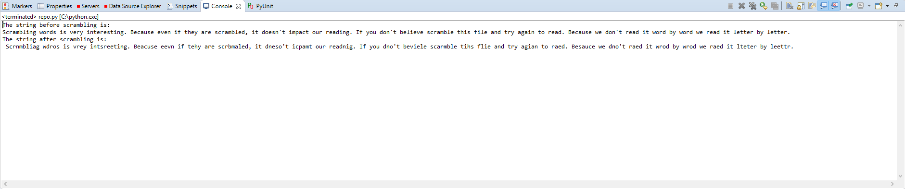

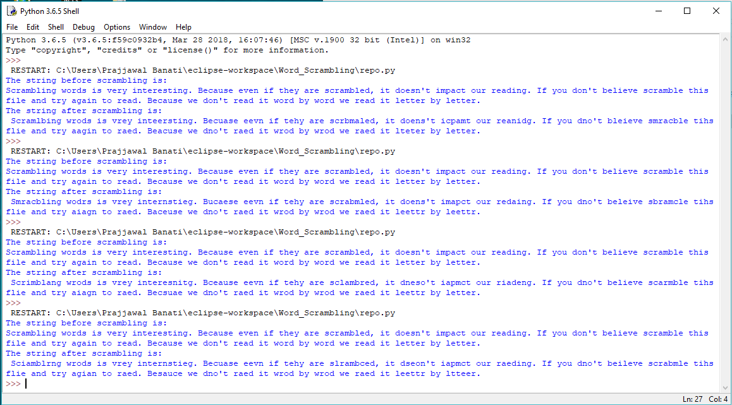

**So that’s all about my project. I hope you liked it also I am uploading this project on git(My username on git is 500060722) so that the version control sense any type of changes in the file**

**Thank you**