LINDLE-AIR SPECS

|  |  |  |  |
| --- | --- | --- | --- |
| Roll NO. | NAME | SAP ID | BATCH |
| 18 | JATIN SINGH | 500067005 | BATCH-1 |
| 19 | KABIR GUPTA | 500066534 | BATCH-1 |
| 73 | YASH VERMA | 500067289 | BATCH-2 |
| 81 | VISHAL  DHIMAN | 500068607 | BATCH-2 |

GROUP NAME : ALPHA

INDEX

Table of Contents

ABSTRACT 3

Entity Relationship Diagram(ERDs) 4

Data Flow Diagrams(DFDs) 5

PROBLEM STATEMENT 6

The 4 Principles of Agile Systems 7

INDRODUCTION 8

Objective of the Project 9

Outcome of the Project 10

Software Development Methodologies 11

WATERFALL MODEL 12

Prototype Model 13

Agile Software Development Model 14

Rapid Application Development (RAD) 15

Dynamic Systems Development Model 16

Spiral Model 17

Extreme Programming Model 18

Feature Driven Development Model 19

Joint Application Development Model 20

Lean Development Model 21

Rational Unified Process Model (RUP) 22

Scrum Development Model 23

SOFTWARE CHARATERISTICS 24

Functionality 25

Reliability 26

Usability 27

Efficiency 28

Maintainability 29

Portability 30

Describing the four principles in our project 31

# ABSTRACT

Our Lindle project will work upon the idea of projection from lens at a particular surface. Implementing it with available hardware we already done so far, we need lens attached with a sort of specs, a system will display and give the instruction directly to the specs. System connected with the specs and then reflecting or splitting the light rays to the particular surface from the given lens or display.

Specs will provide the required information to the user on the desired surface or any type of medium. We will accomplish this project by making it user friendly. Security will be a part of this product that means without correct face recognition it is impossible to install this product on our face. After this process of Security purpose then there will be a quick initialization on which the system will instruct the given product attached to our face then LED illumination Polarised light shines forward to the surface. Software and hardware connection will be included on this document in later coming stages.

# Entity Relationship Diagram(ERDs)

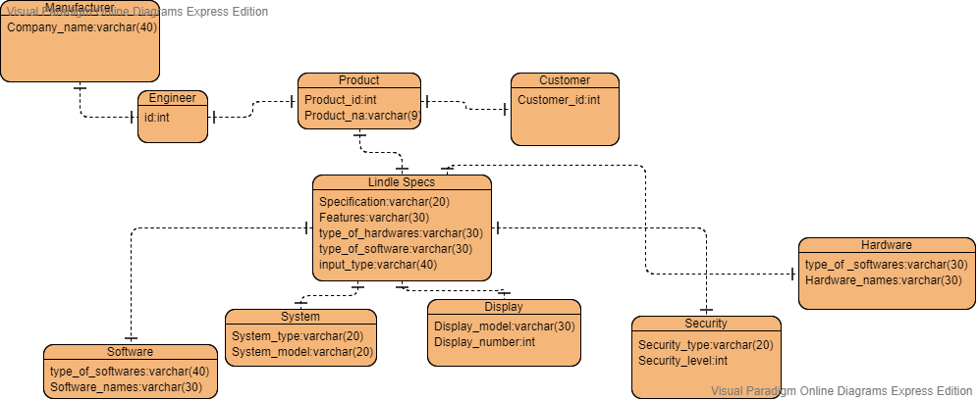

# Data Flow Diagrams(DFDs)

# Level 0 :

# 

# Level 1 :

# 

# PROBLEM STATEMENT

When kindle was launched, it emerged as a great success but still there are so many issues with its features. One of them is less reality touch, customers give feedbacks that they want feel of a book when flipping the pages and portability is also one of the issues with the product. To resolve this issue we created this project that promulgate more reality connection between customers and the users and the product is also more portable as it just has a glass like structure so it easy to carry while travelling and the surface is also a book which decrease the eye strain of the user. Our Lindle project will work upon the idea of projection from lens at a particular surface. Implementing it with available hardware we already done so far, we need lens attached with a sort of specs, a system will display and give the instruction directly to the specs

# The 4 Principles of Agile Systems

The four main principles are kept in mind while making our project. These principles will build a foundational platform around our project. From the project point of view, we as a group built our Innovative project on Lindle-AIR Specs keeping in mind the 4 key principles.

The 4 Principles for Agile Systems are:

1. Individuals and Interactions over processes and tools.
2. Working Software over comprehensive documentation.
3. Customer Collaboration over contract negotiation.
4. Responding to Change over a following plan.

# INDRODUCTION

Our product will be beneficial to the end user in the long run. By engaging us in this project we will get an opportunity to enhance our skill set and to be efficient too. From the project perspective, the end user will be able to work on his reading skills and which will result in improving his vocabulary, soft skills. By incorporating the scrum development in our project will look complex but will look more easy. Keeping the requirements of the end user in mind there will be constant interactions with the product designers and by exchanging ideas, it will result in a collaborative effort to make our product able to sell in the market, it will be efficient, functional, portable, easy to understand and maintain it. The product is open to change which in turn will open the doors of innovation, and therefore responding to change over the existing product. By keeping the end users in mind our product will have a certain reputation intact and will be able to sell globally in the market. Our innovative product augmented reality Lindle specs also known as (Lindle-AIR Specs), it will be associate with the latest technology and will be perfectly blend with the today advancement in technology.

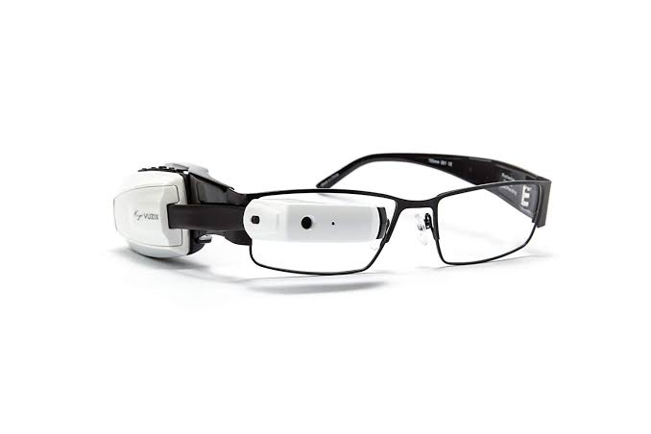

# REVIEW

Our Projects has undergone many changes while its processing as reflecting from the Introduction, we have also added a feature of face recognition in our project as security is a major concern nowadays. We tried to make our project budget friendly as we use normal projecting structure for creating our projects to make it more budget friendly for the end user. Using scrum method, we have involved the end user as much as possible, and tries to make it more personalized according to the user. If we talk about the risk of the project, we have tried to make it as less risky as we can by adding only required features in the project, but there can be risk in the budget reckoner.

We have tried to maintain the quality standards of our project as our projects will be compared to the already existing lens for which we have added more features in it to make it more secure and more user friendly. After this process of Security purpose then there will be a quick initialization on which the system will instruct the given product attached to our face then LED illumination polarized light shines forward to the surface.

# Objective of the Project

Detailed Information of the project:

This project consists of two physical hardware. One is light projecting spectacles that must have a storage chip of minimum size that can be fed into the spectacles easily. The light projecting spectacles is a miniature model of projector that throws light on a medium.

So we as a group consisting of Kabir, Vishal, Jatin and Yash try to create a model of the above project. First of all we will first study in detail about the projector and try to make it as small as it can be converted into the project needed projector.

So, the projector structure is explained by a diagram :

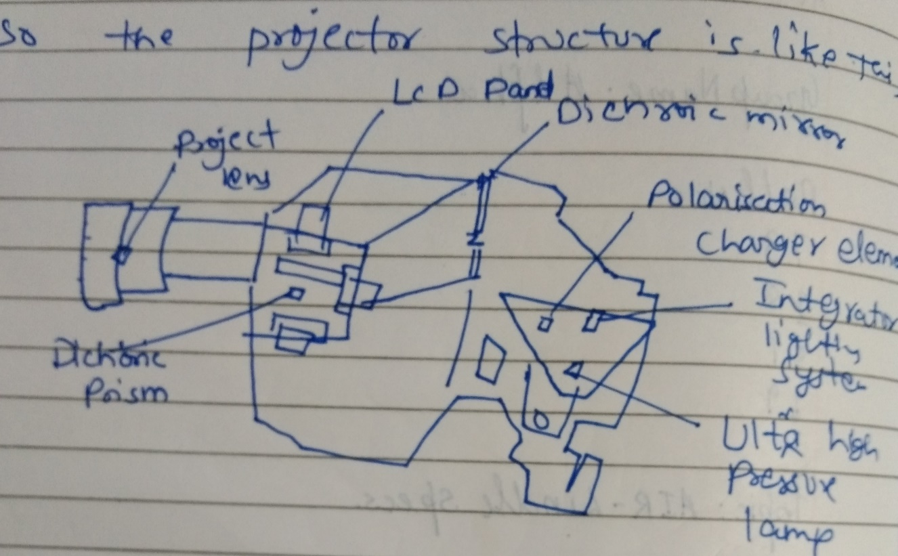We try to create a miniature model of the parts of the projector used in it. The one who is using these spectacles can be customised.

# Outcome of the Project

The outcome of this project is basically to make the end user life easier. This project deals with the information catcher that we can reflect our view or work capacity. The reliability will tell us about how efficiently this device or system will signify its features. The word easier means in the life of the end user is that it is making its life futuristic also reducing user effort.

# Software Development Methodologies

The Software development methodologies are the most important while creating any project or a software because the software goes through the stages of development processes in order to meet the requirements of the end user.

The Software or a project follows certain type of protocols in order to satisfy the end user needs. With the help of these methodologies the project will be successful and will be able to sell in the market. There are 12 software methodologies that needs to be followed keeping in mind the end user requirements these 12 methodologies are described below while creating our project :

1. Waterfall Model
2. Prototype Model
3. Agile Software Development Model
4. Rapid Application Development Model
5. Dynamic Systems Development Model
6. Spiral Model
7. Extreme Programming Model
8. Feature Driven Development Model
9. Joint Application Development Model
10. Lean Development Model
11. Rational Unified Process Model(RUP)
12. Scrum Development Model.

These are 12 methodologies are the key features while creating any software or a project.

Now we will explain each one of them from the perspective of our project that we are trying to create.

## WATERFALL MODEL

The waterfall model is a sequential process where each phase is dependent on the previous one and corresponds to the specialisation of task and the software should be deliverable. The project we are designing follows the series of processes in sequential order.

This model is the starting of the Software development life cycle where the project or the software starts to take the shape from here and this is the initial process for the software. The steps are for waterfall model as follows :

1. Requirement and Analysis
2. Design
3. Code
4. Test
5. Deploy
6. Maintain

Our product Lindle AIR Specs is our future product which is going to be a successful product this innovative product is going to make the end user life easier. Our product is an user friendly and will be able to blend with the external surroundings. This product is integrated with a fast application software.

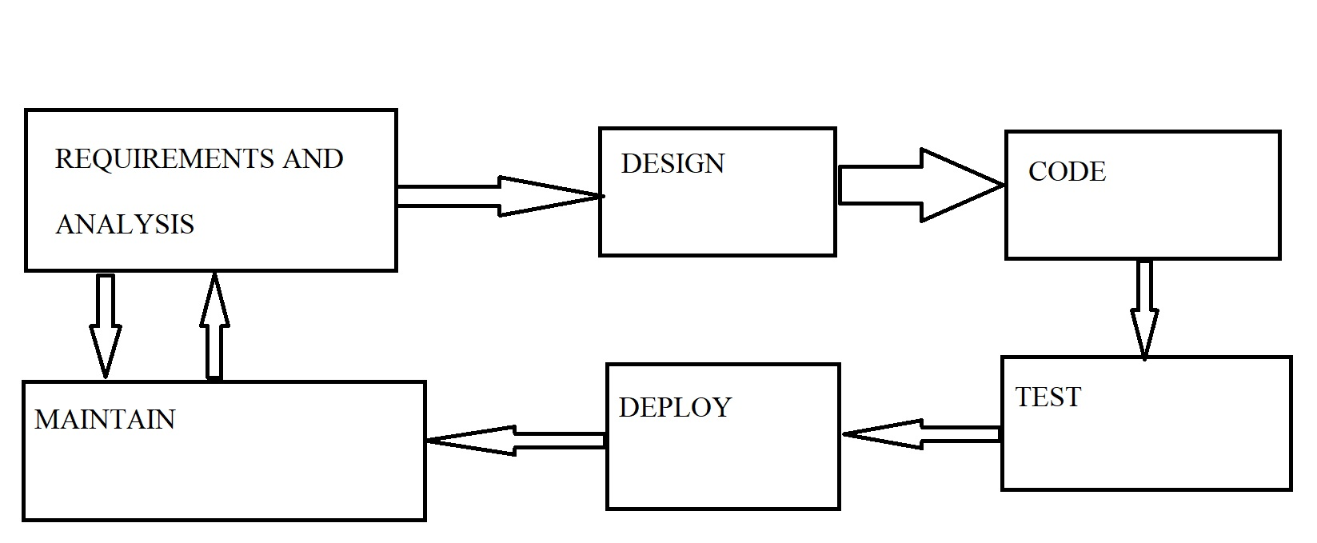

## Prototype Model

The prototype model is a software development process where the testing software is developed, tested and then reworked to meet the needs of the end user. Software or project is yet to be made properly. This is the starting or the initial process where our project slowly and gradually takes it shape from here. The prototype stage is very important so as to understand the requirements of the end user and ultimately meet his necessary goals.

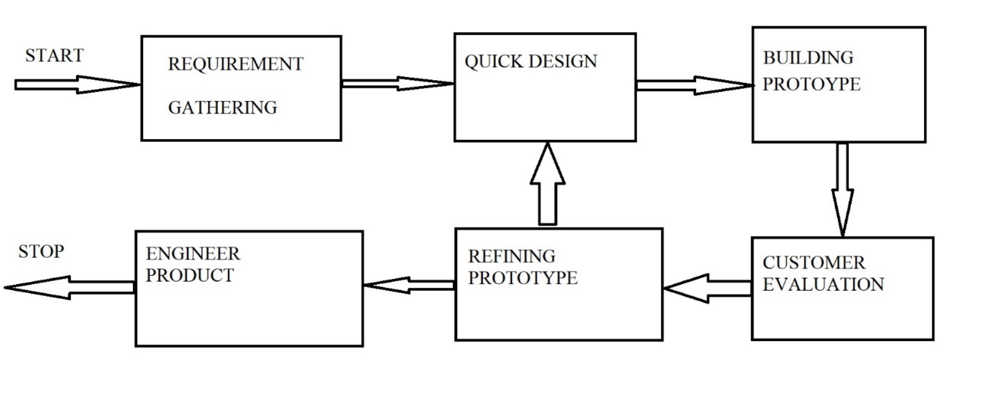

Our product will be test piece so as to try the specs and then we will try to project the image on a medium so as to make the final decision if this product is helpful to the end users then our product will be a success.

## Agile Software Development Model

Agile software development model is a process where it comprises of various approaches under which the collaborative effort is made by the people who are designing the software or the project and these people sit with the customers so that the designers can visualize that how the final product will look like. Designers get a two-way benefit firstly, they do a SWOT analysis while creating this product and secondly, they get a taste of what the end user requirement is and how it will be helpful to them.

This type of development is flexible and is open to new changes and innovations through a continuous development to meet the necessary outcomes. Below is diagram that is linked with the creating our project :

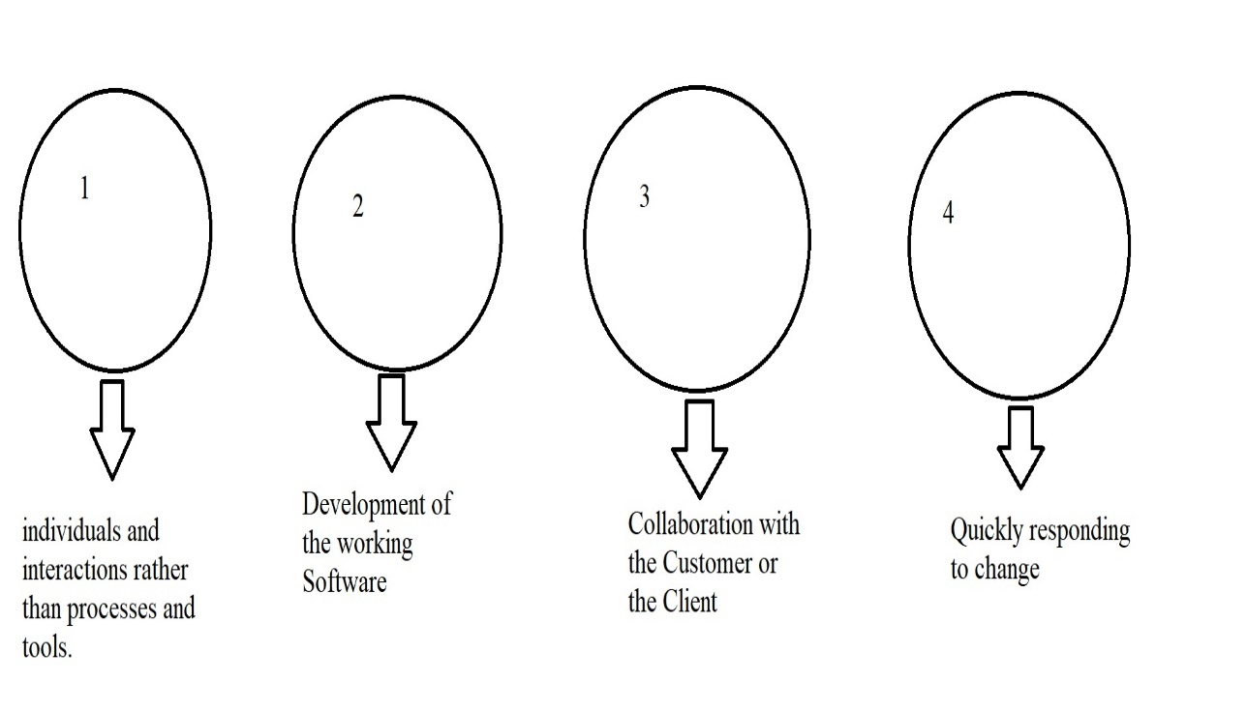

Our project will mainly focus on the development and the phases it will pass through and how the end product will look like. As mentioned earlier, our project is flexible and open to changes and other innovations which we will blend in our project to make it a user friendly product and which can make the project a success.

## Rapid Application Development (RAD)

Rapid Application Development is a form of agile software development methodology that prioritizes rapid prototype releases and iterations.

1. Development of software with this methodology is easier and quicker than other methodology.
2. There is a rapid quality result as compared to the other methodology.
3. The Main objective of this methodology is to accelerate the software development process.
4. It is user friendly and the user can interact with it without any type of intervention.

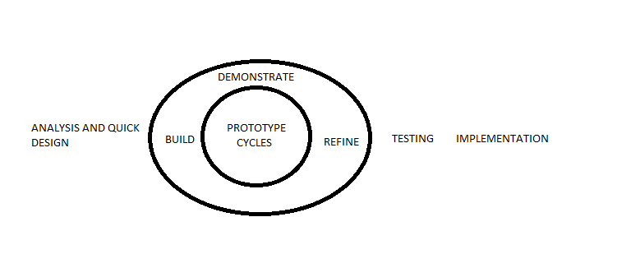

So how we will going to implement this method on our project :

We already describe our innovative product AIR Lindle Specs that is going to work on the projector device principle that uses the required application software such as the software made by third party developers. We will try to make the working of application software fast as possible and also user friendly based upon the above diagram step by step. After getting compatible with the device the user can easily interact.

## Dynamic Systems Development Model

Dynamic Systems Development Model is an associate degree agile code development approach that provides a framework for building and maintaining systems.

1. The main title for this model can be represent by the sentence that 80 percent of an application is often delivered in twenty percent of the time it would desire deliver the entire application.

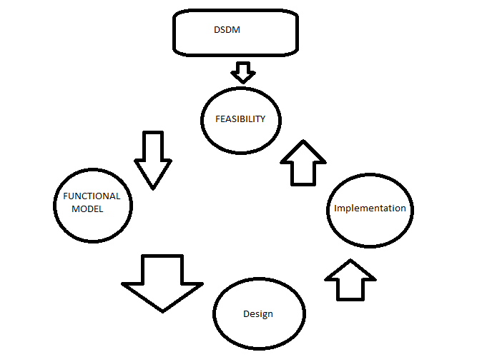

Our mentioned device is compatible with the user interaction so that by the following diagram we will build and maintain our whole system that based upon projecting process that is reflection from lens into the reflecting medium.

## Spiral Model

Spiral Model is the model that is based upon the Development Life Cycle models.

1. Spiral Model provide support for Risk Handling.
2. The Diagrammatic View of this model represent loops.
3. Loops depend upon the project that on what project we are working.
4. Loop of the spiral is called a Phase of the software development process.

Number of phases needed to develop can be varied by the project manager depending on project risk.

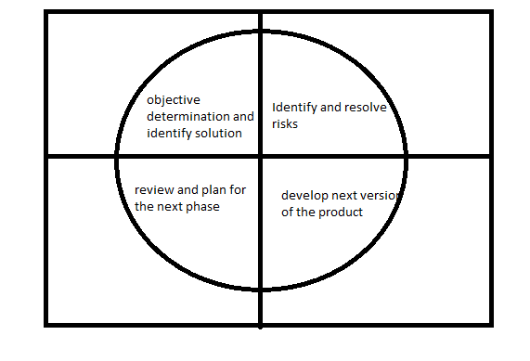

The way we are going to use this model on our project by following the above diagram. This work as a risk handling model so that the project we are working on can establish a backup process. We will define the number loops for our project in the later coming phase.

## Extreme Programming Model

It is that branch of software development in this type of development it improves the quality of the software and it increases the responsiveness to the changing customer requirements. Extreme programming is a branch in software development where the software or project goes through the stages of development and able to deliver the final product.

The steps are very important in order to deliver the final product. According to our project that we are creating it has to go through a series of development process and the steps are as follows :

1. Requirements
2. Specifications
3. Design
4. Coding
5. Testing

These steps all play a vital role while designing the project. The moment these steps are completed the test plan is created. At the moment of the testing phase the release of the software happens.

This all can be understood by a diagram :

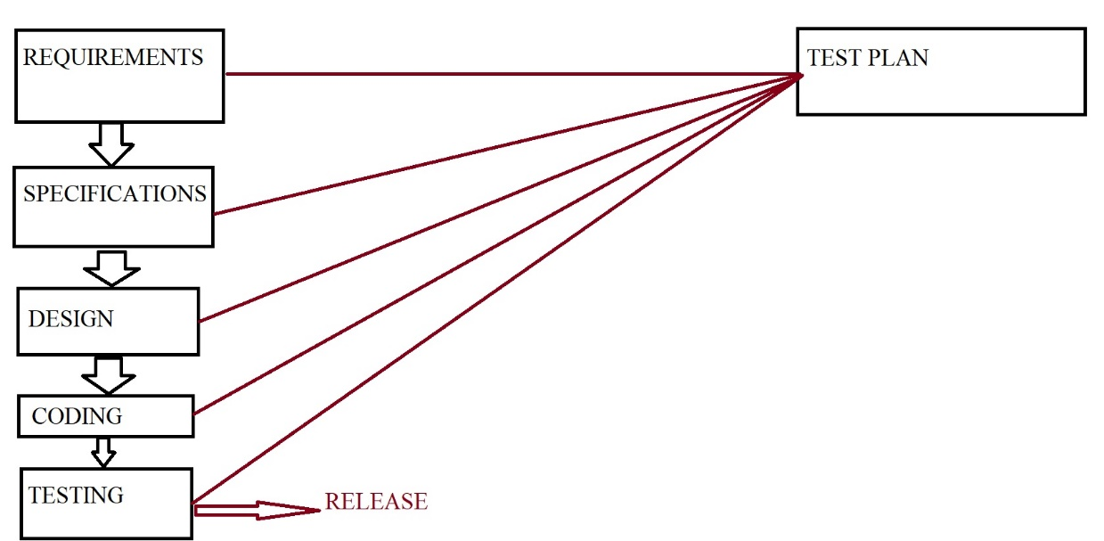

Our product is innovative Lindle- AIR specs this product is going to be our future product this stage called as the extreme programming is a way by which the software gives more clarity to the end user so as to how the product will look like and get a brief of the product.

## Feature Driven Development Model

Feature driven development model is that part of the software development life cycle where the software this stage is customer-centric approach after the software has gone through the testing part , tried , reworked and this time the new features get added to our product to satisfy the end user requirements. As the name implies feature driven development model it adds new features to the product.

This model goes through short iterations and releases to design meeting and retrospectives as mentioned earlier this is feature driven development so it has to be good.

This is can be understood by a model of the Feature development Model :

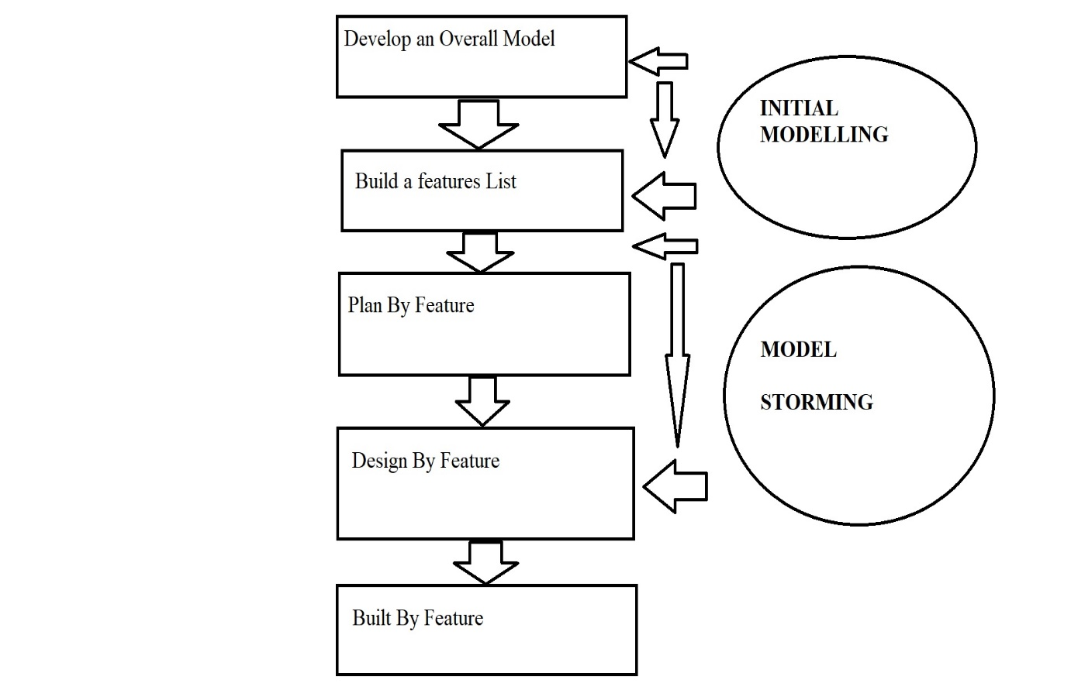

Our product is starting take its shape we added some new features like privacy, security, touchpad and many other new features can be added later.

## Joint Application Development Model

This stage of software development process that the joint application development model is the stage where both the client and the users sit for designing and developing a software. This model requires constant user interaction in order to develop new information systems with the people who are designing the software.

This system can be applied in the development process of this model. This can be understood by a diagram :

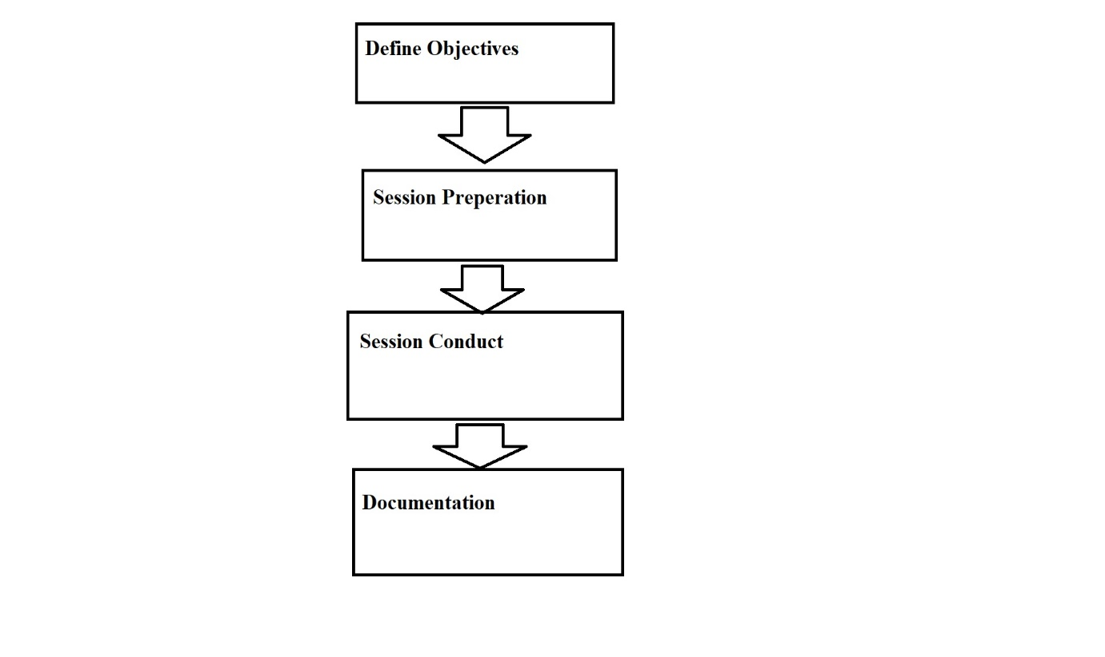

This model is going to be very helpful while creating our product this is where the end users are going to recommend to the designers and going to offer their suggestions that how the end product they want. Our product is an innovative product and ultimately the end user should be satisfied with the product.

## Lean Development Model

The next stage after the Joint Application Model is Lean Development model, this is a software development model where the agile framework comes into the picture. This model’s primary function is the optimization of the software, eliminating waste and ultimately deliver what the product needs.

This model can be understood by a diagram :

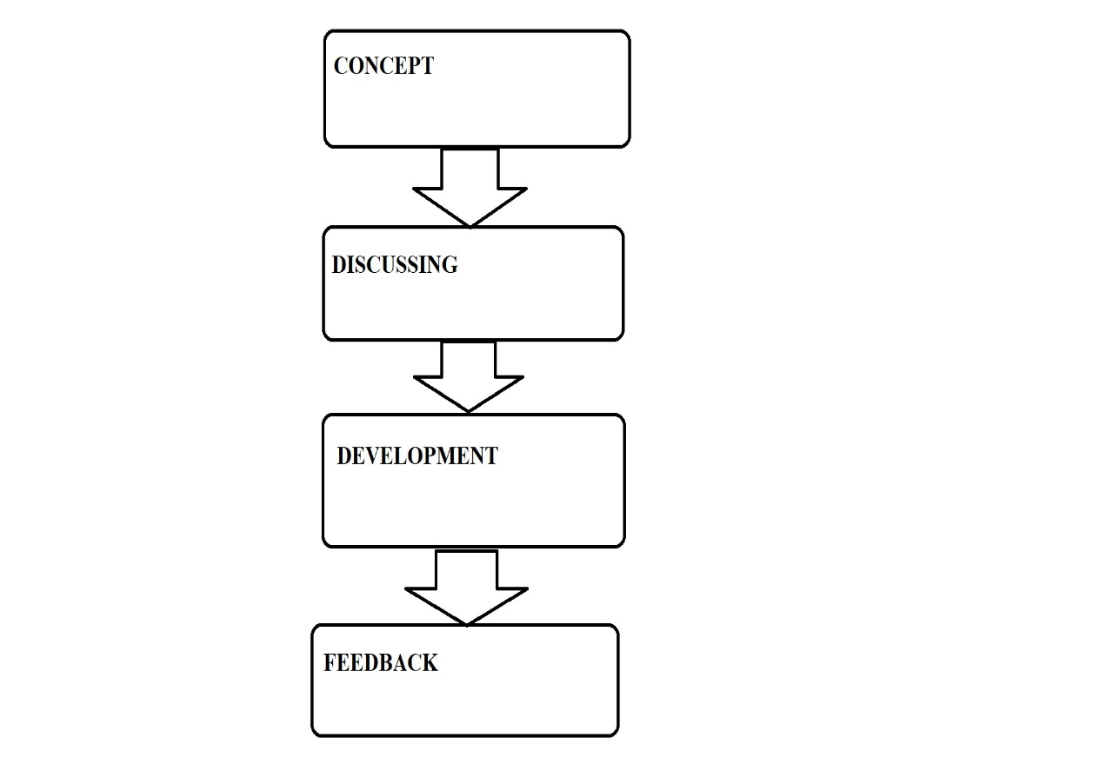

Our product will go through this stage because it is very important to eliminate the redundancy and our focus while developing this product is purely based on how we can optimize our product to be able to sell in the market. This is the key stage while developing our product.

## Rational Unified Process Model (RUP)

Rational Unified Process Model is again an important aspect of the software development process after the Lean Development is achieved. This model is where the software or the project involves distinct phases of development. There are some key steps that needs to be followed in this type of model.

The steps are as follows :

1. Business Modelling
2. Analysis and Design Implementation
3. Testing and deployment

These are 3 key steps that is followed while creating any software or project.

This can be understood by a diagram :

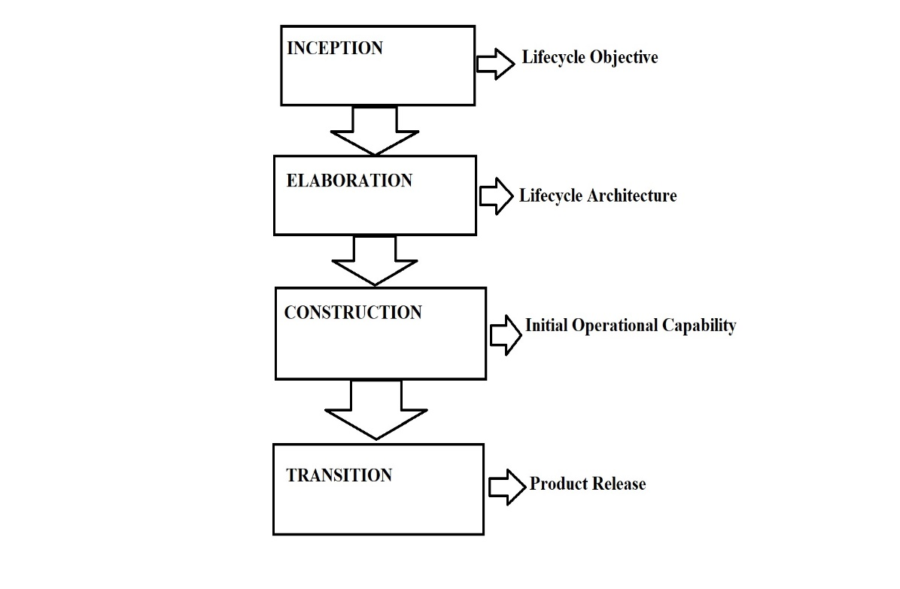According to the project on Lindle-AIR specs it follows the 3 steps mentioned and ultimately making it available to the end users. Our project follows all the protocols (12 methodologies).

The way we implement this type of model in our project by the 3 steps mentioned and the flow chart as seen above.

## Scrum Development Model

The last model under the Software development methodologies after Rational Unified Process Model is the Scrum Development Model. This model is a strategic model where as a team reaches a software developers to reach a common goal as a team in order to make the product or software market ready.

This model is widely used and is a subset of the agile software development, this model has been observed in areas of complex work, Research technologies and advanced technologies.

This model can be understood better by a diagram :

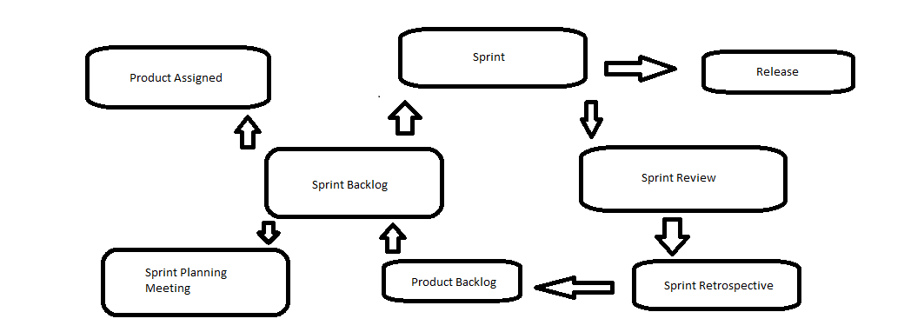

This model works on the principle of the agile framework. This can help in our project too.

In order to implement this in our project.

# SOFTWARE CHARATERISTICS

The software characteristics are very important on that basis it is implemented in our project that are very essential. Thinking about the project perspective the characteristics are the traits while developing the software or the project in order to meet the end user requirements.

The essential characteristics are described as below :

1. Functionality
2. Efficiency
3. Reliability
4. Usability
5. Maintainability
6. Portability.

These are the essential characteristics that we emphasize in the usage of our product to be successful in the future.

The flow – chart is seen below :

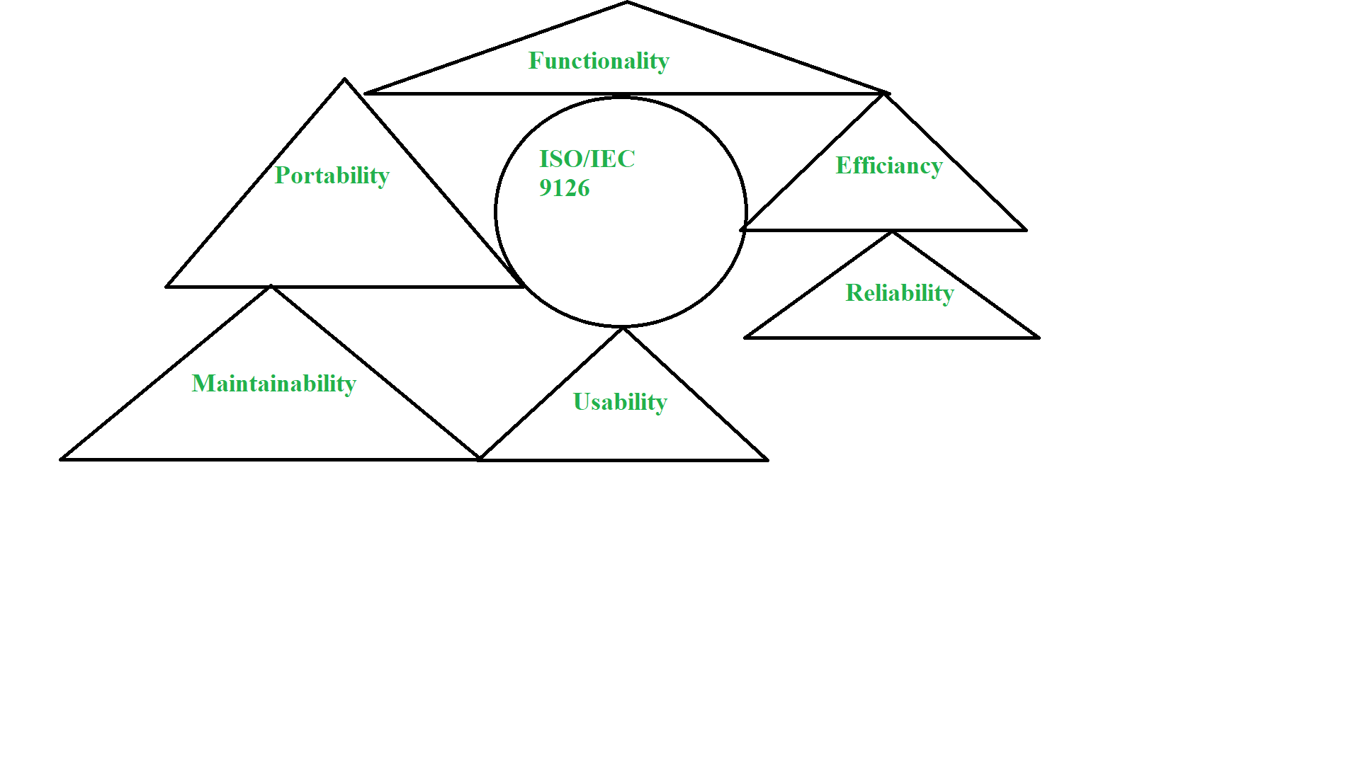

## Functionality

This is a branch of software characteristic that refers to the performance of a software that produce in a time frame. Means it refers to the degree of performance for an intended purpose. It performs the certain type of functions as seen below :

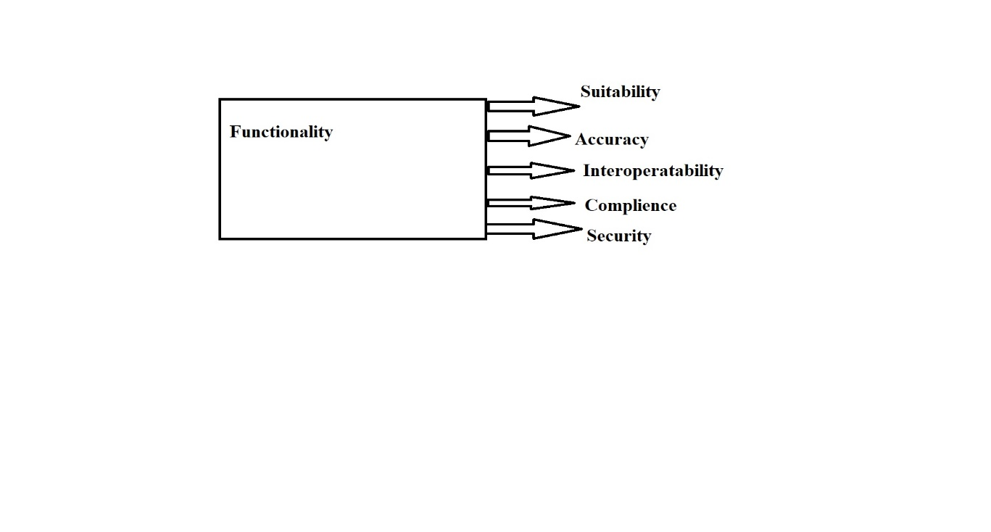

In our project the first under software characteristics is the Functionality. This is key feature and done accordingly. According to our project we want maximum output in a allotted time frame. Our project will adhere to the protocols and will be functional in the long run.

The functions are :

Suitability : The end user may like the product it should suitable for the user means that user can use functions to perform a specified task and user objectives.

Accuracy : The software or the product should be accurate in order to yield better results that means that it should provide the right atmosphere for the working product and effects should be good.

Interoperability : The software or the product should be capable of interacting with one or more systems.

Compliance : The software or the product should adhere to the protocols this is called compliance.

Security : the software or the product should be secured so that no unauthorised user can gain access into the systems. This the key feature our product should be secured by the unauthorised access.

## Reliability

This is also a software characteristic where the product that the end user is using should maintain it performance capability and able to stand under a certain time frame. That is when we say that the software is reliable to use. It performs some functions they are as follows :

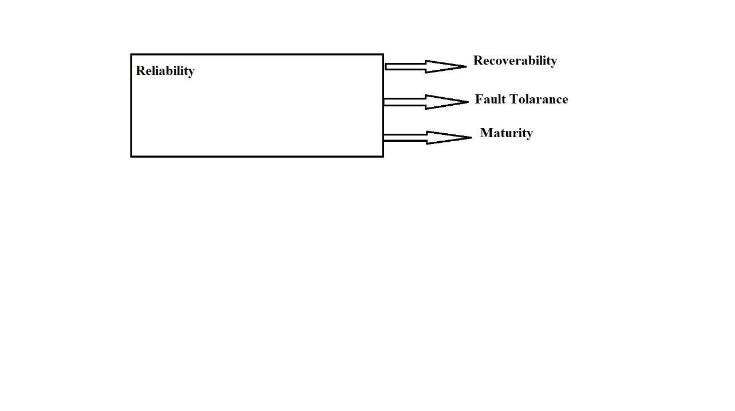

In our project the second under software characteristic is Reliability. Our product will try to maintain the level of performance and able to stand under the certain condition and able to deliver the output in a allotted time frame, the functions are as follows :

Recoverability : Our product will be able to recover from a situation like if our product has failed or crashed it will be able to recover and maintain its performance in a scenario. This is very important feature as our product will able to try to incorporate this.

Fault Tolerance : Our product will able to handle the fault tolerance in case the failure is observed in our system or a product it will try to maintain the level of performance and able to retrieve data in case mishaps occurs.

Maturity : Our product will be try to avoid failure and here the maturity plays a vital role in our project.

## Usability

This is a software characteristic where the software or the product can be used by the end user with ease the amount of effort or time will be reduced this will result in faster understanding of the product. Usability performs certain functions as follows :

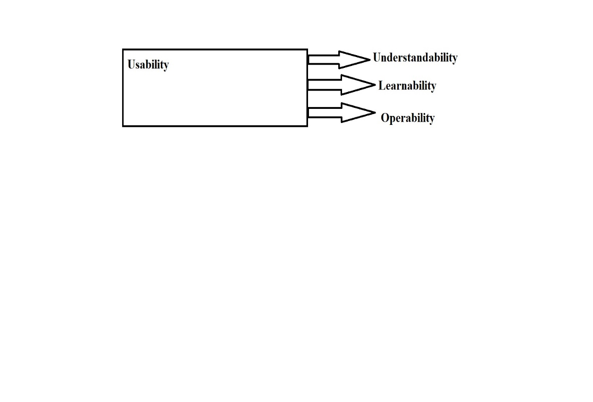

In our project the third under software characteristic is Usability, this is an important feature of the software characteristic so that user can understand the product in a faster manner. There are some certain functions that are there as follows :

Understandability : Our product will be easy to understand that how the product will be used it will also be suitable for the user to use this will result in where the user can read certain facts with just a press of a button. In this case if the user wants to read a book it can directly gather data without a tangible book in hand or by an artificial intelligence voice can read the book just by the retention of the data.

Learnability : Our product will be much more easy to learn and how the product will actually work in person it will showcase the practical aspect in a given scenario. This would enable the users to learn it faster.

Operability : Our product will be easy to operate and is user-friendly at the same time with this product they can use in their daily routine or at work or on a vacation as well.

## Efficiency

This is a software characteristic where the software or a product will try to utilize minimum memory space and will be able to execute the tasks much faster. Our project will be able to do that. There certain functions that is needed to keep in mind to design such a product :

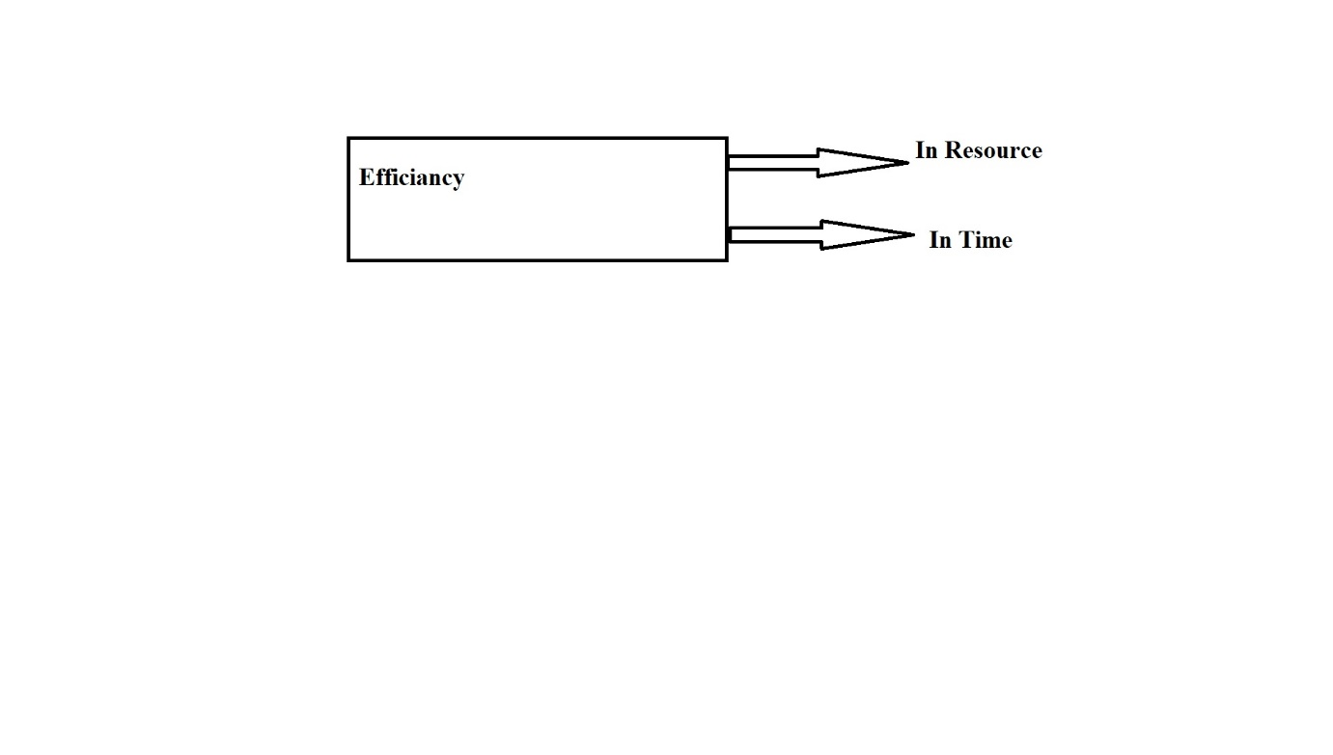

In our project the fourth under software characteristic is the Efficiency, as mentioned earlier our product will be efficient to handle and to use by the end user.

In Resource : Our product will be able to use required resources in an appropriate time frame when our product needs to perform a specified action under an allotted time frame.

In Time : Our product will able to deliver response time and the throughput will be faster under a minimum time frame.

## Maintainability

This is a software characteristic by which we can modify or upgrade the software and improve its performance and correct the errors. The software able to maintain and will get new features as well. It performs some functions :

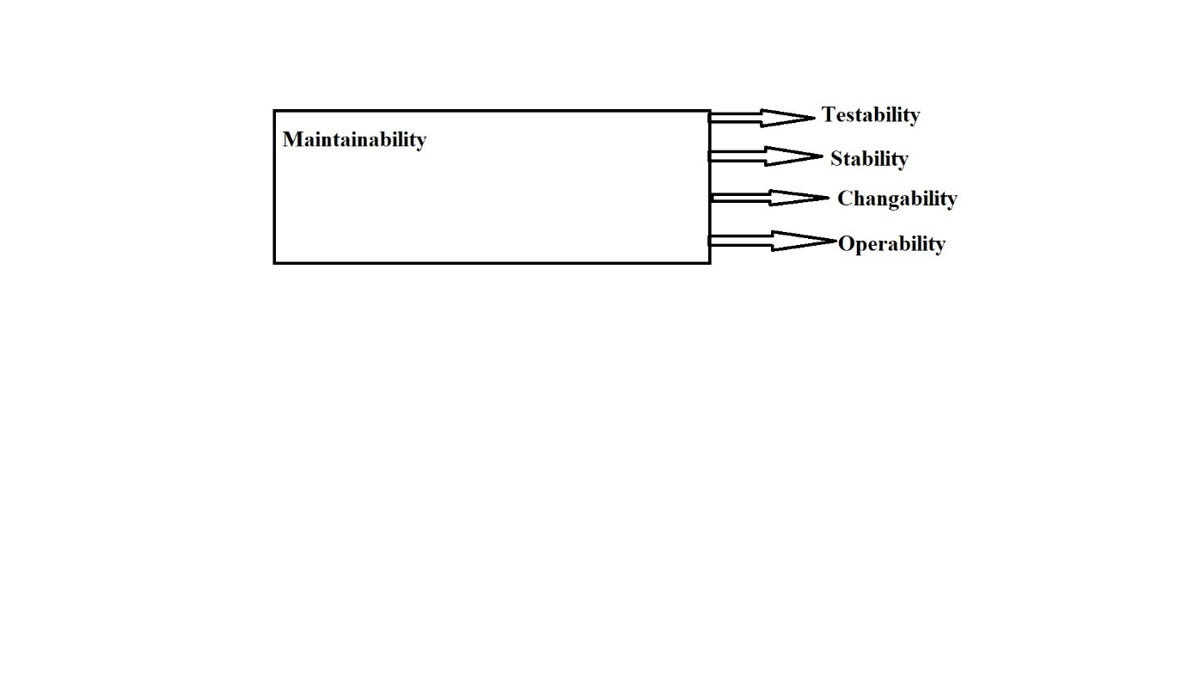

In our project the fifth one under software characteristic is Maintainability, our project will give an upgrade to the product where ever necessary and will deliver what the end user wants and will be at the optimum level. The functions are as follows :

Testability : Our product will be fully tested and approved but in case of a failure it will try to maintain its performance and backup will also be there if the data is lost.

Stability : Our product will be a stable product so a that it does not send any unwanted upgrades and it will be secured as well.

Changeability : Our product will be easily changeable and it will enable a specified modification to be implemented to the intended part.

Operability : Our product will have high value of operable and by that user can perform the tasks much faster and in a limited time frame. The product will have high level of system software running and application as well.

## Portability

This is a software characteristic where the software is transferred from one environment to another with minimum changes. The functions are as follows :

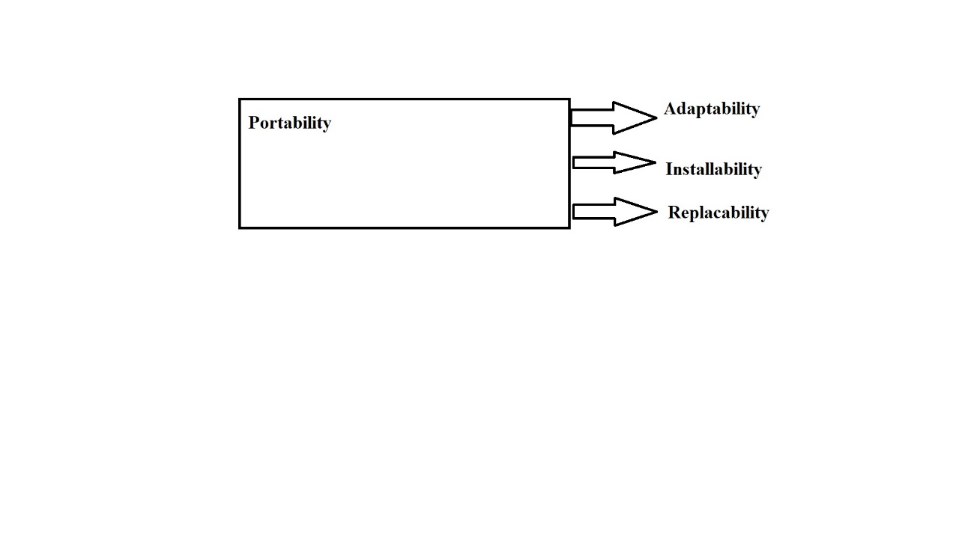

In our project the last one in the software characteristic is the Portability, our product will be good to use and will be portable as well and perform the tasks much faster even when transferred from one environment to another. The functions are discussed :

Adaptability : Our product will be able to adaptable for the different environments as well and able to meet the requirements specified.

Install ability : Our product will be installable in any specified environment as well.

replaceability : Our product can replace other products that depends from product and the way of functioning.

## Describing the four principles in our project

1. Individuals and Interactions over processes and tools.

So, our Lindle Project is totally based upon the human interaction, Making it

comfortable will be our first priority. Processes we are going to use in our project like

applying methodologies and principles etc , beyond these further implementations we

will see individual cooperation regarding the product that whether they are going to

cooperate with our product or not. Tools like Camera and Display will be set

according to the user compatibility by measuring our compatibility in behalf our

future user.

2. Working Software over comprehensive documentation

Software we are going to use in our project are Facial Recognition, Photo

Manipulation and Projector Controller Software. The principle clearly gives us an understanding that well-known full working software is important then project

documentation that is we have to test it before providing final approach. Tests include

that the projector is splitting light properly or not and Facial Recognition software

is providing security or not.

3. Customer collaboration over contract negotiations

Customer should be fully independent with our product though collaboration with one

or more product development parties because of the proper deal it is mandatory for

our product to deliver before signing any type of negotiations. Our Lindle specs might

we have some limitation as the functions desired by the user so the user can freely

collaborate with some other parties.

4. Responding to change over following a plan

If our product ever need modification like Security, Software, Hardware and various

features like projection, Recognition etc then we will see the responding change over following strategies to accomplice our project. Some of the methodologies lacks

backtracking process so we need first to collaborate what will be our next step then

according to that step we will going to react upon conditions. First required

modifications then strategies.