**Build and Release Management lab**

**Submitted by**

**Name – Shriyansh Kaushik**

**Roll No – R171218100**

**SAP – 500067485**

Lab-2

Aim – Adding a maven project and linking it with Jenkins then building that file

* Creating a maven project

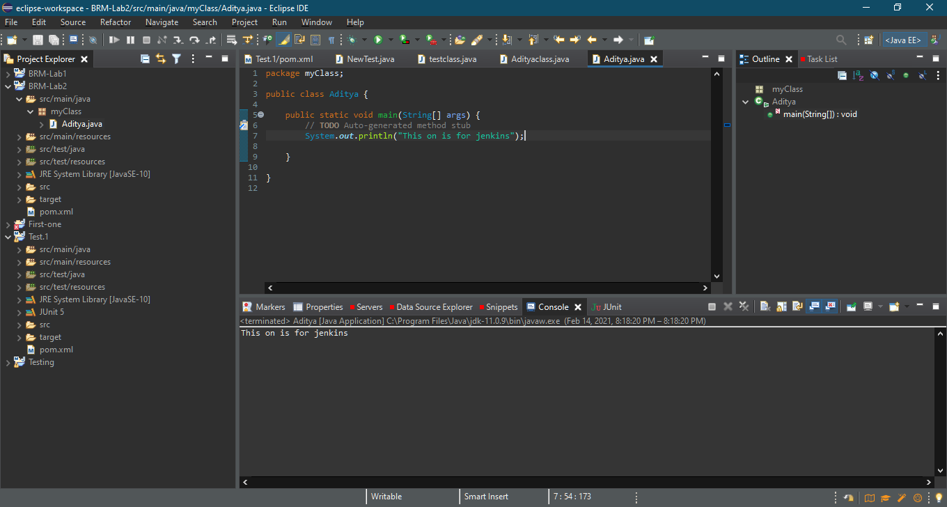

* Configure it with specified Git repository

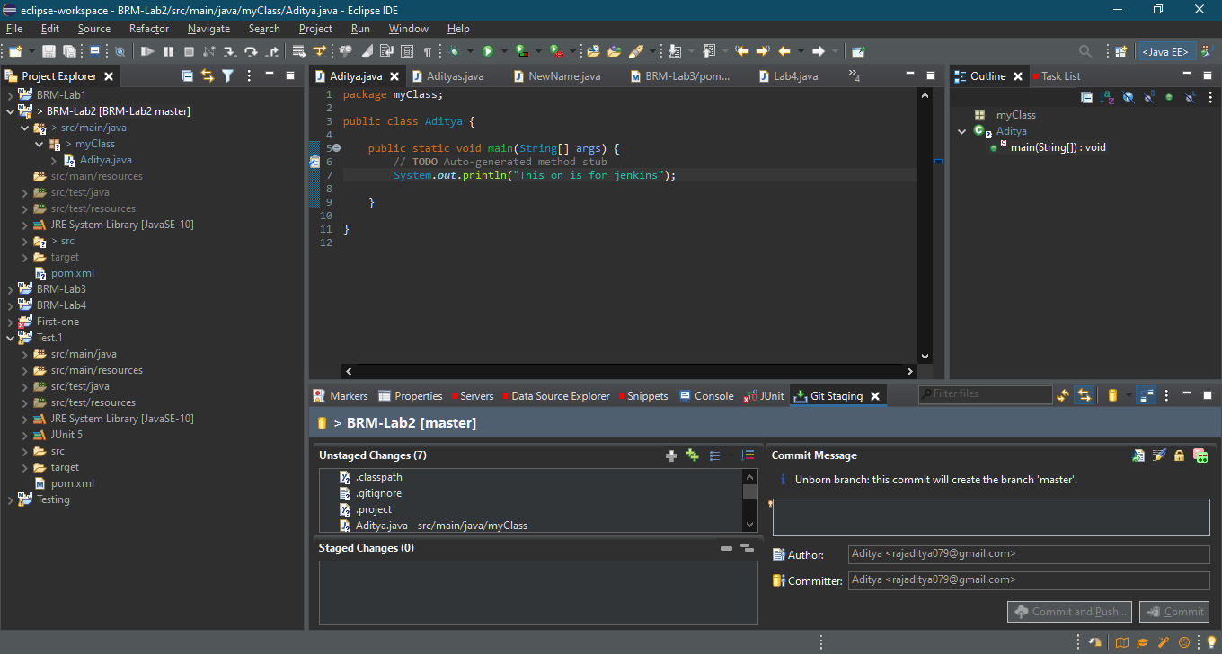

* Moving to staging area and adding comment

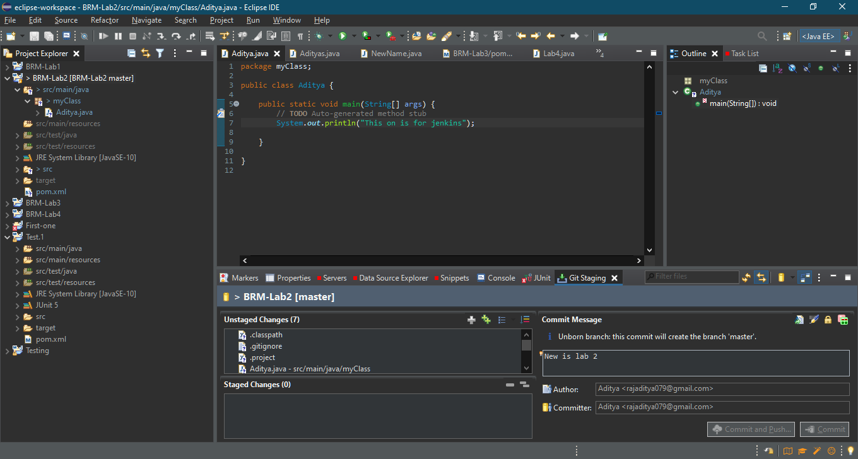

* Github repo created

