**Build and Release Management Lab**

**Name- Sahil Bansal**

**SAPID- 500075412**

**Roll No. - R171219031**

**LAB EXERCISE 6**

**Aim:** Create a simple Maven Project using CLI

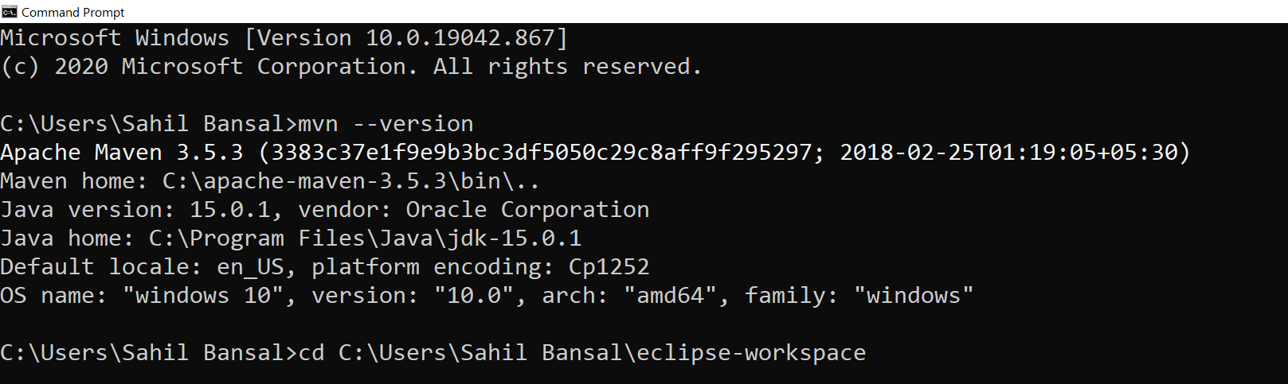

**Creating a Project:**

You will need somewhere for your project to reside, create a directory somewhere and start a shell in that directory. On your command line, execute the following Maven goal

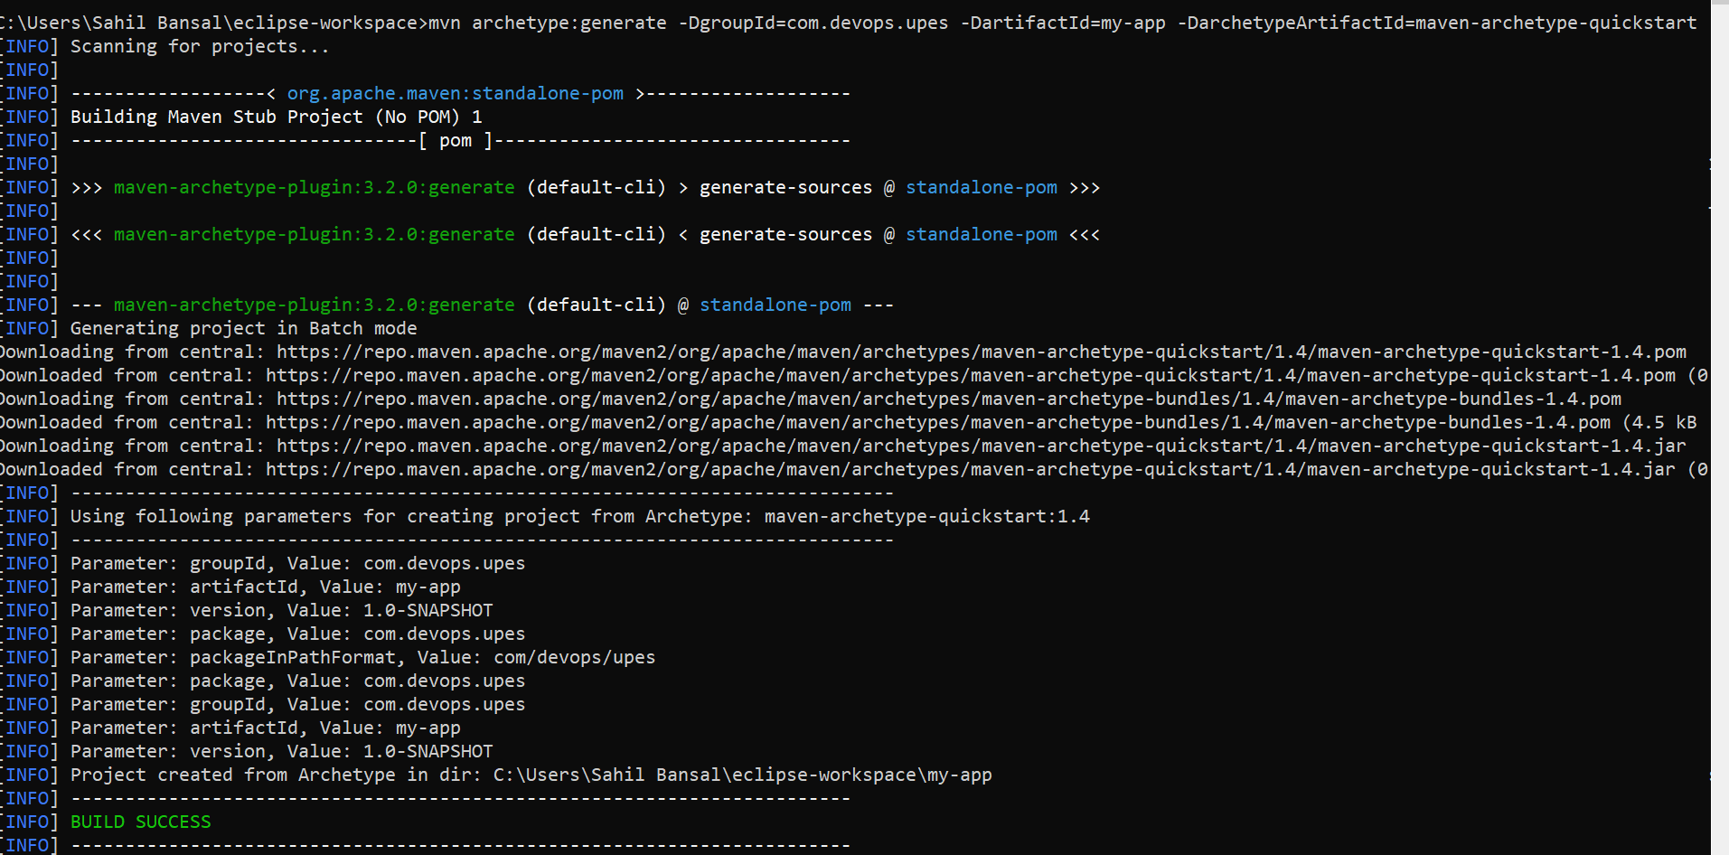

You will notice that the generate goal created a directory with the same name given as the artifact ID. Change into that directory.

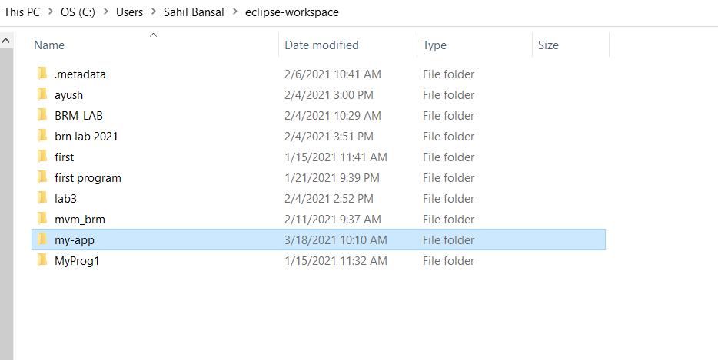

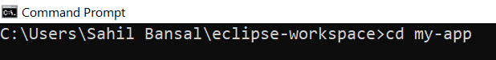

**POM.XML File**

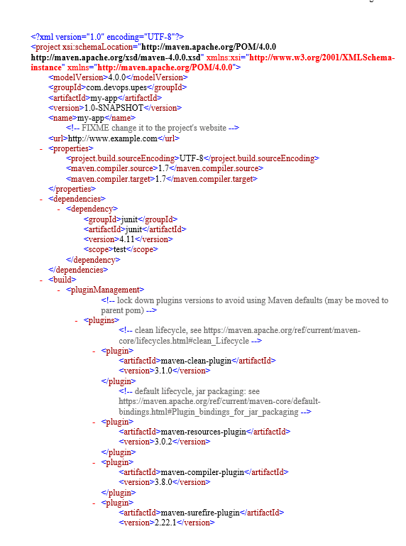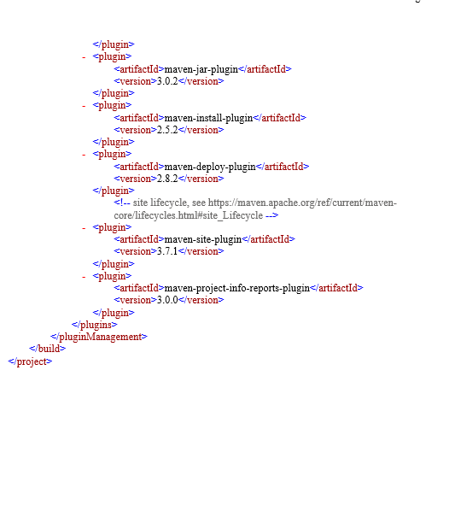

**Build the Project**



The command line will print out various actions, and end with the following:

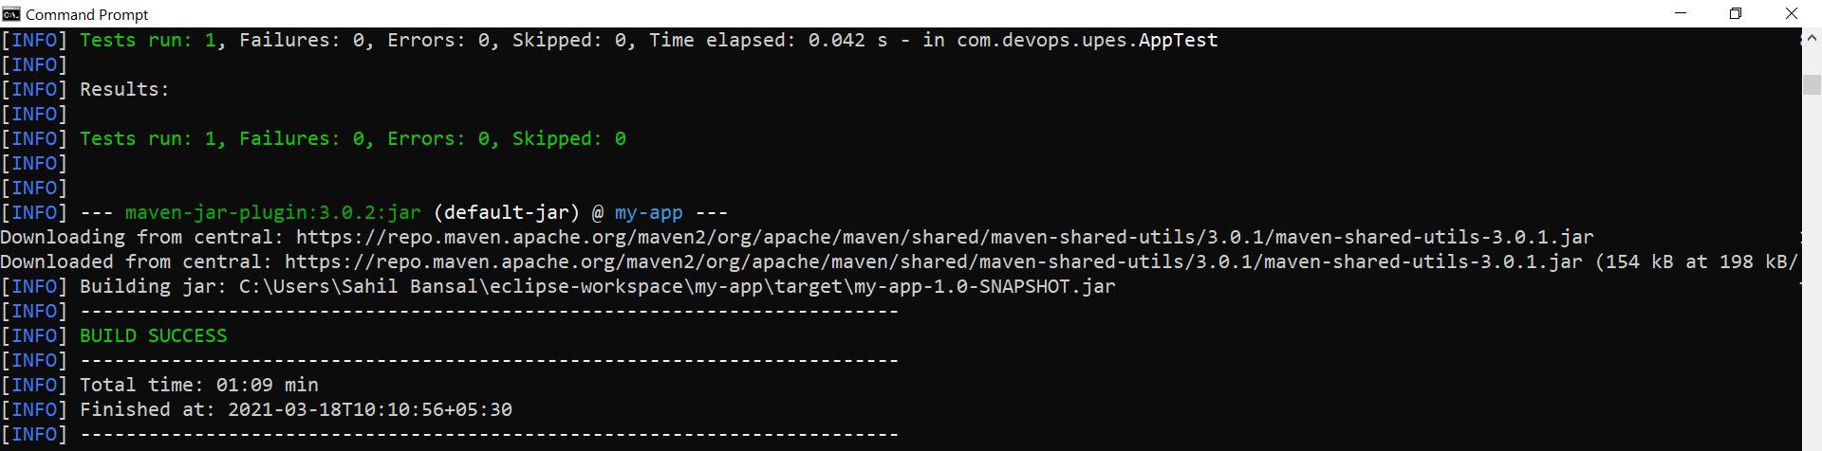

You may test the newly compiled and packaged JAR with the following command, which will print the quintessential:

