# ABSTRACT

Intrusion Detection System (IDS) is a security system that acts as a protection layer to the infrastructure. Throughout the years, the IDS technology has grown enormously to keep up with the advancement of computer crime. Since the beginning of the technology in middle 80’s, researches have been conducted to enhance the capability of detecting attacks without jeopardizing the network performance. In this paper we hope to provide a critical review of the IDS technology, issues that transpire during its implementation and the limitation in the IDS research endeavors.

Lastly we will proposed future work while exploring maturity of the topic, the extent of discussion, the value and contribution of each research to the domain discussed. At the end of this paper, readers would be able to clearly distinguish the gap between each sub-area of research and they would appreciate the importance of these research areas to the industry.

# OUTCOMES

‌The outcomes of the project is to make end user life easier.

## EXPECTED OUTCOME

In this project I would like to help end user life more beneficial and securing their profile from the intruders.

# SOFTWARE DEVELOPMENT METHODOLOGIES

It play a vital part of developing the software. There are many methodologies which are used by the professional [software development companies](https://www.tatvasoft.com/) nowadays. There are certain advantages and disadvantages associated with each of them. The basic purpose of these methodologies is to provide smooth software development according to the project requirements.

Software development methodology is a framework that is used to structure, plan, and control the process of developing an information system. This kind of development methodologies are only concerned with the software development process, so it does not involve any technical aspect of, but only concern with proper planning for the software development.

**The 12 mainly used software development methodologies with their advantages and disadvantages:**

|  |  |  |
| --- | --- | --- |
| [Waterfall Model](https://www.tatvasoft.com/blog/top-12-software-development-methodologies-and-its-advantages-disadvantages/#anchor1) | [Prototype Model](https://www.tatvasoft.com/blog/top-12-software-development-methodologies-and-its-advantages-disadvantages/#anchor2) | [Agile software development](https://www.tatvasoft.com/blog/top-12-software-development-methodologies-and-its-advantages-disadvantages/#anchor3) |
| [Rapid Application Development](https://www.tatvasoft.com/blog/top-12-software-development-methodologies-and-its-advantages-disadvantages/#anchor4) | [Dynamic Systems Development Model](https://www.tatvasoft.com/blog/top-12-software-development-methodologies-and-its-advantages-disadvantages/#anchor5) | [Spiral Model](https://www.tatvasoft.com/blog/top-12-software-development-methodologies-and-its-advantages-disadvantages/#anchor6) |
| [Extreme Programming](https://www.tatvasoft.com/blog/top-12-software-development-methodologies-and-its-advantages-disadvantages/#anchor7) | [Feature Driven Development](https://www.tatvasoft.com/blog/top-12-software-development-methodologies-and-its-advantages-disadvantages/#anchor8) | [Joint Application Development](https://www.tatvasoft.com/blog/top-12-software-development-methodologies-and-its-advantages-disadvantages/#anchor9) |
| [Lean Development](https://www.tatvasoft.com/blog/top-12-software-development-methodologies-and-its-advantages-disadvantages/#anchor10) | [Rational Unified Process](https://www.tatvasoft.com/blog/top-12-software-development-methodologies-and-its-advantages-disadvantages/#anchor11) | [Scrum Development](https://www.tatvasoft.com/blog/top-12-software-development-methodologies-and-its-advantages-disadvantages/#anchor12) |

# METHODOLOGY

**Scrum Development Methodology**

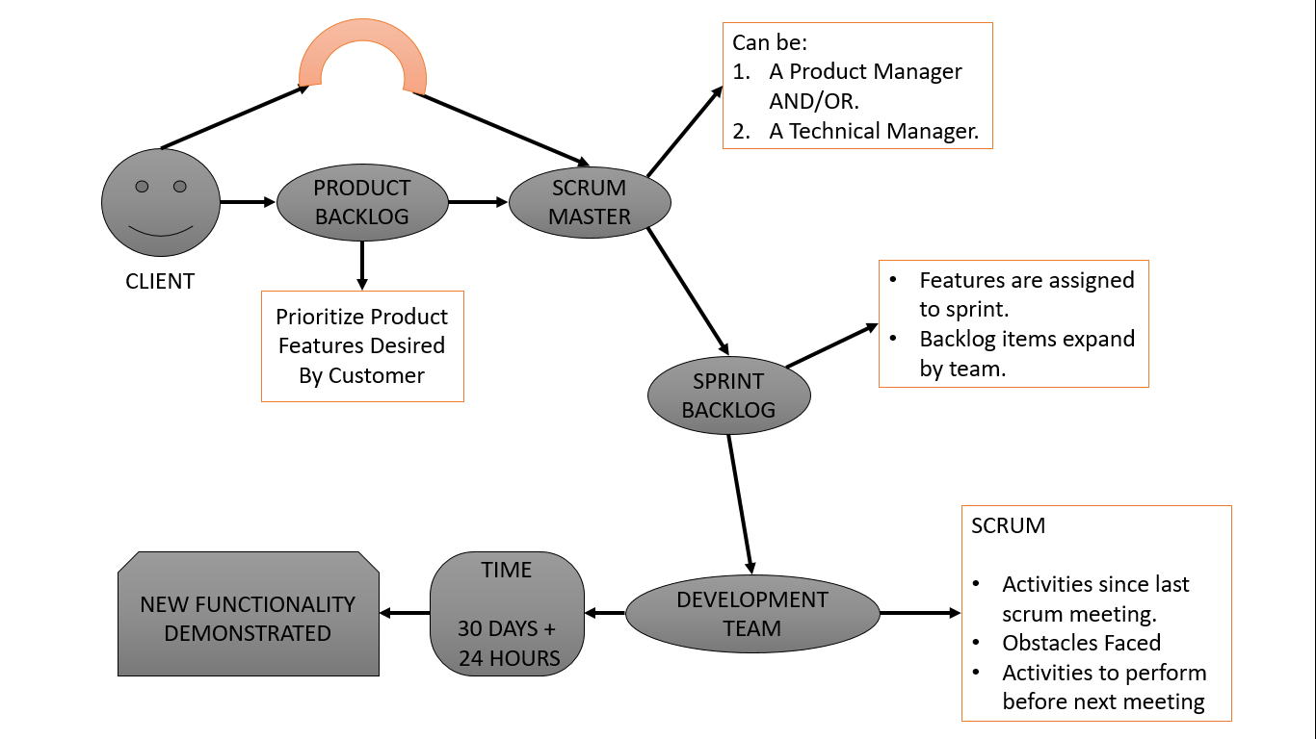

The **Scrum Development Methodology** can be applied to nearly any project. This process is suited for development projects that are rapidly changing or highly emergent requirements. The Scrum software development model begins with a brief planning, meeting and concludes with a final review. This development methodology is used for speedy development of software which includes a series of iterations to create required software. It is an ideal methodology because it easily brings on track even the slowest progressing projects.

#### **Advantages of Scrum Development:**

* + In this methodology, decision-making is entirely in the hands of the teams
  + This methodology enables project’s where the business requirements documentation is not considered very significant for the successful development
  + It is a lightly controlled method which totally empathizes on frequent updating of the progress, therefore, project development steps is visible in this method
  + A daily meeting easily helps the developer to make it possible to measure individual productivity. This leads to the improvement in the productivity of each of the team members

#### **Disadvantages of Scrum Development:**

* + This kind of development model is suffered if the estimating project costs and time will not be accurate
  + It is good for small, fast moving projects but not suitable for large size projects
  + This methodology needs experienced team members only. If the team consists of people who are novices, the project cannot be completed within exact time frame

# ER DIAGRAM

