# INTRODUCTION (Agile Menifesto)

**1. Individuals and Interactions** over processes and tools.

So intrusion detection system is based on to detect the suspicious activity from the database information. This information will automatically monitor and scan the unauthorized to user information does not allow in our system and there is an administrator to secure our database to add security to secure the database example, Administrator ID, Password, etc. Tools like IDS, sensor, alert repository, login, security admin this are used to secure our database.

**2. Working Software** over comprehensive documentation.

The documentation types that the team produces and its scope depend on the software development approach that was chosen. **Scrum Model – Scrum world, instead of providing complete, detailed descriptions of how everything is to be done on a project, much of it is left up to the Scrum software development team. This is because the team will know best how to solve the problem they are presented.**

**3. Customer Collaboration** over contract negotiation.

When the customer and the project manager — or another project team representative — negotiate contract details. When the customer and the project manager negotiate changes to the contract. When the project team delivers a completed product to the customer. If the product doesn’t meet customer expectations, the project manager and the customer negotiate additional changes to the contract.

**4. Responding to Change** over following a plan.

To adaptive planning approach. In this approach, planning is an ongoing activity throughout the execution of the entire project, occurring in small increments as the reality of project execution unfolds. If that the time is going on new feature or update in the future is to update using AI to update our security feature to secure our database user information.

# OBJECTIVE

Intrusion Detection System (IDS) is a detective device designed to detect malicious (including policy-violating) actions. An Intrusion Prevention System (IPS) is primarily a preventive device designed not only to detect but also block malicious actions.

Depending on their physical location in the infrastructure, and the scope of protection required, the IDS’ and IPS’ fall into two basic types: network-based and host-based. Both have the same function and the specific type deployed depends on strategic considerations.

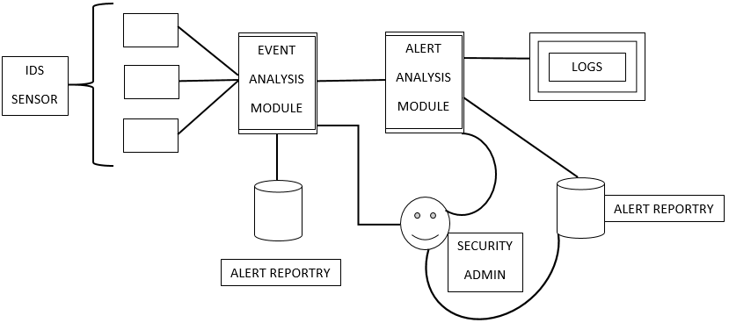

## SUB-OBJECTIVE

The proper identification of mission-critical systems and points of entry requires the following roles in an organization to be involved in any IDS/IPS deployment:

* Senior Management
* Information Security Officers
* Data owners
* Network Administrators
* Database Administrators
* Operating System Administrators

# METHODOLOGY

**Scrum Development Methodology**

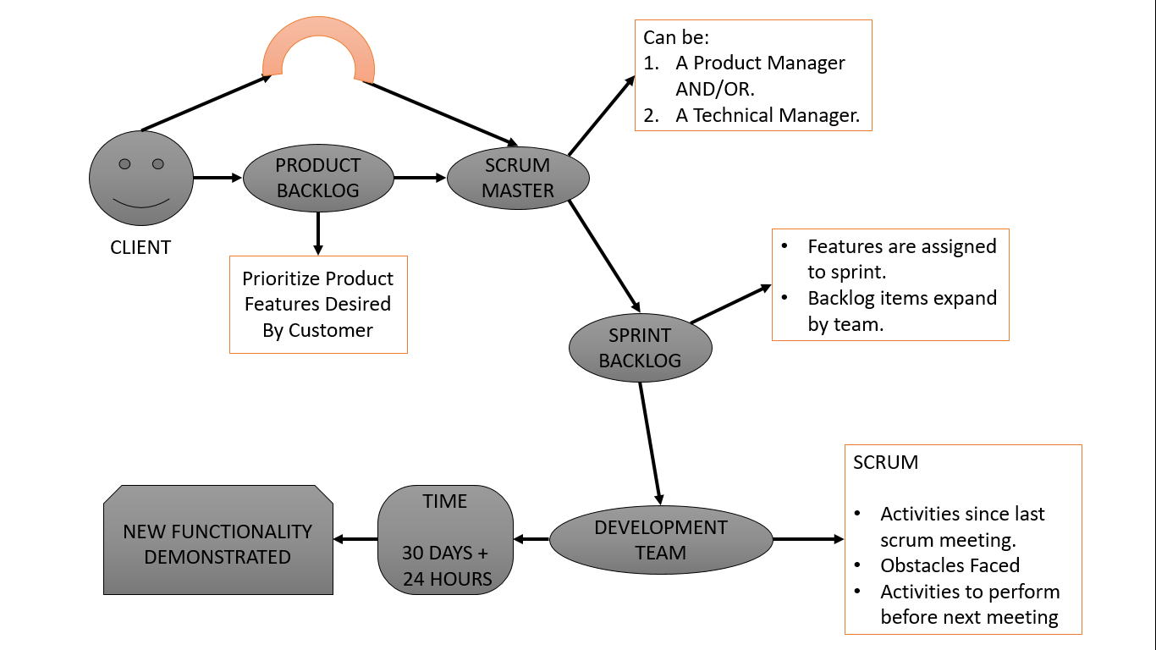

The **Scrum Development Methodology** can be applied to nearly any project. This process is suited for development projects that are rapidly changing or highly emergent requirements. The Scrum software development model begins with a brief planning, meeting and concludes with a final review. This development methodology is used for speedy development of software which includes a series of iterations to create required software. It is an ideal methodology because it easily brings on track even the slowest progressing projects.

#### **Advantages of Scrum Development:**

* + In this methodology, decision-making is entirely in the hands of the teams
  + This methodology enables project’s where the business requirements documentation is not considered very significant for the successful development
  + It is a lightly controlled method which totally empathizes on frequent updating of the progress, therefore, project development steps is visible in this method
  + A daily meeting easily helps the developer to make it possible to measure individual productivity. This leads to the improvement in the productivity of each of the team members

#### **Disadvantages of Scrum Development:**

* + This kind of development model is suffered if the estimating project costs and time will not be accurate
  + It is good for small, fast moving projects but not suitable for large size projects
  + This methodology needs experienced team members only. If the team consists of people who are novices, the project cannot be completed within exact time frame

# DF DIAGRAM (Level 0, Level 1, Level 2)

