<http://blog.csdn.net/napoay/article/details/53896348>

用xiaoming用户执行

sudo yum update -y

报错，原因是xiaoming没有执行的权限，添加进去

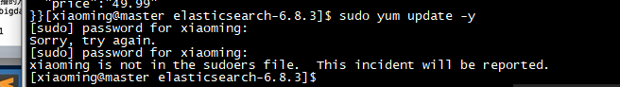

echo "xiaoming ALL = (root) NOPASSWD:ALL" | tee /etc/sudoers.d/xiaonming

chmod 0440 /etc/sudoers.d/xiaoming

#解决sudo: sorry, you must have a tty to run sudo问题，在/etc/sudoer注释掉 Default requiretty 一行

sudo sed -i 's/Defaults requiretty/Defaults:xiaoming !requiretty/' /etc/sudoers

#更新

sudo yum update -y

sudo rpm -ivh http://dl.fedoraproject.org/pub/epel/epel-release-latest-7.noarch.rpm

sudo rpm -ivh https://kojipkgs.fedoraproject.org//packages/http-parser/2.7.1/3.el7/x86_64/http-parser-2.7.1-3.el7.x86_64.rpm

sudo yum install npm

sudo yum install -y git

sudo yum install -y bzip2

git clone git://github.com/mobz/elasticsearch-head.git

#将源码包下载后剪切到/bigdata目录，并改所属用户和组

sudo chown -R xiaoniu:xiaoniu /bigdata/elasticsearch-head

#进入到elasticsearch-head中

cd elasticsearch-head

#编译安装

npm install

打开elasticsearch-head-master/Gruntfile.js，找到下面connect属性，新增hostname: '0.0.0.0',

connect: {

server: {

options: {

hostname: '0.0.0.0',

port: 9100,

base: '.',

keepalive: true

}

}

}

编辑elasticsearch-5.4.3/config/elasticsearch.yml,加入以下内容：

http.cors.enabled: true

http.cors.allow-origin: "*"

#运行服务

npm run start

---------------------------------------------------------------------------------------------