Quick Application Health Check

Application Name: SuperTRUMP

What needs to be check?
1 | 2 | 3 | 4 | 5 | 6
BSCEFSUPERTRUMP.DLL | STSERVER.DLL | FTP server | Misc 2 | Misc 3 | Misc 4
 |  |  |  |  | 

S.No | Check | Steps | Expected Result
1 | BSCEFSUPERTRUMP.DLL | To Check the SuperTRUMP Service–  1.Please click on below link  http://STWebServiceTest.QA.comfin.ge.com  2. Select  PROD:-http://SuperTRUMP.web.comfin.ge.com/BSCEFSupertrumpNET/SupertrumpService.asmx  3. Click on “Ping for test component”. (This tests the ST web service)  In case the above link is not working check the Super Trump service 1.Using link  : http://ceficecluster.comfin.ge.com/BSCEFSuperTRUMPNET/supertrumpservice.asmx | Successful  Refer Screen 1.a in appendix.  Go to appendix to see the screen shot  Refer Screen 1.b in appendix
2 | STSERVER.DLL | To Check the SuperTRUMP Service-  1.Please click on below link  http://itoeintranet.comfin.ge.com/common/stwebsvc/STPerTest.asp  2.Select http://ceficecluster.comfin.ge.com/BSCEFSupertrumpnet/BSCEFSuperTrump.wsdl  3. Click on “Click on “Test-for testing stserver.dll”.  If link mentioned in step 1 is not opening then try to open following links in browser:  http://ceficecluster.comfin.ge.com/BSCEFSupertrumpnet/BSCEFSuperTrump.wsdl  http://ceficecluster.comfin.ge.com/BSCEFSuperTRUMPNET/supertrumpservice.asmx | Successful  Refer Screen 2 in appendix.  Go to appendix to see the screen shot
3 | FTP Server | For SuperTRUMP client, Check the FTP server is available or not using the below link.  ftp://CMFCIOHPAPWX.comfin.ge.com/SuperTRUMP/  FTP Admin Userid/Pwd: supertrumpftp/sup3z1*r  FTP User Userid/Pwd: supertrumpuser/te1234st  OR  Map Drive using SAMBA share:  \\3.131.91.185\supertrumpftp\SuperTRUMP\  Userid/Pwd: supertrumpftp /trump12ftp | Successful.  Refer Screen 3 in appendix.
APPENDIX

Web link Verification

Screen 1.a:
Link - http://itoeintranet.comfin.ge.com/common/stwebsvc/STPerTest.asp
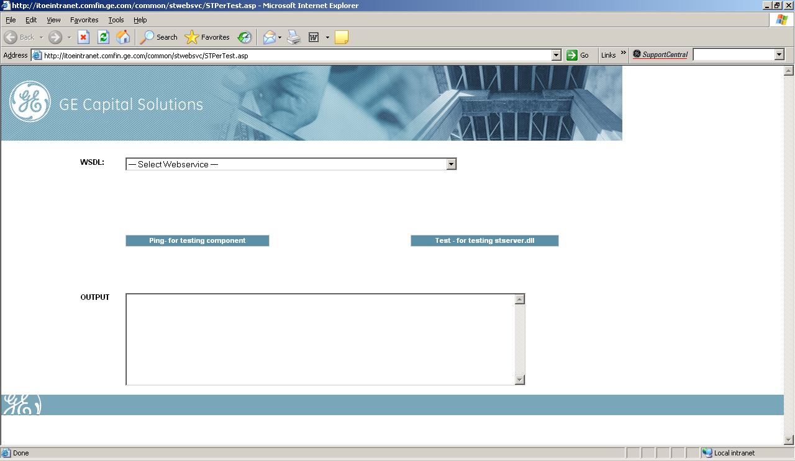

Screen 1.b:

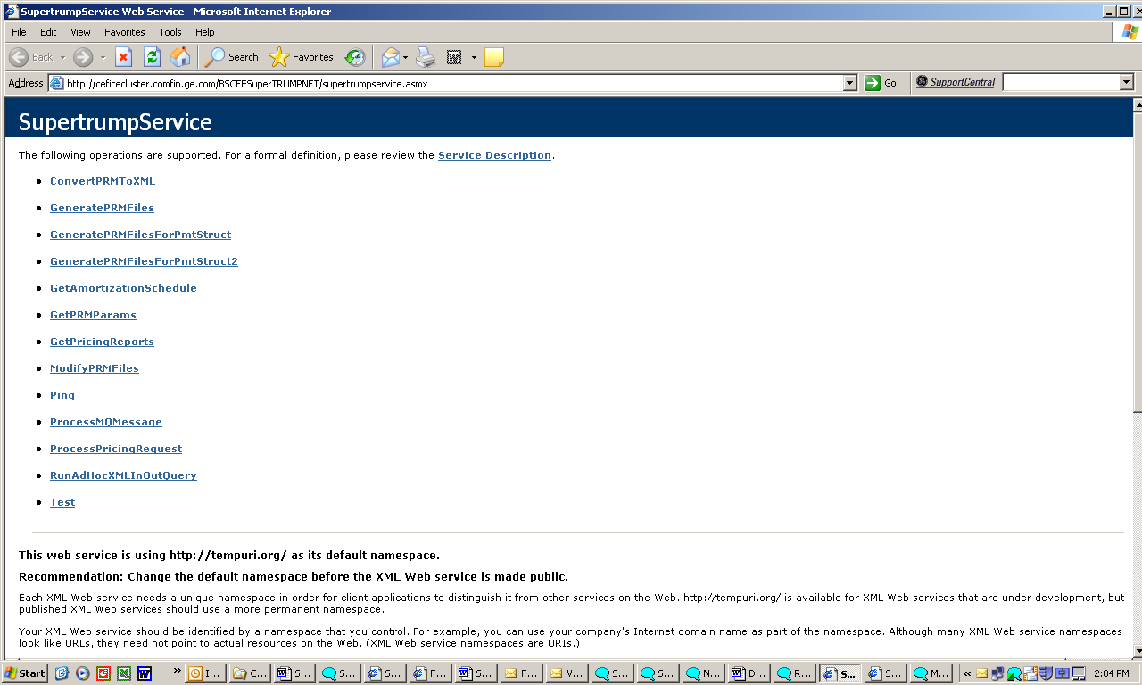

Screen 2:

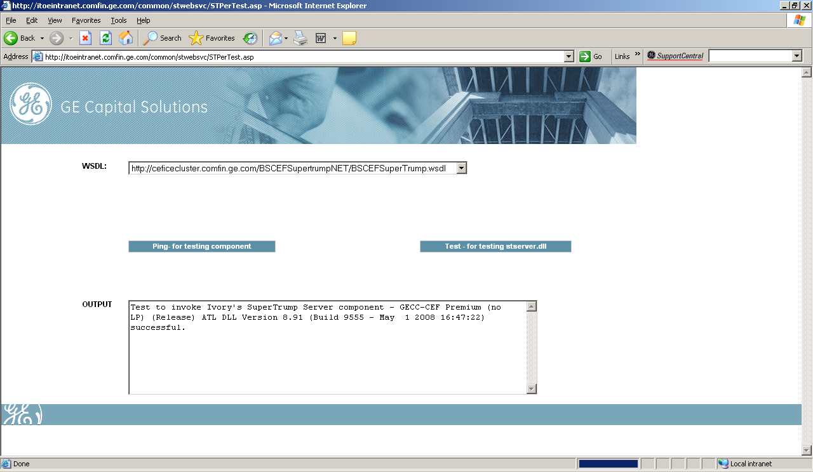
For SuperTRUMP client.
Screen 3:

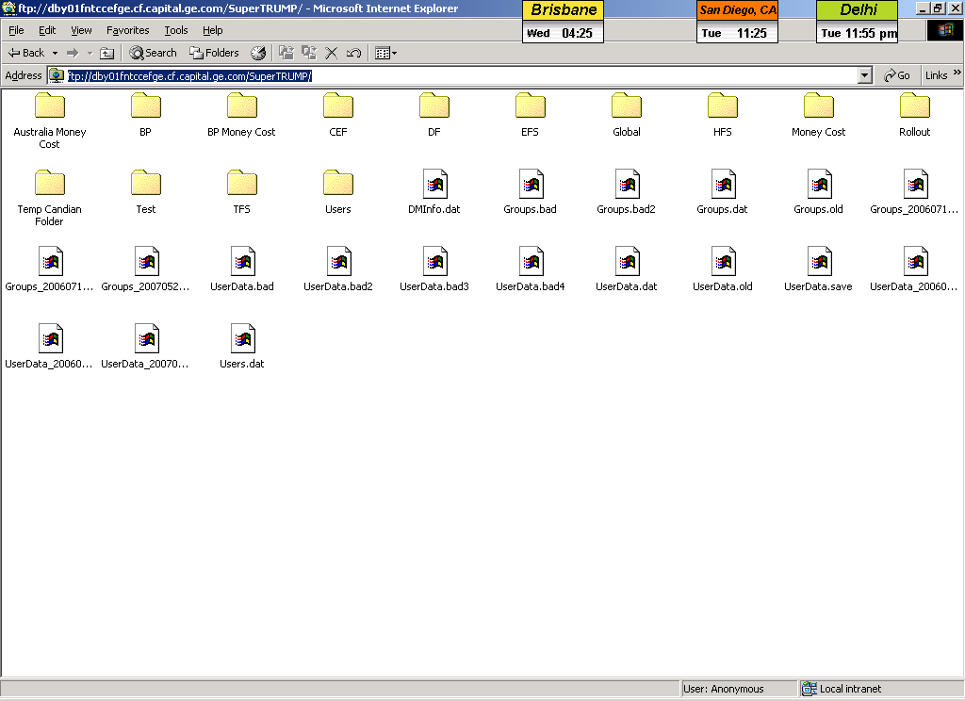

ESCALATION

Problem Type | Process to follow | Contact Person
IT | Charandeep.Singh@ge.com / *447 3127 | Charandeep Singh
IT Product Manager | Gregg.Reinhart@ge.com | Gregg Reinhart

