COMPUTER NETWORKS - LAB-2
SRN-PES2UG25CS405
NAME- PREETHAM S

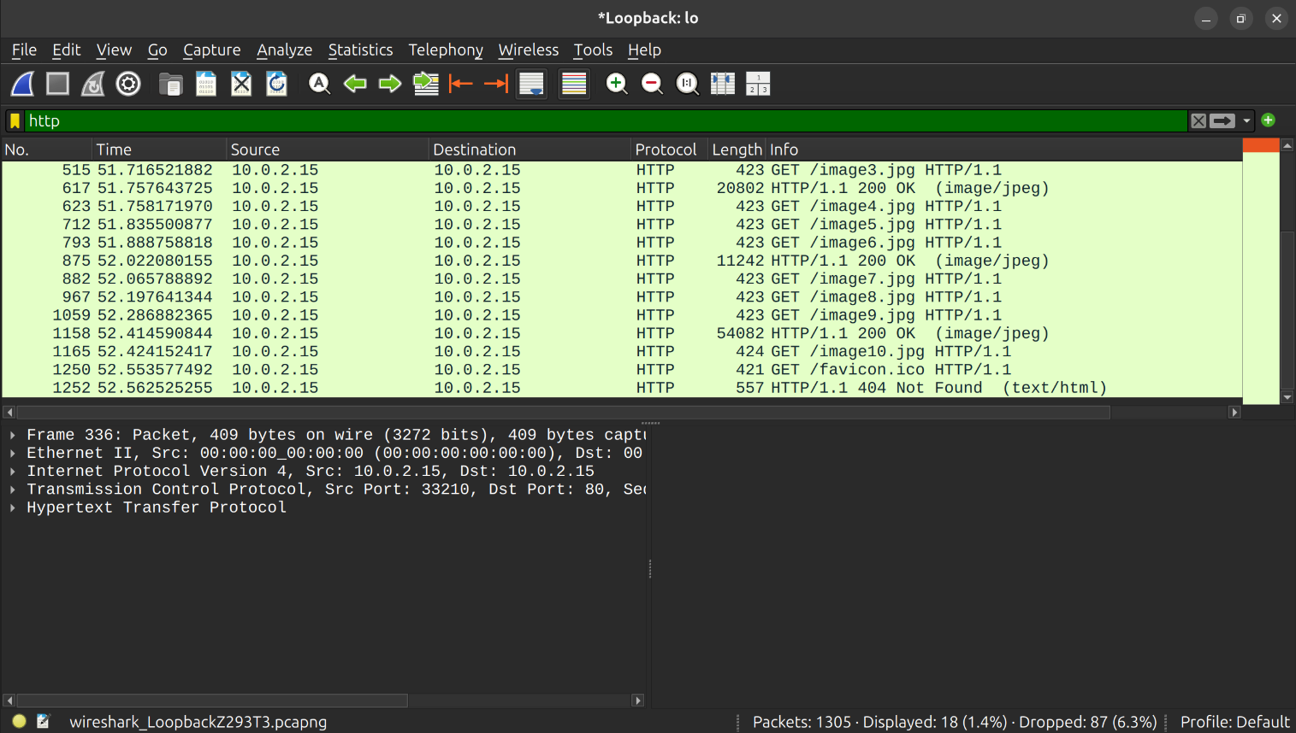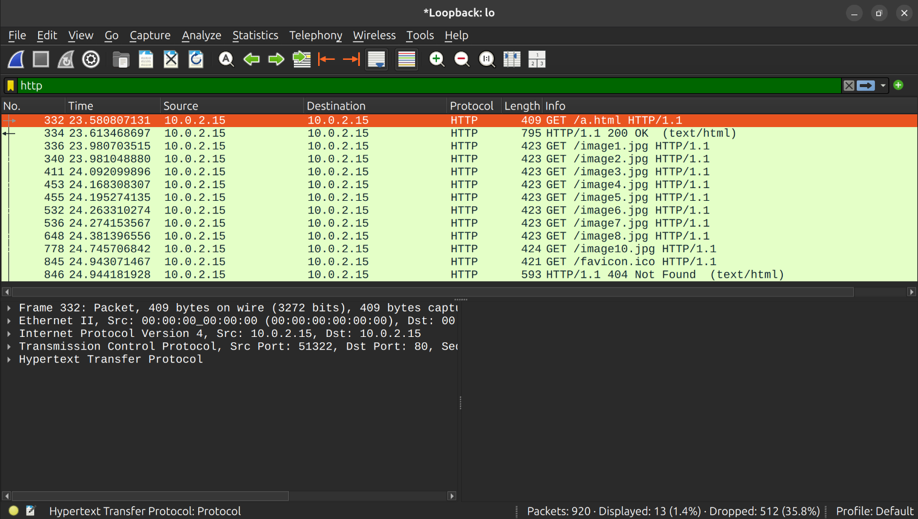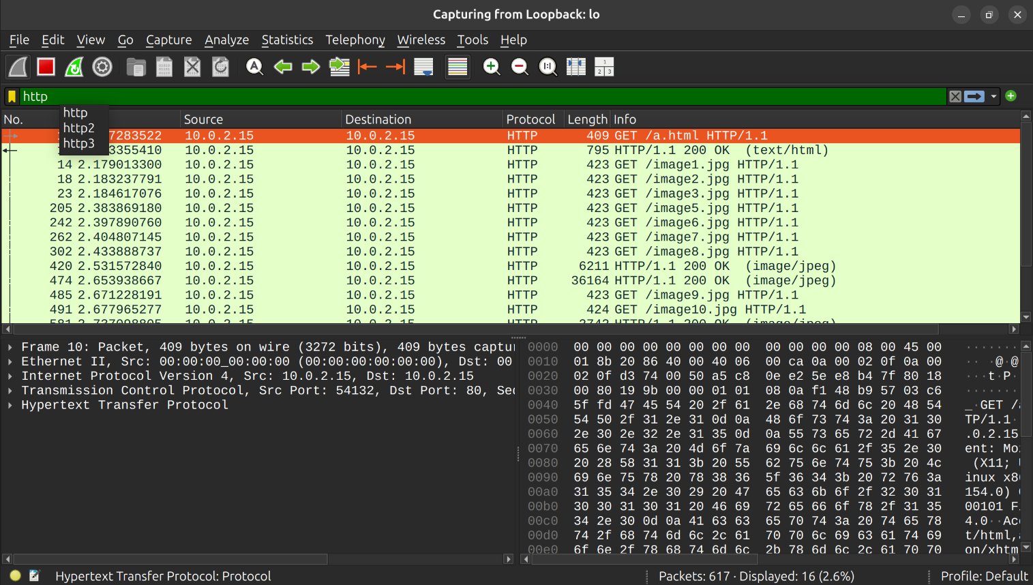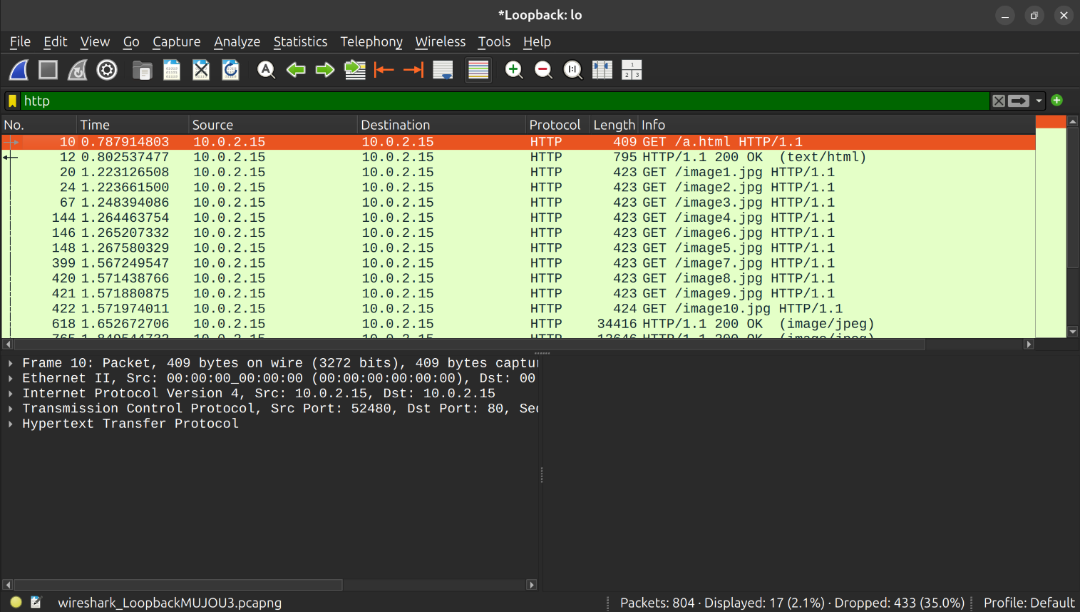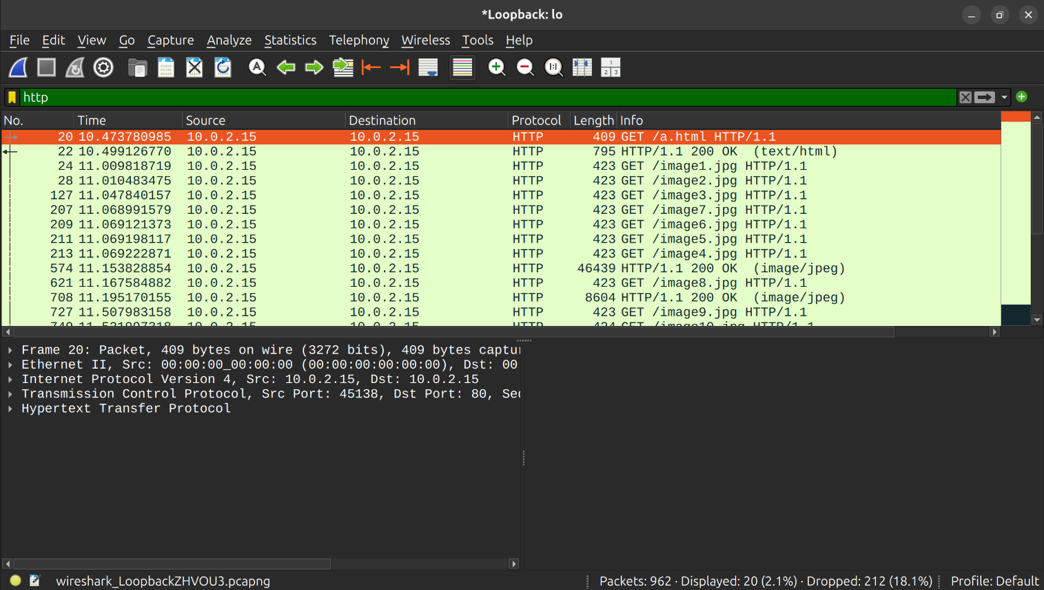

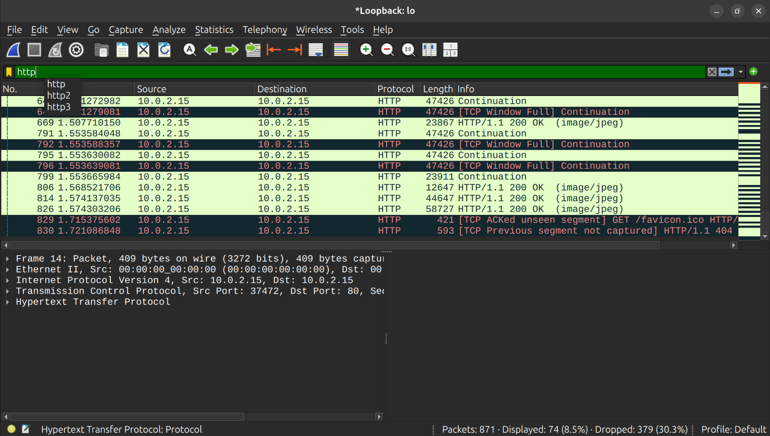
OBSERVATION TABLE: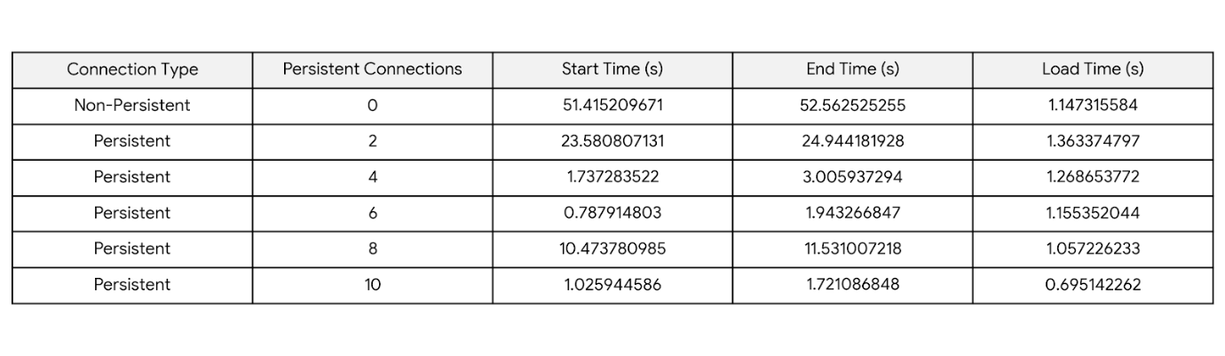
GRAPH PLOT: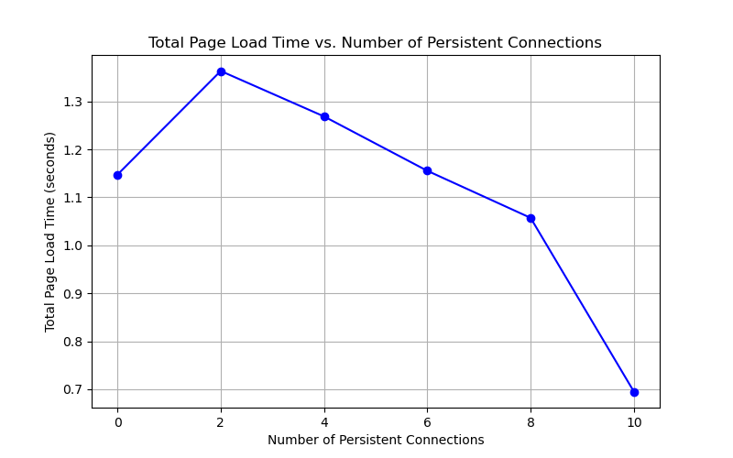
Connection persistence significantly reduces page load times and improves network efficiency by allowing a single TCP connection to send and receive multiple requests and responses. Instead of opening a new connection for every single asset (like images, scripts, and stylesheets), the client and server reuse the same channel.
Here is a brief breakdown of its impact:
Impact on Page Load Time (Latency)
- Eliminates TCP Handshake Delay: Opening a new TCP connection requires a three-way handshake, which takes a full round-trip time (RTT). Reusing connections eliminates this overhead for subsequent requests.
- Reduces TLS/SSL Overhead: Establishing secure connections (HTTPS) requires additional cryptographic handshakes. Connection persistence skips this resource-heavy setup after the initial connection.
- Avoids TCP Slow-Start: New TCP connections start sending data slowly to avoid network congestion. Persistent connections stay "warm," allowing them to transmit data at optimal speeds immediately.
Impact on Network Efficiency
- Lower CPU and Memory Usage: Servers and routers do not have to constantly allocate resources to open, maintain, and close thousands of individual sockets.
- Reduced Packet Congestion: Fewer connection setup and teardown packets (SYN/ACK/FIN) are sent across the internet, reducing overall network noise.
- Enables Modern Protocols: Connection persistence laid the groundwork for HTTP/2 and HTTP/3, which use multiplexing to stream hundreds of assets simultaneously over a single persistent connection.

