DLCD -ASSIGNMENT
PREETHAM s
PES2UG25CS405
G SECTION

1.Dffresetload.v
module dffresetload (
input wire clk,
input wire reset,
input wire load,
input wire in,
output reg out
);

always @(posedge clk) begin
if (reset) begin
out <= 1'b0;
end else if (load) begin
out <= in;
end else begin
out <= out;
end
end

endmodule

DFFRESetload_tb.v
`timescale 1ns / 1ps

module dffresetload_tb;
reg clk;
reg reset;
reg load;
reg in;
wire out;

// Instantiate the D Flip-Flop module
dffresetload uut (
.clk(clk),
.reset(reset),
.load(load),
.in(in),
.out(out)
);

// Display formatted simulation output
initial begin
$monitor("clk=%b, reset=%b, load=%b, in=%b, out=%b", clk, reset, load, in, out);
end

// VCD file dump for GTKWave
initial begin
$dumpfile("dff_test.vcd");
$dumpvars(0, dffresetload_tb);
end

initial begin
clk = 0;
forever #5 clk = ~clk;
end

initial begin
reset = 1; load = 0; in = 1;
#10;
reset = 0; load = 0; in = 1;
#5;
load = 1; in = 1;
#5;
in = 0;
#10;
load = 0; in = 1;
#5;
in = 0;
#5;
$finish;
end

endmodule

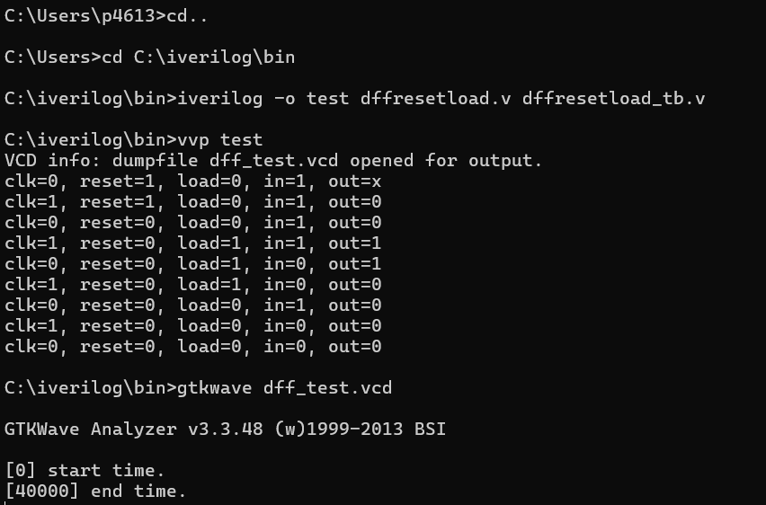
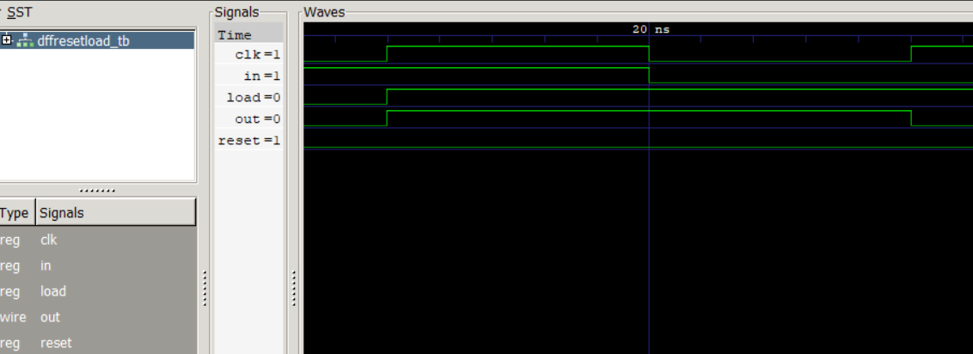

2.Dff.v
module dff (
input wire clk,
input wire in,
output reg out,
output wire out_bar
);

assign out_bar = ~out;

always @(posedge clk) begin
out <= in;
end

endmodule

Dff_tb.v
`timescale 1ns / 1ps

module dff_tb;
reg clk;
reg in;
wire out;
wire out_bar;

dff uut (
.clk(clk),
.in(in),
.out(out),
.out_bar(out_bar)
);

initial begin
$monitor("%0dclk=%b, in=%b, out=%b", $time, clk, in, out);
end

// VCD dump for GTKWave visualization
initial begin
$dumpfile("dff_test.vcd");
$dumpvars(0, dff_tb);
end

// Clock generation (Period = 10ns)
initial begin
clk = 0;
forever #5 clk = ~clk;
end

// Stimulus matching the exact timing sequence (0ns to 40ns)
initial begin
// Time 0ns: initial setup
in = 1;
#5; // Time 5ns (posedge clk) -> in=0

in = 0;
#5; // Time 10ns (negedge clk) -> in=1

in = 1;
#10; // Time 20ns (negedge clk) -> in=0

in = 0;
#10; // Time 30ns (negedge clk) -> in=1

in = 1;
#10;

in = 0;
#0;
$finish;
end

endmodule
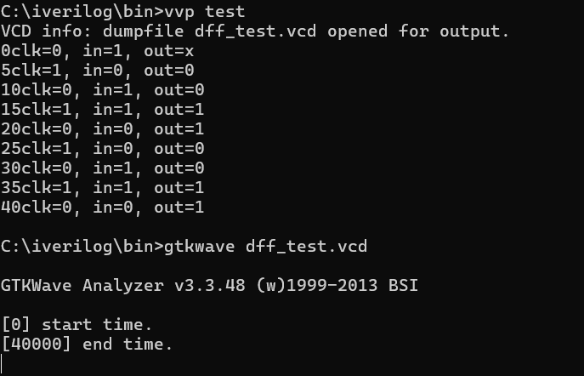
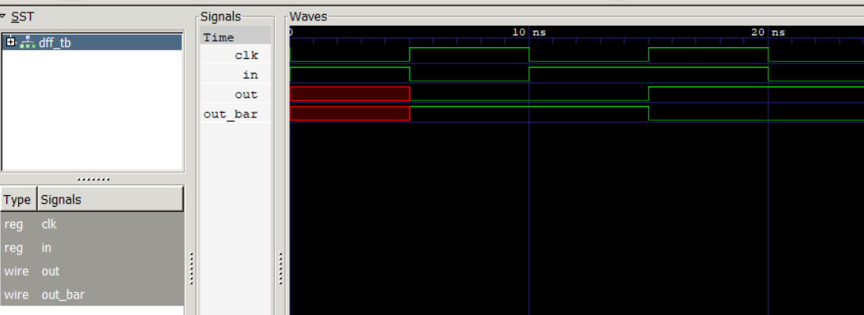

3.Dffreset.v
module dffreset (
input wire clk,
input wire reset,
input wire in,
output reg out
);

always @(posedge clk) begin
if (reset) begin
out <= 1'b0;
end else begin
out <= in;
end
end

endmodule

Dffreset_tb.v
`timescale 1ns / 1ps

module dffreset_tb;
reg clk;
reg reset;
reg in;
wire out;

dffreset uut (
.clk(clk),
.reset(reset),
.in(in),
.out(out)
);

initial begin
$monitor("%0dclk=%b,reset=%b, in=%b, out=%b", $time, clk, reset, in, out);
End

initial begin
$dumpfile("dff_test.vcd");
$dumpvars(0, dffreset_tb);
end

initial begin
clk = 0;
forever #5 clk = ~clk;
end

initial begin
reset = 1; in = 1;
#5; // Time 5ns (posedge clk) -> in=0

in = 0;
#5; // Time 10ns (negedge clk) -> in=1

in = 1;
#3; // Time 13ns -> reset drops to 0

reset = 0;
#2; // Time 15ns (posedge clk) -> in=1

#5; // Time 20ns (negedge clk) -> in=0
in = 0;

#10; // Time 30ns (negedge clk) -> in=1
in = 1;

#10; // Time 40ns (negedge clk) -> in=0
in = 0;

#0; // End simulation at 40ns
$finish;
end

endmodule
