TEAM MEMBERS: J.JEMIMA 2015115079
C.KAVYA 2015115082
N.NANDHINI 2015115092

PROJECT TITLE: UPDATE NOTIFIER

PROBLEM STATEMENT:
User cannot continuously monitor the web pages for updates. So to solve that issue ,page monitor using web scraping can be done.

ABSTRACT:
The main objective of our project is to notify the updation of data in any dynamic website. Web scraping or web data extraction is used for extracting data from websites. Web scrapers typically take something out of a page. So using that if there is any change in the data, it will be notified to the user through email or text messages. The time interval can be changed by the users. So accordingly to the given time interval ,the scrapper program will monitor the webpage and checks for updation. So if there is any changes, it will be notified.

LANGUAGES USED:

Python ,Html , Javascript

SOFTWARE REQUIREMENTS:

Chrome ,Windows OS

ARCHITECTURE DIAGRAM

Web Front End
(Chrome Extension)

Web Scrapper API

Data Extraction

Data Manipulation
Live score website

Notifier

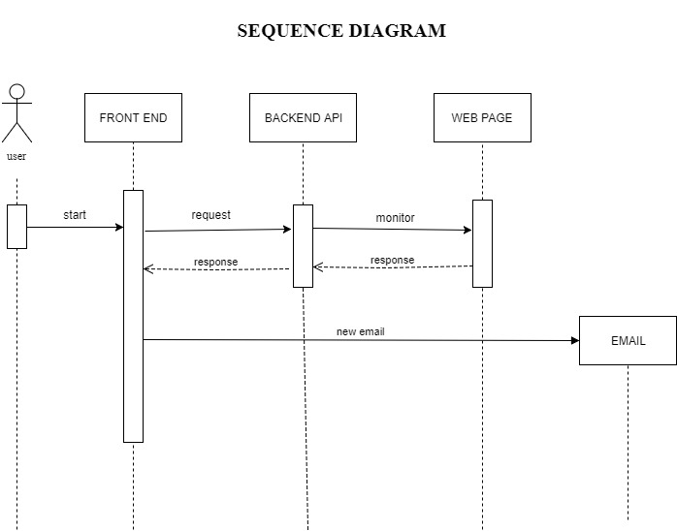

TIMELINE:
2 WEEKS -Planning & Design
3 WEEKS - python coding
3 WEEKS -UI design
2 WEEKS -Converting the application to a chrome extension.
1 WEEK -Documentation and presentaion.

GITHUB LINK: https://github.com/5079jemima/CIP-update-notifier

