Course Project 1
Alberto Chong
12/29/2020

libraries
We will attach the following libraries:
library(dplyr)
library(ggplot2)
library(tidyr)

1. Loading and preprocessing the data

Loading data
activity <- read.csv(unzip(paste0(getwd(),"/activity.zip")))

transform data
activity <- activity %>% mutate(date = as.Date(date))
str(activity)
## 'data.frame': 17568 obs. of 3 variables:
## $ steps : int NA NA NA NA NA NA NA NA NA NA ...
## $ date : Date, format: "2012-10-01" "2012-10-01" ...
## $ interval: int 0 5 10 15 20 25 30 35 40 45 ...

2. What is mean total number of steps taken per day?

Calculate the total number of steps taken per day
Total <- activity %>%
group_by(date) %>%
summarise(total = sum(steps,na.rm = TRUE)) %>%
ungroup()
head(Total)
## # A tibble: 6 x 2
## date total
## <date> <int>
## 1 2012-10-01 0
## 2 2012-10-02 126
## 3 2012-10-03 11352
## 4 2012-10-04 12116
## 5 2012-10-05 13294
## 6 2012-10-06 15420

Make a histogram of the total number of steps taken each day
hist(Total$total,
main = "Histogram",
xlab = "steps per day")
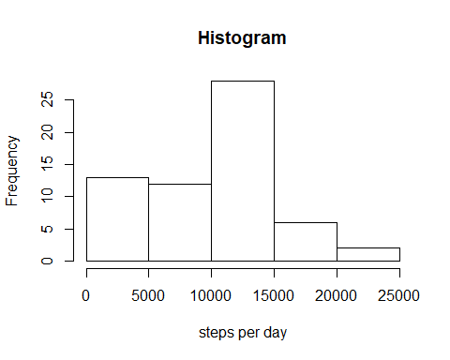

3. Calculate and report the mean and median of the total number of steps taken per day
Mean of total number of steps per day
mean(Total$total)
## [1] 9354.23
Median of total number of steps
median(Total$total)
## [1] 10395

4. What is the average daily activity pattern?

Time series plot
activity %>% group_by(interval) %>%
summarise(avg_steps = mean(steps,na.rm = T)) %>%
ggplot(aes(x = interval, y = avg_steps)) +
geom_line()
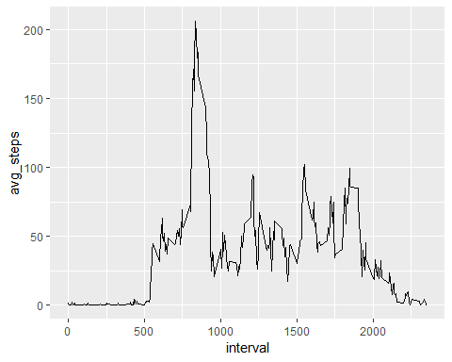

5. 5-minute interval that contains the maximum number of steps on average
avg_interval <- activity %>% group_by(interval) %>%
summarise(avg_steps = mean(steps,na.rm = T))
avg_interval[which(avg_interval$avg_steps == max(avg_interval$avg_steps,na.rm = T)),]
## # A tibble: 1 x 2
## interval avg_steps
## <int> <dbl>
## 1 835 206.

6. Imputing missing values

Calculate and report the total number of missing values in the dataset
sum(is.na(activity$steps))
## [1] 2304

Strategy for filling in all of the missing values in the dataset
avg_day <- activity %>%
group_by(date) %>%
summarise(avg = round(mean(steps, na.rm = TRUE),0)) %>%
ungroup() %>%
replace_na(list(avg = 0))
head(avg_day)
## # A tibble: 6 x 2
## date avg
## <date> <dbl>
## 1 2012-10-01 0
## 2 2012-10-02 0
## 3 2012-10-03 39
## 4 2012-10-04 42
## 5 2012-10-05 46
## 6 2012-10-06 54

Create a new dataset that is equal to the original dataset but with the missing data filled in
imputed_activity <- activity %>%
inner_join(avg_day, by = "date") %>%
mutate(steps = ifelse(is.na(steps),avg,steps)) %>%
select(-avg)
head(imputed_activity)
## steps date interval
## 1 0 2012-10-01 0
## 2 0 2012-10-01 5
## 3 0 2012-10-01 10
## 4 0 2012-10-01 15
## 5 0 2012-10-01 20
## 6 0 2012-10-01 25

7. Make a histogram of the total number of steps taken each day and Calculate and report the mean and median total number of steps taken per day
Histogram
imputed_Total <- imputed_activity %>%
group_by(date) %>%
summarise(total = sum(steps,na.rm = TRUE)) %>%
ungroup()
hist(imputed_Total$total,
main = "Histogram (imputed data)",
xlab = "steps per day")
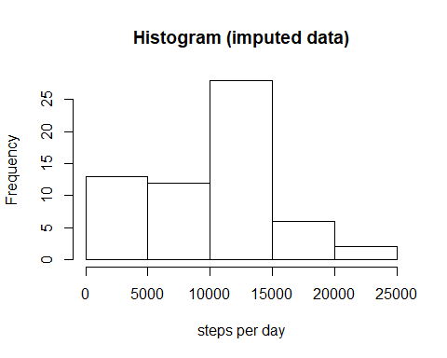
Mean:
mean(imputed_Total$total)
## [1] 9354.23
Median:
median(imputed_Total$total)
## [1] 10395
The values of mean an median didn’t change from the estimates calculated from the first part of the assigment.

8. Are there differences in activity patterns between weekdays and weekends?

Create a new factor variable in the dataset with two levels - “weekday” and “weekend”
imputed_activity$weekday <- weekdays(imputed_activity$date)
imputed_activity <- imputed_activity %>%
mutate(class_weekday = ifelse(weekday %in% c("Saturday","Sunday"),"weekend","weekday"))
head(imputed_activity)
## steps date interval weekday class_weekday
## 1 0 2012-10-01 0 Monday weekday
## 2 0 2012-10-01 5 Monday weekday
## 3 0 2012-10-01 10 Monday weekday
## 4 0 2012-10-01 15 Monday weekday
## 5 0 2012-10-01 20 Monday weekday
## 6 0 2012-10-01 25 Monday weekday

Make a panel plot containing a time series plot
imputed_activity %>%
group_by(interval,class_weekday) %>%
summarise(avg_steps = mean(steps,na.rm = T)) %>%
ggplot(aes(x = interval, y = avg_steps)) +
geom_line() +
facet_wrap(~class_weekday, dir = "v")
