Installation documentation

[Github](https://github.com/50ME0N3/CFPT-Tournament)

# Software

Node.Js v17.0.1

Npm 8.2.0

# Install dependencies

Npm -i (in the root directory)

# Start servers

* API
  + Run the database first
  + Run “npm run api” in the root directory
* BOT
  + Run “node index.js” in the botTournois directory
* SITE
  + Run “npm run site” in the root directory

# Tree

The project tree should look like this

# Bot

Create a config.json file at the root of the bot folder.

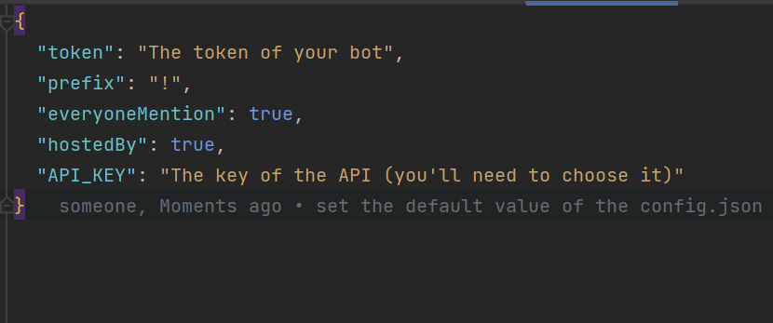

It should look like this.

# API

Create 2 config.json

The first one is called db.config.json and should look like this

The second one is called api.config.json and should look like this

# Site

To create the bracket all you need is a http request to “/bracket”. But you need to be careful on few things

* There’re 8 teams in the database (no more, no less)
* Don’t create a new one if there is another one

# Database

Put the struct.sql in your database server and you should have all the tables and users you’ll need