计算机科学与技术系
实验（项目）报告

一、基本信息
实验（项目）名称 | 单元项目(简易绘图)
课程名称 | Java程序设计 | 学生层次 | 本科
学生专业 | 信息工程 | 学生年级 | 2015级
学生班级 | 信息工程15202 | 学生学号 | 15310920208
学生姓名 | 何宽 | 完成日期 | 2016年12月24日
指导教师 | 贺敏 | 报告成绩
二、目的与要求
目的：
通过该实验巩固Java中的GUI程序基础知识和面向对象知识。
要求：
1.掌握Java中的面向对象编程语法；
2.掌握Java中GUI程序基础技能；
3.掌握Java2D绘图技术。
三、完成实验（项目）过程和效果
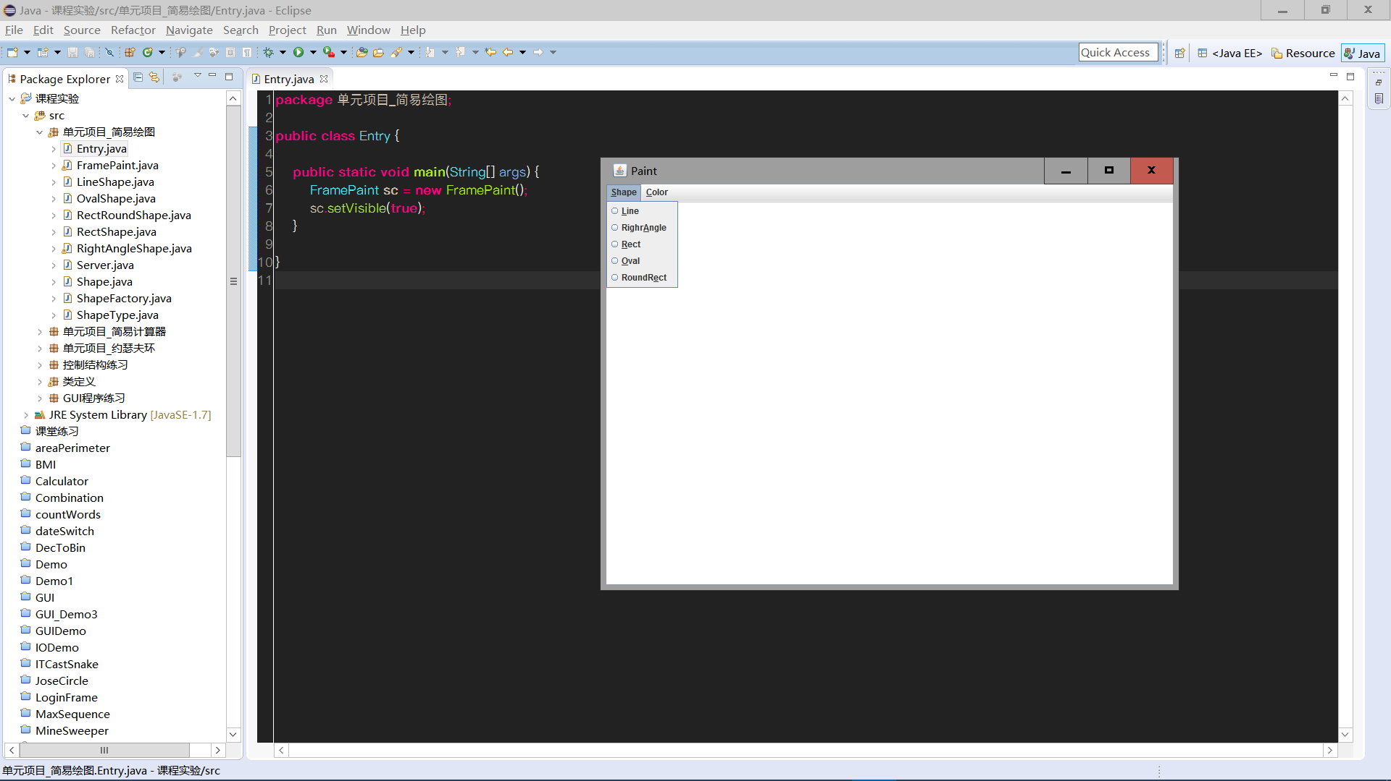
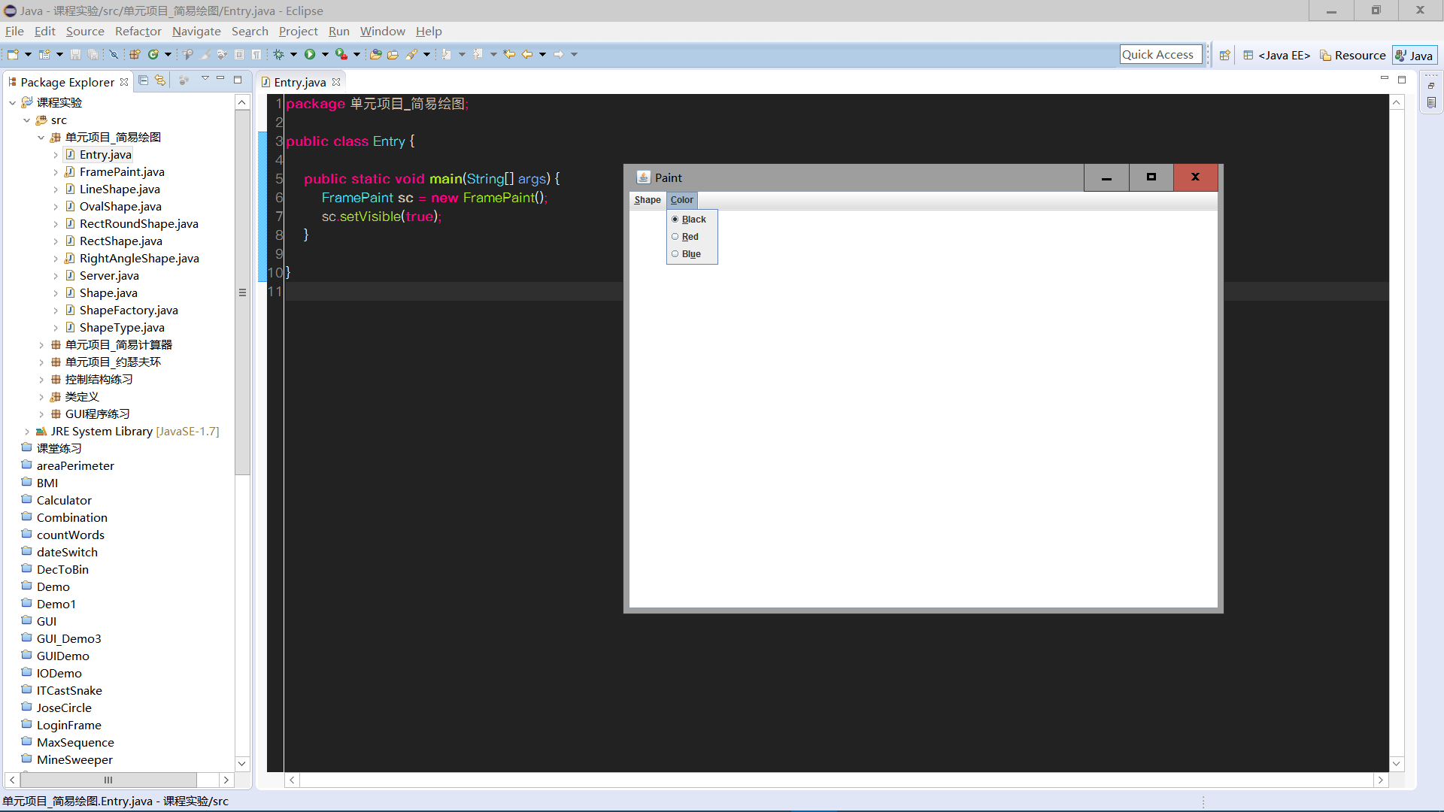
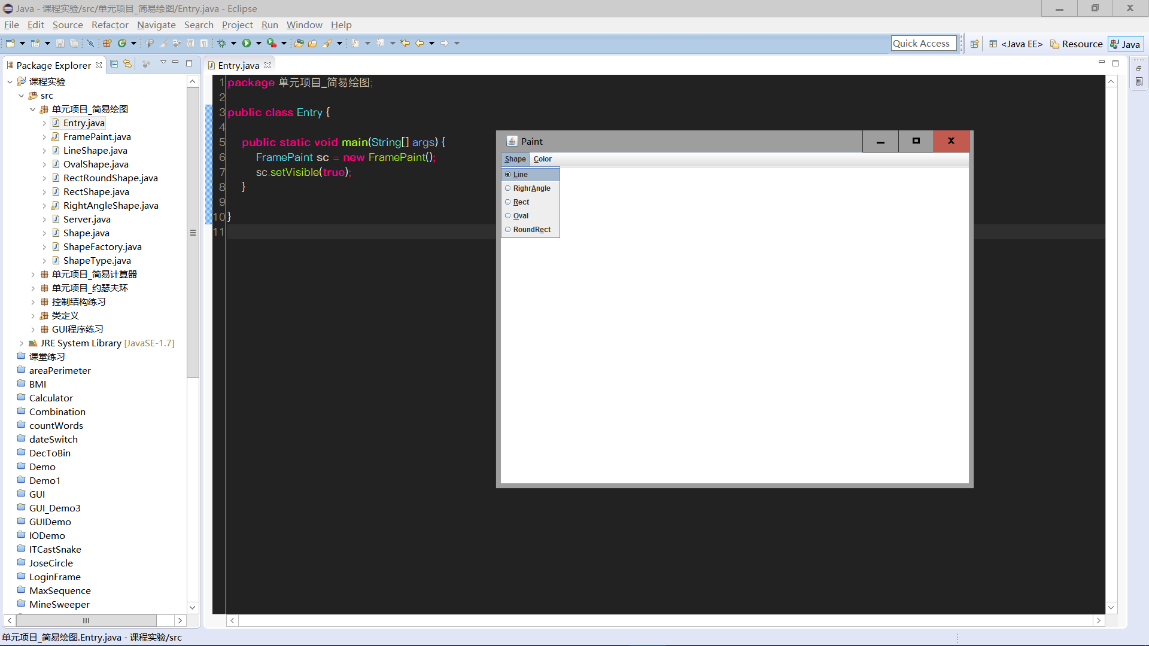
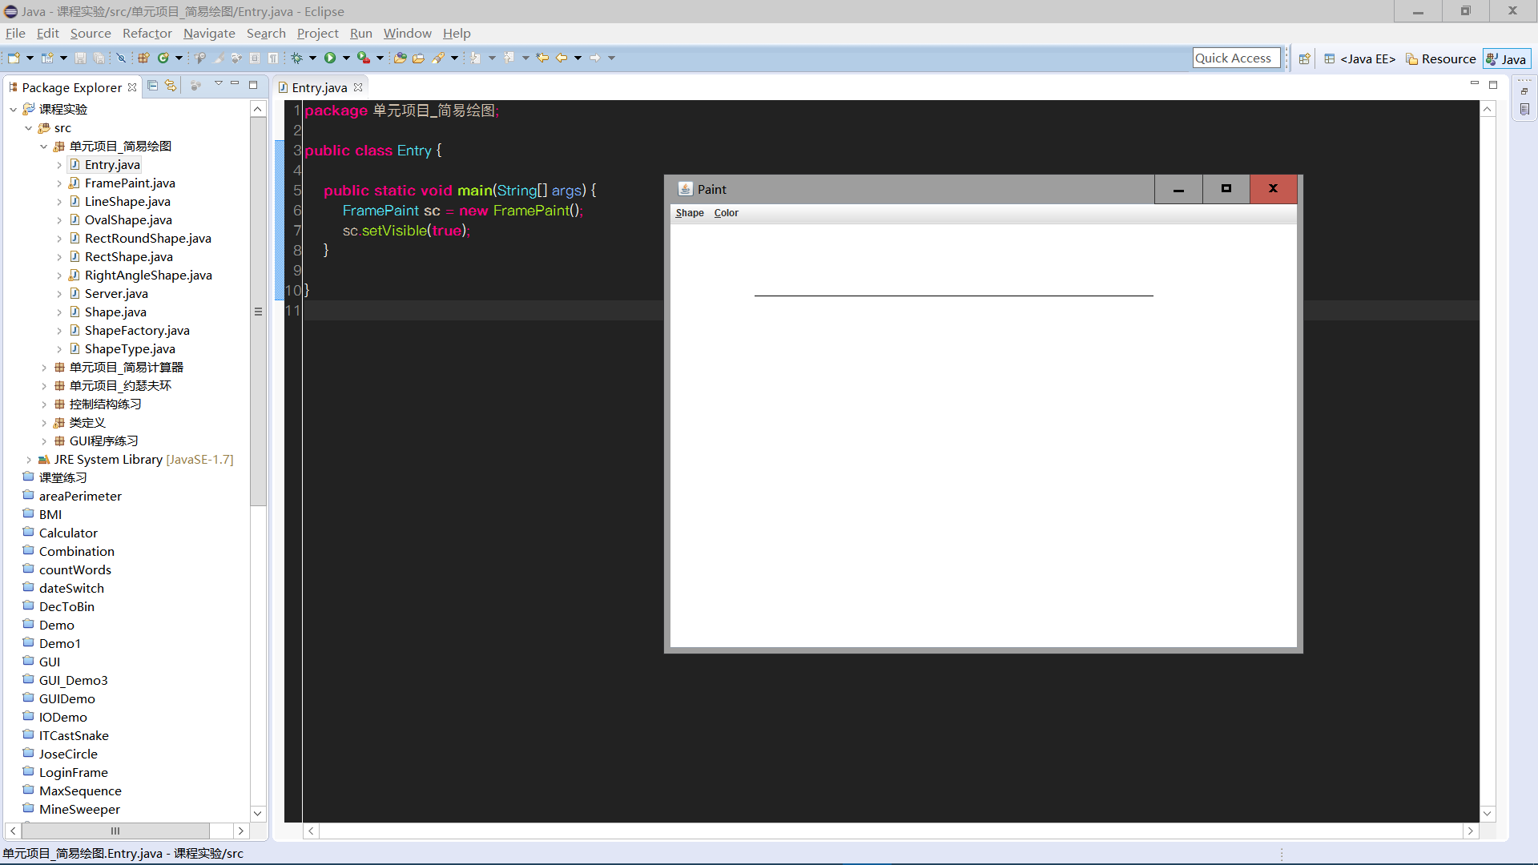
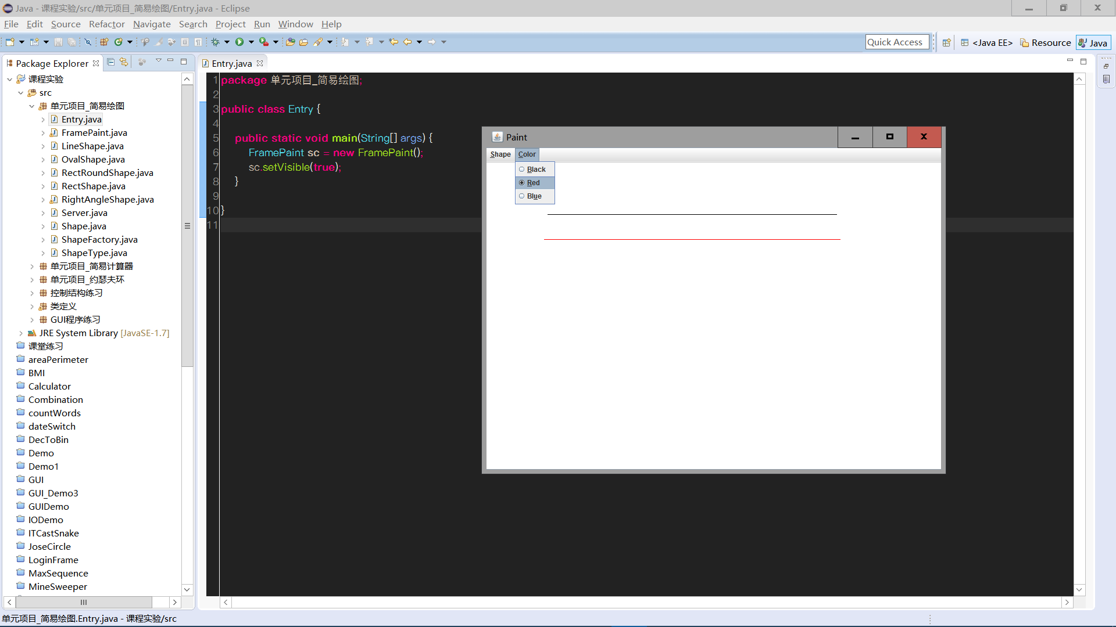
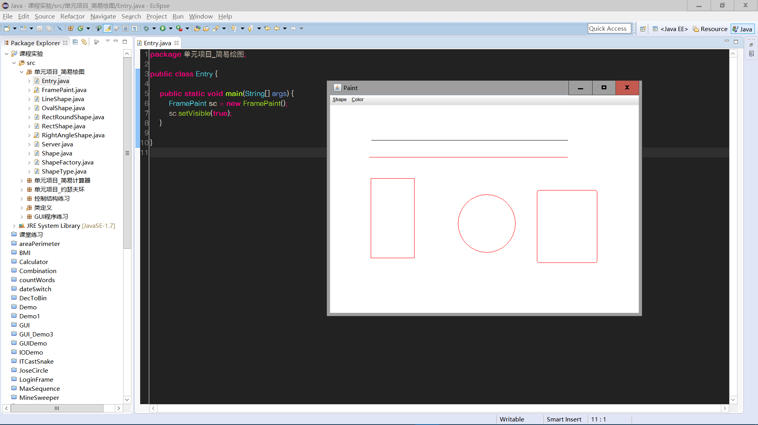

四、知识应用以及经验总结
1.百度学习MVC架构，并简述该架构的优势？
1、安全性。
2、便利性，任何分层都是为了更多人参与开发，更专业的分工，就像是生产汽车轮胎的和生产汽车发动机的工人分离，利于压缩成本。
3、可行性高。

代码查看:
- [Entry.java]
- [FramePaint.java]
- [LineShape]
- [RectRoundShape.java]
- [RectShape.java]
- [RightAngleShape.java]
- [Server.java]
- [Shape.java]
- [ShapeFactory.java]
- [ShapeType.java]

//[Entry.java]
package 单元项目_简易绘图;

public class Entry {

public static void main(String[] args) {
FramePaint sc = new FramePaint();
sc.setVisible(true);
}
}

//[FramePaint.java]

package 单元项目_简易绘图;
import java.awt.Color;
import java.awt.Graphics;
import java.awt.event.ActionEvent;
import java.awt.event.ActionListener;
import java.awt.event.MouseAdapter;
import java.awt.event.MouseEvent;

import javax.swing.ButtonGroup;
import javax.swing.JFrame;
import javax.swing.JMenu;
import javax.swing.JMenuBar;
import javax.swing.JMenuItem;
import javax.swing.JPanel;
import javax.swing.JRadioButtonMenuItem;

public class FramePaint extends JFrame{
private Server server = new Server();
private Canvas canvas = new Canvas();
private String type = "Rect";
private Color fore = Color.BLACK;
private class DrawHandler extends MouseAdapter{

@Override
public void mousePressed(MouseEvent e) {
if (e.getButton() == MouseEvent.BUTTON1) {
server.create(type);
server.setFore(fore);
server.setFirst(e.getPoint());

}
}

@Override
public void mouseReleased(MouseEvent e) {
if (e.getButton() == MouseEvent.BUTTON1) {
server.add();
}
}

@Override
public void mouseDragged(MouseEvent e) {
Graphics g = canvas.getGraphics();
server.clearCurrent(g);
server.setLast(e.getPoint());
server.drawCurrent(canvas.getGraphics());

server.drawAll(g);
}

}

public FramePaint(){
this.setContentPane( canvas);
this.setJMenuBar(createMenuBar());
this.setTitle("Paint");
this.setSize(800,600);
canvas.setBackground(Color.white);
this.setLocationRelativeTo(null);
this.setDefaultCloseOperation(EXIT_ON_CLOSE);

DrawHandler handler =new DrawHandler();
canvas.addMouseListener(handler);
canvas.addMouseMotionListener(handler);
}

private class Canvas extends JPanel{

/**
*
*/
private static final long serialVersionUID = 1L;

@Override
protected void paintComponent(Graphics g) {

super.paintComponent(g);
server.drawAll(g);
}

}

private class ShapeHandler implements ActionListener {

@Override
public void actionPerformed(ActionEvent e) {
JMenuItem item = (JMenuItem) e.getSource();
type = item.getText();
}

}

private class ColorHandler implements ActionListener {

@Override
public void actionPerformed(ActionEvent e) {
JMenuItem item = (JMenuItem) e.getSource();
int rgb = Integer.parseInt(item.getName());
fore = new Color(rgb);
}

}

private JMenuBar createMenuBar() {
JMenuBar bar = new JMenuBar();
JMenu mnShape = new JMenu("Shape");
mnShape.setMnemonic('s');

ButtonGroup sg = new ButtonGroup();
ShapeHandler sh = new ShapeHandler();
JRadioButtonMenuItem itemRect =new JRadioButtonMenuItem("Rect");
itemRect.setMnemonic('R');
itemRect.addActionListener(sh);
sg.add(itemRect);

JRadioButtonMenuItem itemOval = new JRadioButtonMenuItem("Oval");
itemOval.setMnemonic('o');
itemOval.addActionListener(sh);
sg.add(itemOval);

JRadioButtonMenuItem itemRound =new JRadioButtonMenuItem("RoundRect");
itemRound.setMnemonic('e');
itemRound.addActionListener(sh);
sg.add(itemRound);

JRadioButtonMenuItem itemRightAngle = new JRadioButtonMenuItem("RighrAngle");
itemRightAngle.setMnemonic('a');
itemRightAngle.addActionListener(sh);
sg.add(itemRightAngle);

JRadioButtonMenuItem itemLine = new JRadioButtonMenuItem("Line");
itemLine.setMnemonic('l');
itemLine.addActionListener(sh);
sg.add(itemLine);

mnShape.add(itemLine);
mnShape.add(itemRightAngle);
mnShape.add(itemRect);
mnShape.add(itemOval);
mnShape.add(itemRound);

JMenu mncolor = new JMenu("Color");
mncolor.setMnemonic('c');

ColorHandler ch = new ColorHandler();

JRadioButtonMenuItem itemBlack = new JRadioButtonMenuItem("Black");
itemBlack.setMnemonic('B');
itemBlack.setName(String.valueOf(Color.BLACK.getRGB()));
itemBlack.setSelected(true);
itemBlack.addActionListener(ch);
mncolor.add(itemBlack);

JRadioButtonMenuItem itemRed = new JRadioButtonMenuItem("Red");
itemRed.setMnemonic('R');
itemRed.setName(String.valueOf(Color.RED.getRGB()));
itemRed.addActionListener(ch);
mncolor.add(itemRed);

JRadioButtonMenuItem itemBlue = new JRadioButtonMenuItem("Blue");
itemBlue.setMnemonic('u');
itemBlue.setName(String.valueOf(Color.BLUE.getRGB()));
itemBlue.addActionListener(ch);
mncolor.add(itemBlue);

bar.add(mnShape);
bar.add(mncolor);
return bar;
}
}

//[LineShape.java]
package 单元项目_简易绘图;
import java.awt.Graphics;

public class LineShape extends Shape{

@Override
public void draw(Graphics g) {
g.setColor(getFore());
g.drawLine(getFirst().x, getFirst().y, getLast().x, getLast().y);

}

@Override
public void clear(Graphics g) {
g.setColor(getBack());
g.drawLine(getFirst().x, getFirst().y, getLast().x, getLast().y);

}
}

//[OvalShape.java]
package 单元项目_简易绘图;
import java.awt.Graphics;

public class OvalShape extends Shape{

@Override
public void draw(Graphics g) {
g.setColor(getFore());
g.drawOval(getLeftTop().x, getLeftTop().y, getWidth(), getHight());

}

@Override
public void clear(Graphics g) {
g.setColor(getBack());
g.drawOval(getLeftTop().x, getLeftTop().y, getWidth(), getHight());

}
}

//[RectRoundShape.java]
package 单元项目_简易绘图;
import java.awt.Graphics;

public class RectRoundShape extends Shape{

@Override
public void draw(Graphics g) {
g.setColor(getFore());
g.drawRoundRect(getLeftTop().x, getLeftTop().y, getWidth(), getHight(), 10, 10);
}

@Override
public void clear(Graphics g) {
g.setColor(getBack());
g.drawRoundRect(getLeftTop().x, getLeftTop().y, getWidth(), getHight(), 10, 10);
}

}

//[RectShape.java]
package 单元项目_简易绘图;
import java.awt.Graphics;
public class RectShape extends Shape{

@Override
public void draw(Graphics g) {
g.setColor(getFore());
g.drawRect(getLeftTop().x, getLeftTop().y, getWidth(), getHight());

}

@Override
public void clear(Graphics g) {
g.setColor(getBack());
g.drawRect(getLeftTop().x, getLeftTop().y, getWidth(), getHight());

}

}

//[RightAngleShape.java]

package 单元项目_简易绘图;
import java.awt.Graphics;
import java.awt.Point;

public class RightAngleShape extends Shape{

@Override
public void draw(Graphics g) {
g.setColor(getFore());
int[] xPoints = new int[3];
int[] yPoints = new int[3];
xPoints[0] = getLeftTop().x;
xPoints[1] = getLeftTop().x;
xPoints[2] = getLast().x;
yPoints[0] = getLeftTop().y;
yPoints[1] = getLast().y;
yPoints[2] = getLast().y;
g.drawPolygon(xPoints, yPoints, 3);
}

@Override
public void clear(Graphics g) {
g.setColor(getBack());
int[] xPoints = new int[3];
int[] yPoints = new int[3];
xPoints[0] = getLeftTop().x;
xPoints[1] = getLeftTop().x;
xPoints[2] = getLast().x;
yPoints[0] = getLeftTop().y;
yPoints[1] = getLast().y;
yPoints[2] = getLast().y;
g.drawPolygon(xPoints, yPoints, 3);
}

}

//[Server.java]
package 单元项目_简易绘图;
import java.awt.Color;
import java.awt.Graphics;
import java.awt.Point;
import java.util.ArrayList;

public class Server {
private ArrayList<Shape> list;
private Shape current;

public Server(){
list = new ArrayList<>();
}

public void create(String name) {
ShapeType type = ShapeType.valueOf(name);
current = ShapeFactory.create(type);
}

public void add(){
list.add(current);
}

public void drawAll(Graphics g){
for(Shape s : list)
s.draw(g);
}

public void drawCurrent(Graphics g) {
current.draw(g);
}

public void clearCurrent(Graphics g) {
if (current.getLast() != null)
current.clear(g);

}

public void setFirst(Point pt) {
current.setFirst(pt);
}
public void setLast(Point pt) {
current.setLast(pt);

}
public void setFore(Color c){
current.setFore(c);
}

}

//[Shape.java]
package 单元项目_简易绘图;
import java.awt.Color;
import java.awt.Graphics;
import java.awt.Point;

public abstract class Shape implements Cloneable {
private Point first;
private Point last;
private Color fore = Color.BLACK;
private Color back = Color.WHITE;

public abstract void draw(Graphics g);
public abstract void clear(Graphics g);

@Override
protected Object clone() throws CloneNotSupportedException {

return super.clone();
}
public int getWidth(){
return Math.abs(last.x - first.x);
}

public int getHight(){
return Math.abs(last.y - first.y);
}

public Point getLeftTop(){
int x = Math.min(first.x, last.x);
int y = Math.min(first.y, last.y);
return new Point(x, y);
}

public Point getFirst() {
return first;
}
public void setFirst(Point first) {
this.first = first;
}
public Point getLast() {
return last;
}
public void setLast(Point last) {
this.last = last;
}

public Color getFore() {
return fore;
}
public void setFore(Color fore) {
this.fore = fore;
}
public Color getBack() {
return back;
}
public void setBack(Color back) {
this.back = back;
}

}

//[ShapeFactory.java]
package 单元项目_简易绘图;

public class ShapeFactory {
private static Shape[] shapes;

static{ //静态构造方法，静态初始化块
shapes = new Shape[5];
int i = 0;
shapes[i++] = new RectShape();
shapes[i++] = new OvalShape();
shapes[i++] = new RectRoundShape();
shapes[i++] = new RightAngleShape();
shapes[i++] = new LineShape();

}

public static Shape create(ShapeType t) {
Shape ret = null;
try {
ret = (Shape)(shapes[t.ordinal()].clone());
} catch (Exception e) {}
return ret;

}
}

//[ShapeType.java]

package 单元项目_简易绘图;

public enum ShapeType {
Rect,
Oval,
RoundRect,
RightAngle,
Line

}

