计算机科学与技术系
实验（项目）报告

一、基本信息
实验（项目）名称 | 字符串练习
课程名称 | Java程序设计 | 学生层次 | 本科
学生专业 | 信息工程 | 学生年级 | 2015级
学生班级 | 信息工程15202 | 学生学号 | 15310920208
学生姓名 | 何宽 | 完成日期 | 2016年12月24日
指导教师 | 贺敏 | 报告成绩
二、目的与要求
目的：
学会并在实际编程过程中熟练应用字符串及正则表达式。
要求：
1.理解字符串的不变性，掌握字符串的常用方法；
2.掌握字符串生成器StringBuilder的使用；
3.掌握正则表达式的基本规则，并能在Java中应用。
三、完成实验（项目）过程和效果
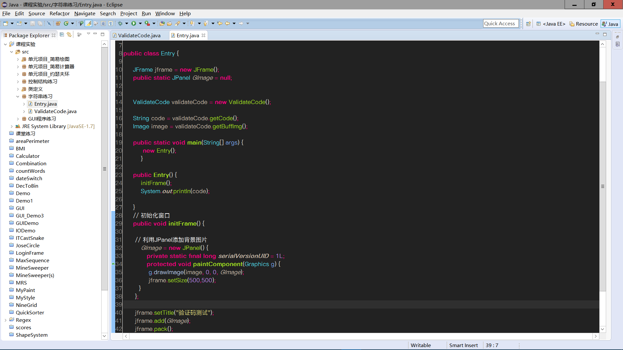

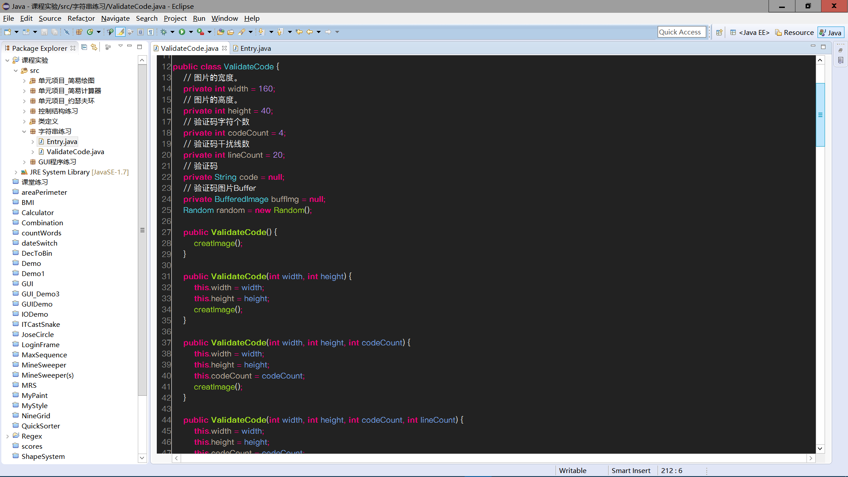

运行效果(最终验证码不区分大小写):
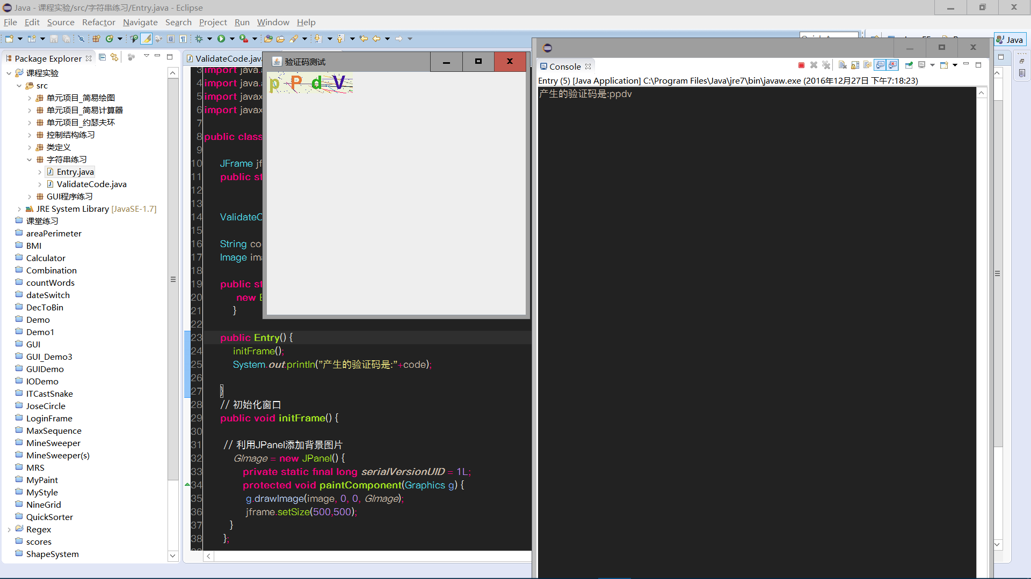

正则表达式:
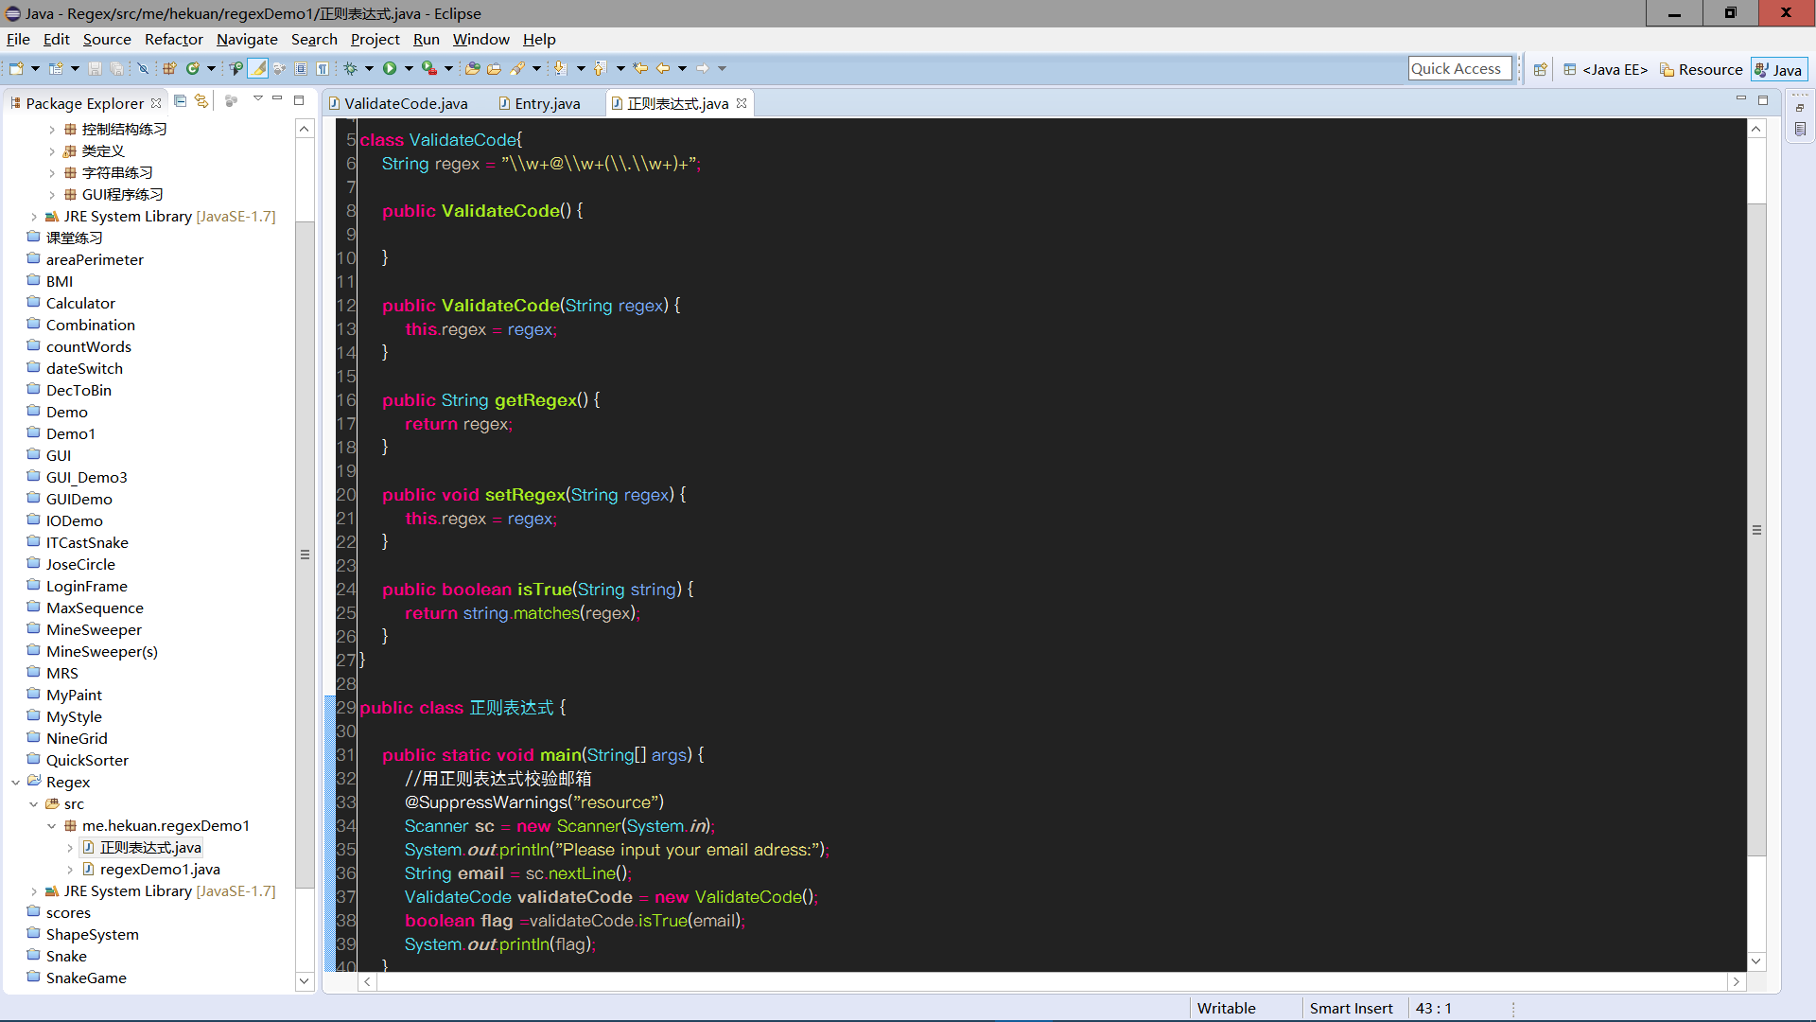

运行效果:

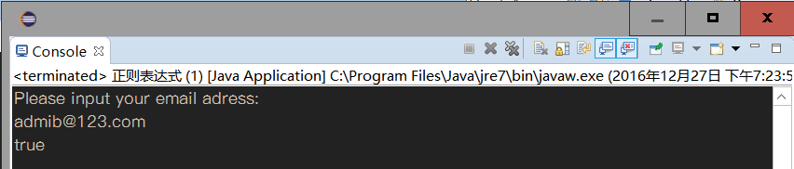
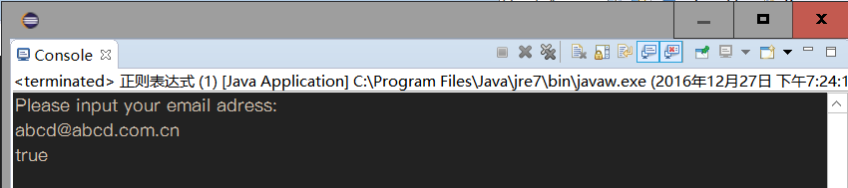
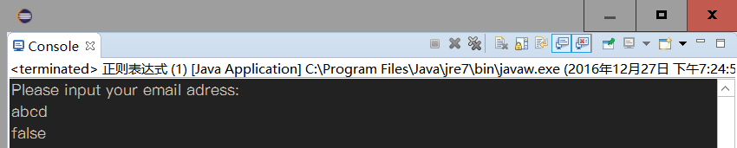
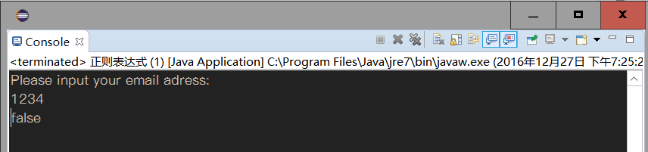
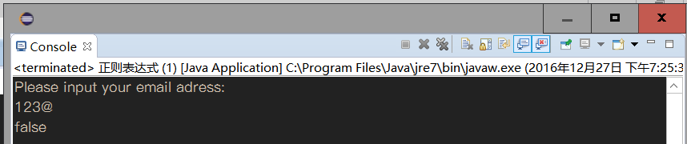

四、知识应用以及经验总结
1.列举正则表达式的常用元素。
. 匹配除换行符以外的任意字符
\w 匹配字母或数字或下划线或汉字
\s 匹配任意的空白符
\d 匹配数字
\b 匹配单词的开始或结束
^ 匹配字符串的开始
$ 匹配字符串的结束

代码:
- [正则表达式.java]

验证码程序:
- [Entry.java]
- [ValidateCode.java]

//[正则表达式.java]
package me.hekuan.regexDemo1;

import java.util.Scanner;

class ValidateCode{
String regex = "\\w+@\\w+(\\.\\w+)+";

public ValidateCode() {

}

public ValidateCode(String regex) {
this.regex = regex;
}

public String getRegex() {
return regex;
}

public void setRegex(String regex) {
this.regex = regex;
}

public boolean isTrue(String string) {
return string.matches(regex);
}
}

public class 正则表达式 {

public static void main(String[] args) {
//用正则表达式校验邮箱
@SuppressWarnings("resource")
Scanner sc = new Scanner(System.in);
System.out.println("Please input your email adress:");
String email = sc.nextLine();
ValidateCode validateCode = new ValidateCode();
boolean flag =validateCode.isTrue(email);
System.out.println(flag);
}

}

//[Entry.java]
package 字符串练习;

import java.awt.Graphics;
import java.awt.Image;
import javax.swing.JFrame;
import javax.swing.JPanel;

public class Entry {

JFrame jframe = new JFrame();
public static JPanel GImage = null;

ValidateCode validateCode = new ValidateCode();

String code = validateCode.getCode();
Image image = validateCode.getBuffImg();

public static void main(String[] args) {
new Entry();
}

public Entry() {
initFrame();
System.out.println("产生的验证码是:"+code);

}
// 初始化窗口
public void initFrame() {

// 利用JPanel添加背景图片
GImage = new JPanel() {
private static final long serialVersionUID = 1L;
protected void paintComponent(Graphics g) {
g.drawImage(image, 0, 0, GImage);
jframe.setSize(500,500);
}
};

jframe.setTitle("验证码测试");
jframe.add(GImage);
jframe.pack();
jframe.setVisible(true);
jframe.setDefaultCloseOperation(JFrame.EXIT_ON_CLOSE);

}
}

//[ValidateCode.java]

package 字符串练习;
import java.awt.Color;
import java.awt.Font;
import java.awt.Graphics;
import java.awt.image.BufferedImage;
import java.io.IOException;
import java.io.OutputStream;
import java.util.Random;

import javax.imageio.ImageIO;

public class ValidateCode {
// 图片的宽度。
private int width = 160;
// 图片的高度。
private int height = 40;
// 验证码字符个数
private int codeCount = 4;
// 验证码干扰线数
private int lineCount = 20;
// 验证码
private String code = null;
// 验证码图片Buffer
private BufferedImage buffImg = null;
Random random = new Random();

public ValidateCode() {
creatImage();
}

public ValidateCode(int width, int height) {
this.width = width;
this.height = height;
creatImage();
}

public ValidateCode(int width, int height, int codeCount) {
this.width = width;
this.height = height;
this.codeCount = codeCount;
creatImage();
}

public ValidateCode(int width, int height, int codeCount, int lineCount) {
this.width = width;
this.height = height;
this.codeCount = codeCount;
this.lineCount = lineCount;
creatImage();
}

// 生成图片
private void creatImage() {
int fontWidth = width / codeCount;// 字体的宽度
int fontHeight = height - 5;// 字体的高度
int codeY = height - 8;

// 图像buffer
buffImg = new BufferedImage(width, height, BufferedImage.TYPE_INT_RGB);
Graphics g = buffImg.getGraphics();
//Graphics2D g = buffImg.createGraphics();
// 设置背景色
g.setColor(getRandColor(200, 250));
g.fillRect(0, 0, width, height);

// 设置字体
//Font font1 = getFont(fontHeight);
Font font = new Font("Fixedsys", Font.BOLD, fontHeight);
g.setFont(font);

// 设置干扰线
for (int i = 0; i < lineCount; i++) {
int xs = random.nextInt(width);
int ys = random.nextInt(height);
int xe = xs + random.nextInt(width);
int ye = ys + random.nextInt(height);
g.setColor(getRandColor(1, 255));
g.drawLine(xs, ys, xe, ye);
}

// 添加噪点
float yawpRate = 0.01f;// 噪声率
int area = (int) (yawpRate * width * height);
for (int i = 0; i < area; i++) {
int x = random.nextInt(width);
int y = random.nextInt(height);

buffImg.setRGB(x, y, random.nextInt(255));
}

String str1 = randomStr(codeCount);// 得到随机字符
this.code = str1;
for (int i = 0; i < codeCount; i++) {
String strRand = str1.substring(i, i + 1);
g.setColor(getRandColor(1, 255));
// g.drawString(a,x,y);
// a为要画出来的东西，x和y表示要画的东西最左侧字符的基线位于此图形上下文坐标系的 (x, y) 位置处

g.drawString(strRand, i*fontWidth+3, codeY);
}

}

// 得到随机字符
private String randomStr(int n) {
String str1 = "ABCDEFGHIJKLMNOPQRSTUVWXYZabcdefghijklmnopqrstuvwxyz1234567890";
String str2 = "";
int len = str1.length() - 1;
double r;
for (int i = 0; i < n; i++) {
r = (Math.random()) * len;
str2 = str2 + str1.charAt((int) r);
}
return str2;
}

// 得到随机颜色
private Color getRandColor(int fc, int bc) {// 给定范围获得随机颜色
if (fc > 255)
fc = 255;
if (bc > 255)
bc = 255;
int r = fc + random.nextInt(bc - fc);
int g = fc + random.nextInt(bc - fc);
int b = fc + random.nextInt(bc - fc);
return new Color(r, g, b);
}

/**
* 产生随机字体
*/
@SuppressWarnings("unused")
private Font getFont(int size) {
Random random = new Random();
Font font[] = new Font[5];
font[0] = new Font("Ravie", Font.PLAIN, size);
font[1] = new Font("Antique Olive Compact", Font.PLAIN, size);
font[2] = new Font("Fixedsys", Font.PLAIN, size);
font[3] = new Font("Wide Latin", Font.PLAIN, size);
font[4] = new Font("Gill Sans Ultra Bold", Font.PLAIN, size);
return font[random.nextInt(5)];
}

// 扭曲方法
@SuppressWarnings("unused")
private void shear(Graphics g, int w1, int h1, Color color) {
shearX(g, w1, h1, color);
shearY(g, w1, h1, color);
}

private void shearX(Graphics g, int w1, int h1, Color color) {

int period = random.nextInt(2);

boolean borderGap = true;
int frames = 1;
int phase = random.nextInt(2);

for (int i = 0; i < h1; i++) {
double d = (double) (period >> 1)
* Math.sin((double) i / (double) period
+ (6.2831853071795862D * (double) phase)
/ (double) frames);
g.copyArea(0, i, w1, 1, (int) d, 0);
if (borderGap) {
g.setColor(color);
g.drawLine((int) d, i, 0, i);
g.drawLine((int) d + w1, i, w1, i);
}
}

}

private void shearY(Graphics g, int w1, int h1, Color color) {

int period = random.nextInt(40) + 10; // 50;

boolean borderGap = true;
int frames = 20;
int phase = 7;
for (int i = 0; i < w1; i++) {
double d = (double) (period >> 1)
* Math.sin((double) i / (double) period
+ (6.2831853071795862D * (double) phase)
/ (double) frames);
g.copyArea(i, 0, 1, h1, 0, (int) d);
if (borderGap) {
g.setColor(color);
g.drawLine(i, (int) d, i, 0);
g.drawLine(i, (int) d + h1, i, h1);
}

}

}

public void write(OutputStream sos) throws IOException {
ImageIO.write(buffImg, "png", sos);
sos.close();
}

public BufferedImage getBuffImg() {
return buffImg;
}

public String getCode() {
return code.toLowerCase();
}

}

