计算机科学与技术系
实验（项目）报告

一、基本信息
实验（项目）名称 | 多线程文件复制
课程名称 | Java程序设计 | 学生层次 | 本科
学生专业 | 信息工程 | 学生年级 | 2015级
学生班级 | 信息工程15202 | 学生学号 | 15310920208
学生姓名 | 何宽 | 完成日期 | 2016年12月24日
指导教师 | 贺敏 | 报告成绩
二、目的与要求
目的：
通过制作文件复制小工具，练习使用JavaIO技术、多线程技术等。
要求：
1.理解多线程的机制，学会使用SwingWorker类；
2.掌握Java文件读写，学会字节流的读写技术；
3.掌握GUI程序的基本技术。
三、完成实验（项目）过程和效果
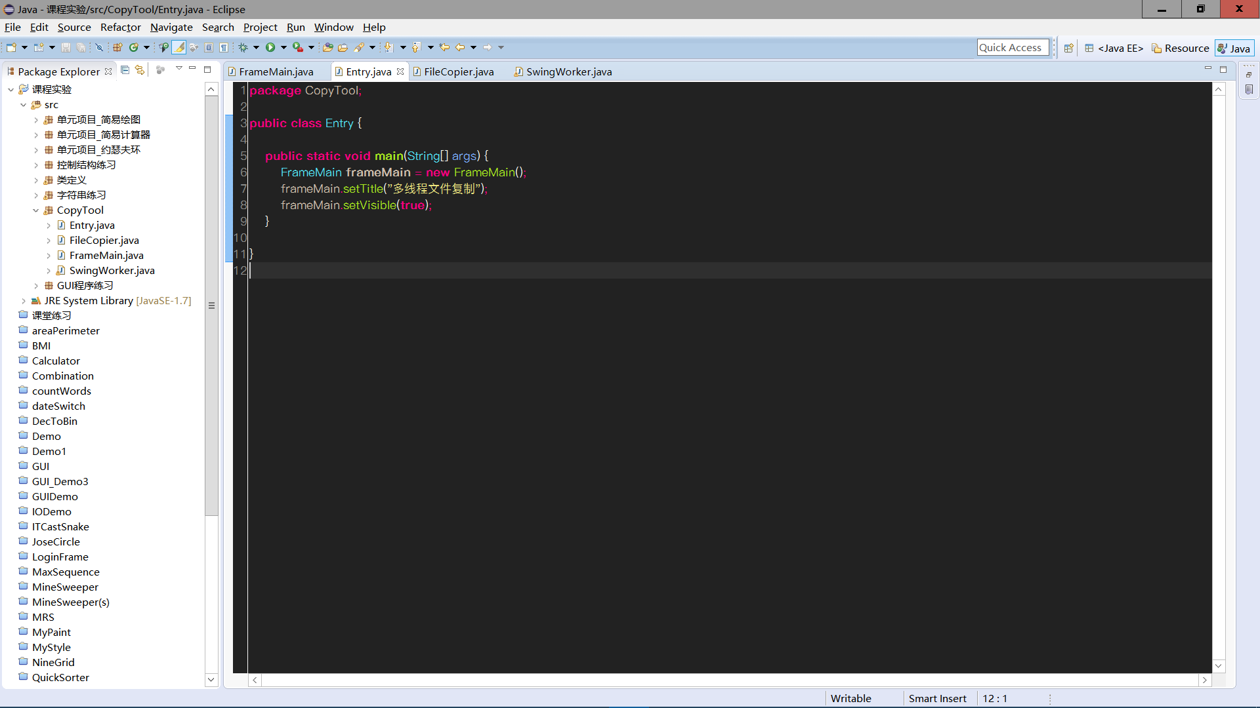
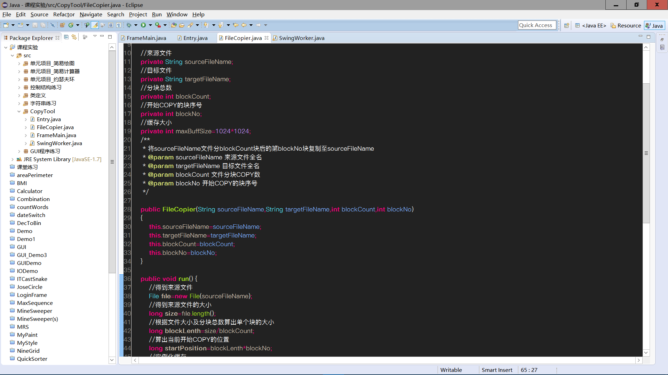
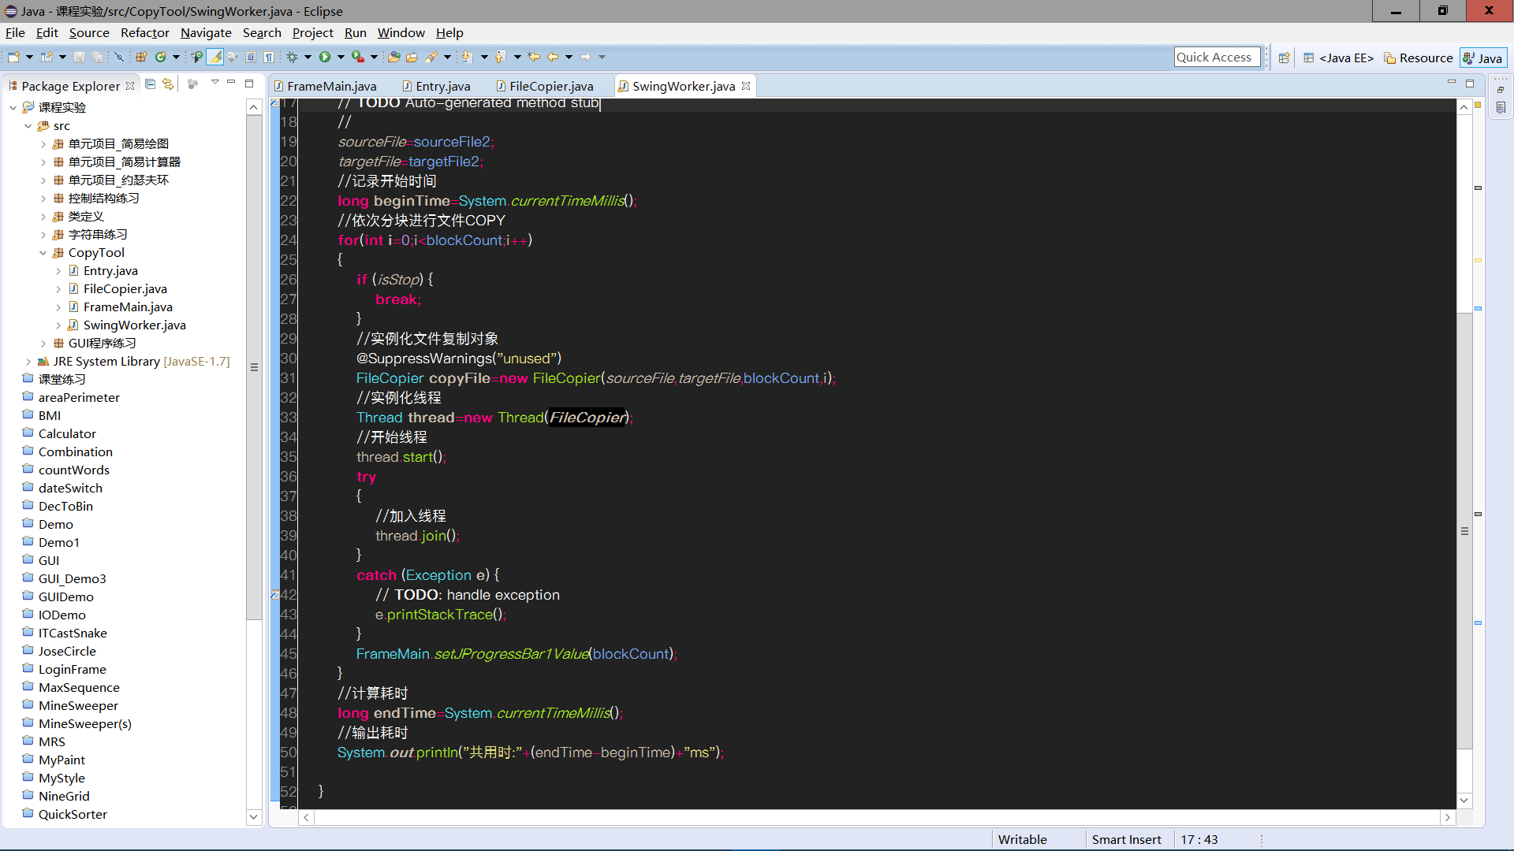
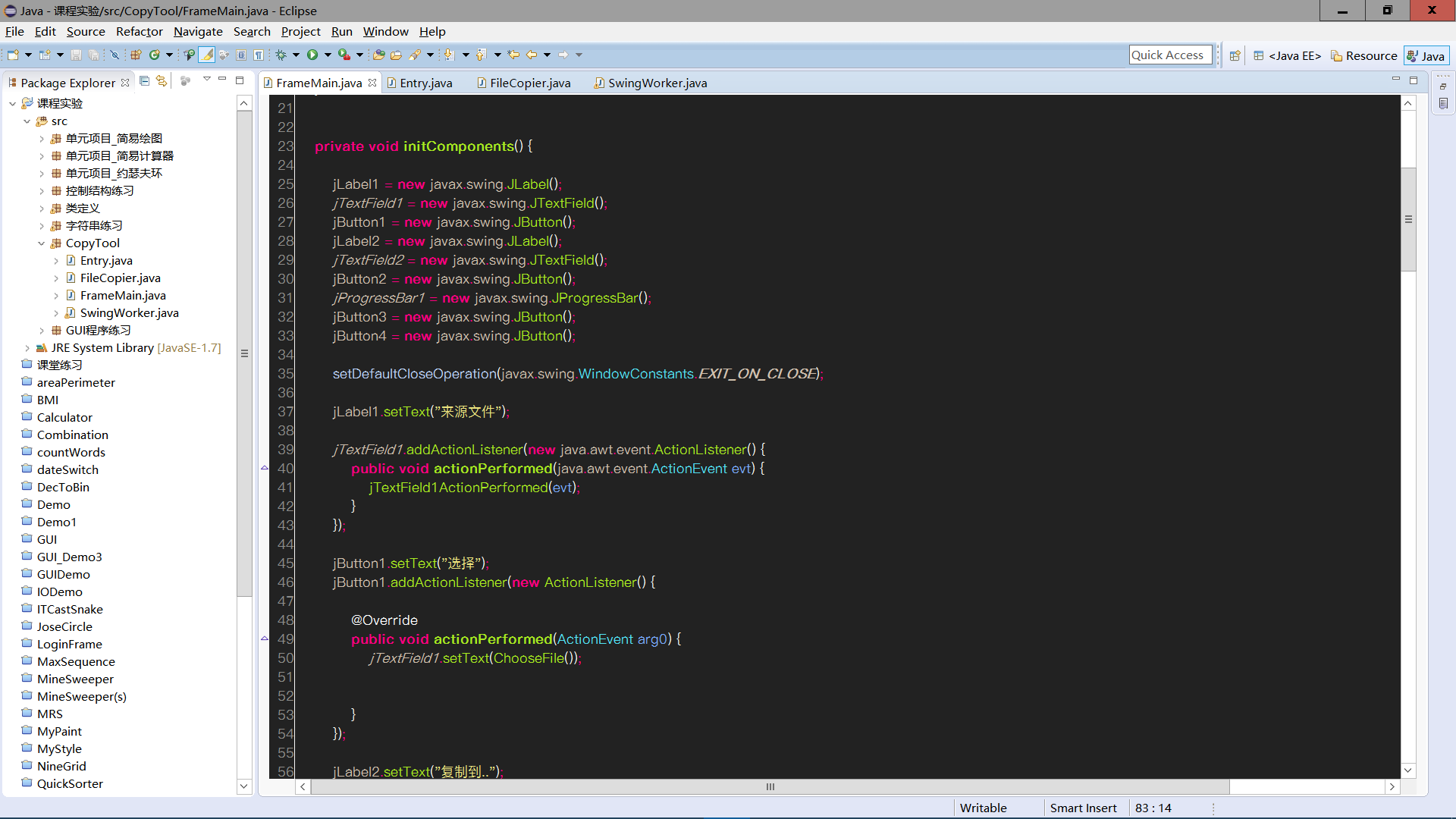

运行效果:
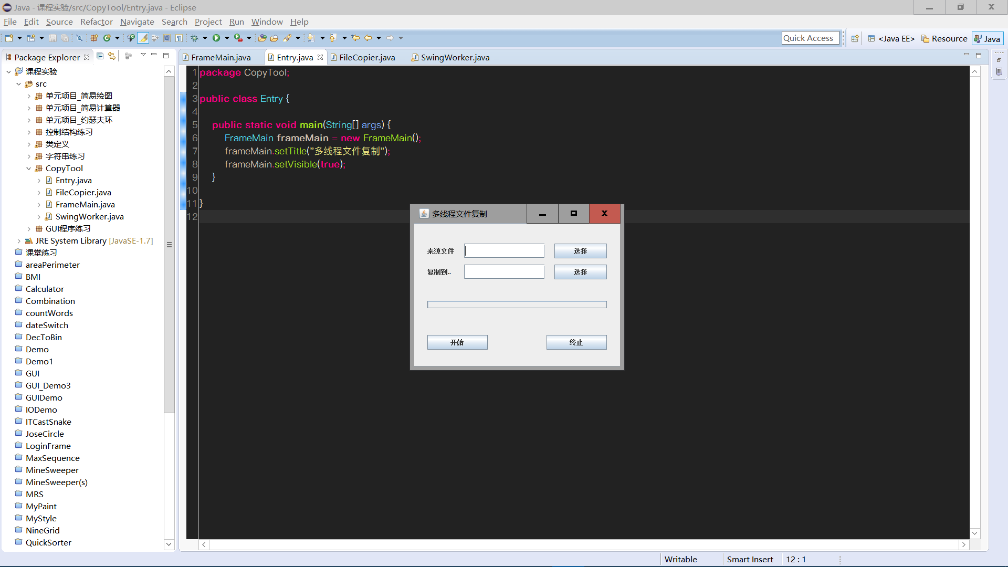
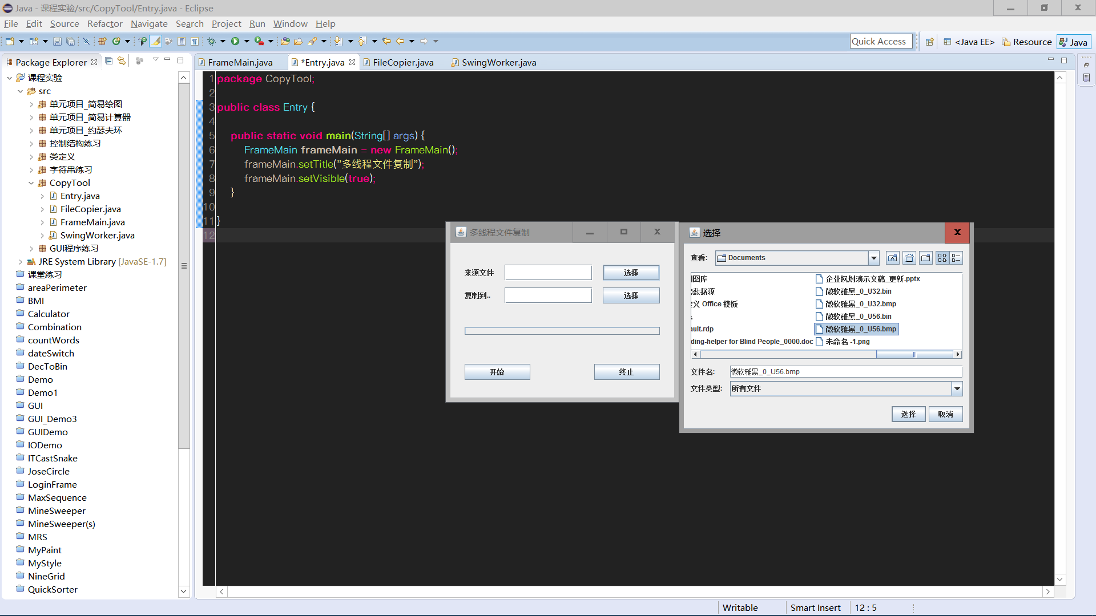
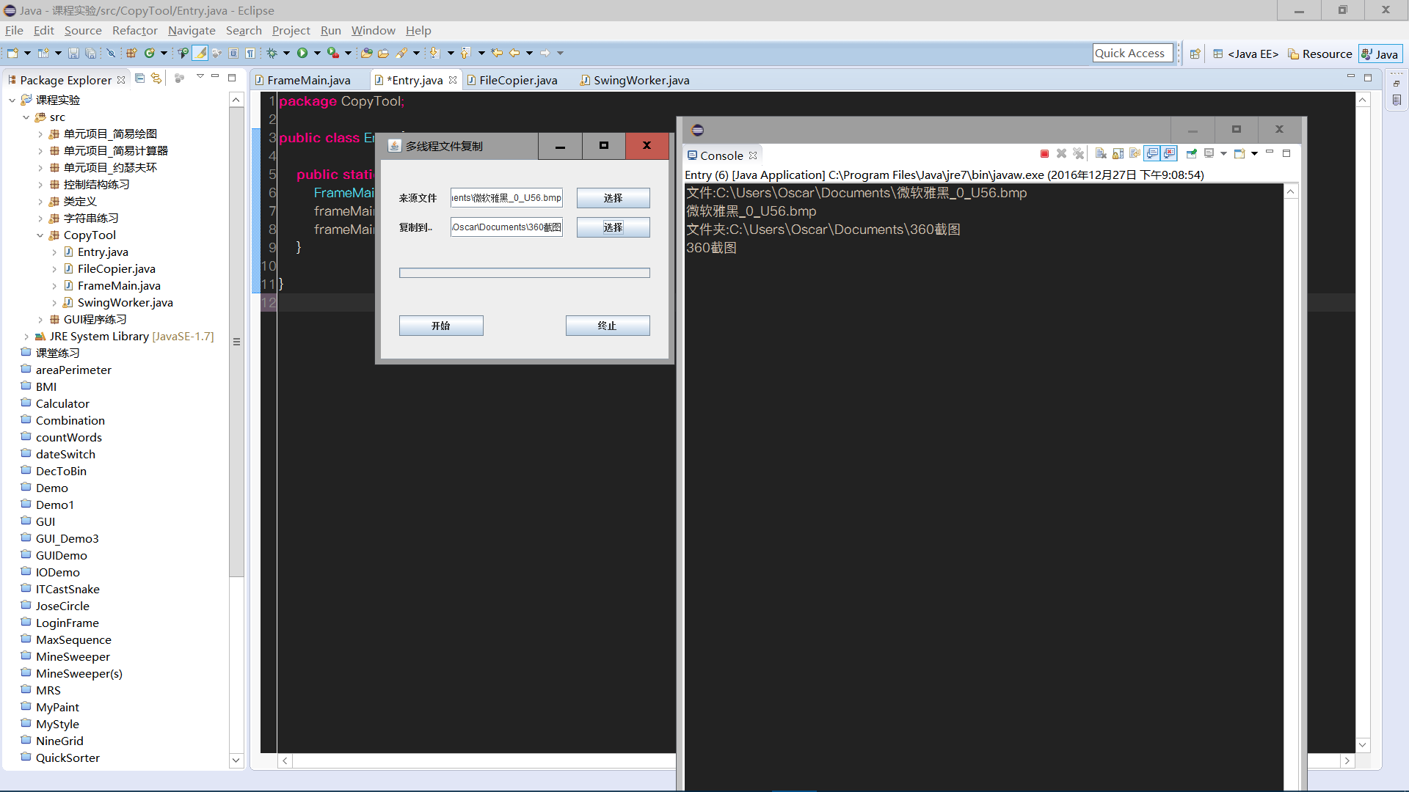
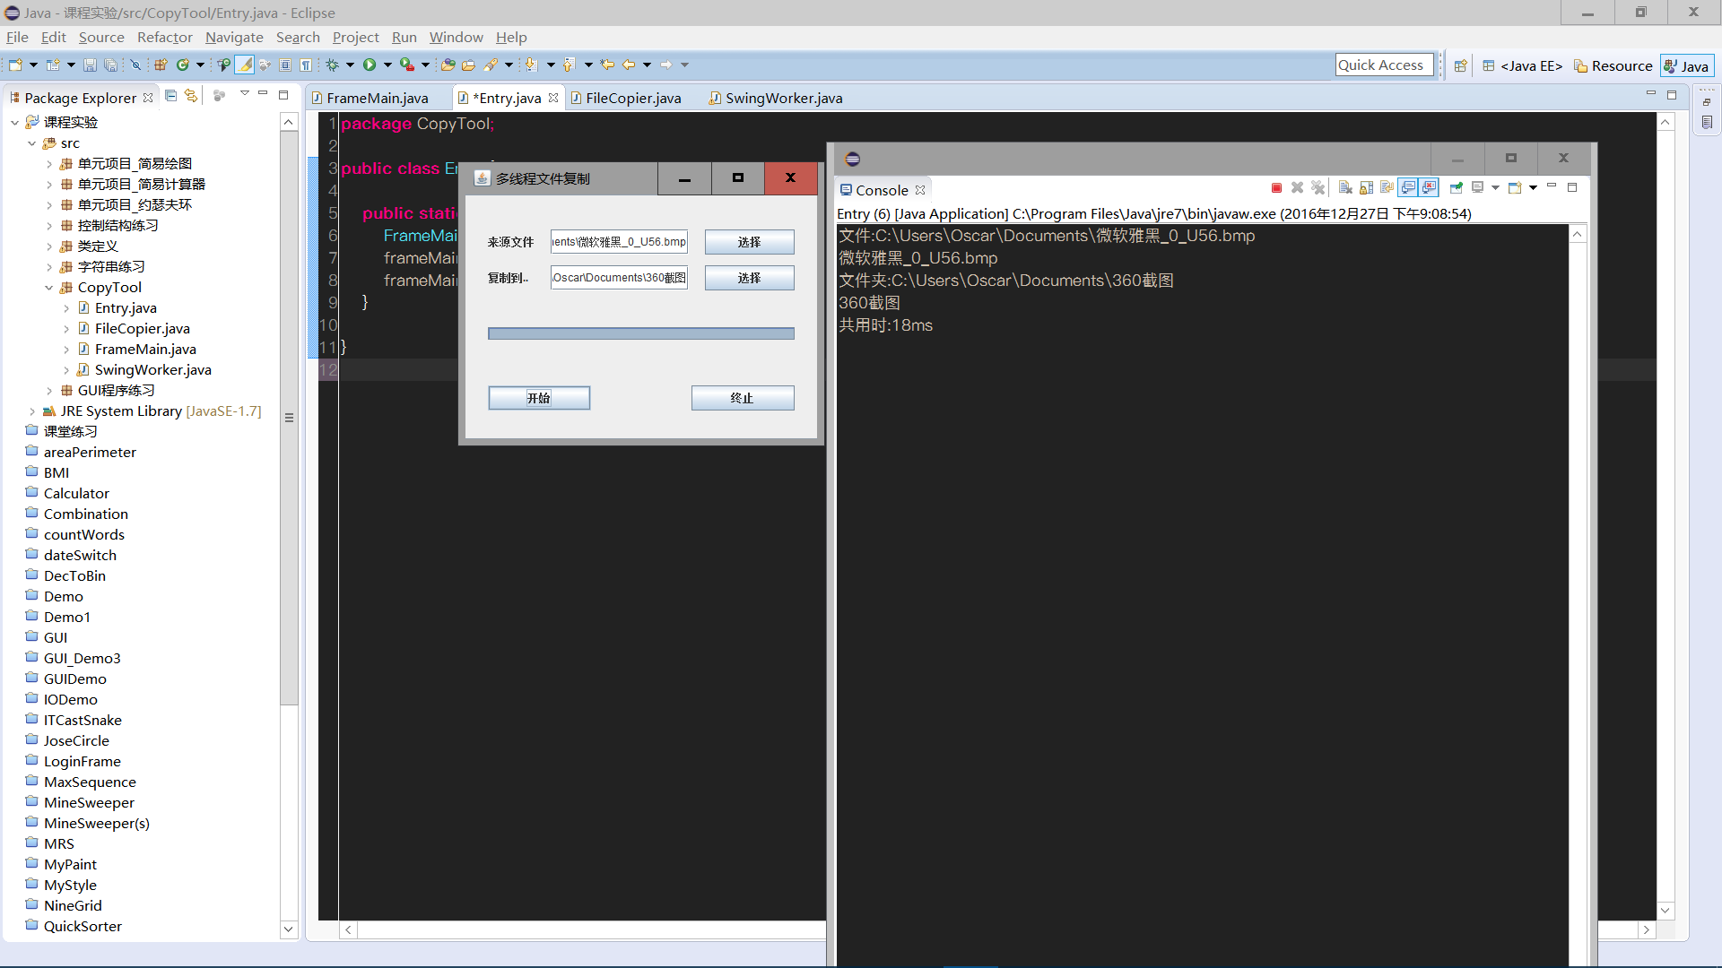

四、知识应用以及经验总结
多线程就是多个指令序列同时执行，能同时占有多个CPU核心，提高整体运算速度。
不过不建议用多线程复制，多个线程同时访问同一个物理设备，同时只有一个线程能获得这个设备的控制权，其他线程都在等待。因此文件复制的瓶颈在disk i/o，不在CPU，多线程不能提高disk i/o的性能，反而有可能增加磁盘的寻道时间。

代码:
- [Entry.java]
- [FileCopier.java]
- [SwingWorker.java]
- [FrameMain.java]

//[Entry.java]

package CopyTool;

public class Entry {

public static void main(String[] args) {
FrameMain frameMain = new FrameMain();
frameMain.setTitle("多线程文件复制");
frameMain.setVisible(true);
}

}

//[FileCopier.java]
package CopyTool;

import java.io.File;
import java.io.FileInputStream;
import java.io.InputStream;
import java.io.RandomAccessFile;

public class FileCopier {

//来源文件
private String sourceFileName;
//目标文件
private String targetFileName;
//分块总数
private int blockCount;
//开始COPY的块序号
private int blockNo;
//缓存大小
private int maxBuffSize=1024*1024;
/**
* 将sourceFileName文件分blockCount块后的第blockNo块复制至sourceFileName
* @param sourceFileName 来源文件全名
* @param targetFileName 目标文件全名
* @param blockCount 文件分块COPY数
* @param blockNo 开始COPY的块序号
*/

public FileCopier(String sourceFileName,String targetFileName,int blockCount,int blockNo)
{
this.sourceFileName=sourceFileName;
this.targetFileName=targetFileName;
this.blockCount=blockCount;
this.blockNo=blockNo;
}

public void run() {
//得到来源文件
File file=new File(sourceFileName);
//得到来源文件的大小
long size=file.length();
//根据文件大小及分块总数算出单个块的大小
long blockLenth=size/blockCount;
//算出当前开始COPY的位置
long startPosition=blockLenth*blockNo;
//实例化缓存
byte[] buff=new byte[maxBuffSize];
try{
//从源文件得到输入流
InputStream inputStream=new FileInputStream(sourceFileName);
//得到目标文件的随机访问对象
RandomAccessFile raf=new RandomAccessFile(targetFileName,"rw");
//将目标文件的指针偏移至开始位置
raf.seek(startPosition);
//当前读取的字节数
int curRedLength;
//累计读取字节数的和
int totalRedLength=0;
//将来源文件的指针偏移至开始位置
inputStream.skip(startPosition);
//依次分块读取文件
while((curRedLength=inputStream.read(buff))>0 && totalRedLength<blockLenth)
{
//将缓存中的字节写入文件?目标文件中
raf.write(buff, 0, curRedLength);
//累计读取的字节数
totalRedLength+=curRedLength;
}
//关闭相关资源
raf.close();
inputStream.close();
}catch(Exception ex)
{
ex.printStackTrace();
}
}
}

//[SwingWorker.java]
package CopyTool;

public class SwingWorker {

public static boolean isStop = false;

private static final Runnable FileCopier = null;
//来源文件
private static String sourceFile;
//目标文件
private static String targetFile;
//分块数
private static int blockCount;

public static void start(String sourceFile2, String targetFile2, int blockCount) {
// TODO Auto-generated method stub
//
sourceFile=sourceFile2;
targetFile=targetFile2;
//记录开始时间
long beginTime=System.currentTimeMillis();
//依次分块进行文件COPY
for(int i=0;i<blockCount;i++)
{
if (isStop) {
break;
}
//实例化文件复制对象
@SuppressWarnings("unused")
FileCopier copyFile=new FileCopier(sourceFile,targetFile,blockCount,i);
//实例化线程
Thread thread=new Thread(FileCopier);
//开始线程
thread.start();
try
{
//加入线程
thread.join();
}
catch (Exception e) {
// TODO: handle exception
e.printStackTrace();
}
FrameMain.setJProgressBar1Value(blockCount);
}
//计算耗时
long endTime=System.currentTimeMillis();
//输出耗时
System.out.println("共用时:"+(endTime-beginTime)+"ms");

}

}

//[FrameMain.java]

package CopyTool;

import java.awt.event.ActionEvent;
import java.awt.event.ActionListener;
import java.io.File;
import javax.swing.JFileChooser;
import javax.swing.JLabel;

/**
*
* @author Oscar
*/
public class FrameMain extends javax.swing.JFrame {
private static final long serialVersionUID = 1L;
/**
* Creates new form FrameMain
*/
public FrameMain() {
initComponents();
}

private void initComponents() {

jLabel1 = new javax.swing.JLabel();
jTextField1 = new javax.swing.JTextField();
jButton1 = new javax.swing.JButton();
jLabel2 = new javax.swing.JLabel();
jTextField2 = new javax.swing.JTextField();
jButton2 = new javax.swing.JButton();
jProgressBar1 = new javax.swing.JProgressBar();
jButton3 = new javax.swing.JButton();
jButton4 = new javax.swing.JButton();

setDefaultCloseOperation(javax.swing.WindowConstants.EXIT_ON_CLOSE);

jLabel1.setText("来源文件");

jTextField1.addActionListener(new java.awt.event.ActionListener() {
public void actionPerformed(java.awt.event.ActionEvent evt) {
jTextField1ActionPerformed(evt);
}
});

jButton1.setText("选择");
jButton1.addActionListener(new ActionListener() {

@Override
public void actionPerformed(ActionEvent arg0) {
jTextField1.setText(ChooseFile());

}
});

jLabel2.setText("复制到..");

jTextField2.addActionListener(new java.awt.event.ActionListener() {
public void actionPerformed(java.awt.event.ActionEvent evt) {
jTextField2ActionPerformed(evt);
}
});

jButton2.setText("选择");
jButton2.addActionListener(new ActionListener() {

@Override
public void actionPerformed(ActionEvent e) {
jTextField2.setText(ChooseFile());

}
});

jButton3.setText("开始");
jButton3.addActionListener(new ActionListener() {

@Override
public void actionPerformed(ActionEvent e) {
@SuppressWarnings("unused")
SwingWorker swingWorker = new SwingWorker();
SwingWorker.start(getSourceFile(),getTargetFile(),100);

}
});

jButton4.setText("终止");

jProgressBar1.setMinimum(0);
jProgressBar1.setMaximum(100);

javax.swing.GroupLayout layout = new javax.swing.GroupLayout(getContentPane());
getContentPane().setLayout(layout);
layout.setHorizontalGroup(
layout.createParallelGroup(javax.swing.GroupLayout.Alignment.LEADING)
.addGroup(layout.createSequentialGroup()
.addGap(25, 25, 25)
.addGroup(layout.createParallelGroup(javax.swing.GroupLayout.Alignment.LEADING)
.addGroup(layout.createSequentialGroup()
.addComponent(jButton3, javax.swing.GroupLayout.PREFERRED_SIZE, 115, javax.swing.GroupLayout.PREFERRED_SIZE)
.addPreferredGap(javax.swing.LayoutStyle.ComponentPlacement.RELATED, javax.swing.GroupLayout.DEFAULT_SIZE, Short.MAX_VALUE)
.addComponent(jButton4))
.addComponent(jProgressBar1, javax.swing.GroupLayout.Alignment.TRAILING, javax.swing.GroupLayout.DEFAULT_SIZE, javax.swing.GroupLayout.DEFAULT_SIZE, Short.MAX_VALUE)
.addGroup(javax.swing.GroupLayout.Alignment.TRAILING, layout.createSequentialGroup()
.addGap(0, 0, Short.MAX_VALUE)
.addGroup(layout.createParallelGroup(javax.swing.GroupLayout.Alignment.LEADING)
.addComponent(jLabel1)
.addComponent(jLabel2))
.addGap(18, 18, 18)
.addGroup(layout.createParallelGroup(javax.swing.GroupLayout.Alignment.CENTER)
.addComponent(jTextField1, javax.swing.GroupLayout.PREFERRED_SIZE, 154, javax.swing.GroupLayout.PREFERRED_SIZE)
.addComponent(jTextField2, javax.swing.GroupLayout.PREFERRED_SIZE, 153, javax.swing.GroupLayout.PREFERRED_SIZE))
.addGap(18, 18, 18)
.addGroup(layout.createParallelGroup(javax.swing.GroupLayout.Alignment.LEADING)
.addComponent(jButton1, javax.swing.GroupLayout.PREFERRED_SIZE, 100, javax.swing.GroupLayout.PREFERRED_SIZE)
.addComponent(jButton2, javax.swing.GroupLayout.PREFERRED_SIZE, 100, javax.swing.GroupLayout.PREFERRED_SIZE))))
.addGap(25, 25, 25))
);

layout.linkSize(javax.swing.SwingConstants.HORIZONTAL, new java.awt.Component[] {jTextField1, jTextField2});

layout.linkSize(javax.swing.SwingConstants.HORIZONTAL, new java.awt.Component[] {jButton3, jButton4});

layout.setVerticalGroup(
layout.createParallelGroup(javax.swing.GroupLayout.Alignment.LEADING)
.addGroup(layout.createSequentialGroup()
.addGap(38, 38, 38)
.addGroup(layout.createParallelGroup(javax.swing.GroupLayout.Alignment.LEADING)
.addComponent(jButton1)
.addGroup(layout.createParallelGroup(javax.swing.GroupLayout.Alignment.BASELINE)
.addComponent(jLabel1)
.addComponent(jTextField1, javax.swing.GroupLayout.PREFERRED_SIZE, javax.swing.GroupLayout.DEFAULT_SIZE, javax.swing.GroupLayout.PREFERRED_SIZE)))
.addPreferredGap(javax.swing.LayoutStyle.ComponentPlacement.UNRELATED)
.addGroup(layout.createParallelGroup(javax.swing.GroupLayout.Alignment.BASELINE)
.addComponent(jLabel2)
.addComponent(jTextField2, javax.swing.GroupLayout.PREFERRED_SIZE, javax.swing.GroupLayout.DEFAULT_SIZE, javax.swing.GroupLayout.PREFERRED_SIZE)
.addComponent(jButton2))
.addGap(41, 41, 41)
.addComponent(jProgressBar1, javax.swing.GroupLayout.PREFERRED_SIZE, javax.swing.GroupLayout.DEFAULT_SIZE, javax.swing.GroupLayout.PREFERRED_SIZE)
.addGap(51, 51, 51)
.addGroup(layout.createParallelGroup(javax.swing.GroupLayout.Alignment.BASELINE)
.addComponent(jButton3)
.addComponent(jButton4))
.addContainerGap(31, Short.MAX_VALUE))
);

layout.linkSize(javax.swing.SwingConstants.VERTICAL, new java.awt.Component[] {jButton1, jLabel1, jTextField1, jTextField2});

pack();
}// </editor-fold>

private void jTextField1ActionPerformed(java.awt.event.ActionEvent evt) {

}

private void jTextField2ActionPerformed(java.awt.event.ActionEvent evt) {

}

public String ChooseFile() {
JFileChooser jfc=new JFileChooser();
jfc.setFileSelectionMode(JFileChooser.FILES_AND_DIRECTORIES );
jfc.showDialog(new JLabel(), "选择");
File file=jfc.getSelectedFile();
if(file.isDirectory()){
System.out.println("文件夹:"+file.getAbsolutePath());
}else if(file.isFile()){
System.out.println("文件:"+file.getAbsolutePath());
}
System.out.println(jfc.getSelectedFile().getName());
return file.getAbsolutePath();
}

public static void setJProgressBar1Value(int num) {
jProgressBar1.setValue(num);
}

public static String getSourceFile() {
return jTextField1.getText();
}

public static String getTargetFile() {
return jTextField2.getText();
}

/**
* @param args the command line arguments
*/
public static void main(String args[]) {
try {
for (javax.swing.UIManager.LookAndFeelInfo info : javax.swing.UIManager.getInstalledLookAndFeels()) {
if ("Nimbus".equals(info.getName())) {
javax.swing.UIManager.setLookAndFeel(info.getClassName());
break;
}
}
} catch (ClassNotFoundException ex) {
java.util.logging.Logger.getLogger(FrameMain.class.getName()).log(java.util.logging.Level.SEVERE, null, ex);
} catch (InstantiationException ex) {
java.util.logging.Logger.getLogger(FrameMain.class.getName()).log(java.util.logging.Level.SEVERE, null, ex);
} catch (IllegalAccessException ex) {
java.util.logging.Logger.getLogger(FrameMain.class.getName()).log(java.util.logging.Level.SEVERE, null, ex);
} catch (javax.swing.UnsupportedLookAndFeelException ex) {
java.util.logging.Logger.getLogger(FrameMain.class.getName()).log(java.util.logging.Level.SEVERE, null, ex);
}
//</editor-fold>

/* Create and display the form */
java.awt.EventQueue.invokeLater(new Runnable() {
public void run() {
new FrameMain().setVisible(true);
}
});
}

// Variables declaration - do not modify
private javax.swing.JButton jButton1;
private javax.swing.JButton jButton2;
private javax.swing.JButton jButton3;
private javax.swing.JButton jButton4;
private javax.swing.JLabel jLabel1;
private javax.swing.JLabel jLabel2;
private static javax.swing.JProgressBar jProgressBar1;
private static javax.swing.JTextField jTextField1;
private static javax.swing.JTextField jTextField2;
// End of variables declaration
}

