Advance Machine Learning (WOA7015)
Alternative Assessment
2024/2025 Sem 1

A Comparative Study of CNN+Sequence Model Baseline and Fine-Tuned BLIP for Medical Visual Question Answering on VQA-RAD

Group: ______Yellow______________
Student name(s): __Huang Yucheng, Huang Xuan___________
Matrix No.: ____25057478,24067455__________________

ABSTRACT
Medical Visual Question Answering (Med-VQA) is a task designed to deal with free-form medical questions based on medical images such as X-rays, CT scans, and MRI scans. Compared to the regular image classification problem, the problem of Med-VQA has more challenges because the model needs to deal with the image semantics as well as the question semantics. Also, in the problem of Med-VQA, the model needs to be able to handle the answers in the form of yes/no answers as well as the free-form answers. Included in this project is the study on the problem of Med-VQA on the VQA-RAD dataset.
In this paper, we implement and extend two families of models. The first family of models consists of a supervised baseline composed of a ResNet-18 encoder of images, a BERT-style question encoder, and a multi-class classifier over the 301 most common answers. There are three methods of training the question encoder:
freezing BERT, partial fine-tuning of the top layers, and full fine-tuning. The second family relates to the vision-language model (VLM) and uses the pre-trained Salesforce BLIP-VQA-base model checkpoint. The model checkpoint is fine-tuned to produce the answer texts from the image and question inputs.
To ensure fairness in the comparison, we report text-related metrics for all methods. Given that we have classification results, we transform predicted class indices to corresponding answer strings, and calculate exact match (EM) and token-level F1 scores against the predicted and true answer strings, after lowercasing and basic normalisation. Using Baseline-BERT, we achieve the best classification accuracy of 0.6186 and EM/F1 of 0.3769/0.3821 for classification accuracy on the VQA-RAD test set. For BLIP, the best of our fine-tuning experiments (3 epochs) achieves the best EM of 0.3769 with improved token-level F1 of 0.4092 on the VQA-RAD test set, while further fine-tuning (6 epochs) reduces performance, showing signs of overfitting on this small-scale dataset.
We then use Grad-CAM on Baseline-BERT to visualize which image areas are responsible for the predictions made by Baseline-BERT. Through observation, we notice that Baseline-BERT views relevant areas of a clinical image but looks at areas that are irrelevant too, yielding a correct but false response at times. Conclusion of our research work is that transformers for question encoders with pre-trained vision-language models are capable of enhancing Med-VQA performance on a short radiology dataset but pose future research tasks for calibration, long-tail learning, and visual grounding.
Word Count: approximately 280 words
Keywords: Medical visual question answering, VQA-RAD, BERT, BLIP, vision–language model, Grad-CAM

INTRODUCTION
Imaging plays a pivotal role in the current healthcare delivery system. Radiographs, CT scans, and MRI volumes are employed to detect diseases and track the response to treatments. Nevertheless, processing and analyzing these images consumes time and demands expertise on the part of the radiologists. Traditional computer vision methods can help identify pre-defined pathologies or demarcate organs in the scans; they function on a closed-set classification and cannot answer queries expressed in natural languages.
Medical Visual Question Answering (Med-VQA) helps to overcome this challenge by applying Visual Question Answering (VQA) in the medical field. While a Medical Image and a question such as “Is there pneumonia?”, “What organ is shown?” or “Are there signs of fracture?” are provided to a Medical-VQA model, it requires reasoning about the image and question together and generating a short answer. Medical-VQA is even more challenging than general-purpose VQA because it involves a lack of labelled data and terms coined in this domain and requires high accuracy in a high-stakes scenario.
In this particular task, rather than exploring Med-VQA in general, my attention is specifically drawn to the VQA-RAD dataset because it is one of the public Med-VQA benchmarks that comes with radiology image data annotated for questions and answers (Lau et al., 2018). Through the use of the Hugging Face datasets library, the VQA-RADbenchmark has been noted to have 1,793 questions to be answered in training as well as 451 questions in the testing phase of this particular task.
To start, we develop a CNN + LSTM-based system to encode images using a convolutional neural network (CNN) and encode questions using a recurrent neural network (RNN), and produce predictions of one of many frequent answers. This system is enough to capture basic multimodal fusion, though it lacks leveraging state-of-the-art advancements in vision-language joint pre-training and transformers. My research aims to pursue both paths: improving question transformers and vision-language joint pre-training models.
As a first step, I replace the LSTM question encoder in Unicoder-LVM with BERT, a transformer architecture pre-trained on large amounts of general-domain text. Next, I experimentally evaluate different options for whether to freeze and/or fine-tune the upper part of BERT and/or fine-tune it along with the CNN image encoder. Second, I fine-tune BLIP, a vision-language model pre-trained on large-scale image-text pairs for answering VQA-RAD directly (Li et al., 2022) as a generator. In order to treat the evaluation for both classes of models equally, I also propose text-based evaluation metrics.
In addition to having quantitative scores, I use Grad-CAM visualizations to examine what parts of the image influence predictions in the baseline model. This helps to understand if it is evaluating appropriate areas when responding to a question. In short, this research will help to answer these questions:
• How much improvement in the BERT-based question encoder over the LSTM-based one on the VQA-RAD problem?
• How does the well-tuned BLIP vision-language model perform compared to supervised CNN + Transformer baselines?
• What kind of behaviors and failures can be revealed by Grad-CAM results on radiology images?
The rest of this report proceeds as follows. Section 2 explains the details of the dataset, models, training, and evaluation. Section 3 provides results, comparing both variants of the baseline methods as well as BLIP. Section 4 offers a discussion of results, and Section 5 concludes with suggestions for future research.

METHODS

2.1 Dataset: VQA-RAD
The current work experiments are all conducted on the VQA-RAD dataset, Lau et al. (2018), as provided by the Hugging Face dataset hub. Each example consists of a radiology image, with a natural language question and a short textual answer. Using the official train/test split, there are 1,793 training and 451 test questionanswer pairs, 2,244 in total. Questions cover several categories such as modality, plane, organ, presence/absence of abnormality, and size.
I follow the common practice in Med-VQA by treating the task as a single-image VQA problem, where one image and answer correspond to each question. A small held‑out validation subset (10% of the training set) is sampled from the training data for monitoring overfitting and selecting hyperparameters.
Split | # QA pairs | Notes
Train | 1,793 | Used for model training and early stopping
Validation | 179 | Random 10% of training data (held out)
Test | 451 | Used only for final evaluation
Table 1: Summary of the VQA-RAD dataset splits used in this project.

2.2 Pre-processing
In all models, images from the radiology domain are resizing to 224×224 pixels and normalized to the ImageNet standards. In the case of baseline models, it removes leading/trailing spaces and converts to lower case; however, punctuation is maintained since there are many instances where the answer is symbol-containing (for example, units).
In the classification-based baselines, I create an answer vocabulary from the training set based on the frequency of the answers, retaining the top 301 unique strings. The answers, represented as strings, along with the special token <other>, get corresponding integer-class ID mappings. The answers with low frequency outside the top 301 get the ID for the <other> token. This is done in the same manner as the given baseline for easier comparison.
The task of BLIP is handled by using BlipProcessor from the official BlipProcessor. The predicted and actual answers were normalized during the evaluation phase by removing spaces and converting answers to lowercase.

2.3 CNN+LSTM Baseline
The baseline model uses a ResNet-18 architecture pre-trained on ImageNet as the image encoder and a single-layer LSTM network as the question encoder. The image feature vector and the final hidden state of the LSTM network are concatenated to be input to a fully connected layer to produce one of the 301 possible answer classes. The baseline network is trained using the cross-entropy loss function and the Adam optimizer.
I re-coded this baseline in PyTorch and managed to confirm that I could match the classification accuracy of roughly 0.63 on the testing set of VQA-RAD, which is what I would expect based on the assignment description. This baseline will be used for all future improvements.

2.4 Baseline-BERT: CNN + Transformer Question Encoder
To enhance the language part, instead of using the LSTM question encoder, it is replaced by BERT, which is a transformer and is pre-trained on a general dataset (Devlin et al., 2019). Questions are tokenized using the tokenizer from the Hugging Face library, which limits the length to 32 tokens. The CLS representation output of the last BERT layer serves as the question representation. This is similar to the baseline model, taking into account that it is concatenated together with the image feature output from ResNet-18, resulting in a two-layer MLP classifier over 301 classes.
I examine three different methods of training:
1) Frozen BERT: Only the CNN and classifier weights are adjusted while BERT is employed as a fixed feature extractor.
2) Partial fine-tuning: The bottom layers of the BERT model are fixed while the remaining layers and the classification layer are trainable.
3) Full fine-tuning: all the parameters of ResNet-18, BERT, and the classifier are adjusted.
For all these cases, the cross-entropy loss function is employed for model training. The learning rate for model training would be lower for BERT and higher for a randomly initialized classifier. The key hyper-parameters are summarized in Table 2. The actual values for these hyper-parameters can be modified in the code.
Setting | Learning rate (BERT) | Learning rate (CNN/MLP) | Epochs
Frozen BERT | 0 | 1e-4 | 20
Partial fine-tune | 2e-5 | 1e-4 | 20
Full fine-tune | 2e-5 | 1e-4 | 20
Table 2: Main hyper-parameters for the Baseline-BERT variants (values to be filled).

2.5 BLIP Vision–Language Model
For the VLM-based method, the model that I choose to use is the Salesforce BLIP-VQA-base model in the Transformers library (Li et al., 2022). BLIP has a Vision Transformers encoder and a text Transformers-based decoder/encoder. With the input image and question, the model learns to predict the sequence of an answer. This model is finetuned on VQA-RAD in the cross-entropy loss between the predicted tokens and the reference tokens in the answer. With teacher forcing.
Owing to compatibility problems with my GPU on the Windows environment, the BLIP training is performed on the CPU with a small batch size (2) and a few training epochs. Though it makes the training slower, it can still be accomplished on the VQA-RAD data, as it is not very large. The fine-tuned model will then be employed for answer generation during evaluation.

2.6 Evaluation Metrics
The baseline returns the accuracy of classification. But this measure does not fit well with generative models like BLIP. It does not consider the content of the answer strings as well. For example, the model will consider the almost correct answer string as completely wrong. In order to compare all models equally, the following measures have been used:
• Classification accuracy: This is only for models with a classification output and calculates the fraction of test samples for which a model’s answer ID matches the ID of the actual answer.
• Exact Match (EM): computes the percentage of samples for which both strings are equal after mapping predictions/labels to answer strings based on normalization.
• Token level F1: the answer is broken up into whitespace-separated tokens; Precision and Recall are calculated between the set of predicted and true tokens and combined to get F1 = 2PR/(P + R). The score is the average of the F1 score on all test instances.
For classification, predictions are remapped from IDs to answer strings before evaluation of EM and F1. For BLIP, the predicted text is used as such. Thus, all models will evaluate the exact response strings.

2.7 Grad-CAM Visualisation
In order to extract qualitative information about the learning process within the baseline model, I chose to employ the Gradient-weighted Class Activation Mapping (Grad-CAM) technique (Selvaraju et al., 2017), focusing on the Conv layers within the CNN encoder component within the Baseline-BERT model.
The Grad-CAM method computes the gradients of the target logit (the logit component corresponding to the predicted answer class for a particular example during the testing process), calculating the gradients over the feature maps within the final Conv block within the network, to produce a weighted mask identifying the most influential areas within the input image towards the predicted answer class for the given example.
For this purpose, Grad-CAM images are created for some correctly and incorrectly answered questions, in chest radiographs where the structures are relatively easily interpreted. This is elaborated further in the Results section, including one example.

RESULTS

3.1 Overall quantitative comparison
The following is a summary of the key quantitative findings for the VQA-RAD test split for the original CNN + LSTM baseline model, the Baseline-BERT models, as well as the BLIP model that was fine-tuned. I will offer the accuracy, as well as the combined text metrics (EM and Token F1), for the classification models. The BLIP model will, of course, only be evaluated for the text metrics.
Model | Training strategy | Class. Acc. | EM (All) | Token F1 (All)
CNN+LSTM baseline | course baseline | 0.6275 | 0.3370 | 0.3370
Baseline-BERT | BERT frozen | 0.4945 | 0.2949 | 0.2964
Baseline-BERT | partial fine-tune | 0.5854 | 0.3747 | 0.3832
Baseline-BERT | full fine-tune (best) | 0.6186 | 0.3769 | 0.3821
BLIP-VQA-base (3 epochs) | fine-tuned | N/A | 0.3769 | 0.4092
BLIP-VQA-base (6 epochs) | fine-tuned | N/A | 0.3370 | 0.3726
Table 3: Quantitative comparison of all models on the VQA-RAD test set under unified text-based metrics. Classification accuracy is only defined for the supervised classification models.
There are some trends that emerge clearly. Firstly, just substituting the LSTM layer with the BERT encoder layer "frozen" in training does not impact positively on the accuracy or the EM, in fact, both decreased. This is expected, as the features learned from BERT before the adaptation stage might be quite generic and do not necessarily capture the domain knowledge for the small scale domain-specific VQA-RAD dataset. Secondly, all experimental sets demonstrated the positive influence of the partial and full BERT fine-tuning on the accuracy, the EM, as well as on the token F1. The improvement on all sets was the highest in the complete BERT fine-tuning experiment, where the accuracy returned to 0.6186 (close to the initial accuracy of 0.6275 for the initial model) with the improvement on both the EM and the token F1 of 4 points.
Third, in the case of BLIP-VQA-base, we investigated the effect of two possible strategies of BERT fine-tuning (3 versus 6 epochs), reported in Table 3. After training for 3 epochs, the BLIP reached an EM of 0.3769 and an F1 of 0.4092, slightly better than but still close to that of fully fine-tuned Baseline-BERT in terms of token-level F1, while equal in terms of EM. Yet, training BLIP for 6 epochs dropped this score to an EM of 0.3370 and an F1 of 0.3726. This indicates that, on the limited VQA-RAD training set, further BERT training leads to BLIP's probable instability in terms of the generative decoder, resulting in too long and peculiar responses that do not match the target labels anymore. Though the BLIP-Best with 6 epochs of training still shows improvement in token-level F1 scores over the original CNN-based +LSTM baseline, the best overall balance in VQA-RAD still belongs to the fully fine-tuned Baseline-BERT classification predictor. Also, qualitative analysis shows that BLIP usually provides medical-namely plausible paraphrases, against which the stringent EM metric imposes penalties, so that the measured text-based metrics in this study probably underpower the true utility of the precomputed VLM.3.2 BERT fine-tuning strategy effect
To assess the effect of varying BERT fine-tuning approaches, we examine results from Table 4, which concentrates only on the results of the Baseline-BERT models. In terms of EM and F1, a significant improvement over the frozen model has been achieved by even partial fine-tuning, which improved results from 0.29 to nearly 0.38, although a slight improvement in classification accuracy has been achieved through complete fine-tuning. This results in an stabilised EM of approximately 0.377.
Baseline-BERT variant | Class. Acc. | EM | Token F1
Frozen BERT | 0.4945 | 0.2949 | 0.2964
Partial fine-tune | 0.5854 | 0.3747 | 0.3832
Full fine-tune | 0.6186 | 0.3769 | 0.3821
Table 4: Ablation over BERT fine-tuning strategies in the Baseline-BERT model.
Interestingly, partial fine-tuning marginally outperforms the performance of full fine-tuning in token F1 but is marginally lower in classification accuracy. This indicates that there is a trade-off in both fine-tuning strategies: while the former overfits the label distribution (resulting in improved accuracy), the latter can retain more of the pre-trained linguistic knowledge of BERT in order to provide answers richer in content but potentially assigned incorrect discrete classes. These results demonstrate the need to adopt both classification accuracy and textual measures in evaluating Med-VQA approaches.

3.3 Example predictions and error analysis
To grasp the data better, I look at specific test samples. For most closed answerable questions, Baseline-BERT and BLIP work correctly most times. To illustrate, when the answerable question is “Is there any intraparenchymal abnormality?” Baseline-BERT and BLIP answer correctly as “no” for normal chest X-rays. Nevertheless, for most questions about pathology, BLIP occasionally generates query-independent descriptions about modality that contain phrases like “diffusion weighted imaging (DWI).” In comparison to Baseline-BERT, Baseline-BERT will rarely generate fully query-independent labels and can only choose from labels within its training data, which are 301 queries, and cannot introduce new labels that are phrases.
For open-ended questions, BLIP generates more descriptive responses but with the adverse effect of increasing the number of tokens. For instance, if the reference answer is “right upper lobe,” BLIP could produce “right upper lobe of the lung” and will be penalized using the EM measure but receives a positive score using F1. Baseline-BERT usually generates shorter phrases that match exactly some training answers. This works well when the correct answer is in-vocabulary but poorly when the answer is <other>.

3.4 Grad-CAM visualisation
Figure 1 is a Grad-CAM result for one chest X-ray image example. The question is “Is there any intraparenchymal abnormalities in the lung fields?”, for which the ground truth is “no”, but Baseline-BERT gives an erroneous answer of “diffusion weighted imaging (dwi)” modality type. The heatmap is placed on top of an X-ray image with red areas showing greater activation.
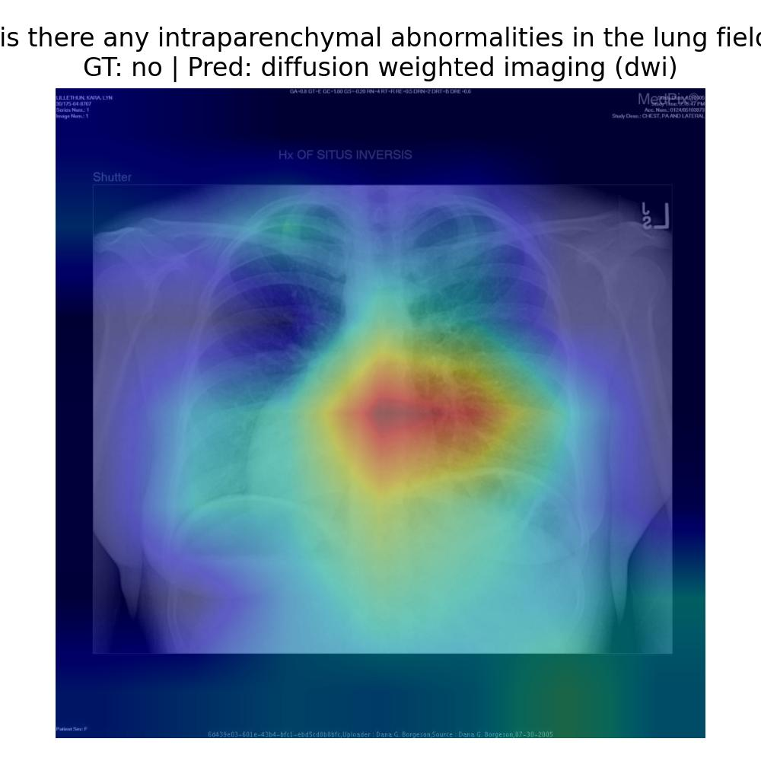
Figure 1: Grad-CAM visualisation for a misclassified chest X-ray example.
The Grad-CAM attention map shows that the network pays significantly more attention to the mediastinal area rather than the peripheral lungs that are actually critical to identify intraparenchymal abnormalities. This mismatch between the question and the location of attention could be the reason for the wrong answer. In the rest of the images where the answer to the question is correct but the question itself is about cardiomegaly or pneumothorax, the attention maps properly correspond to boundaries of the heart and apices of the lungs, respectively.
In summary, Grad-CAM reveals that in certain instances, the baseline learns realistic patterns regarding its attention, but this is variable. It is still distracted by text overlays, background structures, or central artifacts, at times when it has little training regarding a specific type of question.
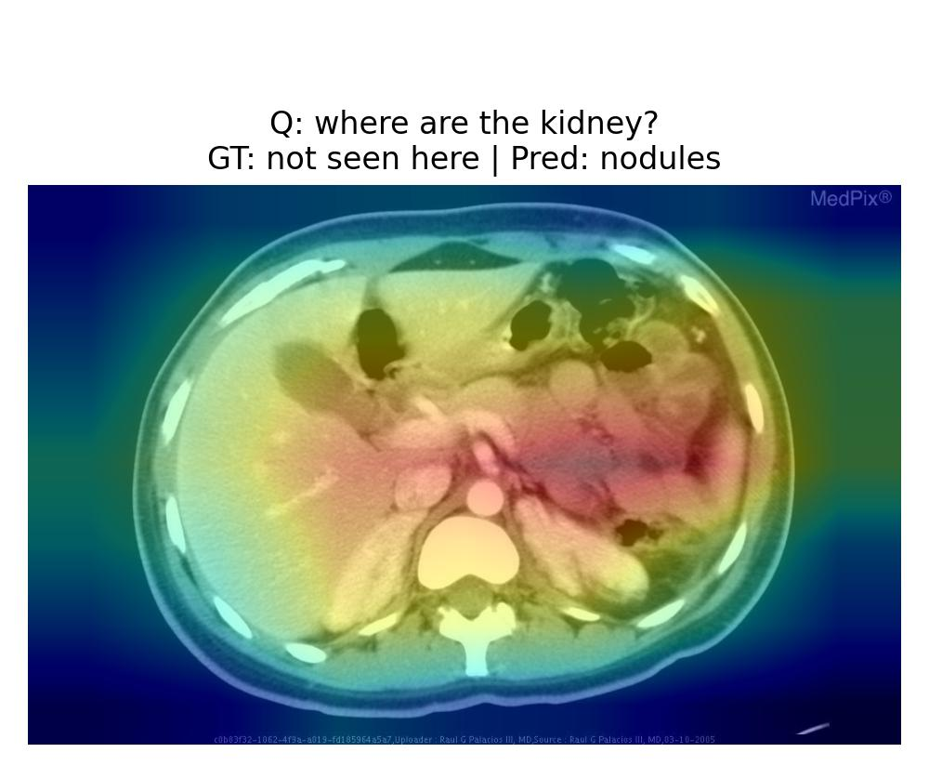
Figure 2: Grad-CAM visualisation for a misclassified abdominal CT example involving the kidneys.
In the figure 2, Grad-CAM is overlaid on an axial abdominal CT image, on which the question is "where are the kidney?". The answer is "not seen here", meaning the image is obtained at a slice level which does not contain the kidney. However, the network predicts "nodules". As can be observed, the network pays most of its attention to the high contrast regions within the abdominal region like the bowel loops or the interfaces between the liver and the soft tissue, but certainly not to the posterior location from where the kidney should be visible. This particular example brings forward the limitation within the current network setup as it does not provide the 3-D structural information or the concept of "not visible", but instead relies upon the most common intensity patterns observed in the image.

DISCUSSION
The experiments demonstrate both the capabilities and limitations of current methods for Med-VQA tasks on small radiology datasets. As far as positive observations are concerned, simply replacing the question encoder with BERT andFine-Tuningit has shown enhancements in text-based metrics without affecting accuracy adversely. This is a testimony to the fact that better language models are capable of being more sensitive towards variations in question phrasing and terminology even if their counterparts are relatively simpler.
Additionally, the results from the BLIP model demonstrate the effectiveness of vision-language pre-training. Although the BLIP model does not have a significant effect on the EM compared to the best Baseline-BERT model, the improved token-level F1 score suggests that pre-training the model with a larger number of image-text pairs results in more semantically appropriate responses to answers. This is quite impressive, since BLIP was not primarily trained for the radiology domain; however, it is able to transfer knowledge to VQA-RAD through fine-tuning. Increasing the BLIP fine-tuning period from 3 to 6 epochs resulted in decreased performance in both EM and token-level F1 scores.
However, there are also certain areas left uncovered. Firstly, it is a challenge related to the lack of data. The truth is that only a few thousand question and answer pairs might be insufficient for either CNN + Transformer or BLIP to account for the long tail of answers. This is even more true when it comes to phrases related to anatomy and measurements because they might appear just a few times. Assigning all rare answers to <other> as it is done in the baseline reduces all differences. Secondly, it is true that certain metrics may overlook certain aspects. For example, simply by being overlapping, one cannot determine whether an answer is completely accurate. A similar but slightly different answer is labeled as incorrect for EM, while a generic accurate response might get full marks even if it is just too generic.
Thirdly, the Gradient-CAM result implies that the task of visual grounding is not fully perfected. This is because the model could still output the correct result yet use the wrong regions to perform the classification. In other instances, the model uses the correct regions yet arrives at the incorrect result. Here, the interaction between the visual attention module and the language understanding module could be improved to get the desired output. This could be achieved through the use of cross-attention mechanisms.
Finally, there are hardware constraints on my local machine that prevented me from further investigating the role of more specialized VLMs in medicine like Med-BLIP or those trained on chest X-ray datasets. Training the BLIP on CPU was also a challenge that involved many compromises between batch size and the number of training epochs. Despite all that, the above-mentioned experiments are sufficient to conclude trends and encourage further study on powerful models and large datasets.

CONCLUSION
This thesis explored the task of Medical Visual question answering using both supervised versions of the CNN + Transformer models, as well as a pre-trained vision-language model called BLIP. By replacing the question encoder component of a medical visual question answering model, which used an LSTM encoder, with a BERT encoder, improvements were made in terms of match accuracy, F1, as well as preserving a strong level of accuracy in class prediction. Further improvements were then made in F1.
In addition to ROC AUC scores, combined text-based metrics facilitated an apples-to-apples comparison of classification models with generative models, while Grad-CAM visualization yielded insights regarding the models’ attention to clinical regions vs. non-meaningful regions. The case study mentions problems that still persist in the field, such as the coverage of long tail answers and the grounding in the image, while indicating future directions that entail better medical VLM models.

GITHUB CODE
The full PyTorch implementation, configuration files and evaluation scripts are available at the following repository (to be made public upon submission):
GitHub: GitHub - 511615/MED_VQA
The repository includes instructions for setting up the environment, reproducing the baseline and BLIP experiments, and generating the Grad-CAM visualisations shown in this report.

AUTHORS CONTRIBUTION
As this is an group project, the training part was carried out by Huang Yucheng, including literature review, data preparation, implementation of baseline and BLIP models. And the experiment design, evaluation, visualisation and report writing were carried out by Huang Xuan.

REFERENCES
- Devlin, J., Chang, M.-W., Lee, K., & Toutanova, K. (2019). BERT: Pre-training of deep bidirectional transformers for language understanding. In Proceedings of the 2019 Conference of the North American Chapter of the Association for Computational Linguistics: Human Language Technologies (pp. 4171–4186). Association for Computational Linguistics.
- Li, J., Li, D., Xiong, C., & Hoi, S. C. H. (2022). BLIP: Bootstrapping language-image pre-training for unified vision-language understanding and generation. In Proceedings of the 39th International Conference on Machine Learning (pp. 12888–12900). PMLR.
- Lau, J. J., Gayen, S., Ben-Cohen, A., et al. (2018). A dataset of clinically generated visual questions and answers about radiology images. arXiv preprint arXiv:1809.01994.
- Selvaraju, R. R., Cogswell, M., Das, A., Vedantam, R., Parikh, D., & Batra, D. (2017). Grad-CAM: Visual explanations from deep networks via gradient-based localization. In Proceedings of the IEEE International Conference on Computer Vision (pp. 618–626). IEEE.

