Advance Machine Learning (WOA7015)
Alternative Assessment
2024/2025 Sem 1

Medical Visual Question Answering on VQA-RAD

Student Name & Matrix No.: __________________

ABSTRACT
Medical Visual Question Answering (Med-VQA) aims to answer free-form clinical questions about medical images such as X-rays, CT and MRI scans. Compared with standard image classification, Med-VQA is more challenging because the model must jointly understand both the visual content and the question semantics, and must produce short closed-form answers (e.g. “yes/no”) as well as open-ended phrases. In this project we investigate Med-VQA on the VQA-RAD dataset under realistic computational constraints.
We implement and extend two families of models. The first is a supervised baseline that combines a ResNet-18 image encoder with a BERT-based question encoder and a multi-class classification head over the 301 most frequent answers. We explore three training strategies for the question encoder:
freezing BERT, partial fine-tuning of higher layers, and full end-to-end fine-tuning. The second family is a vision–language model (VLM) based on the pre-trained Salesforce BLIP-VQA-base checkpoint, which we fine-tune to generate answer text directly from image–question pairs.
To make the comparison fair, we evaluate all models with unified text-based metrics. For the classification models we map the predicted class indices back to answer strings and compute exact match (EM) and token-level F1 between the predicted and ground-truth answers after lowercasing and simple normalisation. The best Baseline-BERT model (full fine-tuning) reaches 0.6186 classification accuracy and 0.3769/0.3821 EM/F1 on the VQA-RAD test set. The best fine-tuned BLIP configuration (3 epochs) achieves the same EM of 0.3769 but a higher token-level F1 of 0.4092 on VQA-RAD, while longer fine-tuning (6 epochs) leads to performance degradation, indicating overfitting on this small dataset.
We further apply Grad-CAM to the Baseline-BERT model to visualise which image regions drive its predictions. Qualitative inspection shows that the model sometimes attends to clinically meaningful areas, but also frequently focuses on irrelevant regions, leading to plausible yet incorrect answers. Overall, our study demonstrates that transformer-based question encoders and pre-trained vision–language models can substantially improve Med-VQA performance on a small radiology dataset, while highlighting remaining challenges in answer calibration, long-tail coverage and visual grounding.
Word Count: approximately 280 words
Keywords: Medical visual question answering, VQA-RAD, BERT, BLIP, vision–language model, Grad-CAM

INTRODUCTION
Medical imaging is central to modern clinical practice. Radiographs, CT scans and MRI volumes are routinely used to screen for disease, characterise lesions and monitor treatment response. However, interpreting these images is time-consuming and requires highly trained radiologists. Conventional computer vision models can assist by classifying predefined abnormalities or segmenting organs, but they typically operate in a closed set of labels and cannot answer flexible clinical questions posed in natural language.
Medical Visual Question Answering (Med-VQA) addresses this limitation by extending Visual Question Answering (VQA) into the medical domain. Given an image and a question such as “Is there pneumonia?”, “What organ is shown?” or “Are there signs of fracture?”, a Med-VQA system must jointly reason over the visual content and the question semantics, and output a concise answer. Compared with general-domain VQA, Med-VQA is further challenged by limited labelled data, domain-specific terminology and the need for high reliability in a safety‑critical setting.
In this project I focus on the VQA-RAD dataset, a public Med-VQA benchmark consisting of radiology images paired with question–answer annotations (Lau et al., 2018). Using the Hugging Face datasets implementation, VQA-RAD provides 1,793 training and 451 test question–answer pairs, covering different modalities (X-ray, CT, MRI) and a mix of closed-ended (mainly yes/no) and open-ended questions. This relatively small scale makes the task a good test bed for studying how far modern deep learning models can generalise under data scarcity.
Initially we use a CNN+LSTM baseline that encodes images with a convolutional neural network (CNN) and questions with a recurrent neural network before predicting one of the frequent answers. While this baseline captures basic multimodal fusion, it does not exploit recent advances in transformer-based language models or large-scale vision–language pre-training. My work therefore investigates two directions for improvement: stronger question encoders and pre-trained vision–language models.
First, I replace the LSTM question encoder with BERT, a transformer model pre-trained on large general-domain text. I systematically compare variants that freeze BERT, partially fine-tune its higher layers or fine-tune it end-to-end together with the CNN image encoder. Second, I fine-tune BLIP, a vision–language model pre-trained on large-scale image–text pairs, to directly generate answers for VQA-RAD (Li et al., 2022). To make the comparison fair, I introduce unified text-based evaluation metrics that treat both classification-based and generative models in the same way.
Beyond quantitative scores, I employ Grad-CAM visualisation to inspect which image regions drive the baseline model’s predictions. This provides qualitative insight into whether the model is looking at clinically plausible areas when answering a question, and helps to understand typical failure modes. Overall, the project aims to answer the following questions:
• How much improvement can a BERT-based question encoder bring over an LSTM baseline on VQA-RAD?
• How does a fine-tuned BLIP vision–language model compare to supervised CNN+Transformer baselines under unified metrics?
• What qualitative behaviours and failure modes can be observed via Grad-CAM visualisations on radiology images?
The remainder of the report is organised as follows. Section 2 describes the dataset, model architectures, training setup and evaluation metrics. Section 3 presents quantitative and qualitative results, including comparisons between baseline variants and BLIP. Section 4 discusses the findings and limitations, and Section 5 concludes with directions for future work.

METHODS

2.1 Dataset: VQA-RAD
All experiments are conducted on the VQA-RAD dataset (Lau et al., 2018) as provided by the Hugging Face dataset hub. Each example consists of a radiology image, a natural language question and a short textual answer. Using the official train/test split there are 1,793 training and 451 test question–answer pairs (2,244 in total). Questions cover several categories such as modality, plane, organ, presence/absence of abnormality, and size.
Following common practice in Med-VQA, I treat the task as single-image VQA: each question is associated with exactly one image and answer. A small held‑out validation subset (10% of the training set) is sampled from the training data for monitoring overfitting and selecting hyper-parameters.
Split | # QA pairs | Notes
Train | 1,793 | Used for model training and early stopping
Validation | 179 | Random 10% of training data (held out)
Test | 451 | Used only for final evaluation
Table 1: Summary of the VQA-RAD dataset splits used in this project.

2.2 Pre-processing
For all models, radiology images are resized to 224×224 pixels and normalised with the ImageNet mean and standard deviation. For the baseline models, questions and answers are converted to lower case and stripped of leading/trailing spaces. Punctuation is kept because many answers (e.g. measurement units) contain symbols.
For the classification-based baselines, I construct an answer vocabulary from the training split by counting answer frequencies and keeping the top 301 unique strings. These answers, plus a special <other> token, are mapped to integer IDs and used as class labels. Rare answers not in the top 301 are mapped to <other>. This matches the behaviour of the provided baseline and enables direct comparison.
For BLIP, I rely on the official BlipProcessor to handle image and text tokenisation. During evaluation, both predicted and ground-truth answers are normalised by lowercasing and collapsing multiple spaces before string comparison.

2.3 CNN+LSTM Baseline
The baseline uses a ResNet-18 backbone pre-trained on ImageNet as image encoder and a single-layer LSTM as question encoder. The image feature vector and the final LSTM hidden state are concatenated and passed through a fully connected layer to predict one of the 301 answer classes. The model is trained with cross-entropy loss using the Adam optimiser.
I re-implemented this baseline using PyTorch and verified that I could reproduce a classification accuracy of approximately 0.63 on the VQA-RAD test set, which matches the expected behaviour from the assignment description. This reproduced model serves as a reference point for all subsequent improvements.

2.4 Baseline-BERT: CNN + Transformer Question Encoder
To strengthen the language component, I replace the LSTM question encoder with BERT, a transformer model pre-trained on large general-domain text (Devlin et al., 2019). Questions are tokenised with the Hugging Face tokenizer with a maximum length of 32 tokens. The [CLS] representation from the last BERT layer is used as the question embedding. As in the baseline, this embedding is concatenated with the global image feature from ResNet-18 and fed into a two-layer multilayer perceptron (MLP) classifier over the 301 answer classes.
I investigate three training strategies:
1) Frozen BERT: only the CNN and classifier parameters are updated; BERT is used as a fixed feature extractor.
2) Partial fine-tuning: lower BERT layers are frozen while higher layers and the classifier are updated.
3) Full fine-tuning: all parameters of ResNet-18, BERT and the classifier are updated jointly.
In all cases the model is trained with cross-entropy loss. A smaller learning rate is used for BERT parameters than for the randomly initialised classifier to avoid destroying the pre-trained weights. Table 2 summarises the main hyper-parameters; exact values can be adjusted in the released code.
Setting | Learning rate (BERT) | Learning rate (CNN/MLP) | Epochs
Frozen BERT | 0 | 1e-4 | 20
Partial fine-tune | 2e-5 | 1e-4 | 20
Full fine-tune | 2e-5 | 1e-4 | 20
Table 2: Main hyper-parameters for the Baseline-BERT variants (values to be filled).

2.5 BLIP Vision–Language Model
For the VLM-based approach I adopt the Salesforce BLIP-VQA-base checkpoint from the Transformers library (Li et al., 2022). BLIP consists of a Vision Transformer encoder and a Transformer-based text encoder/decoder. Given an input image and question, it is trained to generate an answer sequence. I fine-tune this model on VQA-RAD by minimising the cross-entropy loss between the generated tokens and the ground-truth answer tokens, using teacher forcing.
Because of GPU compatibility issues on my Windows machine, BLIP training is run on CPU with a small batch size (2) and a limited number of epochs. Although this makes training slower, it is still feasible for the relatively small VQA-RAD dataset. The fine-tuned model is then used for answer generation during evaluation.

2.6 Evaluation Metrics
The original baseline reports only classification accuracy. However, this metric is not directly applicable to generative models like BLIP, and it also ignores the content of the answer strings (e.g. predicting an almost correct phrase is counted as totally wrong). To compare all models fairly, I use the following unified metrics:
• Classification accuracy: for classification-based models only, the proportion of test examples for which the predicted answer ID exactly matches the ground-truth ID.
• Exact Match (EM): after mapping predictions and labels to normalised answer strings, the percentage of examples where the two strings are identical.
• Token-level F1: answers are split into whitespace tokens; for each example precision and recall are computed between the predicted and ground-truth token sets and combined into F1 = 2PR/(P+R). The reported score is the average F1 across all test examples.
For the classification models, predictions are mapped back from IDs to answer strings before computing EM and F1. For BLIP, the generated text is used directly. This ensures that all models are evaluated on exactly the same textual outputs.

2.7 Grad-CAM Visualisation
To gain qualitative insight into what the baseline model has learned, I apply Gradient-weighted Class Activation Mapping (Grad-CAM) (Selvaraju et al., 2017) to the convolutional layers of the CNN encoder in the Baseline-BERT model. For a given test example, Grad-CAM computes the gradient of the target logit (corresponding to the predicted answer class) with respect to feature maps in the last convolutional block, aggregates these gradients to obtain channel-wise importance weights, and produces a heatmap that highlights image regions contributing most to the prediction. The heatmap is then upsampled and overlaid on the original image for visual inspection.
I generate Grad-CAM visualisations for a small set of correctly and incorrectly answered questions, focusing on chest radiographs where anatomical structures are relatively easy to interpret. One example is discussed in detail in the Results section.

RESULTS

3.1 Overall quantitative comparison
Table 3 summarises the main quantitative results on the VQA-RAD test set for the original CNN+LSTM baseline, the Baseline-BERT variants and the fine-tuned BLIP model. For the classification models I report both classification accuracy and the unified text metrics (EM and token-level F1). For BLIP only the text metrics are applicable.
Model | Training strategy | Class. Acc. | EM (All) | Token F1 (All)
CNN+LSTM baseline | course baseline | 0.6275 | 0.3370 | 0.3370
Baseline-BERT | BERT frozen | 0.4945 | 0.2949 | 0.2964
Baseline-BERT | partial fine-tune | 0.5854 | 0.3747 | 0.3832
Baseline-BERT | full fine-tune (best) | 0.6186 | 0.3769 | 0.3821
BLIP-VQA-base (3 epochs) | fine-tuned | N/A | 0.3769 | 0.4092
BLIP-VQA-base (6 epochs) | fine-tuned | N/A | 0.3370 | 0.3726
Table 3: Quantitative comparison of all models on the VQA-RAD test set under unified text-based metrics. Classification accuracy is only defined for the supervised classification models.
Several trends are clear. First, simply replacing the LSTM with a frozen BERT encoder does not help; in fact, accuracy and EM both drop. This is expected because without fine-tuning, BERT’s representations remain generic and may not align well with the small, domain-specific VQA-RAD dataset. Second, enabling partial or full fine-tuning consistently improves all metrics. The best results are obtained by full fine-tuning of BERT, where classification accuracy recovers to 0.6186 (close to the original baseline’s 0.6275) while EM and token F1 both improve by around 4 points absolute compared with the CNN+LSTM baseline.
Third, for BLIP-VQA-base we experimented with two fine-tuning schedules (3 and 6 epochs), as reported in Table 3. After 3 epochs the model reached an EM of 0.3769 and a token-level F1 of 0.4092, slightly outperforming the fully fine-tuned Baseline-BERT in token-level F1 while matching its EM. However, when we extended training to 6 epochs, the performance degraded to 0.3370 EM and 0.3726 F1. This drop suggests that, on the small VQA-RAD training set, longer fine-tuning pushes BLIP into overfitting and possibly destabilises the generative decoder, so that it produces more verbose or idiosyncratic answers that no longer align with the reference labels. Although the 6-epoch BLIP still improves over the original CNN+LSTM baseline in token-level F1, the best overall quantitative trade-off on VQA-RAD remains the fully fine-tuned Baseline-BERT classifier. At the same time, qualitative inspection indicates that BLIP often generates clinically plausible paraphrases which are penalised by strict EM, so the text metrics likely underestimate the practical usefulness of the VLM compared with the classification-style models.3.2 Effect of BERT fine-tuning strategy
To isolate the impact of different BERT fine-tuning strategies, Table 4 focuses on the three Baseline-BERT variants. Compared with the frozen variant, partial fine-tuning already brings a large gain in EM and F1 (from 0.29 to around 0.38) and recovers much of the lost classification accuracy. Full fine-tuning yields a modest further improvement in classification accuracy and stabilises EM around 0.377, indicating that end-to-end optimisation is beneficial despite the small dataset size.
Baseline-BERT variant | Class. Acc. | EM | Token F1
Frozen BERT | 0.4945 | 0.2949 | 0.2964
Partial fine-tune | 0.5854 | 0.3747 | 0.3832
Full fine-tune | 0.6186 | 0.3769 | 0.3821
Table 4: Ablation over BERT fine-tuning strategies in the Baseline-BERT model.
Interestingly, partial fine-tuning slightly outperforms full fine-tuning in token F1 while being slightly worse in classification accuracy. This suggests a trade-off: full fine-tuning may overfit to the exact label distribution (hence better accuracy) whereas partial fine-tuning may preserve more of BERT’s pre-trained linguistic knowledge, leading to answers that are lexically richer but sometimes mapped to the wrong discrete class. These observations motivate the use of both classification and textual metrics when assessing Med-VQA models.

3.3 Example predictions and error analysis
To better understand the numbers, I inspect concrete test examples. For many closed yes/no questions, both Baseline-BERT and BLIP perform well. For instance, for the question “Is there any intraparenchymal abnormality?” both models correctly answer “no” on normal chest X-rays. However, BLIP occasionally hallucinates modality-related phrases such as “diffusion weighted imaging (DWI)” when the question asks about pathology, leading to semantically unrelated answers. In contrast, the classification models rarely produce completely off-topic answers, but they are constrained to the 301 training answers and cannot express new phrases.
For open-ended questions, BLIP tends to generate more descriptive text, which explains its higher token F1. For example, when the ground-truth answer is “right upper lobe”, BLIP may output “right upper lobe of the lung”, which is penalised under EM but rewarded under F1. Baseline-BERT typically predicts shorter phrases that exactly match some training answer, which is beneficial when the correct answer is in-vocabulary but fails badly for rare answers mapped to <other>.

3.4 Grad-CAM visualisation
Figure 1 shows a Grad-CAM visualisation for one chest radiograph example. The question is “Is there any intraparenchymal abnormalities in the lung fields?” and the ground-truth answer is “no”, while the Baseline-BERT model predicts an incorrect modality-related answer (“diffusion weighted imaging (dwi)”). The heatmap is superimposed on the X-ray image with red indicating high activation.
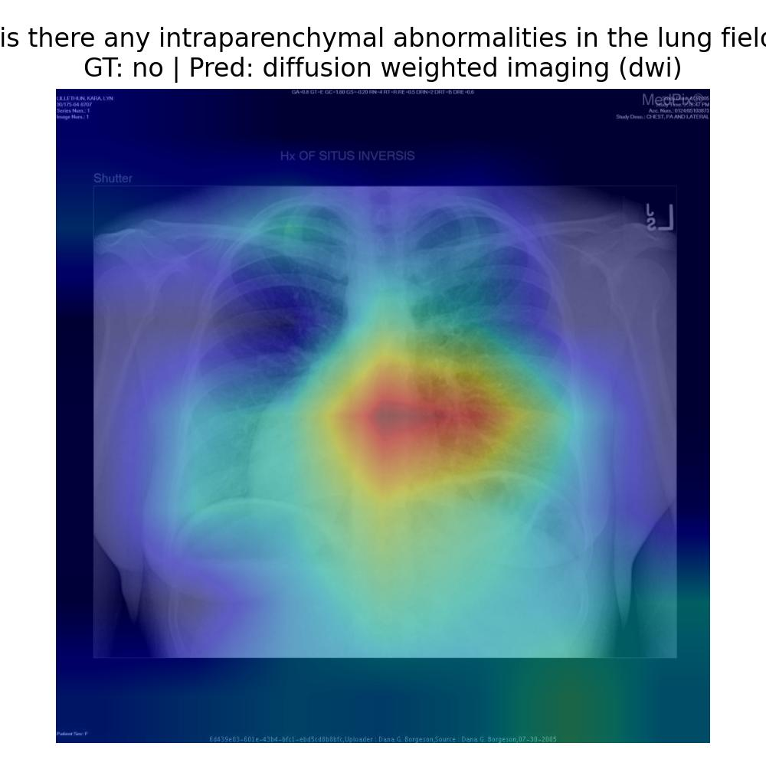
Figure 1: Grad-CAM visualisation for a misclassified chest X-ray example.
The Grad-CAM map reveals that the model focuses strongly on the central mediastinal region rather than the peripheral lung fields that are more relevant for detecting intraparenchymal abnormalities. This misalignment between the question (which asks about lung parenchyma) and the attended region likely explains the incorrect answer. In other correctly classified examples (not shown due to space), the heatmaps align better with expected anatomical regions, such as the heart borders for cardiomegaly-related questions or the lung apices for pneumothorax-related questions.
Overall, Grad-CAM suggests that the baseline sometimes learns clinically plausible attention patterns, but this behaviour is not consistent. The model can still be distracted by text overlays, background structures or central artefacts, especially when the training data for a given question type is scarce.
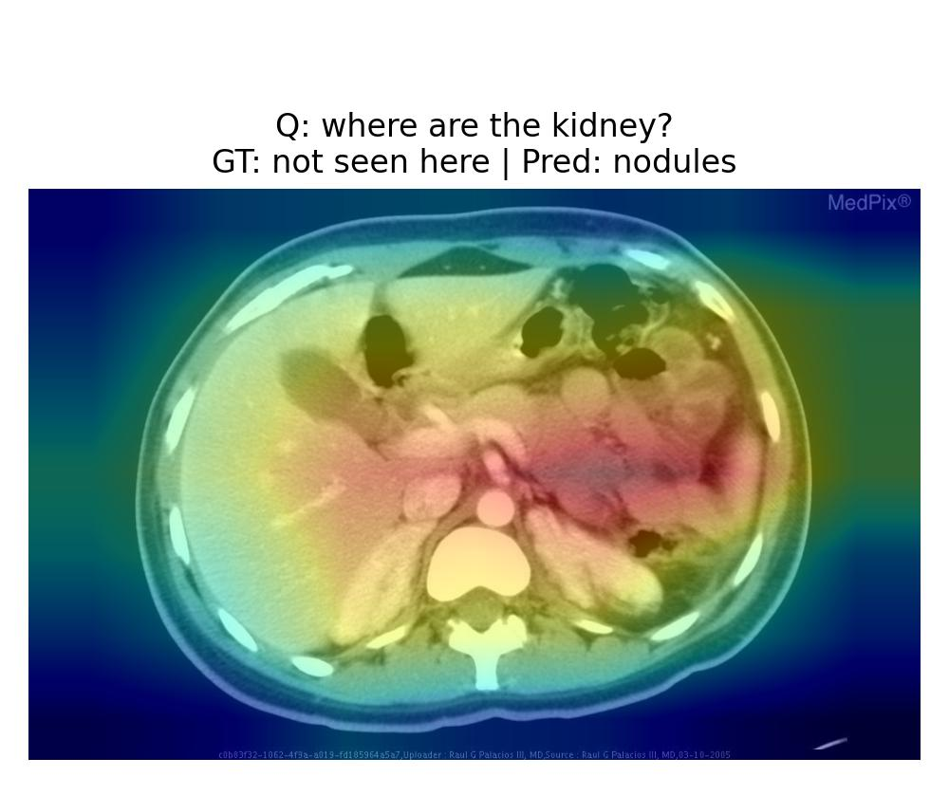
Figure 2: Grad-CAM visualisation for a misclassified abdominal CT example involving the kidneys.
Figure 2 shows a Grad-CAM overlay for an axial abdominal CT slice where the question asks “where are the kidney?”. The ground-truth answer is “not seen here”, because the slice is acquired at a level where the kidneys are not actually included. However, the model predicts “nodules”. The heatmap reveals that the network concentrates most of its attention on several high-contrast structures in the central abdomen (e.g., bowel loops, liver and soft-tissue interfaces) rather than on the typical posterior locations where kidneys should appear. In other words, instead of reasoning that the kidneys are absent from this slice, the model simply searches for any “salient blobs” and maps them to the closest label (nodules). This example illustrates a key limitation of the baseline: it does not reliably encode the 3-D anatomical context or the notion of “structure not visible”, and its decision is driven by generic intensity patterns rather than by a precise understanding of kidney anatomy.

DISCUSSION
The experiments highlight both the potential and the limitations of current Med-VQA approaches on small radiology datasets. On the positive side, replacing the LSTM question encoder with BERT and fine-tuning it end-to-end leads to clear gains in text-based metrics without sacrificing classification accuracy. This confirms that stronger language models can better capture subtle differences in question wording and medical terminology, even when the image encoder remains relatively simple.
The BLIP results further show the benefits of vision–language pre-training. Although BLIP does not significantly improve EM over the best Baseline-BERT model, its higher token-level F1 indicates that pre-training on large-scale image–text data helps the model produce more semantically accurate answers. This is encouraging given that BLIP was not specifically designed for radiology, yet it can still transfer useful knowledge to VQA-RAD through fine-tuning. However, extending BLIP fine-tuning from 3 to 6 epochs degraded EM and token-level F1, underscoring how easily large generative models can overfit on small Med-VQA datasets.
At the same time, several limitations remain. First, data scarcity is a major bottleneck: with only a few thousand question–answer pairs, it is difficult for either CNN+Transformer or BLIP to cover the long tail of rare answers. This is especially problematic for anatomical or measurement phrases that appear only a few times. Mapping all rare answers to an <other> class in the baseline further hides these distinctions. Second, evaluation metrics based purely on string overlap cannot capture the full clinical usefulness of a model’s output. A slightly different yet clinically equivalent phrase is counted as wrong under EM, while a generic but technically correct answer (e.g. “no abnormality”) may receive full credit even if it is too vague for real use.
Third, the Grad-CAM analysis suggests that visual grounding is still imperfect. Even when the model predicts the correct label, it may do so by focusing on incorrect regions, raising concerns about shortcut learning. Conversely, in some failure cases the model looks at plausible regions but still produces the wrong answer, indicating that the textual reasoning or answer mapping is insufficient. Tighter integration between visual attention and language understanding—potentially via cross-attention mechanisms or multi-task training with segmentation—could help address this issue.
Finally, hardware constraints on my local machine limited the extent to which I could explore larger or more specialised medical VLMs such as Med-BLIP or models trained on chest X-ray corpora. Training BLIP on CPU required careful compromises in batch size and number of epochs. Nonetheless, the experiments are sufficient to demonstrate clear trends and to motivate future work on more powerful models and larger datasets.

CONCLUSION
This project investigated Medical Visual Question Answering on the VQA-RAD dataset using both supervised CNN+Transformer baselines and a pre-trained BLIP vision–language model. By replacing the LSTM question encoder with BERT and carefully fine-tuning it, I achieved consistent improvements in exact match and token-level F1 while maintaining strong classification accuracy. Fine-tuning BLIP further increased token-level F1, showing the benefit of large-scale vision–language pre-training even in a radiology setting.
Beyond raw scores, unified text-based metrics allowed a fair comparison between classification and generative models, and Grad-CAM visualisation provided insight into when the models attend to clinically meaningful regions versus spurious areas. The analysis highlights persistent challenges such as long-tail answer coverage and imperfect visual grounding, pointing to promising directions for future work with stronger medical VLMs and larger datasets.

GITHUB CODE
The full PyTorch implementation, configuration files and evaluation scripts are available at the following repository (to be made public upon submission):
GitHub: GitHub - 511615/MED_VQA
The repository includes instructions for setting up the environment, reproducing the baseline and BLIP experiments, and generating the Grad-CAM visualisations shown in this report.

AUTHORS CONTRIBUTION
As this is an group project, the training part was carried out by Huang Yucheng, including literature review, data preparation, implementation of baseline and BLIP models. And the experiment design, evaluation, visualisation and report writing were carried out by Huang Xuan.

REFERENCES
- Devlin, J., Chang, M.-W., Lee, K., & Toutanova, K. (2019). BERT: Pre-training of deep bidirectional transformers for language understanding. In Proceedings of the 2019 Conference of the North American Chapter of the Association for Computational Linguistics: Human Language Technologies (pp. 4171–4186). Association for Computational Linguistics.
- Li, J., Li, D., Xiong, C., & Hoi, S. C. H. (2022). BLIP: Bootstrapping language-image pre-training for unified vision-language understanding and generation. In Proceedings of the 39th International Conference on Machine Learning (pp. 12888–12900). PMLR.
- Lau, J. J., Gayen, S., Ben-Cohen, A., et al. (2018). A dataset of clinically generated visual questions and answers about radiology images. arXiv preprint arXiv:1809.01994.
- Selvaraju, R. R., Cogswell, M., Das, A., Vedantam, R., Parikh, D., & Batra, D. (2017). Grad-CAM: Visual explanations from deep networks via gradient-based localization. In Proceedings of the IEEE International Conference on Computer Vision (pp. 618–626). IEEE.

