%%Time Response of a Second order System

z=[]

p=[-10+30i -10-30i]

k=1000

G=zpk(z,p,k)

figure(1)

step(G)

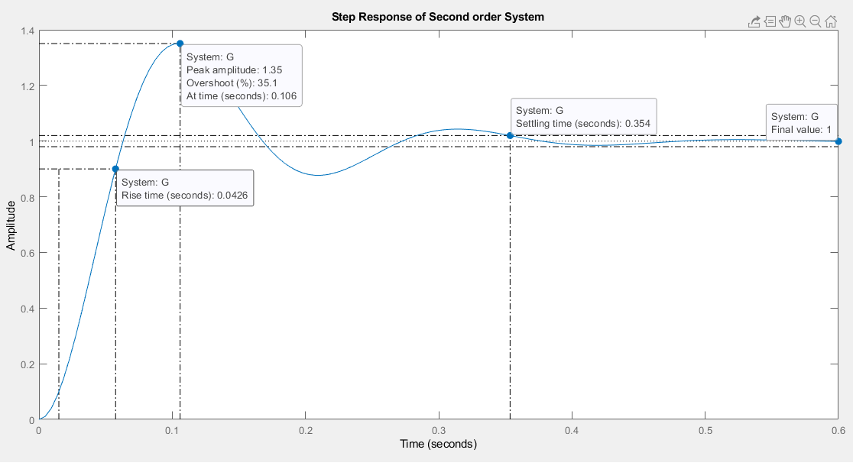

%%Evaluation of addition of poles

%%Addition of pole at -1

z=[]

p=[-10+30i -10-30i -1]

k=1000

G=zpk(z,p,k)

figure(2)

step(G)

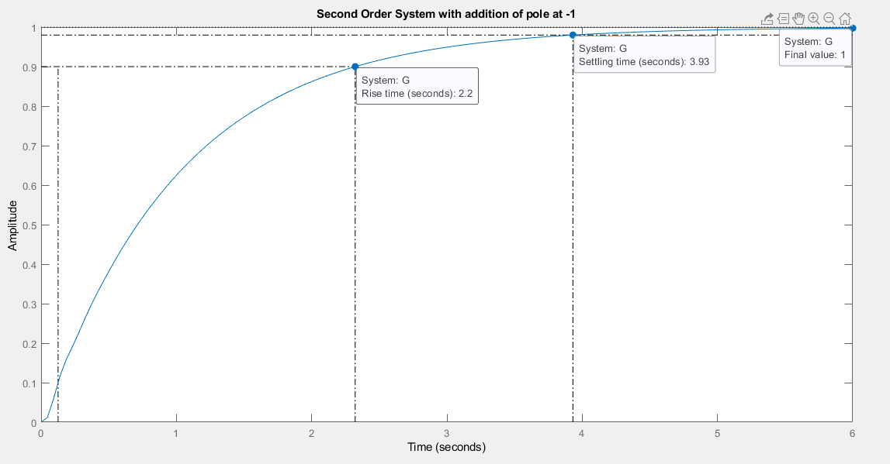

%%Addition of pole at -10

z=[]

p=[-10+30i -10-30i -10]

k=1000

G=zpk(z,p,k)

figure(3)

step(G)

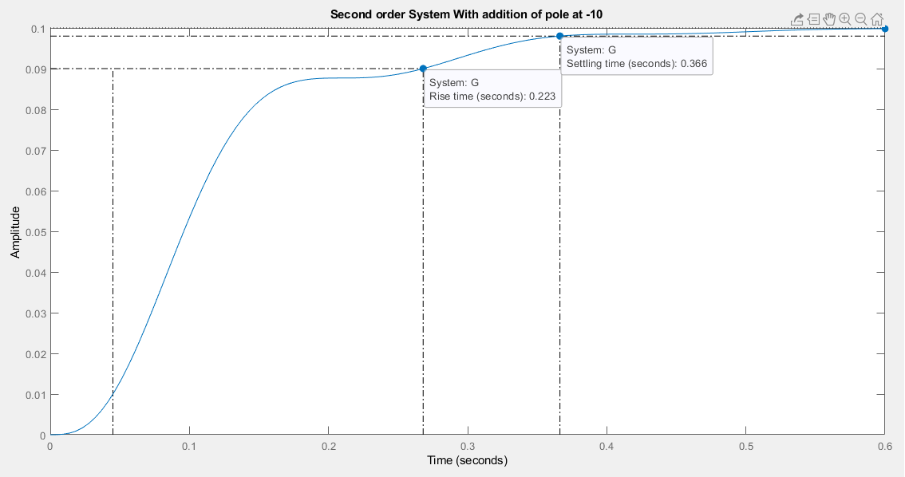

%%Addition of pole at -100

z=[]

p=[-10+30i -10-30i -100]

k=1000

G=zpk(z,p,k)

figure(4)

step(G)

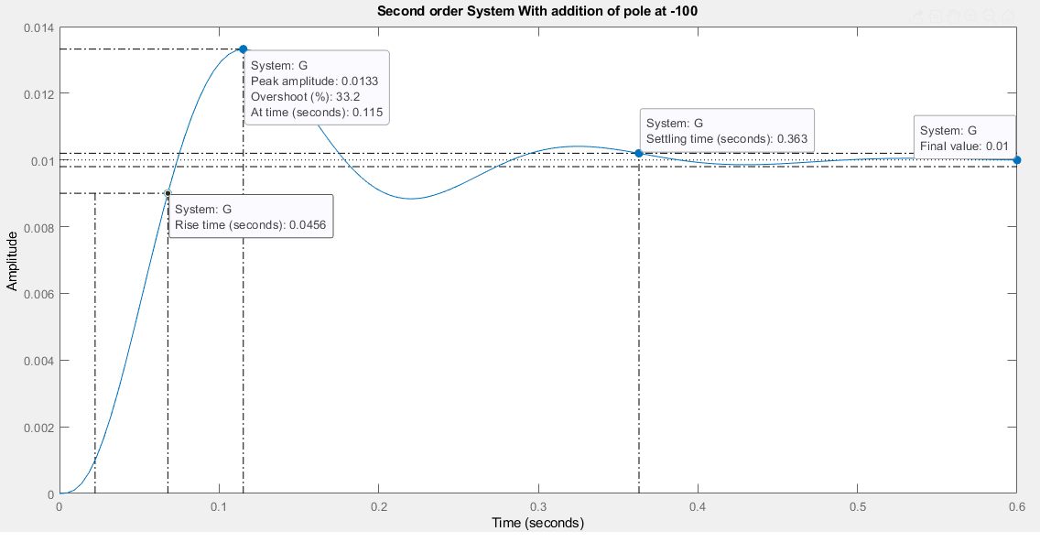

%%Evaluation of addition of zeros

%%Addition of zero at -1

z=[-1]

p=[-10+30i -10-30i]

k=1000

G=zpk(z,p,k)

figure(5)

step(G)

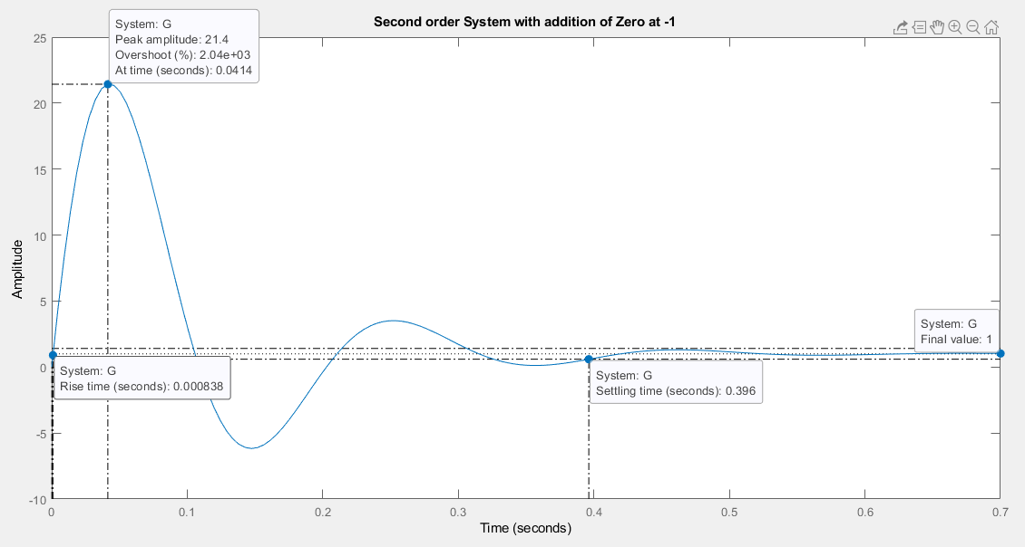

%%Addition of zero at -10

z=[-10]

p=[-10+30i -10-30i]

k=1000

G=zpk(z,p,k)

figure(6)

step(G)

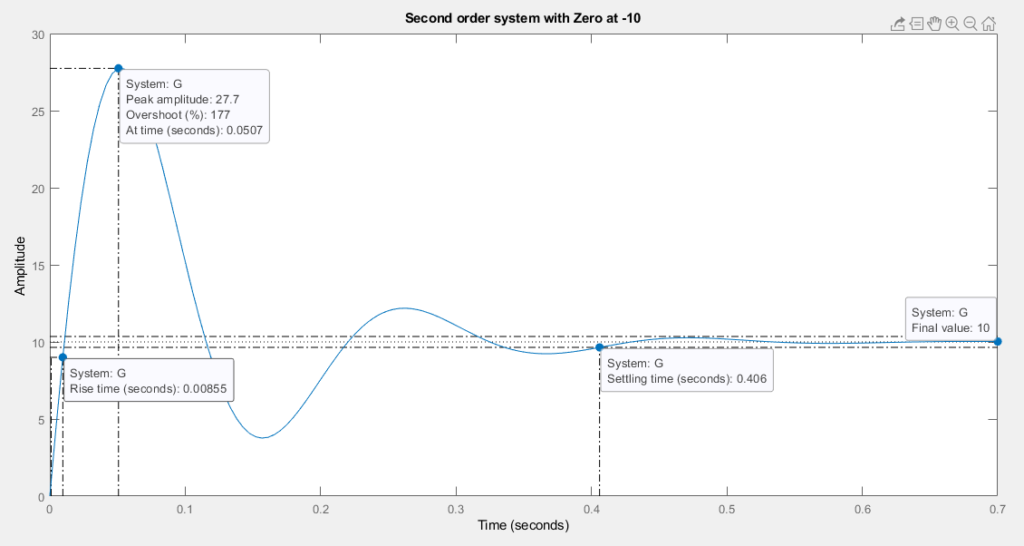

%%Addition of zero at -100

z=[-100]

p=[-10+30i -10-30i]

k=1000

G=zpk(z,p,k)

figure(7)

step(G)

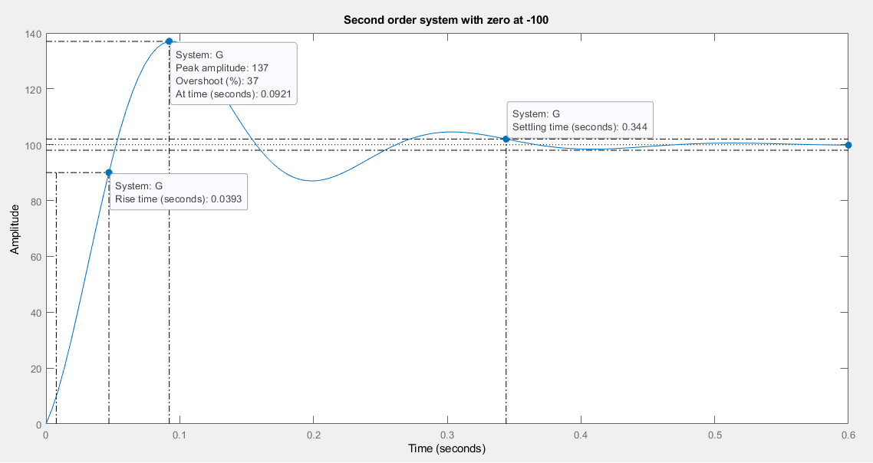

%%effect of loop gain of a negative feedback system of on stability

z=[]

p=[-0.5+i -0.5-i -1]

k1=10

k2=20

k3=30

G1=zpk(z,p,k1)

G2=zpk(z,p,k2)

G3=zpk(z,p,k3)

t=[0:0.01:20]

[y1,t]=step(G1,t)

[y2,t]=step(G2,t)

[y3,t]=step(G3,t)

figure(8)

plot(t,y1,t,y2,t,y3)

legend('k=1','k=2','k=3')

grid

