%%P,PI,PD,PID controller

%%Openloop Step Response

n=[1]

d=[1 10 20]

plant=tf(n,d)

figure(1)

step(plant)

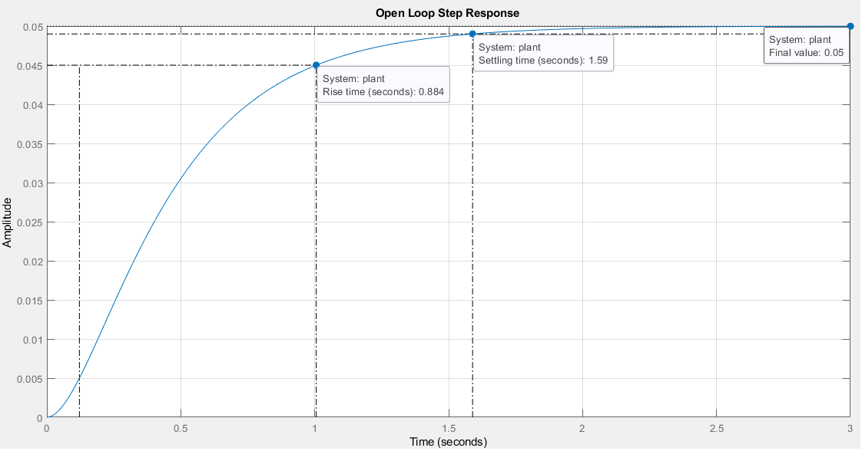

%%P Control

Kp=300;

cont=Kp

sys=feedback(cont\*plant,1)

figure(2)

step(sys)

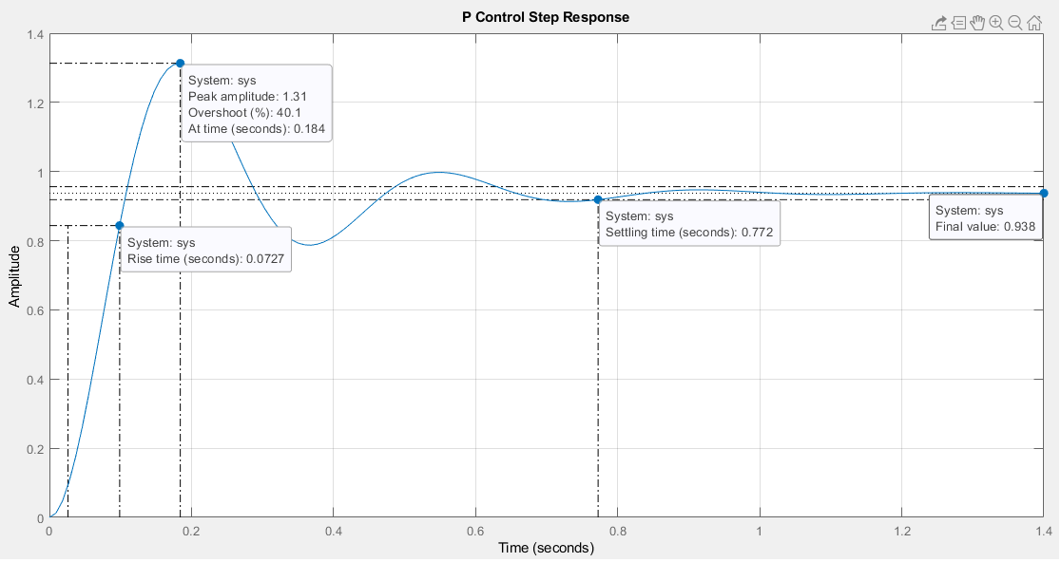

%%PI Control

Kp=30;

Ki=70

cont=tf([Kp Ki],[1 0])

sys=feedback(cont\*plant,1)

figure(3)

step(sys)

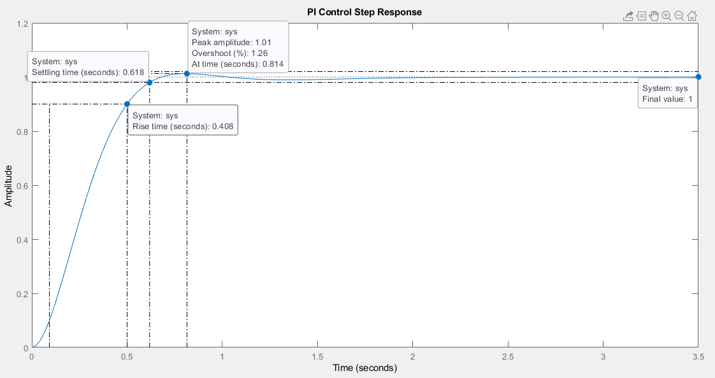

%%PD Control

Kp=300;

Kd=10

cont=tf([Kd Kp],1)

sys=feedback(cont\*plant,1)

figure(4)

step(sys)

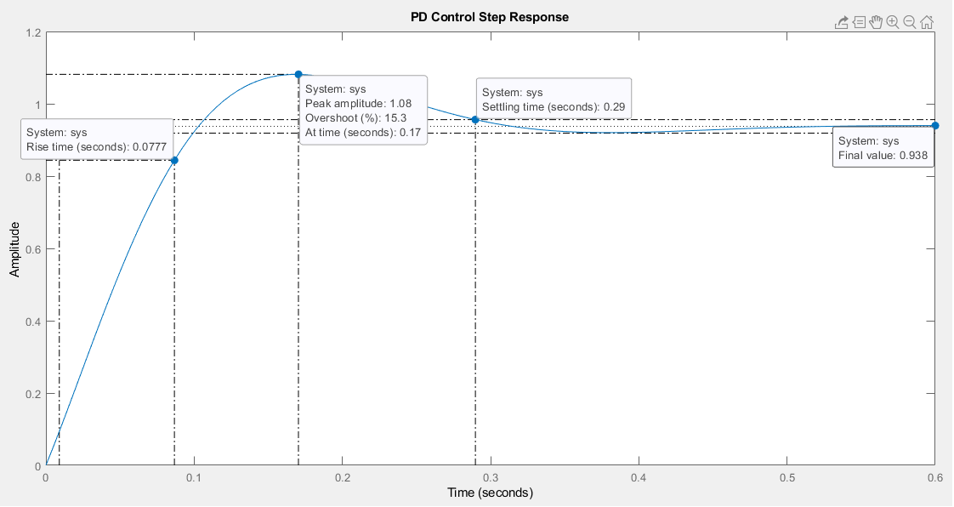

%%PID Control

Kp=350;

Kd=50

Ki=300

cont=tf([Kd Kp Ki],[1 0])

sys=feedback(cont\*plant,1)

figure(5)

step(sys)

