%%Time Response of First order System

n=[1];

d=[1 4];

G=tf(n,d)

figure(1)

step(G);

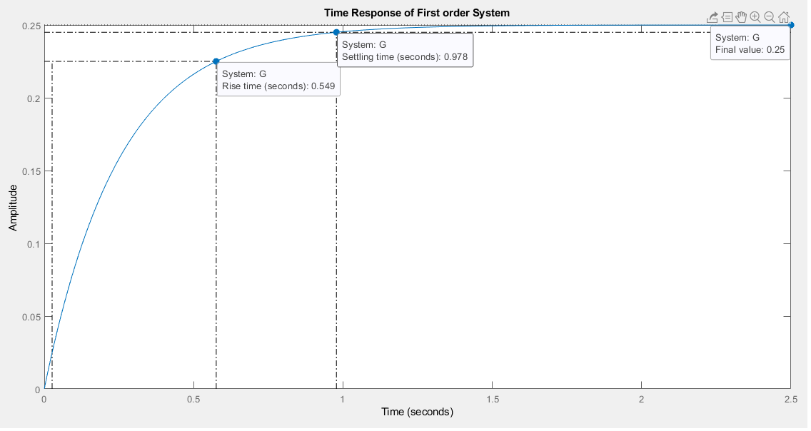

%%Time Response of a Second order System

z=[]

p=[-10+30i -10-30i]

k=1000

G=zpk(z,p,k)

figure(1)

step(G)

