# Conceptual Design

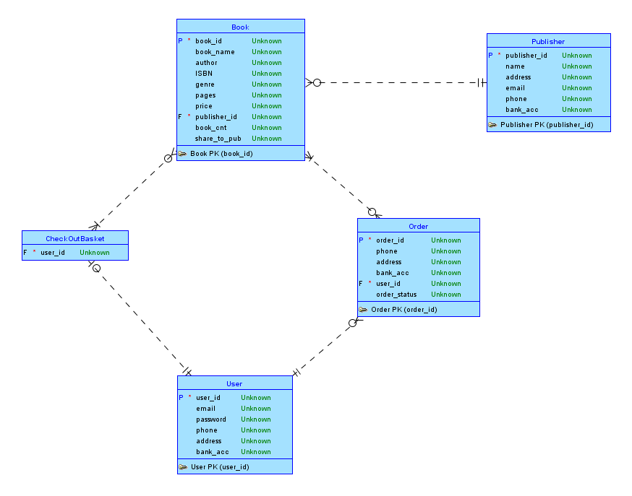

# Reduction to Relation Schemas

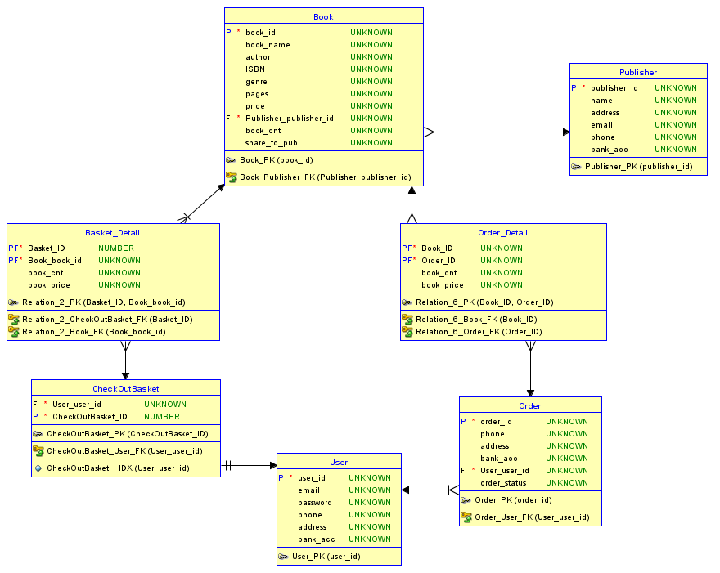

# Normalization of Relation Schemas

## 1NF test ok

There are no repeating groups of data

All tables has primary key.

## 2NF test ok

All columns of table have no partial dependent on primary key.

## 3NF test ok

There is no dependency between no primary key columns.

# Database Schema Diagram

Because many features of CheckOutBasket just like Orders, we can treat CheckOutBasket as an unpaied Order, with Order.status equals to “00”, so we remove CheckOutBasket related tables.

