

**5 Rituals To Happiness And Fulfillment**

What’s life without happiness and fulfillment? It’s like living a life without meaning or purpose. When was the last time you feel that you are living your life to the fullest? Are you still desperately trying to figure out how to do that? If that is the case, you are not alone. Unfortunately, many people have been living their life without experiencing what life has to offer.

Regardless of your business, career, life or relationship, it is crucial to develop several essential habits to stay happy and achieve a sense of fulfillment in life. Adapting to a change in lifestyle and following habitul routine is fundamental in order to achieve happiness and fulfillment in the long run. Habit formation is not easy but as long as you maintain consistency in everything you do, you will eventually succeed.

I have done many researches and noticed the consistent patterns that happy and successful people follow. They practice daily habits which keep them motivated and leads to higher productivity, happiness and fulfillment. There are 5 essential habits discussed below that can help you to effortlessly achieve happiness and fulfillment in life.



***Essential Habit #1 : Make Exercise A Regular Habit***

One of the most essential habits that leads to happiness and fulfillment is exercising regularly. It does not necessarily have to be heavy weightlifting or running a marathon. This is about doing lightly arduous activity to oxygenate your blood and strengthen the endorphins in your body. Regardless of what kind of exercise you do, you will benefit from it as long as you do it regularly.

Make a schedule for exercise and commit to it no matter how busy you are. Aim for an hour of exercise at least 5 days a week to achieve optimum results. However, there is a strong likelihood of you sticking to something you enjoy doing more. You’re not limited to working out at the gym or strapping on jogging shoes. Therefore, allow yourself to look for something you enjoy doing which better suit your lifestyle and preferences. For instance, you could participate in a dance class, shooting basketball hoops, walking in nature, swimming laps at the pool, joining a community sports league, playing tennis, jogging with your dog, hiking, riding a bike, or doing yoga in the park. If you are having a hard time thinking of activities you enjoy, recall back to when you were a kid. What sports or games did you enjoy playing?

Exercise isn’t just beneficial for the body. It has a powerful positive impact on both physical and mental well-being. Besides, exercise also releases dopaminine, oxytocin and serotonin into the system, resulting in an almost euphoric effect without having to consume any drugs. Once you have started this habit, you will feel more motivated, more mental clarity as well as be more emotionally sound. People who exercise regularly tend to be happier across the board. Also, they tend to be less stresssed, angry, anxious and depressed. In addition, exercise doesn’t just help you maintain your health and attractiveness. Studies have shown that it acts as antidepressants which keeps you happy.

Based on research, exercising physically is simply mind-boggling; how physical exercise brings positive impacts to both physical and mental health. It’s known to be as powerful as the most effecitve psychiatric medication in the absence of side effects. Researchers believe that physical exercise can protect bodies against some of the illness that can hit people in their later lives which include cognitive decline but it can also help stave off feelings of depression and anxiety to individuals of different age groups. When dealing with patients suffering from attention-deficit disorder or depression, doing physical exercise is highly recommended by most psychologists as it works wonders. As stated by the NEF report, “we do not have to do plenty of them, even as minimal as running 3 separate 30-minute sessions a week or brisk walking could be beneficial”. However, in general, the longer and more intense the physical activity is, the better the impact on health. But as the NEF report has pointed out, even a single exercise session of 10 minutes or less can have a positive effect on one’s mental health. However, one study found that habit formation takes an average time of 66 days to solidify but may happen anywhere between 18 to 254 days. Therefore, do not get discouraged if you feel lethargic or demotivated to exercise at first as you are going to take time to develop the habit to exercise.



***Essential Habit #2 : Wellness***

Another important ritual of happiness and fulfillment is to develop wellness. Wellness means doing anything to enhance your body and overall health. For example, being engaged in any activities of self-pampering is of paramount importance for mental health and happiness. This could include one or a combination of the following: meditating, getting a hot bath, getting sufficient sleep, drinking plenty of water, taking your vitamins, eating food that are both nourishing and healthy, getting a massage and many more.

Happiness, vitality and emotional stability is directly affected when you’re sleep deprived. It is of paramount importance to get quality sleep every night in order to be productive, think creatively, and make wise decisions. Sleep scientists stated that the average person needs at least 7.5 – 9 hours every night. Apart from getting sufficient sleep, the practice of meditation is one of the most effective technique to live a happier life. Meditation is an effective ancient practice that helps us to control our mind and thoughts as well as enjoy living in the moment. In other words, meditation is a kind of exercise for the brain. When meditation is practiced regularly, part of the brain filled with negative thoughts, anxiety and depression is reduced whereas the other part of the brain filled with joy, fulfillment, and peace is increased. It also boosts parts of the brain responsible in controlling emotions and managing attention.

Furthermore, being mindful enables you to be more entirely involved in your surroundings and hence more aware and appreciative of everything. To meditate, its not necessary to be religious or even spiritual to reap its advantages. No pan flutes, chanting, or yoga pants are needed during meditation. Mindfulness meditation is a simple task which can be carried out by anyone, anywhere and anytime. It is not necessary to sit on a mountain and say a mantra in order to meditate.

To begin, there are a several mindfulness exercises for you to practice such as body scanning, walking meditation and mindful eating. Through body scanning, mindfulness is cultivated by paying attention on your different body parts. To do this, you should focus on your feet first and slowly move upwards like progressive muscle relaxation. Rather than relaxing and tensing your muscles, you should concentrate on the feelings obtained from every part of your body without judging them as either “pleasant” or “unpleasant”. Meditation should be made a habit or a daily ritual, as the poet John Dryden once said “We first make our habits and then our habits make us.” Meditation also does not need you to be in a sitting posture or still. Mindfulness in walking meditation includes focusing on every step you take – how you feel when your feet touches the ground, your flow of breath while you move, and when the wind blows against your face.

Next, if you hunt for food especially when you’re stressed out or swallow your food down hurrily, you should attempt to eat mindfully. All you have to do is take a seat at the table and give undivided attention to your food without any distractions from television, newspaper and others. Take your time to eat slowly so that you can enjoy fully and focus on every bite. If you are able to implement a practice of mindfulness meditation, you will eventually start to realize and savor life’s pleasures more.

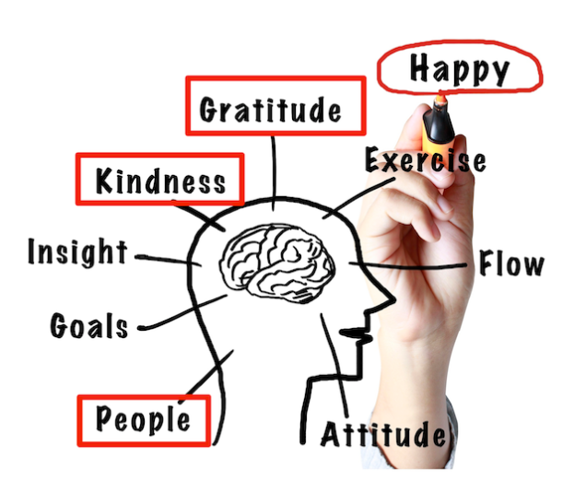

***Essential Habit #3 : Develop Positive Thinking***

The third essential habit that leads to fulfillment and happiness is to emphasize on cultivating positivity. Our brains tend to be more aware of something unpleasant that has happened rather than the good things. Therefore, our brains should be trained to develop positive thinking. However, this does not mean wearing a fake smile everyday or sing a happy song regardless of what is happening. You should not ignore reality and act like everything is amazing even when things are not going your way. Mulling over negative things contributes to anxiety and depression whereas deciding to observe, appreciate and expect positivity is a strong cheerfulness booster.

Allowing yourself to feel grateful can make a big impact in your total happiness. Research has shown that gratitude helps to trigger positive feelings, have a good feeling about yourself, build better relationships and enhance the immune system of your body. A new study proves that gratitude causes you to be more penny-wise on things you spend on. There are multiple simple tasks you can benefit from to boost and develop an attitude of gratitude. Firstly, you should learn to thank others sincerely. When someone lends u a hand and ease your day, be fast to thank them and show your appreciation no matter how big or small the favour is. It does not only cause the person to be happy as you will also gain a happiness lift from it. It becomes an immediate reward to observe how an expression of gratitude can make a positive change in someone else’s day. Then, you will realize that there’s a connection between humans and the things we do to each other matters.

According to research, owning a gratitude diary is an effective way to make you feel more contented right away as you will feel more connection with other people and become genuinely appreciative. It is also important to make a mental list of the things you appreciate about your life, whether small or big, as well as counting your blessings. Make a routine to reflect on everything you are thankful for regularly, notice all the wonderful people you’ve come across in life who have taught you valuable lessons, your past experiences whether good and bad as well as the things you have in your life now. It is of paramount importance to accept the negative event from your past as you can gain positive lessons from even the most painful experiences. You will definitely be happier and more grateful when you can find meaning in even the bad things you’ve experienced.

Other than that, a letter of gratitude can brighten up someone’s day too. Write a thoughtful gratitude letter to someone who has done something that affected your life in a good way whom you never have to chance to thank properly. In the letter, you should express the positive impact that this person brings to your life and how much it means to you and then mail the letter. Martin Seligman, a positive psychology expert states that reading a letter of gratitude can cause a boost in happiness. The importance of developing positive thinking aside, it is essential to surround ourselves with positive people too. It’s true that we can’t make everybody happy meaning that we can’t be friends with some people either. In other words, we should cut contact with those who constantly let us down by injecting negativity into our lives. The key to happiness and fulfillment is to to spend quality time with positive minded people who can influence us positively.

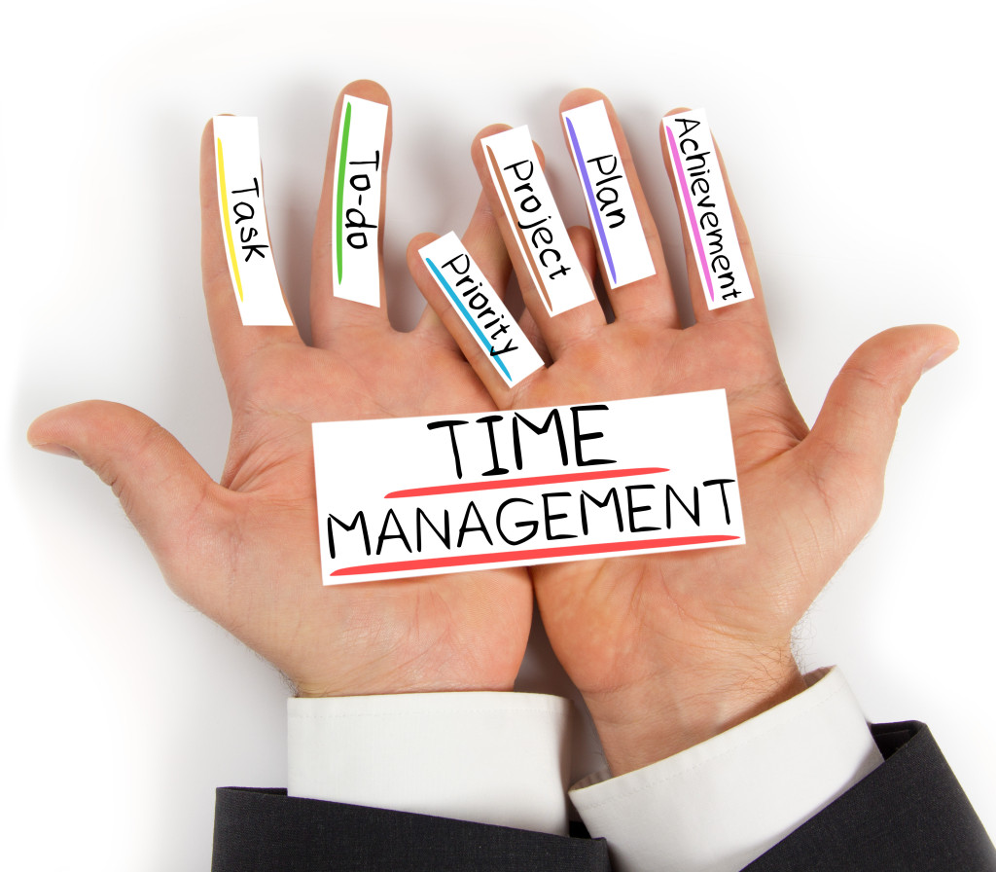

***Essential Habit #4: Effective Time Management***

[Effective time management](https://www.entrepreneur.com/video/284632) is a crucial aspect that can influence your overall happiness and sucess. How well you manage the precious time you have says a lot about what you are capable of achieving. Also, since all of us have equal amount of time in this world, how you leverage this resource will determine your potential for success. We all have 24 hours a day, with 1,440 minutes or 86,400 seconds. Not one person, regardless of how they look, whether they are wealthy or poor, their race and religion, or their geographic location has more time than the other. People who manage time effectively can handle their responsibilities in life and manage to juggle everything appropriately. They pay attention on their goals in the long run and proritize activities that will strive to motivate them instead of dragging them behind. Therefore, it is essential to implement a good system for managing time and make it habitual. This isn’t difficult to do but requires conscious and consistent effort to make it happen.

Once this habit has been adapted into your daily routine, virtually anything is possible and it wouldn’t be a problem to attain any goals in life. At times, isolation is the most effective technique to complete your to-do list. Keep in mind that the best reward for your effort and discipline is that you have completed all the things you had to do. However, when we fail to manage time effectively, most likely that our stress and worries would increase. We tend to get so distracted daily responding to life’s stressors and thus fail to tackle things preemptively that will help us get rid of unwanted crises or emergencies in the near future. For example, we forget to settle our bills, miss important meetings, and neglect our activities to pursue our goals.

Without proper time management, we have the tendency to procrastinate, become too socially active and also binge-watch series. Left unmanaged and uncontrolled, mobile phones, text messages and emails, more laptops and gadgets make us constantly available and attentive for long periods of time. So much precious time were taken away from more important long-term goals. Eventually, we end up feeling depressed when our wants or necessities in life aren’t fulfilled. Instead of making good use of time advancing towards our goals, we would regret at that moment as we realized that we are a few steps further away from reaching our goals due to time spent doing unecessary activities. As a result, it is clear that it’s not about the amount of time we have that causes unhappiness or discourage us from reaching our goals, it’s about how we can make full use of the little precious time we have.

On the other hand, it is important to manage time effectively as having too much or too little to do may be harmful to our mental health. If we get too busy, we won’t have sufficient time for self-enhancement which would prevent us from learning and growing. Conversely, if we have too little to do, we will begin overthinking everything in our lives which does not only drastically boost our stress levels, but would also not help us to blossom. The importance of effective time management can bring a positive impact to our lives by allowing us to continuously feel balanced, productive and inspired.

***Essential Habit #5: Efficient Goal-Setting***

Even in the best of times, long-term goals may appear overwhelming. However, by adopting a daily goal-setting strategy, this can be overcomed by focusing on the one-day-at-time, short-term scenarios. Efficient goal setting means setting the right intention where you’re clear about what you want to achieve. No matter what your goal is; short-term and small, or long-term and grandiose, you are required to take actionable steps in order to attain your goals. You should ensure that your goals are difficult enough to stimulate your interest and keep you motivated but not so laborious that you realistically have zero chance of achieving them.

As you can see, the comparison between setting a goal to become a world-class air pilot and setting a goal to literally fly a bird are two completely different goals. Finally, you need to have a constant check back on your goals to make sure you are on the right track to achieving them. It is pointless and time-consuming to set goals you have no intention of achieving them. Normally, what prevents us from succeding in life is our failure in setting goals appropriately.

Recently, a study has shown that only approximately 8% of the population who make a new year resolution actually attain them. Apart from those New Year’s resolution, its very common for most of the people to set goals without having the intention to achieve them. Definitely, we’ve all set goals before but eventually gave up in the end due to the inefficient process of setting goals. Whenever we set goals which are passive, we often just say it for fun but we don’t actually note down the goals and list all out with full details, nor make a plan to achieve them. As a result, we either end up failing or gave up on our goals.

On the other hand, others who have appropriate goal-setting, the SMARTER technique tend to have higher chances to achieve success. SMARTER goals are defined by as (S)pecific, (M)eaningful, (A)chievable, (R)elevant, and (T)ime-Based goals which are (E)valuated, with a (R)e-Adjusted approach which have been set until you achieve success. This is a crucial process to acheive success and those who don’t follow this goal setting would find goal attainment way tougher. SMARTER goals only work when you start writing your goals down on paper. Include what you want to achieve specifically and elaborate it in full details without missing out any important points. For instance, don’t just mention you aim to be a millionaire or to become fit.

State an exact figure on how much you aim to earn and an accurate quantity of pounds that you aim to lose as well as include a specific date for its attainment. If the goals you set are meaningful where they aren’t just superficial goals which keep you motivated, you’re halfway there. In addition, lofty goals are also discouraged as you don’t want to end up getting disappointed. For instance, you aim to earn a billion bucks within 1 year but you’re currently having a heavy debt burden. Having progress on our goals contirbutes to more positive emotions and more fulfillment with life. Also, it boosts our well being and overall happiness. Consequently, positive emotions drives up our motivation to act. This is a win-win situation if we can just get started with the setting of SMARTER goals.

# Conclusion

It is your choice to make your own decision in life. Would you like to reach for the stars or remained trapped in the endless loop of dull working life? Are you willing to get out of the comfort zone and strike happiness and success? Remember, nothing is holding you back except yourself. Start practicing these healthy habits and take actions to attain success and live your life to the fullest. I wish you the best of luck in overcoming challenges you face and conquering the negative force of life which prevents you from being happy and from achieving fulfilment in life.

If you wish to bring your level of happiness and fulfilment to a whole new level, I highly recommend you to check our this amazing blueprint!



>> CLICK HERE TO CHECK IT OUT<<  
[INSERT LINK HERE]