TraceInbox
  - A Privacy Aware Email Intelligence Workspace
Final Project Report
October 2026

Live demonstration | GitHub repository
20 synthetic emails | 10 cross email questions | 42 automated tests

Executive Summary
TraceInbox is a bilingual email intelligence workspace designed for students and knowledge workers who receive decisions, deadlines and updates across disconnected messages. The system imports mail, recovers the true sender from forwarded messages, applies a deterministic security gate, uses a language model for structured triage, extracts actions, groups related messages and answers cross-email questions with numbered source citations. It remains read-only: users return to the original mailbox when they need the full message or an external action.
The final prototype demonstrates the complete workflow through a privacy-safe public deployment containing 20 fictional but interrelated messages. Evaluation shows a useful but bounded result. DeepSeek reached 89.5% intent accuracy, 73.7% priority accuracy, 79.0% action accuracy and 73.7% exact deadline accuracy. Retrieval selected the expected sources for all ten development questions, but only six generated answers were fully acceptable and one misclassified a legitimate security notice as phishing. The project therefore succeeds as a traceable course prototype, not as a production-ready autonomous assistant.

Problem and Product Design
Email clients preserve messages well but do not convert scattered information into a reliable working view. A deadline extension may supersede an earlier date, a payment failure may sit beside routine subscription updates, and several messages may describe one course or project. Reading each message independently leaves the user to reconstruct state and remember what still requires action.
TraceInbox treats the original mailbox as the source of truth. Its interface provides prioritised summaries, action items, knowledge topics and a daily digest, while every answer exposes the supporting messages. English is the default submission interface and Chinese is available for personal use. The product supports Gmail and NetEase through IMAP; forwarded Outlook messages are normalised inside Gmail. The design intentionally excludes automatic sending, deletion, archiving and reply approval because those operations would increase risk without strengthening the central research question.

Architecture and Implementation
The application is a modular Flask service backed by SQLite. IMAP synchronization uses provider UIDs for incremental, idempotent imports. Deterministic code controls authentication, deduplication, security thresholds, database state, retrieval limits and original-message links. DeepSeek or local Ollama handles tasks that require language understanding, including intent classification, summaries and cited synthesis. Hosted accounts use separate workspace databases; passwords are hashed and mailbox credentials and model keys are encrypted before storage.
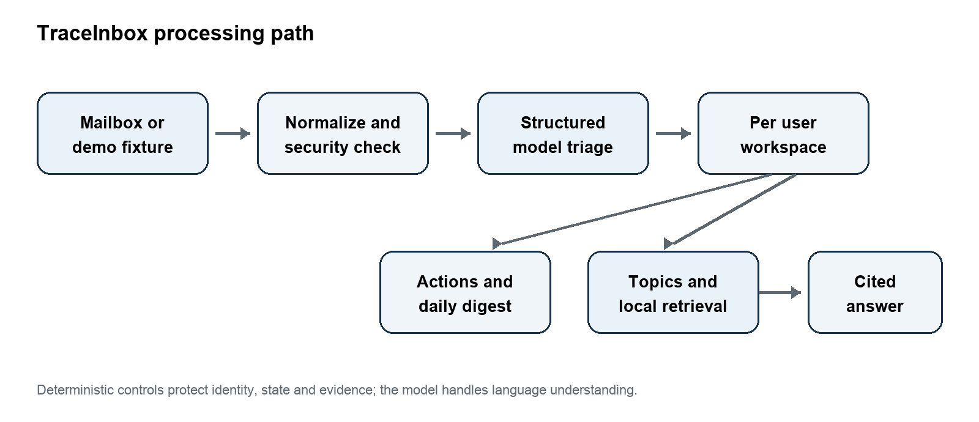
Figure 1 High level processing architecture
This split limits the model's authority. A failed call can affect one analysis, but it cannot silently mark mail as read, duplicate a completed action or invent a provider link. The public Render deployment goes further: it disables mailbox and model access, seeds fictional messages and uses checked-in answers so assessors can reproduce the same demonstration without exposing credentials or personal mail.

Evaluation Method
The repository separates four forms of evidence. The 20-email development set is a transparent regression suite. A frozen ten-email holdout tests unseen identifiers and wording. A live validation checks the deployed Render application. A separate model-backed run sends only synthetic content to DeepSeek and saves every prediction, answer and latency value. Gold labels define expected outcomes but are not shown to the model. The repository also includes the datasets, evaluation scripts, scoring rubric and raw JSON results.
Evaluation | Main result | Interpretation
Known regression | 100% product checks | Reproducibility, not generalisation
First frozen holdout | 87.5% precision, 80% exact sources | Exposed topic and refusal overfitting
Real model triage | 73.7% to 89.5% | Useful but inconsistent field extraction
Real model answers | 6 of 10 fully acceptable | Retrieval success did not ensure answer quality

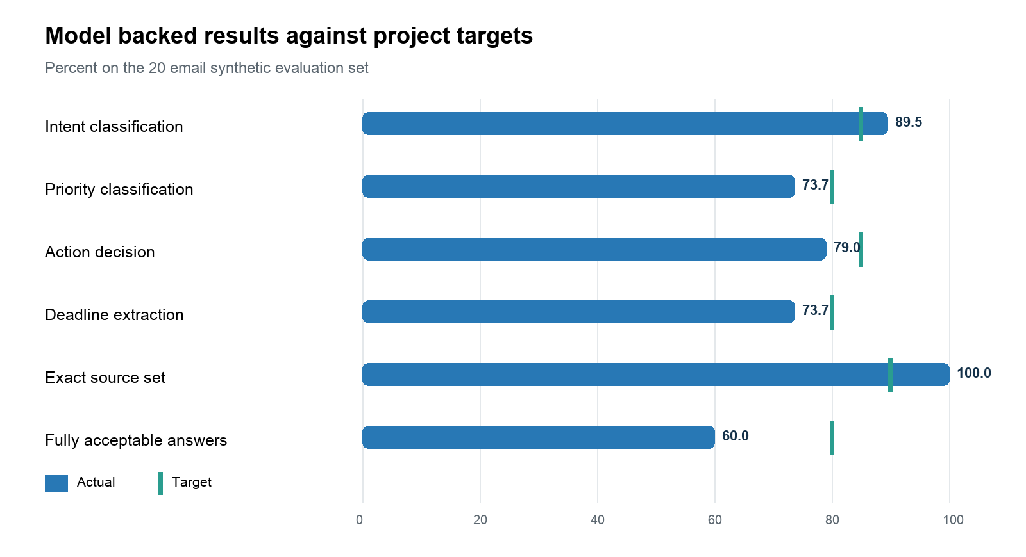
Figure 2 Reached results compared with project targets

Results and Critique
The tuned deterministic layer passed all checks on the known set, but the first holdout initially produced only 10% exact topic keys and failed the unsupported-question refusal. The result showed that early rules depended too heavily on familiar identifiers. General course, project, subscription and event patterns improved the known holdout, although that rerun is reported only as regression evidence because the failures had already influenced the code.
The real-model run exposed a different limitation. Exact retrieval sources reached 100% on the curated questions, yet generated answers omitted relevant facts in three cases. More seriously, one answer called a legitimate security alert phishing even though its cited source said the alert was legitimate. Answer latency was also high: the median was 40.9 seconds and the P95 was 51.9 seconds. These findings prevent a credible claim of production accuracy and show why retrieval, generation, safety and latency require separate metrics.

Trade Offs and Engineering Decisions
The main business trade-off is convenience versus privacy. DeepSeek is easy to access but selected email content leaves the device. Ollama keeps inference local but needs adequate hardware and may respond more slowly. The interface exposes this choice instead of silently changing providers. IMAP app passwords accelerated a provider-neutral prototype, while OAuth would offer better onboarding and revocation in a production service.
SQLite makes local installation portable and keeps each user's data easy to inspect. It is a poor fit for a durable hosted service on Render's ephemeral filesystem, so a managed encrypted database is required before real multi-user release. Lexical retrieval is transparent and works well for course codes and case IDs, but hybrid lexical and vector retrieval would better handle paraphrases. The public demo sacrifices live personalization to guarantee privacy, repeatability and predictable assessment.

Difficulties and Performance Tuning
The most difficult work involved identity and state rather than page construction. Forwarded university mail initially appeared to come from the account owner, so the parser had to recover the original sender from nested headers and body markers. Gmail search URLs were unreliable; exact thread IDs now produce direct links, while safe demo links open simulated originals. Reprocessing also created duplicate actions until action keys and status updates became idempotent.
Retrieval originally attached unrelated subscription messages to course questions. Exact identifier constraints, stopword handling, query-only expansions and confidence thresholds improved precision. The team also separated informational subscriptions from billing failures and excluded quarantined mail from the daily digest. These changes improved the demonstration, but they created a precision-recall tension: stricter thresholds can omit supporting messages in broader questions.

Future Development
The next evaluation should freeze a second multilingual holdout and ask an independent reviewer to score the saved answers. Product work should prioritise OAuth, durable encrypted storage, attachment parsing, user corrections, hybrid retrieval, calibrated confidence, security-specific answer rules and cost telemetry. These additions would address the measured failures rather than simply expanding the interface.

Conclusion
TraceInbox demonstrates that a small email agent can convert messages into a useful, inspectable workspace while preserving links to evidence. Its strongest result is the complete trace from summary to source. Its central limitation is equally clear: correct retrieval does not guarantee a complete or safe generated answer. The project is therefore a credible prototype with transparent evidence and a defined path to stronger reliability.

