Table of Contents

Table of Contents 1

Revision History 2

1. Introduction 3

1.1 Purpose 3

1.2 Document Conventions 4

1.3 Definitions, Acronyms and Abbreviations 4

1.4 References 4

2. High level requirement 5

2.1 Product Perspective 5

2.2 User case decriptions 6

2.2.1 Use case decriptionagram 6

2.3 Operating Environment 9

2.4 User Classes and Characteristics 9

2.5 Design and Implementation Constraints 10

2.6 User Documentation 10

2.7 Assumptions and Dependencies 10

3. FUNCTIONAL REQUIREMENT 10

3.1 Module 01 10

3.2 Module 02 14

4. Interface of Admin page and Client page 15

4.1 Interface of Admin page 15

4.2 Interface of Client page 16

16

5. System Features 17

5.1 Auto get client 17

5.2 Get list of client 17

5.3 Take one client to start a chat 17

5.4 Remove a client from client list 18

5.5 Display text 18

5.6 Display image 18

5.7 Send message 19

6. Other Nonfunctional Requirements 19

6.1 Performance Requirements 19

6.2 Safety Requirements 19

6.3 Security Requirements 19

6.4 Maintainability 19

7. Analyze chat session between Admin and Client (Sentiment Analysis) 20

7.1 Operation model 20

7.2 Code 21

21

21

7.3 Result 22

22

Revision History

|  |  |  |  |
| --- | --- | --- | --- |
| **Name** | **Date** | **Reason For Changes** | **Version** |
| Ho Tan Viet | 02/08/2019 |  | 2.0 |
|  |  |  |  |
|  |  |  |  |
|  |  |  |  |
|  |  |  |  |
|  |  |  |  |
|  |  |  |  |
|  |  |  |  |
|  |  |  |  |
|  |  |  |  |
|  |  |  |  |
|  |  |  |  |
|  |  |  |  |
|  |  |  |  |
|  |  |  |  |
|  |  |  |  |
|  |  |  |  |
|  |  |  |  |
|  |  |  |  |
|  |  |  |  |
|  |  |  |  |
|  |  |  |  |
|  |  |  |  |
|  |  |  |  |
|  |  |  |  |

# Introduction

## Purpose

Live chat is a Web service that allows businesses to communicate or chat in real-time with visitors to their website. Live Chat Services are often used to provide customer support services as quickly as possible, as well as information that customers need to know.

* Use online chat to increase customer satisfaction :

Leaving a special impression on customers is something that successful businesses can always do, no matter what field or business model they are. The important part that makes that special impression is truly different care and customer support services. When using online chat, many businesses also consider it the most important goal and value. With the presence of online chat on the website, customers can quickly and easily connect with businesses, thereby helping businesses maximize the ability to meet and satisfaction of customers. Compared to interactive channels, traditional customer support such as phone or email, online chat benefits many times higher customer satisfaction. This is also one of the extremely competitive advantages of any business.

* Use live chat to increase sales opportunities :

Many businesses consider online chat to be the main sales advisory channel, helping them get more orders or potential customers. Using smart features such as automatically inviting chat with triggers, we can easily identify and reach visitors with compelling information such as discount codes, promotions to promote the process. make decisions as soon as they are considering using certain products or services. This is especially effective for online retailers, travel websites or gifts.

* Live chat creates potential customers for businesses :

Customer data from live chat help us monitor visitor behavior to provide personalized advice that provides a special experience that contributes to the decision making the process. Use API to transfer customer data into CRM tools, email marketing to manage and maintain relationships with customers, easily connect to send promotional and preferential information later. Label the visitor category to identify the right audience.

* Apply online chat with the desire to reduce the number of guests leaving the shopping cart:

There are many solutions that can help us reduce the percentage of guests leaving the shopping cart or payment page via online chat. One of them is an active appearance in an appropriate and impressive position. Many visitors visit the website and add products to our shopping cart, but by the time the payment is completed, they feel they do not need to buy or consider when they see the price. This is the right time for us to actively approach and promote the buying process. By answering questions, advising product information, offering promotional incentives at this time, customers will surely have better psychology and ability to decide faster.

## Document Conventions

None

## Definitions, Acronyms and Abbreviations

|  |  |  |
| --- | --- | --- |
| **#** | **Abbreviations/T**  **erms** | **Explanation** |
| 1 | SRS | Software Requirement Specification |
| 2 | BR | Business Rule |
| 3 | SC | Screen |
| 4 | UC | Use Case |
| 5 | CRUD | Create/Read/Update/Delete a record in database |

## References

|  |  |  |  |  |
| --- | --- | --- | --- | --- |
| **Title** | **Author** | **Version** | **Date** | **Source Location** |
|  |  |  |  |  |
|  |  |  |  |  |
|  |  |  |  |  |
|  |  |  |  |  |
|  |  |  |  |  |
|  |  |  |  |  |
|  |  |  |  |  |
|  |  |  |  |  |
|  |  |  |  |  |
|  |  |  |  |  |
|  |  |  |  |  |
|  |  |  |  |  |
|  |  |  |  |  |
|  |  |  |  |  |
|  |  |  |  |  |

# High level requirement

## Product Perspective

The product is supposed to be an open-source, under the GNU General Public License. It is a web-based system implementing a client-server model. The Live Chat service system provides simple mechanisms for Admin to support multiple clients at the same time.

The following are the main features built into the system:

* Auto get client: Automatically add clients to the client list if they are online on the admin website.
* Get list of client : Show the number of clients online on admin's website.
* Take one client to start a chat: A client in the client list is clicked by admin, only the client starts chatting first will the admin be granted the right to reply.
* Remove a client from client list: The client exits the website, the client will be removed from the client list.
* Display text: Show chat history as well as current chat with the client.
* Display image: Show the avatar image of the client.
* Send message: Send the chat to start the conversation.
* Turn off website : Turn off the web, then automatically send the remove message to admin.
* Join client list: Logging into the admin web site is automatically added to the client list.

## User case decriptions

## 2.2.1Use case decriptionagram

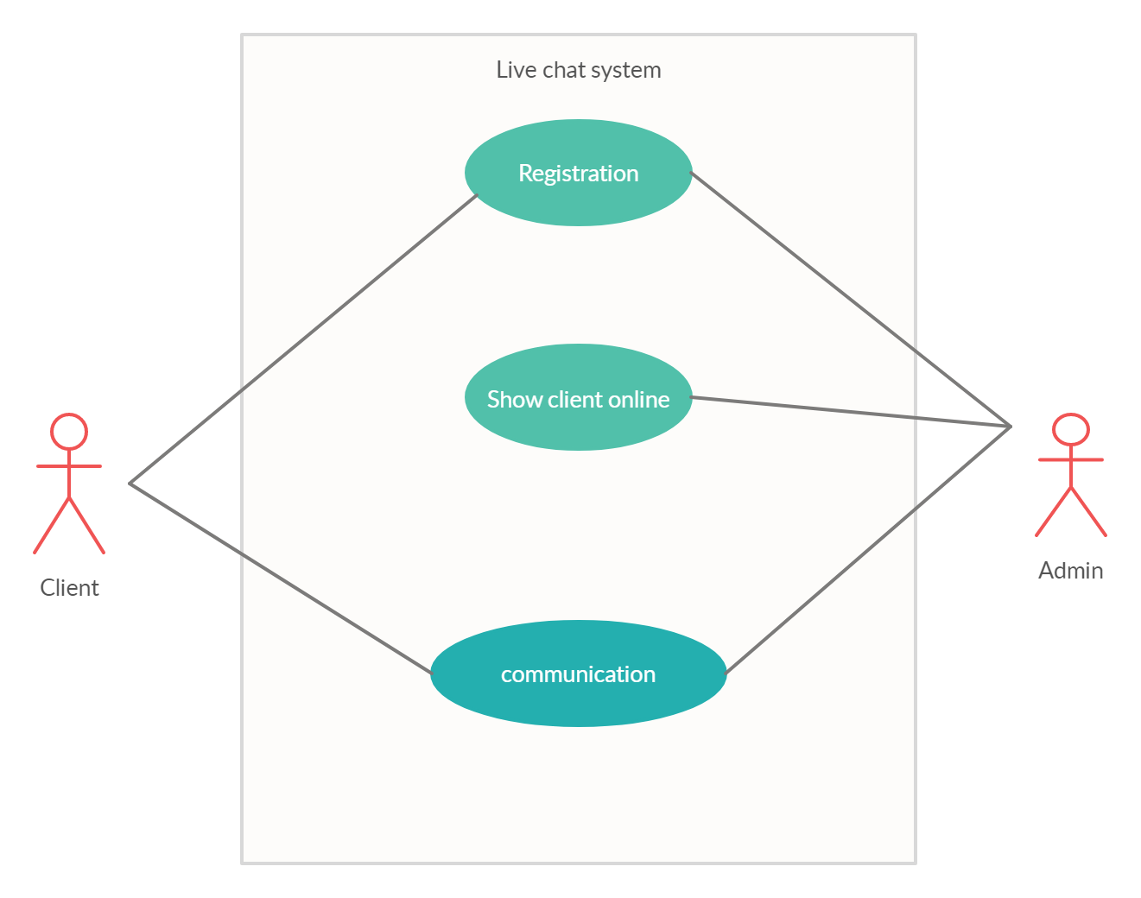

Diagram 1: function of client and admin

Note: An admin can talk to multiple clients.

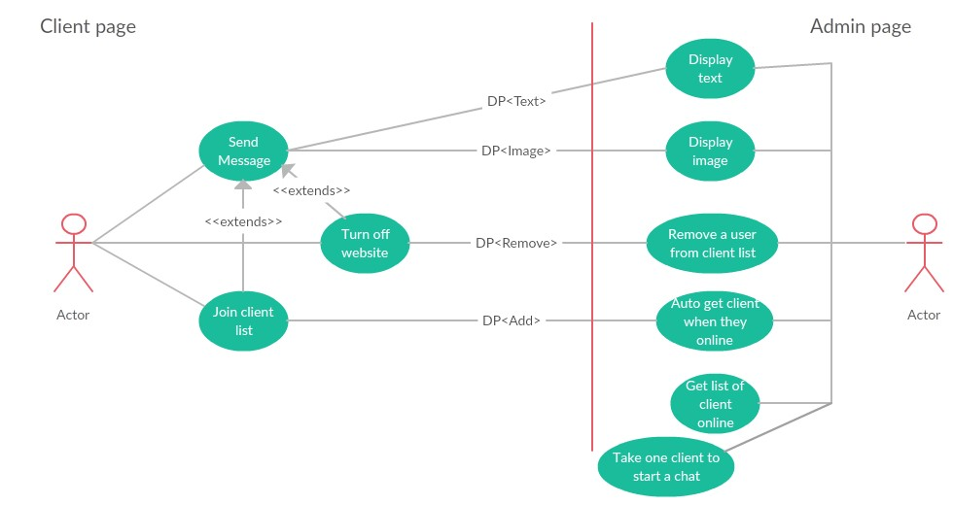

Diagram 2: show details of the operation of the live chat service system

Note: The remove a user from client list function is incomplete and the client can only talk to one admin.

**2.2.2 User DecriptionZ**

|  |  |  |
| --- | --- | --- |
| **#** | **Actor Name** | **Definition & Interests** |
| 1 | Admin | The admin page will automatically show the clients that are online and only when the client starts the conversation, will the admin be able to communicate with the client, the admin can view the avatar, the previous chat history with the client and possibly the Support multiple clients at the same time. |
| 2 | Client | The client will talk to admin and request support as desired. |
| 3 | Live Chat System | Get information from the program |

**2.2.3 Use Case Decriptionagram**

|  |  |  |  |
| --- | --- | --- | --- |
| **#** | **ID** | **Name** | **Brief Description** |
| **1** | UC01 | Auto get client | Automatically add clients to the client list if they are online on the admin website. |
| **2** | UC02 | Get list of client | Show the number of clients online on admin's website. |
| **3** | UC03 | Take one client to start a chat | A client in the client list is clicked by admin, only the client starts chatting first will the admin be granted the right to reply. |
| **4** | UC04 | Remove a client from client list | The client exits the website, the client will be removed from the client list. |
| **5** | UC05 | Display text | Show chat history as well as current chat with client. |
| **6** | UC06 | Display image | Show the avatar image of the client. |
| **7** | UC07 | Send message | Send the chat to start the conversation. |
| **8** | UC08 | Turn off website | Turn off the web, then automatically send the remove message to admin. |
| **9** | UC09 | Join client list | Logging into the admin web site is automatically added to the client list |

### 2.2.4 Use Case & User Permission Mapping

|  |  |  |  |
| --- | --- | --- | --- |
| **Use Case** | **Use Case Name** | **Admin** | **Client** |
| **UC01** | Auto get client | X |  |
| **UC02** | Get list of client | X |  |
| **UC03** | Take one client to start a chat | X |  |
| **UC04** | Remove a client from client list | X |  |
| **UC05** | Display text | X |  |
| **UC06** | Display image | X |  |
| **UC07** | Send message |  | X |
| **UC08** | Turn off website |  | X |
| **UC09** | Join client list |  | X |

## Operating Environment

Web applications must be used on desktops or laptops.

Request desktop device, laptop.

Must have an internet connection.

## User Classes and Characteristics

**Types of clients that will use this software include:**

**Student:**

+ Education level: secondary school and high school, university students, colleges, ........

+ Frequency: can be used anytime anywhere 24/7

+ Security level: absolutely safe because the conversation is only between the admin and the client.

**Who went to work:**

+ Education level: at university level or above or without a degree.

+ Frequency: can be used anytime, anywhere

+ Security level: absolutely safe because the conversation is only between the admin and the client.

**Others:**

+ Frequency: can be used anytime, anywhere

+ Security level: absolutely safe because the conversation is only between the admin and the client.

## Design and Implementation Constraints

Made by the team without a corporate and legal policy.

Program Is written in java language with the support of html and java script can be run on the web platform and use ajax to connect to the web application's backend and data when uploaded will not refresh the page..

Security: The client must start the conversation first.

## User Documentation

Documents include manual files that can be downloaded online or attached with software. Can contact via the email address of the team or phone, ....

Document format: .pdf, .docx files.

## Assumptions and Dependencies

# FUNCTIONAL REQUIREMENT

## Module 01

### UC01: Auto get client

|  |  |  |  |  |  |
| --- | --- | --- | --- | --- | --- |
| **ID** | **Name** | **Account** | **Trigger** | **Pre-condition** | **Post condition** |
| UC01 | Auto get client | Admin | client online on the admin website. |  |  |

**Activities**

|  |  |  |
| --- | --- | --- |
| **Admin** | **System** | |
| Main flow | | |
|  | 1 | Auto get client |

|  |  |
| --- | --- |
| Alternative flow | none |

System Messages

|  |  |
| --- | --- |
| MS01 | Error. |
|  |  |

### UC02: Get list of client

|  |  |  |  |  |  |
| --- | --- | --- | --- | --- | --- |
| **ID** | **Name** | **Account** | **Trigger** | **Pre-condition** | **Post condition** |
| UC02 | Get list of client | Admin | Admin press get all client button |  |  |

**Activities**

|  |  |  |  |
| --- | --- | --- | --- |
| **Admin** | | **System** | |
| Main flow | | | |
| 1 | Admin press get all client button |  | |
|  |  | 2 | Show all client online. |

|  |  |
| --- | --- |
| Alternative flow | none |

System Messages

|  |  |
| --- | --- |
| MS02 | Error. |

### UC03: Take one client to start a chat

|  |  |  |  |  |  |
| --- | --- | --- | --- | --- | --- |
| **ID** | **Name** | **Account** | **Trigger** | **Pre-condition** | **Post condition** |
| UC03 | Take one client to start a chat | Admin | Admin click one client on client list |  |  |

**Activities**

|  |  |  |  |
| --- | --- | --- | --- |
| **Admin** | | **System** | |
| Main flow | | | |
| 1 | Admin click one client on client list |  | |
|  |  | 2 | If client start chat first, allow admin to reply. |

|  |  |
| --- | --- |
| Alternative flow | none |

System Messages

|  |  |
| --- | --- |
| MS03 | Error. |

### UC04: Remove a client from client list

|  |  |  |  |  |  |
| --- | --- | --- | --- | --- | --- |
| **ID** | **Name** | **Account** | **Trigger** | **Pre-condition** | **Post condition** |
| UC04 | Remove a client from client list | Admin | Client turn off the website |  |  |

**Activities**

|  |  |  |  |
| --- | --- | --- | --- |
| **Admin** | | **System** | |
| Main flow | | | |
|  |  | 1 | If client turn off the website, remove them from client list. |

|  |  |
| --- | --- |
| Alternative flow | none |

System Messages

|  |  |
| --- | --- |
| MS04 | Error. |

### UC05: Display text

|  |  |  |  |  |  |
| --- | --- | --- | --- | --- | --- |
| **ID** | **Name** | **Account** | **Trigger** | **Pre-condition** | **Post condition** |
| UC05 | Display text | Admin | A client sending the first message or message |  |  |

**Activities**

|  |  |  |  |
| --- | --- | --- | --- |
| **Admin** | | **System** | |
| Main flow | | | |
|  |  | 1 | If the client sends the first message or message, it is displayed under the avatar icon of the client list |

|  |  |
| --- | --- |
| Alternative flow | none |

System Messages

|  |  |
| --- | --- |
| MS05 | Error. |

### UC06: Display image

|  |  |  |  |  |  |
| --- | --- | --- | --- | --- | --- |
| **ID** | **Name** | **Account** | **Trigger** | **Pre-condition** | **Post condition** |
| UC06 | Display image | Admin | A client sending the first message or message |  |  |

**Activities**

|  |  |  |  |
| --- | --- | --- | --- |
| **Admin** | | **System** | |
| Main flow | | | |
|  |  | 1 | If the client sends the first message or message, it is displayed under the avatar icon contain client avatar of the client list. |

|  |  |
| --- | --- |
| Alternative flow | none |

System Messages

|  |  |
| --- | --- |
| MS06 | Error. |

### UC07: Send message

|  |  |  |  |  |  |
| --- | --- | --- | --- | --- | --- |
| **ID** | **Name** | **Account** | **Trigger** | **Pre-condition** | **Post condition** |
| UC07 | Send message | Admin & Client | Press sending message button |  |  |

**Activities**

|  |  |  |
| --- | --- | --- |
| **Admin & Client** | | **System** |
| Main flow | | |
| 1 | Press sending message button |  |

|  |  |
| --- | --- |
| Alternative flow | none |

System Messages

|  |  |
| --- | --- |
| MS07 | Error. |

## Module 02

### 3.2.1 UC08: Turn off website

|  |  |  |  |  |  |
| --- | --- | --- | --- | --- | --- |
| **ID** | **Name** | **Account** | **Trigger** | **Pre-condition** | **Post condition** |
| UC08 | Turn off website | Client | Client turn off website |  |  |

Activities

|  |  |  |  |
| --- | --- | --- | --- |
| **Client** | | **System** | |
| Main flow: Move to List of User successful | | | |
| 1 | Client turn off website |  | |
|  |  | 2 | System remove the client from the client list |

|  |  |
| --- | --- |
| Alternative flow | none |

System Messages

|  |  |
| --- | --- |
| MS08 | Error |
|  |  |

### 

### 3.2.2 UC09: Join client list

|  |  |  |  |  |  |
| --- | --- | --- | --- | --- | --- |
| **ID** | **Name** | **Account** | **Trigger** | **Pre-condition** | **Post condition** |
| UC09 | Join client list | Client | Client access to the website of admin |  |  |

Activities

|  |  |  |  |
| --- | --- | --- | --- |
| **Client** | | **System** | |
| Main flow | | | |
| 1 | Client access to the website of admin. |  | |
|  |  | 2 | System adds the client to the client list. |

|  |  |
| --- | --- |
| Alternative flow | none |

System Messages

|  |  |
| --- | --- |
| MS09 | Error. |

# Interface of Admin page and Client page

## Interface of Admin page

## Interface of Client page

## 

# System Features

## Auto get client

### Description and Priority

Automatically add clients to the client list if they are online on the admin website.

Priority : High

### Stimulus/Response Sequences

The system show client has just logged into the website.

### Functional Requirements

REQ-1: The system must retrieve the correct client with real time.

## Get list of client

### Description and Priority

Show the number of clients online on admin's website.

Priority : High

### Stimulus/Reponse Sequences

Admin press get all client button.

### Functional Requirements

REQ-1: Obtain all the online clients and continuously update the client list when new clients log in.

## Take one client to start a chat

### Description and Priority

A client in the client list is clicked by admin, only the client starts chatting first will the admin be granted the right to reply.

Priority : High

### Stimulus/Reponse Sequences

Access to that client's address and show chat history if available or the first message.

### Functional Requirements

REQ-1: Returns the client's chat history correctly.

## Remove a client from client list

### Description and Priority

The client exits the website, the client will be removed from the client list.

Priority : High

### Stimulus/Reponse Sequences

The client turns off the website and the client will be removed from the client list.

### 5.4.3 Functional Requirements

REQ-1: Delete the correct client that has turned off the web.

## Display text

### Description and Priority

Show chat history as well as current chat with client.

### Stimulus/Reponse Sequences

The function is executed after the function “ Take one client to start a chat” is completed.

### Functional Requirements

REQ-1: Show the correct chat history of the client.

## Display image

### Description and Priority

Show the avatar image of the client.

### Stimulus/Reponse Sequences

User avatar image is random.

### Functional Requirements

REQ-1: display images successfully

## Send message

### Description and Priority

Send the chat to start the conversation..

### Stimulus/Reponse Sequences

For the client, they must start chatting first, then the admin will be given the right to reply.

### Functional Requirements

REQ-1: display texts successfully

# Other Nonfunctional Requirements

## Performance Requirements

- After the client accesses the website, if the client list of the admin page is in the enabled state, the client appears on the list no more than 2 seconds.

- The chat from both sides is displayed on the chat frame for no more than 2 seconds.

- Speed of loading chat frames when admin selects client to communicate, no more than 2 seconds.

- The image of the client is uploaded in no more than 3 seconds

- All data of the conversation is stored continuously in the database

- Time to remove client no more than 2 seconds.

## Safety Requirements

An admin should only support 3 people at the same time, the conversation data saved should not be known to customers.

## Security Requirements

The system ensures that the conversation between the client and admin has no third person involved.

## Maintainability

The software is built according to MVC model with spring boot, so it is easy to maintain and upgrade new functions.

# Analyze chat session between Admin and Client (Sentiment Analysis)

## Operation model

## Code

## 

- Using pymongo to connect to get data.

- Using TextBlod library and nltk library.

## 

Function stmSentence(str) : cut str each sentence , Calculate positive their average

Function tong(arr) : Calculate the total positive of admin or customer

## Result

## 

The above are 2 chats and their results