# Shine-server内存分析

## 概述:

客户报告shine-server在生产环境下内存使用逐步攀升,采用pmap命令观察shine-server内存使用发现有已经分配但是没有使用的空内存,怀疑是这些分配内存导致shine-server占用过多内存.

针对客户提出疑问,对shine-server的内存转储dump文件进行分析,由于实时分析JVM运行情况需要对JVM进行配置并且重启,再加上对系统性能的影响也比较明显,因此采用了模拟的方式对相同通道配置的shine-server进行了测试.

## 二.版本管理

|  |  |  |  |  |  |
| --- | --- | --- | --- | --- | --- |
| 版本 | 修改人 | 修改日期 | 描述 | 审批人 | 审批日期 |
| V1.0 | 刘盾 | 2016-12-27 | 创建 |  |  |

## 三.Dump文件分析内容:

### 3.1 dump文件概览:

|  |  |
| --- | --- |
| Property Name | Property Value |
| Used heap dump | 72.9 MB |
| Number of objects | 1,368,992 |
| Number of classes | 9,079 |
| Number of class loaders | 154 |
| Number of GC roots | 3,063 |
| Format | hprof |
| JVM version |  |
| Time | GMT+8 上午10:25:46 |
| Date | 2016年12月29日 |
| Identifier size | 64-bit |
| Compressed object pointers | TRUE |
| File path | F:\mirth生产环境\生产二次dump\mirth.bin |
| File length | 388,995,685 |

### 3.2线程

|  |  |  |  |  |  |  |
| --- | --- | --- | --- | --- | --- | --- |
|  | Object / Stack Frame | Name | Shallow Heap | Retained Heap | Context Class Loader | Is Daemon |
| 1 | com.mirth.connect.donkey.server.data.DonkeyStatisticsUpdater @ 0x5cce73310 | Statistics Updater Thread | 136 | 26608 | java.net.URLClassLoader @ 0x5ca41c780 | FALSE |
| 2 | com.mirth.connect.server.Mirth @ 0x5ca41c5b8 | Main Server Thread | 184 | 21128 | java.net.URLClassLoader @ 0x5ca41c780 | FALSE |
| 3 | java.lang.Thread @ 0x5cc46dff8 | qtp1522119580-65 | 120 | 6200 | java.net.URLClassLoader @ 0x5ca41c780 | FALSE |
| 4 | java.lang.Thread @ 0x5cc46de20 | qtp1522119580-64 | 120 | 6200 | java.net.URLClassLoader @ 0x5ca41c780 | FALSE |
| 5 | java.lang.Thread @ 0x5d8046b50 | qtp1346061225-76817 | 120 | 6128 | java.net.URLClassLoader @ 0x5ca41c780 | FALSE |
| 6 | java.lang.Thread @ 0x5cc46dc40 | qtp1522119580-66 | 120 | 6128 | java.net.URLClassLoader @ 0x5ca41c780 | FALSE |
| 7 | java.lang.Thread @ 0x5d80458c0 | qtp1346061225-76828 | 120 | 5984 | java.net.URLClassLoader @ 0x5ca41c780 | FALSE |
| 8 | java.lang.Thread @ 0x5d7b63650 | qtp1346061225-76811 | 120 | 5984 | java.net.URLClassLoader @ 0x5ca41c780 | FALSE |
| 9 | java.lang.Thread @ 0x5cab4bf90 | qtp161054747-27-selector-ServerConnectorManager@2331a4f7/0 | 120 | 5416 | java.net.URLClassLoader @ 0x5ca41c780 | FALSE |
| 10 | java.lang.Thread @ 0x5cab4c190 | qtp161054747-28-selector-ServerConnectorManager@2331a4f7/1 | 120 | 4736 | java.net.URLClassLoader @ 0x5ca41c780 | FALSE |
| 11 | java.lang.Thread @ 0x5cc0e7c80 | qtp161054747-34-selector-ServerConnectorManager@2331a4f7/3 | 120 | 4664 | java.net.URLClassLoader @ 0x5ca41c780 | FALSE |
| 12 | java.lang.Thread @ 0x5cab4ae48 | qtp161054747-29-selector-ServerConnectorManager@2331a4f7/2 | 120 | 4664 | java.net.URLClassLoader @ 0x5ca41c780 | FALSE |
| 13 | java.lang.Thread @ 0x73a1fcbe8 | pool-15-thread-24204 | 120 | 1128 | java.net.URLClassLoader @ 0x5ca41c780 | FALSE |
| 14 | java.lang.Thread @ 0x5d8096fa0 | pool-15-thread-24201 | 120 | 1128 | java.net.URLClassLoader @ 0x5ca41c780 | FALSE |
| 15 | java.lang.Thread @ 0x5d8096a40 | pool-15-thread-24202 | 120 | 1128 | java.net.URLClassLoader @ 0x5ca41c780 | FALSE |
| 16 | java.lang.Thread @ 0x5d80964e0 | pool-15-thread-24203 | 120 | 1128 | java.net.URLClassLoader @ 0x5ca41c780 | FALSE |
| 17 | java.lang.Thread @ 0x5d7b17368 | pool-15-thread-24197 | 120 | 1128 | java.net.URLClassLoader @ 0x5ca41c780 | FALSE |
| 18 | java.lang.Thread @ 0x5d7aeabe8 | pool-15-thread-24195 | 120 | 1128 | java.net.URLClassLoader @ 0x5ca41c780 | FALSE |
| 19 | java.lang.Thread @ 0x5d7adfc28 | pool-15-thread-24198 | 120 | 1128 | java.net.URLClassLoader @ 0x5ca41c780 | FALSE |
| 20 | java.lang.Thread @ 0x5d68987a0 | pool-15-thread-24193 | 120 | 1128 | java.net.URLClassLoader @ 0x5ca41c780 | FALSE |
| 21 | java.lang.Thread @ 0x5d6898168 | pool-15-thread-24194 | 120 | 1128 | java.net.URLClassLoader @ 0x5ca41c780 | FALSE |
| 22 | java.lang.Thread @ 0x5d2df7aa8 | pool-15-thread-24190 | 120 | 1128 | java.net.URLClassLoader @ 0x5ca41c780 | FALSE |
| 23 | java.lang.Thread @ 0x5d2d20980 | pool-15-thread-24188 | 120 | 1128 | java.net.URLClassLoader @ 0x5ca41c780 | FALSE |
| 24 | java.lang.Thread @ 0x5d2d1ec80 | pool-15-thread-24189 | 120 | 1128 | java.net.URLClassLoader @ 0x5ca41c780 | FALSE |
| 25 | java.lang.Thread @ 0x5d2cb50b8 | pool-15-thread-24187 | 120 | 1128 | java.net.URLClassLoader @ 0x5ca41c780 | FALSE |
| 26 | java.lang.Thread @ 0x5d2ab99c0 | pool-15-thread-24177 | 120 | 1128 | java.net.URLClassLoader @ 0x5ca41c780 | FALSE |
| 27 | java.lang.Thread @ 0x5d2ab8e20 | pool-15-thread-24180 | 120 | 1128 | java.net.URLClassLoader @ 0x5ca41c780 | FALSE |
| 28 | java.lang.Thread @ 0x5d22137e8 | pool-15-thread-24171 | 120 | 1128 | java.net.URLClassLoader @ 0x5ca41c780 | FALSE |
| 29 | java.lang.Thread @ 0x5d2141f38 | pool-15-thread-24170 | 120 | 1128 | java.net.URLClassLoader @ 0x5ca41c780 | FALSE |
| 30 | java.lang.Thread @ 0x5d150a0b8 | pool-15-thread-24158 | 120 | 1128 | java.net.URLClassLoader @ 0x5ca41c780 | FALSE |
| 31 | java.lang.Thread @ 0x5d0956bc8 | pool-15-thread-24146 | 120 | 1128 | java.net.URLClassLoader @ 0x5ca41c780 | FALSE |
| 32 | java.lang.Thread @ 0x5d02c8250 | pool-15-thread-24130 | 120 | 1128 | java.net.URLClassLoader @ 0x5ca41c780 | FALSE |
| 33 | java.lang.Thread @ 0x5ca414eb8 | AuditableEventListener Consumer Thread | 120 | 1008 | sun.misc.Launcher$AppClassLoader @ 0x5ca4270c0 | FALSE |
| 34 | java.util.TimerThread @ 0x5cc6ebaa0 | Timer-1 | 128 | 1000 | java.net.URLClassLoader @ 0x5ca41c780 | FALSE |
| 35 | java.lang.Thread @ 0x5cc0d6070 | qtp1346061225-85-selector-ServerConnectorManager@391060dc/1 | 120 | 808 | java.net.URLClassLoader @ 0x5ca41c780 | FALSE |
| 36 | java.lang.Thread @ 0x5cc0cc4f8 | qtp1346061225-86-selector-ServerConnectorManager@391060dc/2 | 120 | 736 | java.net.URLClassLoader @ 0x5ca41c780 | FALSE |
| 37 | java.lang.Thread @ 0x5cc0a68e8 | qtp1346061225-87-selector-ServerConnectorManager@391060dc/3 | 120 | 736 | java.net.URLClassLoader @ 0x5ca41c780 | FALSE |
| 38 | java.lang.Thread @ 0x5cc0db778 | qtp1346061225-88-acceptor-0@352e70e9-ServerConnector@11d1349b{HTTP/1.1}{0.0.0.0:8001} | 120 | 696 | java.net.URLClassLoader @ 0x5ca41c780 | FALSE |
| 39 | java.lang.Thread @ 0x5cab4b590 | qtp161054747-22-selector-ServerConnectorManager@3359405b/0 | 120 | 640 | java.net.URLClassLoader @ 0x5ca41c780 | FALSE |
| 40 | java.lang.Thread @ 0x5cbfaed88 | qtp1346061225-84-selector-ServerConnectorManager@391060dc/0 | 120 | 632 | java.net.URLClassLoader @ 0x5ca41c780 | FALSE |
| 41 | java.lang.Thread @ 0x5cc0e7728 | qtp161054747-35-acceptor-0@55f1c07b-sslconnector@a42e5ce{SSL-HTTP/1.1}{0.0.0.0:8004} | 120 | 624 | java.net.URLClassLoader @ 0x5ca41c780 | FALSE |
| 42 | org.quartz.core.QuartzSchedulerThread @ 0x5cad11aa8 | DataPruner_QuartzSchedulerThread | 176 | 600 | java.net.URLClassLoader @ 0x5ca41c780 | FALSE |
| 43 | java.lang.Thread @ 0x73a1fc7b8 | pool-15-thread-24205 | 120 | 600 | java.net.URLClassLoader @ 0x5ca41c780 | FALSE |
| 44 | java.lang.Thread @ 0x5cc477c98 | qtp1522119580-59-selector-ServerConnectorManager@31e8c860/0 | 120 | 576 | java.net.URLClassLoader @ 0x5ca41c780 | FALSE |
| 45 | java.lang.Thread @ 0x5cc476638 | qtp1522119580-62-selector-ServerConnectorManager@31e8c860/3 | 120 | 576 | java.net.URLClassLoader @ 0x5ca41c780 | FALSE |
| 46 | java.lang.Thread @ 0x5cc46e240 | qtp1522119580-60-selector-ServerConnectorManager@31e8c860/1 | 120 | 576 | java.net.URLClassLoader @ 0x5ca41c780 | FALSE |
| 47 | java.lang.Thread @ 0x5cc46d610 | qtp1522119580-61-selector-ServerConnectorManager@31e8c860/2 | 120 | 576 | java.net.URLClassLoader @ 0x5ca41c780 | FALSE |
| 48 | java.lang.Thread @ 0x5cc72dfe0 | DashboardConnectorEventListener Consumer Thread | 120 | 568 | java.net.URLClassLoader @ 0x5ca41c780 | FALSE |
| 49 | java.lang.Thread @ 0x5cab4bb90 | qtp161054747-25-selector-ServerConnectorManager@3359405b/3 | 120 | 568 | java.net.URLClassLoader @ 0x5ca41c780 | FALSE |
| 50 | java.lang.Thread @ 0x5cab4b990 | qtp161054747-24-selector-ServerConnectorManager@3359405b/2 | 120 | 568 | java.net.URLClassLoader @ 0x5ca41c780 | FALSE |
| 51 | java.lang.Thread @ 0x5cab4b790 | qtp161054747-23-selector-ServerConnectorManager@3359405b/1 | 120 | 568 | java.net.URLClassLoader @ 0x5ca41c780 | FALSE |
| 52 | java.lang.Thread @ 0x5cc46d100 | qtp1522119580-63-acceptor-0@5c2e7ccf-ServerConnector@4d968759{HTTP/1.1}{0.0.0.0:8084} | 120 | 536 | java.net.URLClassLoader @ 0x5ca41c780 | FALSE |
| 53 | java.lang.Thread @ 0x5cab4bd90 | qtp161054747-26-acceptor-0@39a1e580-connector@793ef041{HTTP/1.1}{0.0.0.0:2207} | 120 | 512 | java.net.URLClassLoader @ 0x5ca41c780 | FALSE |
| 54 | java.lang.Thread @ 0x5cc0e3f20 | Scheduler-390751162 | 120 | 504 | java.net.URLClassLoader @ 0x5ca41c780 | FALSE |
| 55 | java.lang.Thread @ 0x73a1fe720 | pool-7-thread-27843 | 120 | 488 | java.net.URLClassLoader @ 0x5ca41c780 | FALSE |
| 56 | java.lang.Thread @ 0x73a1fe3b0 | pool-7-thread-27844 | 120 | 488 | java.net.URLClassLoader @ 0x5ca41c780 | FALSE |
| 57 | java.lang.Thread @ 0x73a1fe078 | pool-7-thread-27847 | 120 | 488 | java.net.URLClassLoader @ 0x5ca41c780 | FALSE |
| 58 | java.lang.Thread @ 0x73a1fdd40 | pool-7-thread-27846 | 120 | 488 | java.net.URLClassLoader @ 0x5ca41c780 | FALSE |
| 59 | java.lang.Thread @ 0x73a1fda08 | pool-7-thread-27845 | 120 | 488 | java.net.URLClassLoader @ 0x5ca41c780 | FALSE |
| 60 | java.lang.Thread @ 0x73a1fd6d0 | pool-7-thread-27848 | 120 | 488 | java.net.URLClassLoader @ 0x5ca41c780 | FALSE |
| 61 | java.lang.Thread @ 0x5d8097b00 | pool-7-thread-27837 | 120 | 488 | java.net.URLClassLoader @ 0x5ca41c780 | FALSE |
| 62 | java.lang.Thread @ 0x5d8097800 | pool-7-thread-27839 | 120 | 488 | java.net.URLClassLoader @ 0x5ca41c780 | FALSE |
| 63 | java.lang.Thread @ 0x5d8094bc8 | pool-7-thread-27836 | 120 | 488 | java.net.URLClassLoader @ 0x5ca41c780 | FALSE |
| 64 | java.lang.Thread @ 0x5d7af0ab8 | pool-7-thread-27828 | 120 | 488 | java.net.URLClassLoader @ 0x5ca41c780 | FALSE |
| 65 | java.lang.Thread @ 0x5d7adf948 | pool-7-thread-27824 | 120 | 488 | java.net.URLClassLoader @ 0x5ca41c780 | FALSE |
| 66 | java.lang.Thread @ 0x5d7adf388 | pool-7-thread-27827 | 120 | 488 | java.net.URLClassLoader @ 0x5ca41c780 | FALSE |
| 67 | java.lang.Thread @ 0x5d7add088 | pool-7-thread-27825 | 120 | 488 | java.net.URLClassLoader @ 0x5ca41c780 | FALSE |
| 68 | java.lang.Thread @ 0x5d688c318 | pool-7-thread-27819 | 120 | 488 | java.net.URLClassLoader @ 0x5ca41c780 | FALSE |
| 69 | java.lang.Thread @ 0x5d542a528 | pool-7-thread-27809 | 120 | 488 | java.net.URLClassLoader @ 0x5ca41c780 | FALSE |
| 70 | java.lang.Thread @ 0x5d2cb5968 | pool-7-thread-27794 | 120 | 488 | java.net.URLClassLoader @ 0x5ca41c780 | FALSE |
| 71 | org.quartz.simpl.SimpleThreadPool$WorkerThread @ 0x5cabf01f8 | DataPruner_Worker-1 | 144 | 488 | java.net.URLClassLoader @ 0x5ca41c780 | FALSE |
| 72 | java.lang.Thread @ 0x5ca414c98 | DefaultAlertWorker Consumer Thread | 120 | 392 | sun.misc.Launcher$AppClassLoader @ 0x5ca4270c0 | FALSE |
| 73 | java.lang.Thread @ 0x5cc79b960 | org.eclipse.jetty.server.session.HashSessionManager@2f87a1e3Timer | 120 | 368 | java.net.URLClassLoader @ 0x5ca41c780 | TRUE |
| 74 | java.lang.Thread @ 0x5cc1e3700 | org.eclipse.jetty.server.session.HashSessionManager@2b1edeedTimer | 120 | 368 | java.net.URLClassLoader @ 0x5ca41c780 | TRUE |
| 75 | java.lang.Thread @ 0x5cb56c140 | org.eclipse.jetty.server.session.HashSessionManager@1cd01171Timer | 120 | 368 | java.net.URLClassLoader @ 0x5ca41c780 | TRUE |
| 76 | java.lang.Thread @ 0x5cabe2170 | org.eclipse.jetty.server.session.HashSessionManager@5a997840Timer | 120 | 368 | java.net.URLClassLoader @ 0x5ca41c780 | TRUE |
| 77 | java.lang.Thread @ 0x5ccbb5900 | Hikari Housekeeping Timer (pool HikariPool-0) | 120 | 320 | java.net.URLClassLoader @ 0x5ca41c780 | TRUE |
| 78 | java.lang.Thread @ 0x71b68b9f8 | qtp161054747-76865 | 120 | 296 | java.net.URLClassLoader @ 0x5ca41c780 | FALSE |
| 79 | com.mysql.jdbc.AbandonedConnectionCleanupThread @ 0x5ca414af0 | Abandoned connection cleanup thread | 120 | 288 | java.net.URLClassLoader @ 0x5ca41c780 | TRUE |
| 80 | java.lang.Thread @ 0x5cc14caa8 | Scheduler-1819442367 | 120 | 272 | java.net.URLClassLoader @ 0x5ca41c780 | FALSE |
| 81 | java.util.TimerThread @ 0x5cabefdd8 | Timer-0 | 128 | 248 | java.net.URLClassLoader @ 0x5ca41c780 | FALSE |
| 82 | java.lang.ref.Reference$ReferenceHandler @ 0x5ca50f968 | Reference Handler | 120 | 232 |  | TRUE |
| 83 | java.lang.Thread @ 0x5ca50f560 | Signal Dispatcher | 120 | 232 | sun.misc.Launcher$AppClassLoader @ 0x5ca4270c0 | TRUE |
| 84 | java.lang.ref.Finalizer$FinalizerThread @ 0x5ca50f748 | Finalizer | 128 | 224 |  | TRUE |
| 85 | java.lang.Thread @ 0x5cd89af40 | Attach Listener | 120 | 224 | sun.misc.Launcher$AppClassLoader @ 0x5ca4270c0 | TRUE |
| 86 | java.lang.Thread @ 0x5ca41c440 | DestroyJavaVM | 120 | 224 |  | FALSE |
| 87 | java.util.logging.LogManager$Cleaner @ 0x5caab8930 | Thread-2 | 128 | 216 |  | FALSE |
| 88 | java.lang.Thread @ 0x5ce9e1650 | Data Pruner Thread | 120 | 192 | java.net.URLClassLoader @ 0x5ca41c780 | FALSE |
| 89 | java.lang.Thread @ 0x5cc785bd0 | ShutdownMonitor | 120 | 184 | java.net.URLClassLoader @ 0x5ca41c780 | TRUE |
| 90 | com.mirth.connect.server.Mirth$ShutdownHook @ 0x5caab8780 | Thread-3 | 128 | 176 | java.net.URLClassLoader @ 0x5ca41c780 | FALSE |

### 3.3堆使用情况概览

说明:

* 类"com.mysql.jdbc.NonRegisteringDriver",一共占据了13,781,408 (18.03%)的内存,这些内存主要是由对象”java.util.concurrent.ConcurrentHashMap$Node[]"所占据.
* 类"org.eclipse.jetty.servlet.ServletHandler",其四个实例一共占据了19,193,936 (25.11%) bytes内存,四个实例的引用与"org.eclipse.jetty.server.Handler[]"对象相关.

所有对象占用内存情况排序(取前12个)

|  |  |  |  |  |
| --- | --- | --- | --- | --- |
|  | Class Name | Shallow Heap | Retained Heap | Percentage |
| 1 | class com.mysql.jdbc.NonRegisteringDriver @ 0x5ca56bea0 | 112 | 13781408 | 18.03% |
| 2 | java.net.URLClassLoader @ 0x5ca41c780 | 80 | 6845512 | 8.96% |
| 3 | org.eclipse.jetty.servlet.ServletHandler @ 0x5cabbed38 | 160 | 5201328 | 6.81% |
| 4 | org.eclipse.jetty.servlet.ServletHandler @ 0x5cab60da8 | 160 | 4681456 | 6.13% |
| 5 | org.eclipse.jetty.servlet.ServletHandler @ 0x5cabd9b18 | 160 | 4672536 | 6.11% |
| 6 | org.eclipse.jetty.servlet.ServletHandler @ 0x5cabce3d8 | 160 | 4638616 | 6.07% |
| 7 | com.mirth.connect.server.util.CompiledScriptCache @ 0x5cced0440 | 24 | 3586632 | 4.69% |
| 8 | com.mirth.connect.plugins.dashboardstatus.DashboardConnectorEventListener @ 0x5cc72dfa8 | 56 | 1355824 | 1.77% |
| 9 | org.eclipse.jetty.io.ArrayByteBufferPool @ 0x5cc0a6ee8 | 32 | 1345136 | 1.76% |
| 10 | class java.lang.ref.Finalizer @ 0x5ca5da478 | 16 | 1335456 | 1.75% |
| 11 | com.mirth.connect.server.controllers.DefaultChannelController @ 0x5ca762fa8 | 48 | 1299688 | 1.70% |
| 12 | org.apache.http.conn.util.PublicSuffixMatcher @ 0x5ca8829f0 | 24 | 810368 | 1.06% |

#### 3.3.1对象java.util.concurrent.ConcurrentHashMap$Node[]

Path to GC root

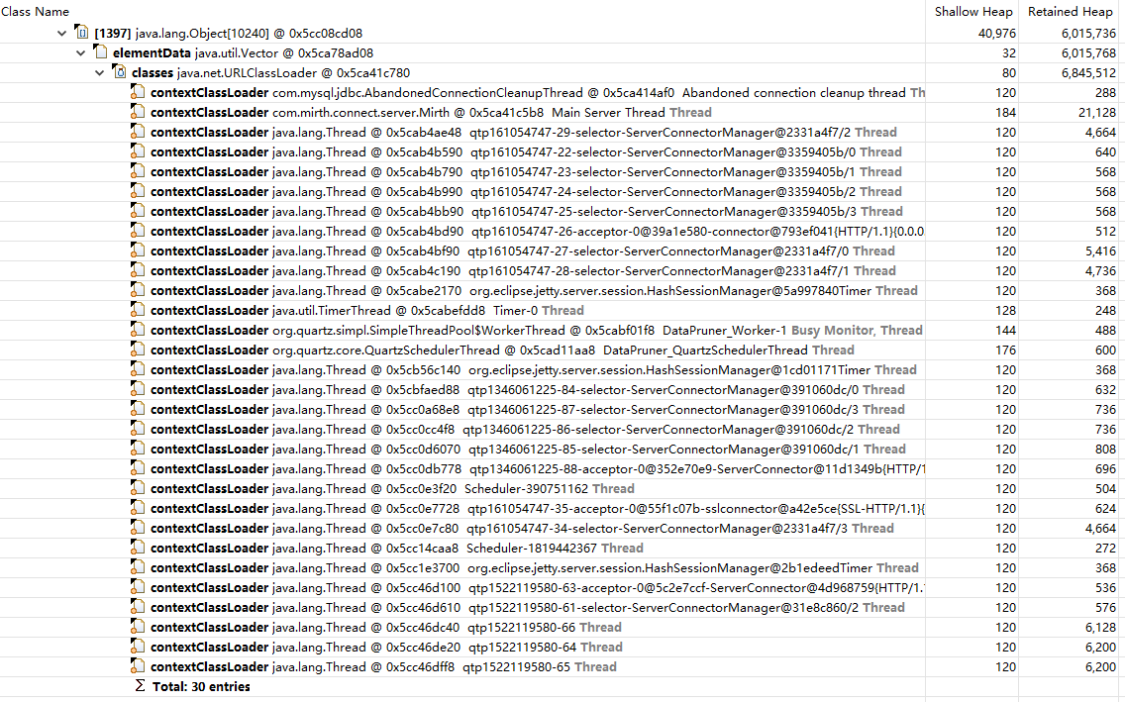

Dominator_tree

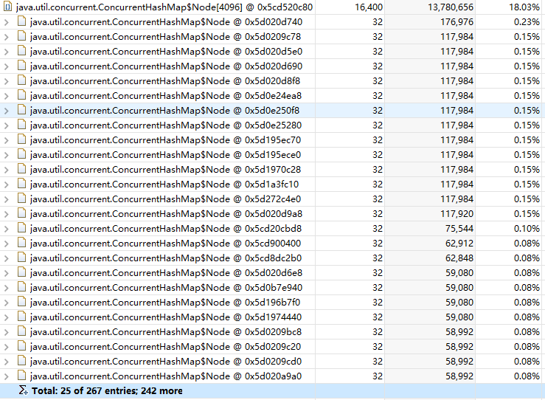

#### 3.3.2 "org.eclipse.jetty.server.Handler[]"对象

Path to GC root

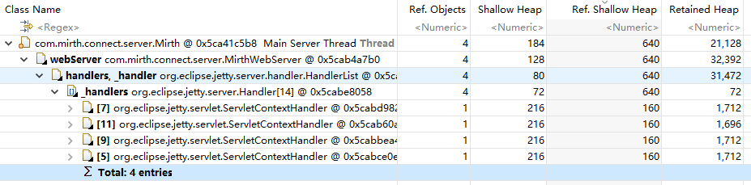

2

### 3.4数组,集合等容器对象的使用情况:

含有90%-100%空节点的容器对象统计(只取前几个):

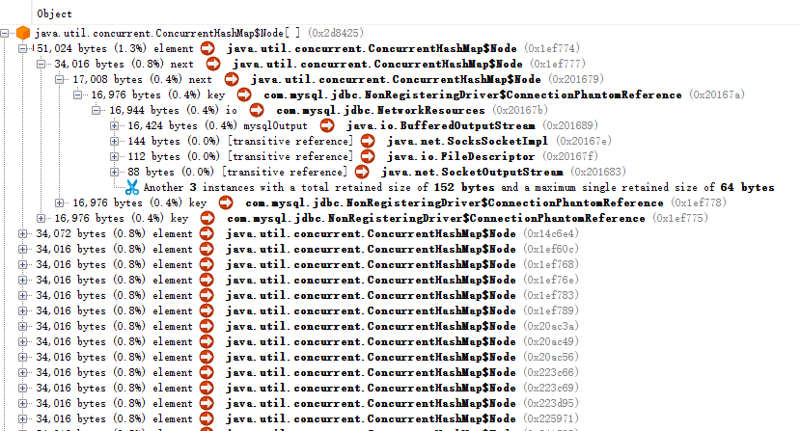

容器对象path to GC root

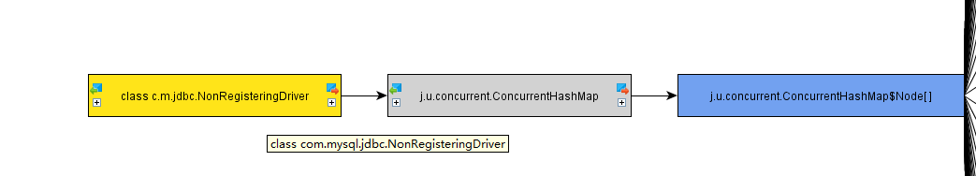

### 3.5 JVM GC情况统计:



说明:自启动以来,系统一共进行了42468次minorGC,共耗时226.08秒,fullGC一共发生了43次,耗时8.963秒,GC总时间一共是235.043秒.minorGC次数较多,平均耗时为0.005秒,fullGC发生分频率较低,平均耗时0.208秒,无论从GC发生的频率还是fullGC持续时间来看均比较正常.

### 3.6小结

由shine-server的内存转储dump文件,我们进行了相关的分析,包括运行时的线程状态,JVM堆的使用情况,系统数组,集合等容器的运行期使用情况,JVM运行期GC情况统计等,发现JVM运行情况是比较的正常的.

## 四.模拟并发情况分析

### 4.1测试用例:

系统:centos6.8 final

内存:1GB

Java版本: Java 1.8.0_111

JVM版本: HotSpot VM

测试软件:jmeter3.1

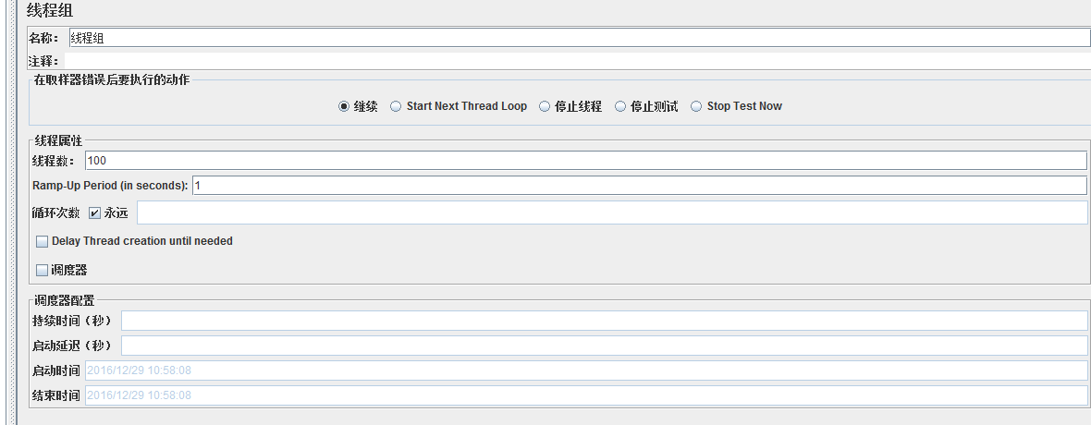

### 4.2测试情况:

#### 4.2.1总览

对比未开启jmeter的情况,jvm的GC频率明显加快随着GC的进行,堆区内存只用情况呈现锯齿状波动

#### 4.2.2堆内存占用

使用106MB,空闲44.14MB

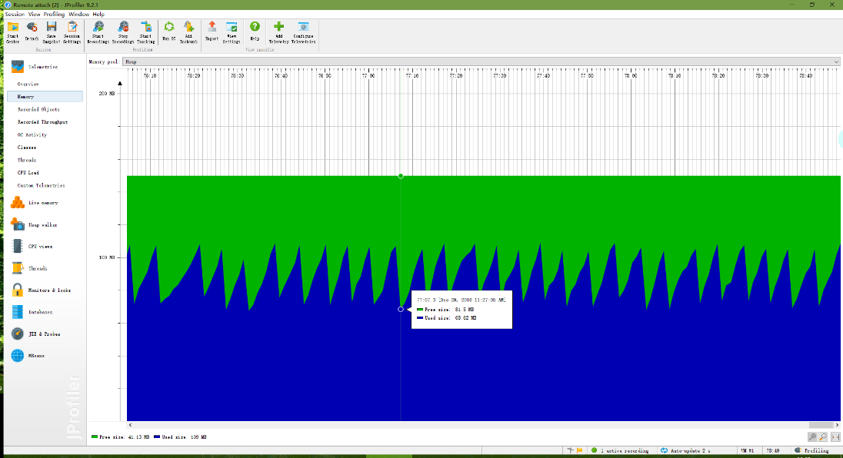

MinorGC后,使用48MB,空闲81MB

#### 4.2.3老年代内存占用

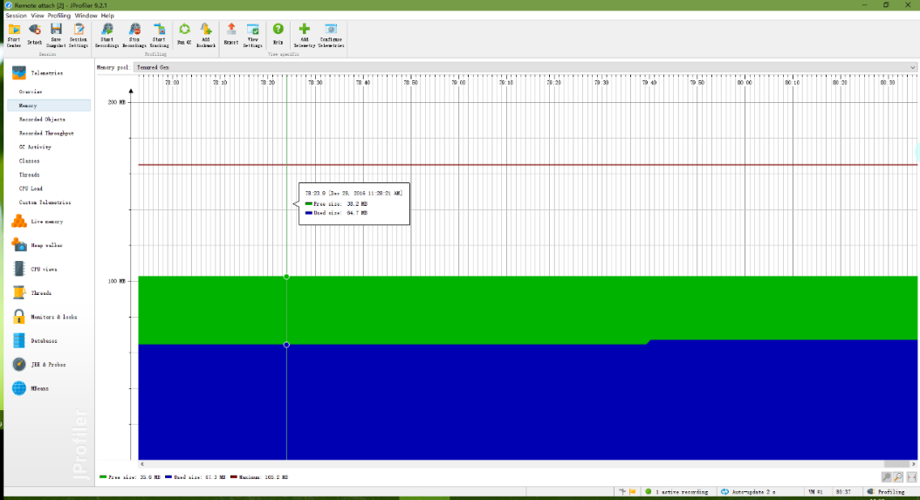

老年代内存占用稳定:使用64MB,贡空闲38MB

#### 4.2.4metaspace永久带内存占用

永久带内存使用76MB,空闲1.4MB,永久带只存放字节流类文件等数据,因此运行时期波动非常微小.

#### 4.2.5线程运行状态

绿色为正在运行的线程,红色为阻塞线程,浅蓝色为IO或者网络资源线程,黄色为正在等待运行的线程.

#### 4.2.6大对象

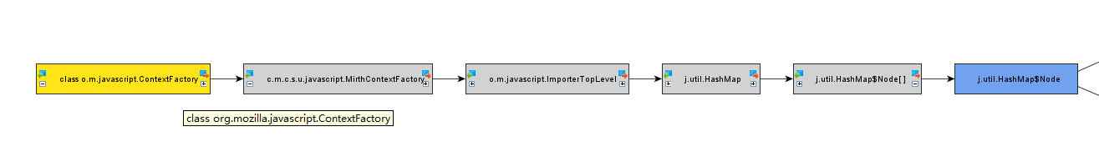reference & path to GC root

#### 4.2.7 Jstat

MinorGC共发生2052次,耗时422.538秒,平均GC时间为0.206秒

FullGC共发生6次,耗时1.183秒,平局GC时间为0.20秒

### 4.3小结

本节中采用Jmeter模拟100条线程并发访问同通道配置的shine-server,发现在模拟测试的环境下,shine-server的JVM虚拟机的GC频率明显加快,堆区内存中用明显升高,这是由于通道需要处理较高的并发访问造成的.

## 五.总结

本调研报告采用了堆转储dump文件分析和并发模拟测试两种手段对shin-server的运行期JVM状态进行了分析.

在dump文件分析中,发现shine-server的JVM堆区大小为72.9MB,其中类"com.mysql.jdbc.NonRegisteringDriver",和类"org.eclipse.jetty.servlet.ServletHandler"的多个实例对象占据了较大的堆区内存空间.但是均在正常的范围内.

在采用Jmeter模拟并发访问的测试环境下,发现shine-server的JVM堆区使用内存升高,而且GC的频率加快,这是由于shin-server中的通道为了响应较高的并发请求而造成的,当关闭Jmeter后shin-server又会回复到正常的状态.