Project Documentation: Customer Churn Classification
Project Overview
This project focuses on analyzing customer data to predict whether a customer will churn (leave the service) or not. By using machine learning models, we aim to identify customers at risk and help businesses take preventive actions.

Code and Notebooks
- Jupyter Notebook:
The complete implementation including data preprocessing, model training, and evaluation is available in:
Customer_Churn_Classification.ipynb

Screenshots

1. Notebook Running
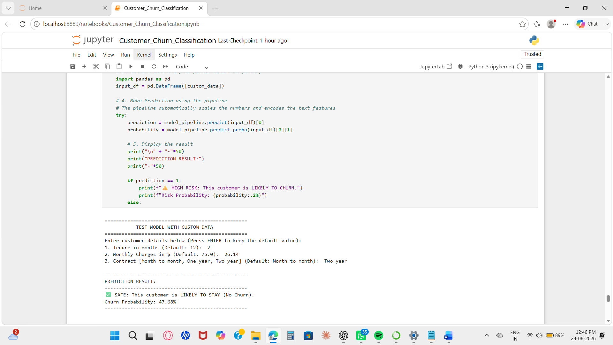

2. Code with Output
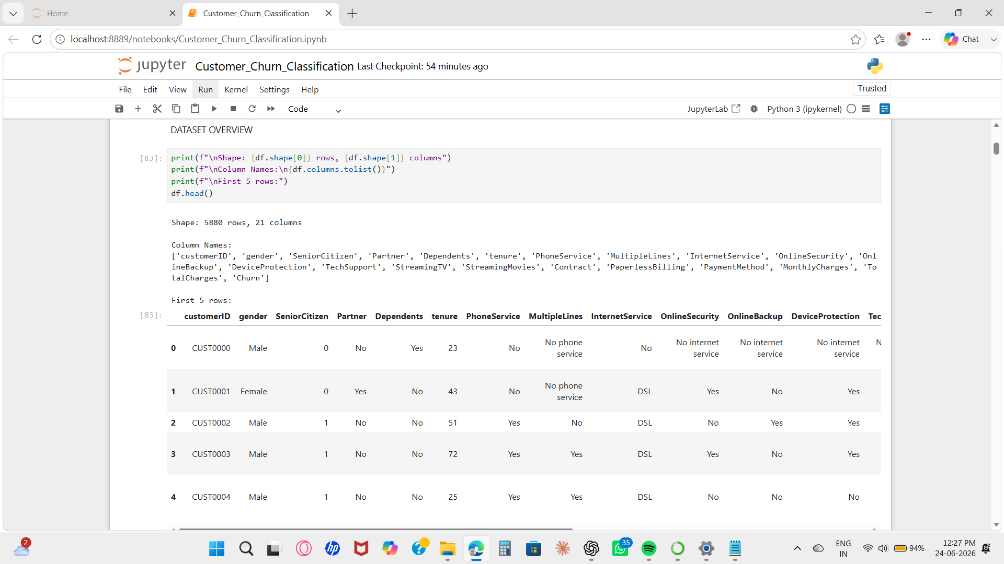

3. Model Performance (Accuracy / Metrics)
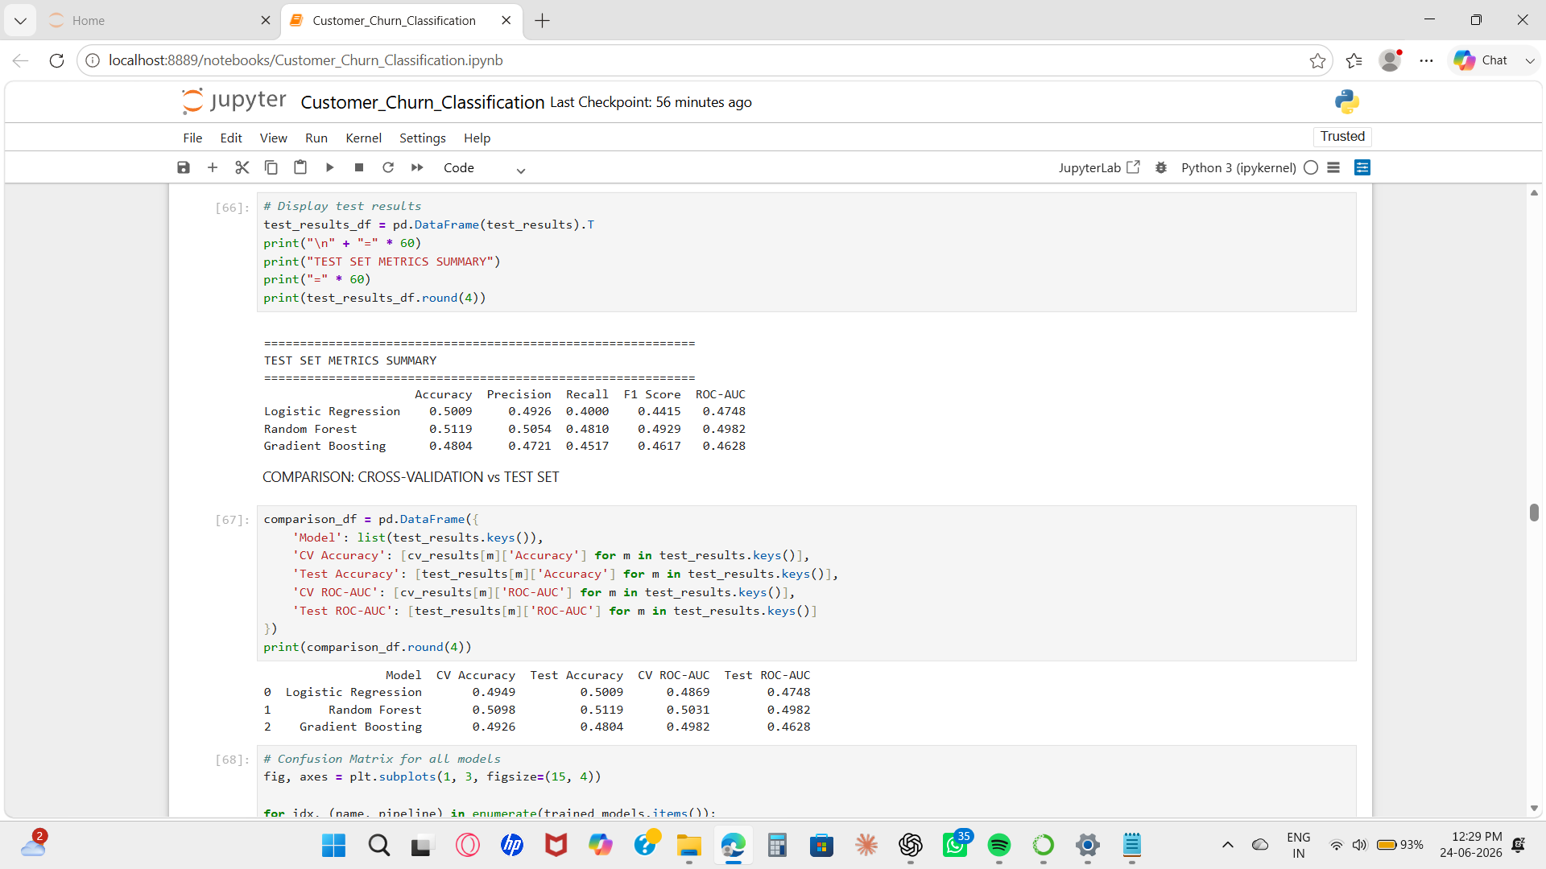

4. Graph (ROC Curve / Confusion Matrix / Comparison Chart)

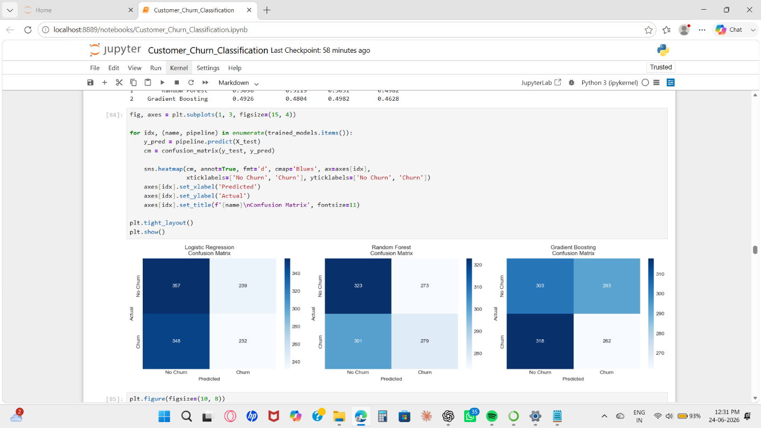

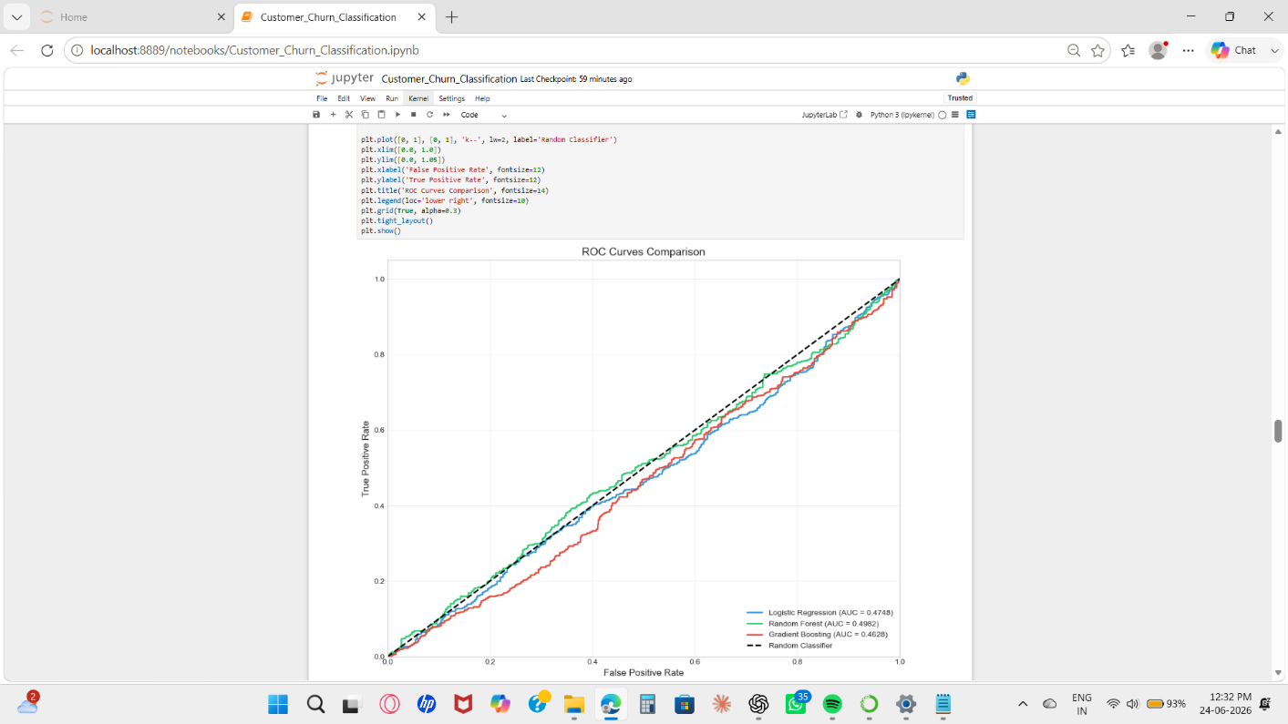

Explanation
1. Data Loading and Exploration
- The dataset customer_churn_data.csv is loaded.
- Initial exploration includes checking:
  - Shape of dataset
  - Column names
  - Data types
- Statistical summary is analyzed.
- Distribution of target variable Churn is visualized.

2. Data Preprocessing
- customerID column is removed as it is not useful.
- Target variable Churn is converted:
  - Yes → 1
  - No → 0
- TotalCharges column is converted to numeric.
- Missing values are handled using median.
- Features are divided into:
  - Categorical
  - Numerical

3. Feature Engineering and Train/Test Split
- Features (X) and target (y) are separated.
- Dataset split:
  - Training: 80%
  - Testing: 20%
- Stratified sampling ensures balanced class distribution.
- Preprocessing pipeline:
  - Categorical: OneHotEncoder
  - Numerical: StandardScaler

4. Model Training and Evaluation
Three models are trained:
- Logistic Regression
- Random Forest
- Gradient Boosting
- 5-fold cross-validation is applied.
- Evaluation metrics:
  - Accuracy
  - Precision
  - Recall
  - F1 Score
  - ROC-AUC
- Models are tested on unseen test data.

5. Results
- All models are compared based on performance.
- Visualizations:
  - Confusion Matrix
  - ROC Curve
- Best Model: Random Forest
- Reason: Achieved highest ROC-AUC score on test data.
- Model Accuracy: 51.19%

Conclusion
The project successfully implemented multiple machine learning models to predict customer churn. Among them, the Random Forest model performed the best. This model can help businesses identify potential churn customers and take necessary actions to improve retention.

References
- Scikit-learn Documentation
- Python Documentation
- Course Materials

