  - -- 1. Total Revenue
SELECT
SUM(total_price) AS total_revenue
FROM orders;
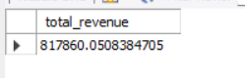
  - -- 2. Average order Value
SELECT
SUM(total_price)/COUNT(DISTINCT order_id) AS Avg_order_value
FROM orders;
  - 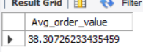
  - -- 3. Total Pizza Sold
SELECT
SUM(quantity) AS Total_pizza_sold
FROM orders;
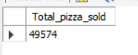
  - -- 4. Total order placed
SELECT
COUNT(DISTINCT order_id) AS Total_order_placed
FROM orders;
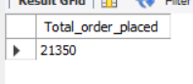
  - -- 5. Average Pizza Sold
SELECT
COUNT(quantity)/COUNT(DISTINCT order_id) AS AVG_pizza_Per_Order
FROM orders;
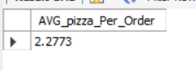
  - -- 6. Day vise trends
SELECT
DAYNAME(order_date) AS Week_days,COUNT(DISTINCT order_id) AS Order_placed
FROM orders
GROUP BY 1;
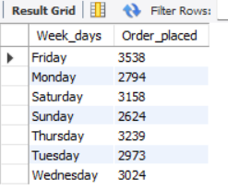
  - -- 7. Hourly Trends
SELECT
HOUR(order_time) AS Hour_of_day, COUNT(DISTINCT order_id) AS Order_placed_in_hour
FROM orders
GROUP BY 1
ORDER BY 2 DESC;
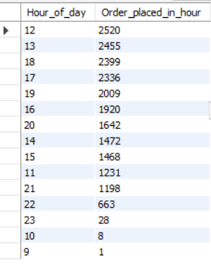
  - -- 8. Percentage sales on pizza category
SELECT
pizza_category,
ROUND(
(SUM(total_price) /(SELECT SUM(total_price) FROM orders)
)*100,2) AS Pizza_category_sales_percentage
FROM orders
GROUP BY 1;
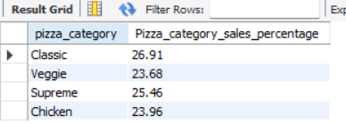
  - -- 9. Percentage of sales by Pizza_size
SELECT
pizza_size,
ROUND(
(SUM(total_price) /(SELECT SUM(total_price) FROM orders)
)*100,2) AS Pizza_size_sales_percentage
FROM orders
GROUP BY 1;
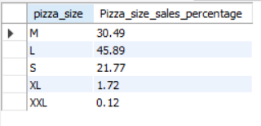
  - -- 10. Total Pizza sold by category
SELECT
pizza_category,
SUM(quantity) AS Total_pizza_sold
FROM orders
GROUP BY 1;
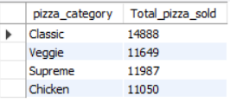
  - -- 11. TOP 5 bestSeller PizzAS
SELECT
pizza_name,
SUM(quantity) AS Total_sales_amount
FROM orders
GROUP BY 1
ORDER BY 2 DESC
LIMIT 5;
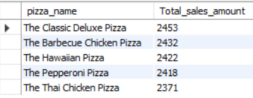
  - -- 12. Bottom 5 bestSeller PizzAS
SELECT
pizza_name,
SUM(quantity) AS Total_sales_amount
FROM orders
GROUP BY 1
ORDER BY 2
LIMIT 5
