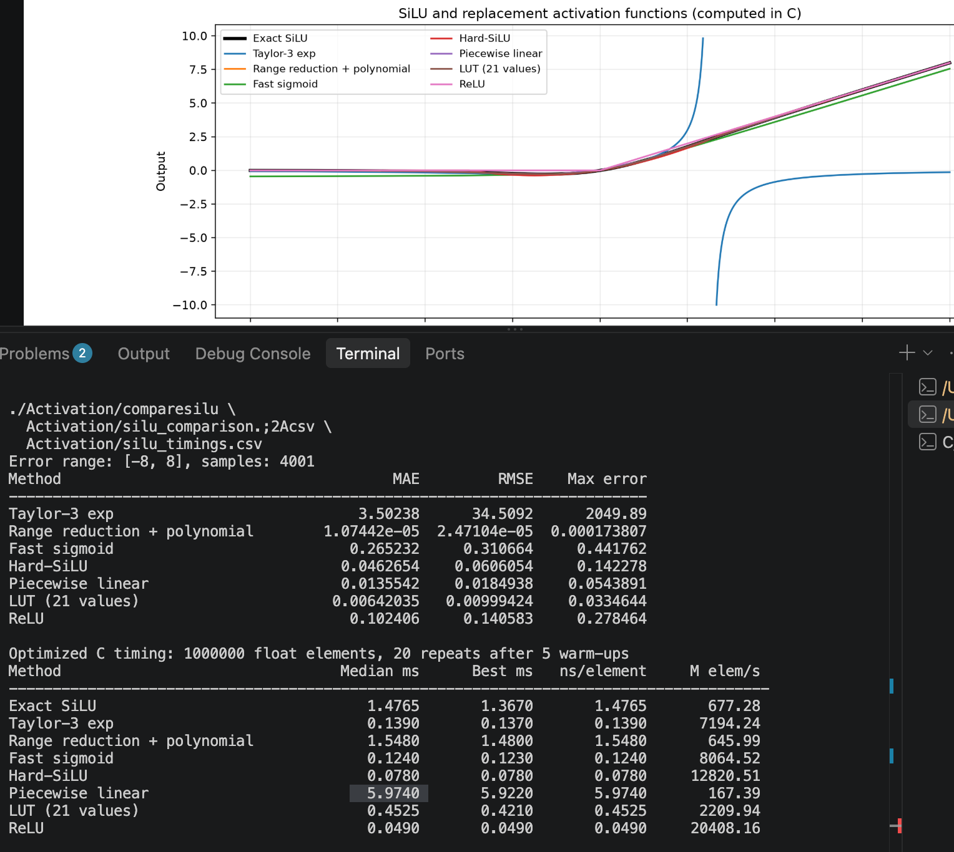

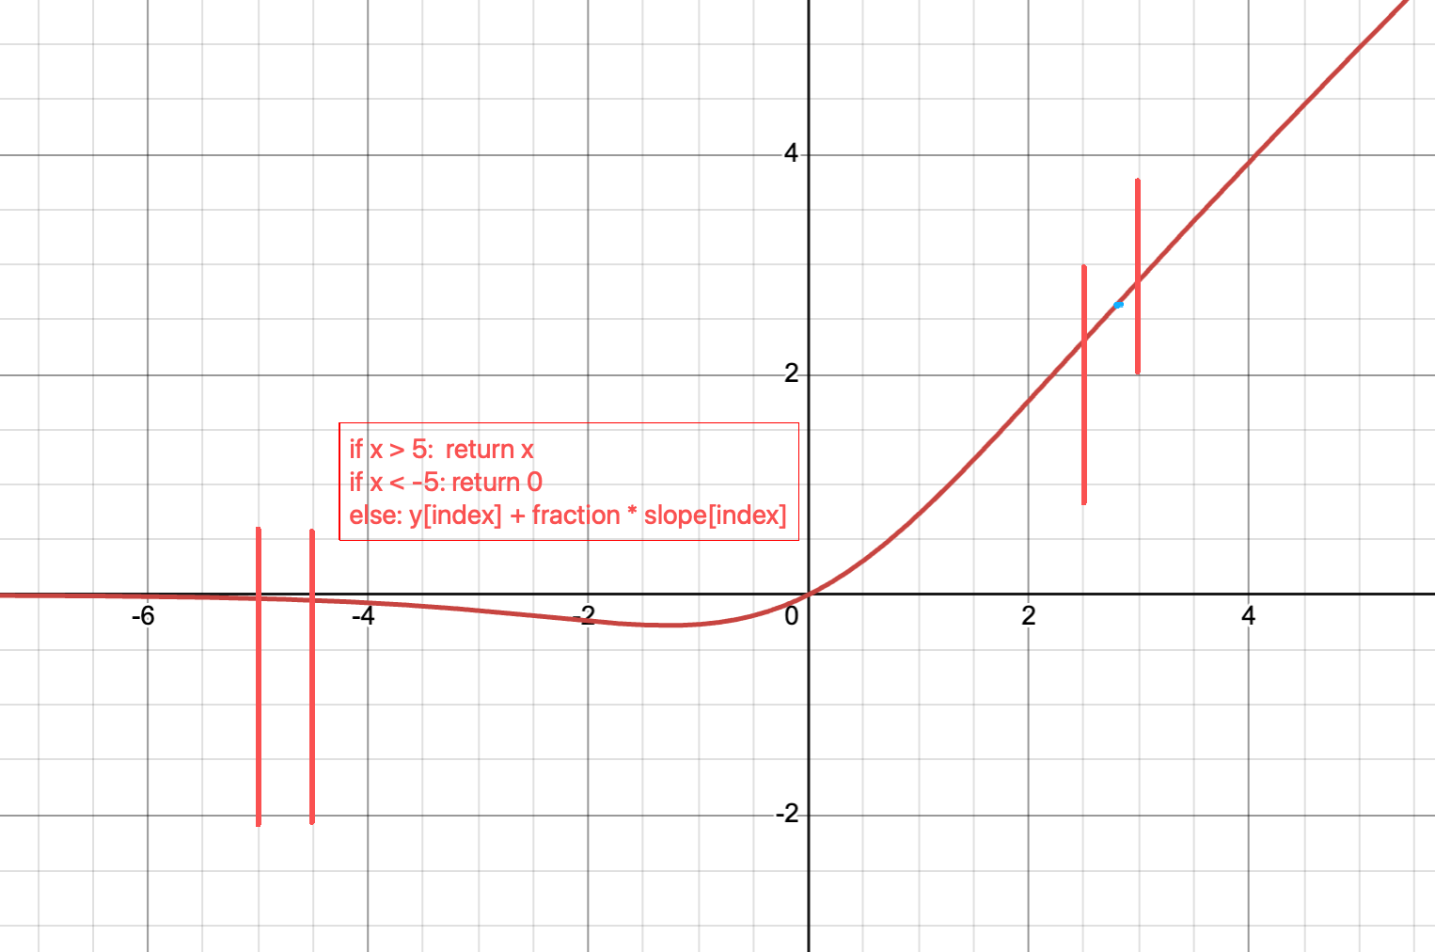
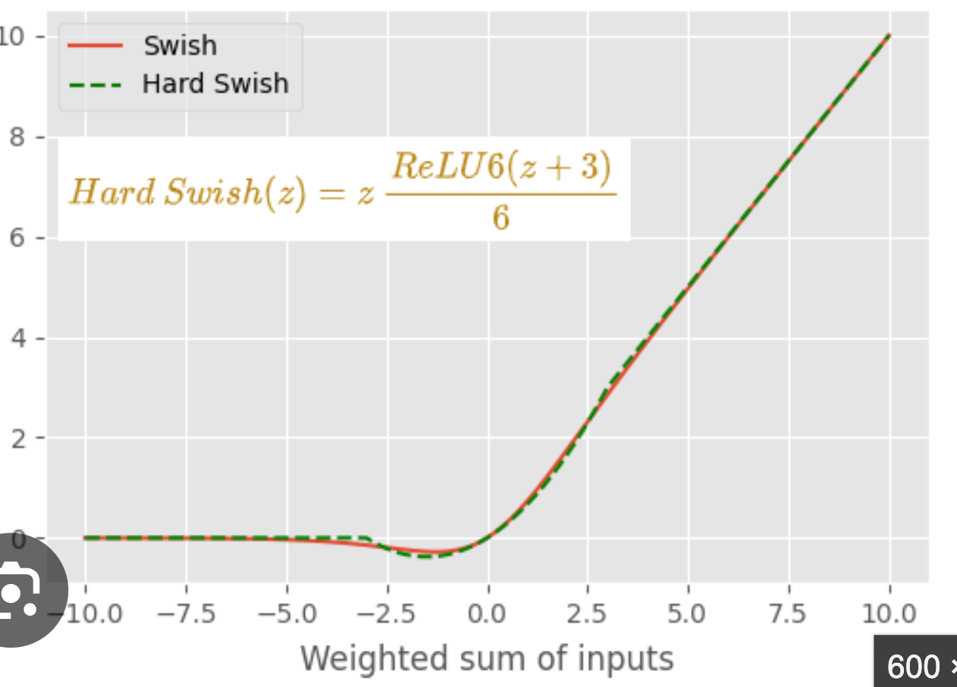
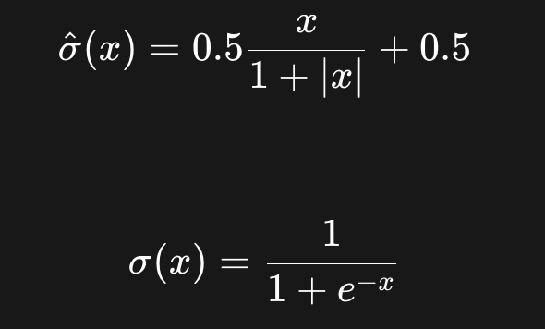 fast sigmoid

- kitti 8n workers 0 threads 1
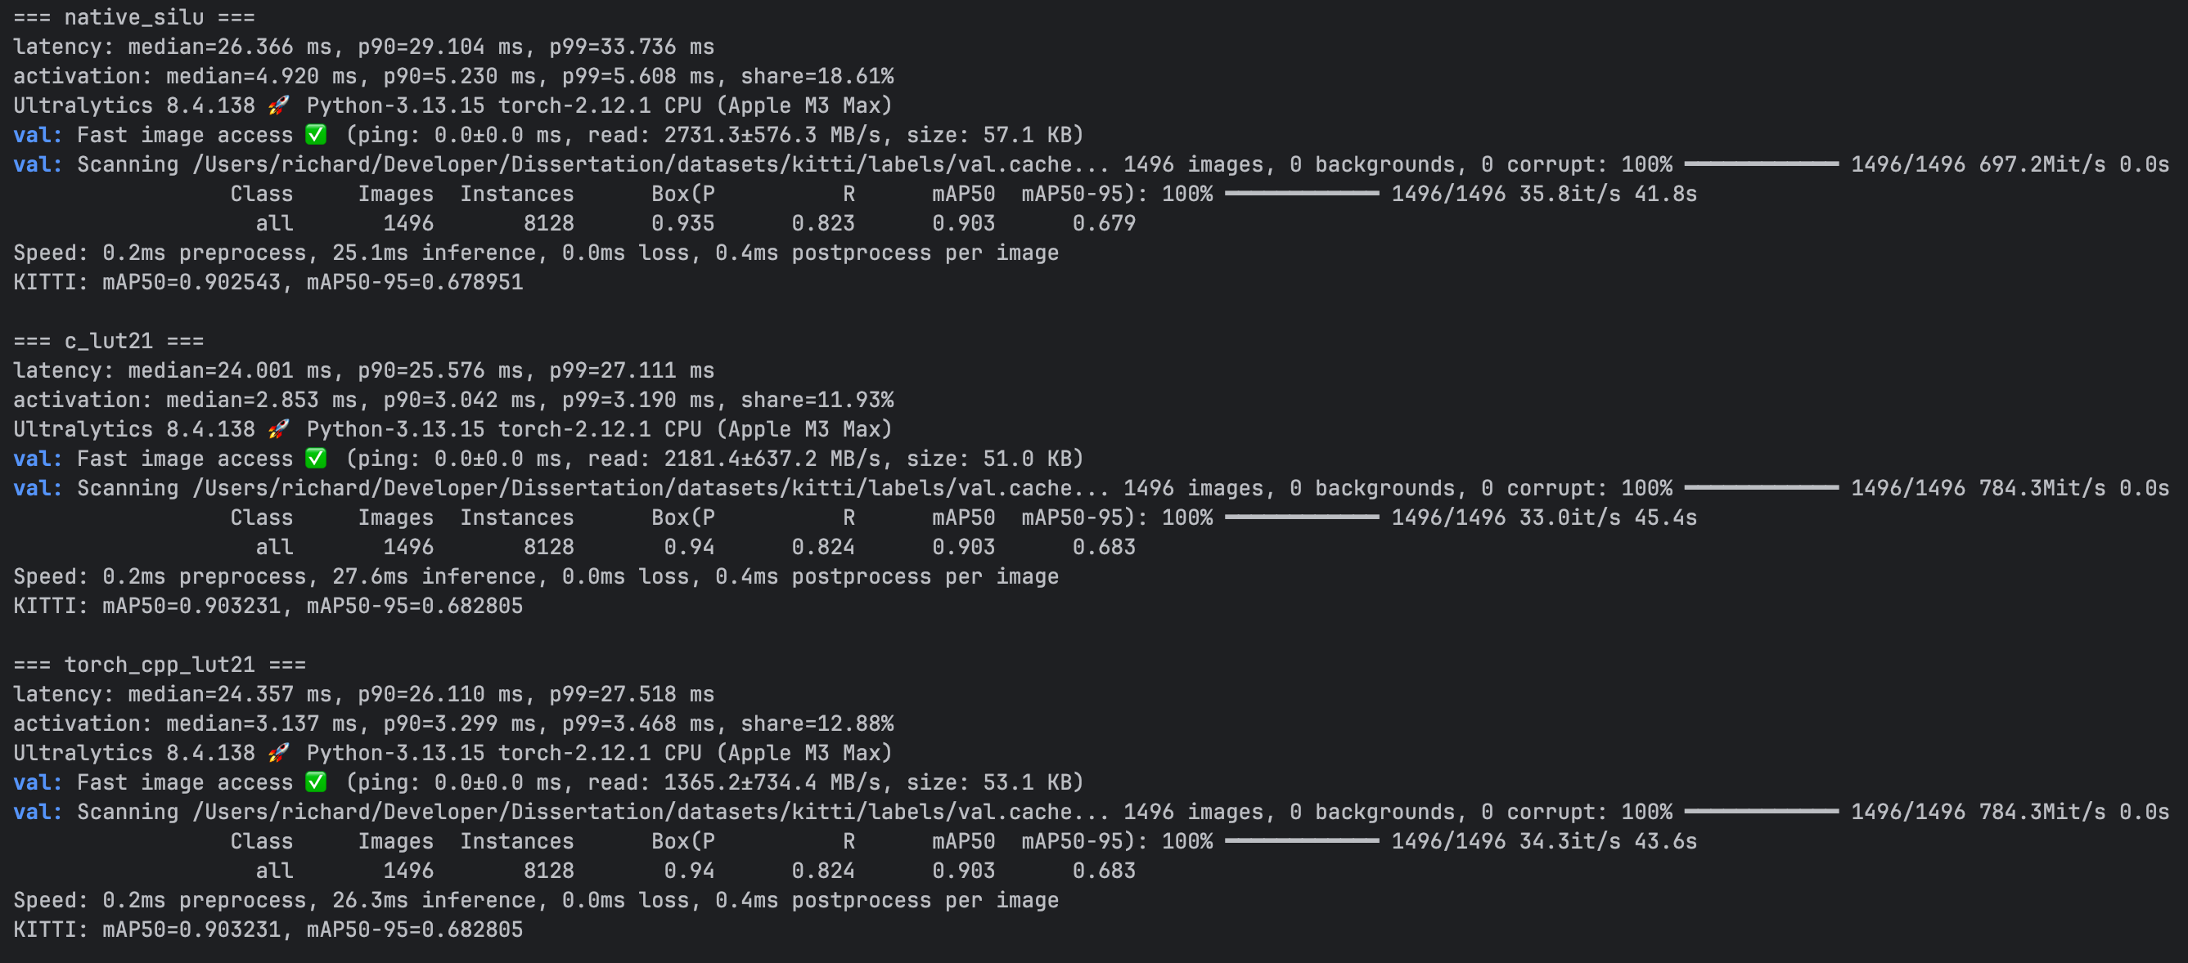
- kitti 8n workers 4 threads 8
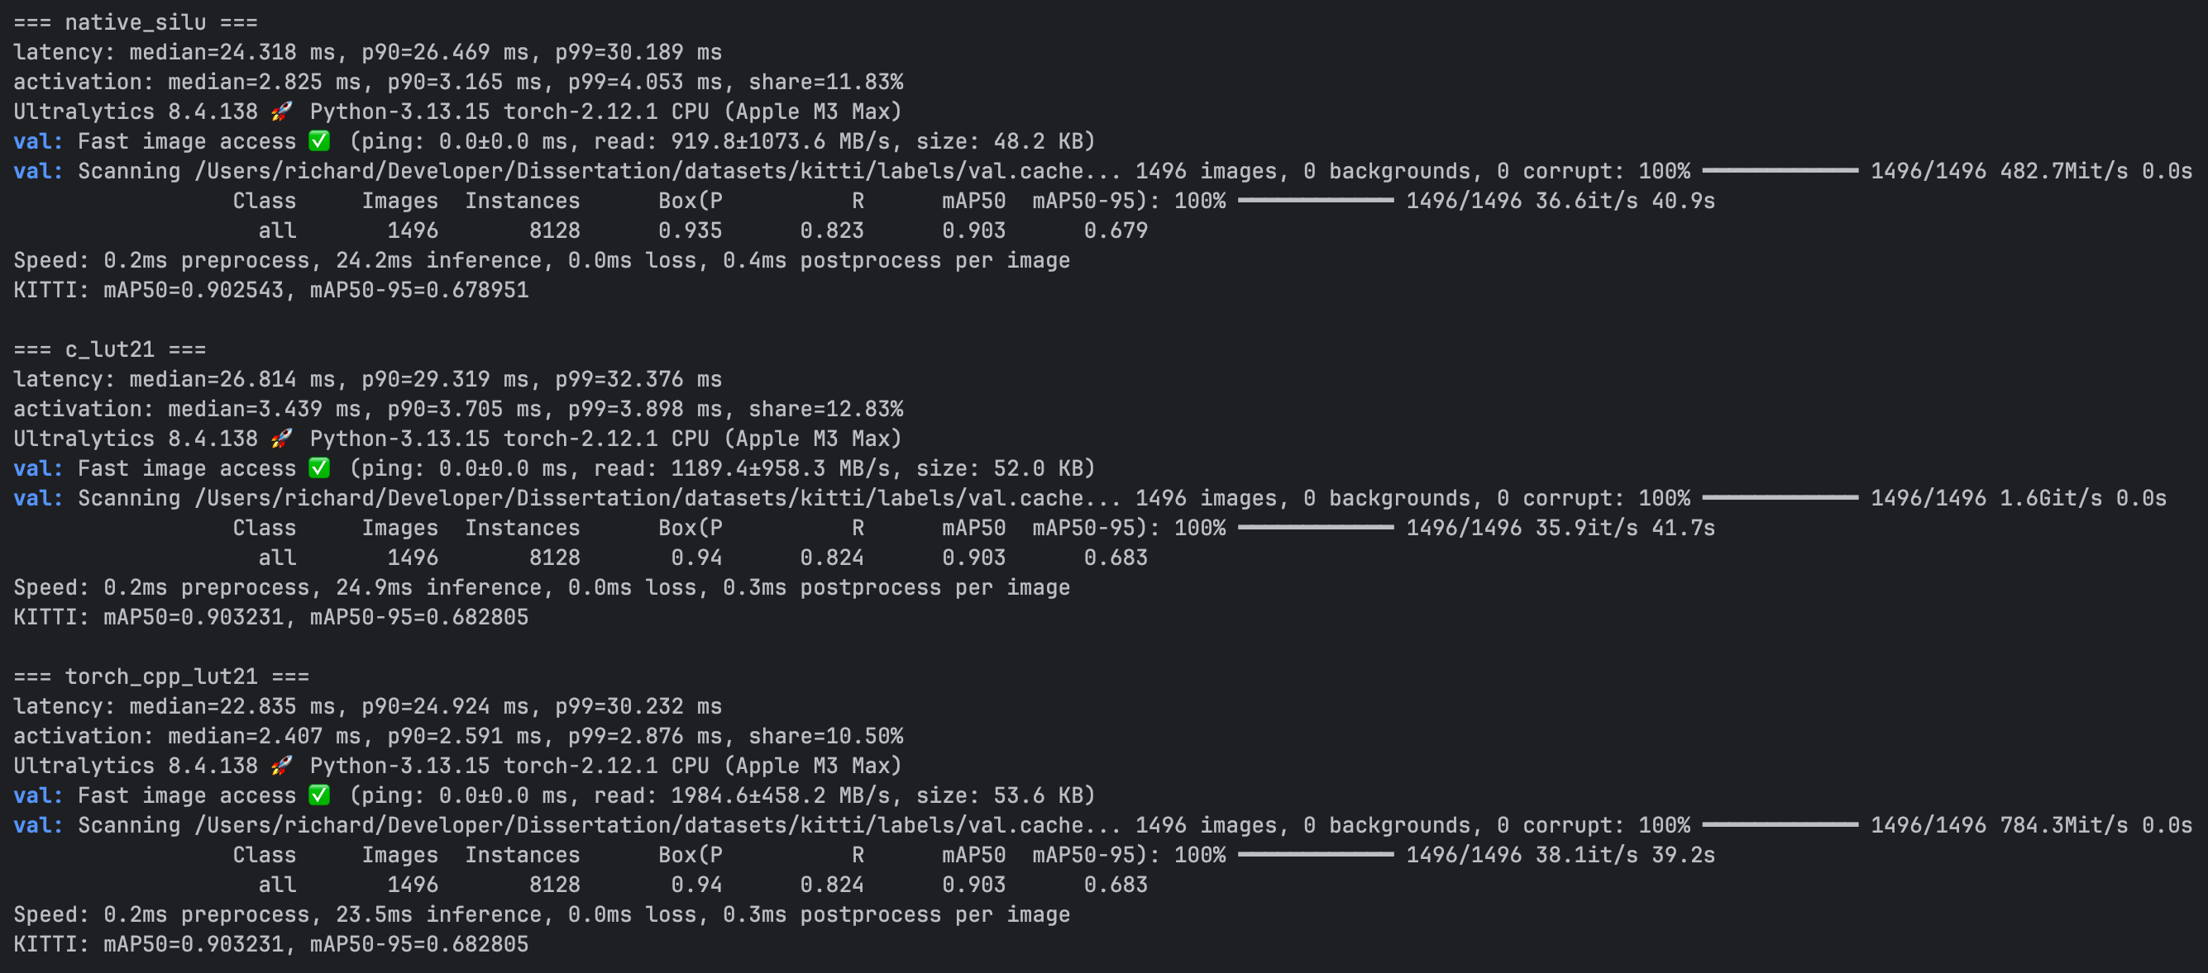

 | single thread |  |  | multi-threads
Type | act.median | act.share | latenct | act.median | act.share | latenct | m50/50-95
silu | 4.920ms | 18.61% | 26.366ms | 2.825ms | 11.83% | 24.318ms | 90.25/67.89
20split c | 2.853ms | 11.93% | 24.001ms | 3.439ms | 12.83% | 26.814ms | 90.32/68.28
20split c++ | 3.137ms | 12.88% | 24.357ms | 2.407ms | 10.50% | 22.835ms | 90.32/68.28
hard-swish/hard-silu | 0.765ms | 3.45% | 22.332ms | 1.698ms | 7.42% | 22.581ms | 86.96/60.54

