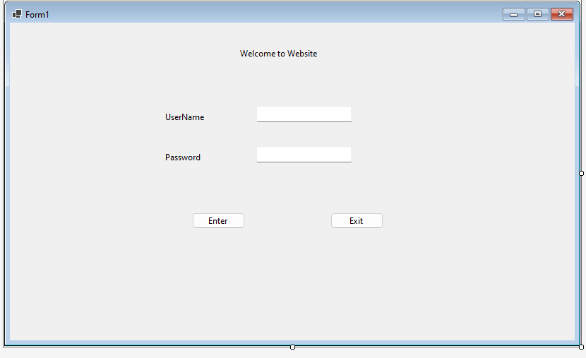

Design the form with user-friendly labels and text boxes.

Mask the password input for privacy.

Connect to your database and verify the credentials when the user tries to log in.

Designing the Management Form

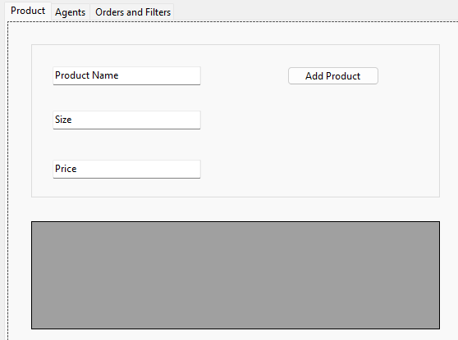

Setting Up the Print Order Form

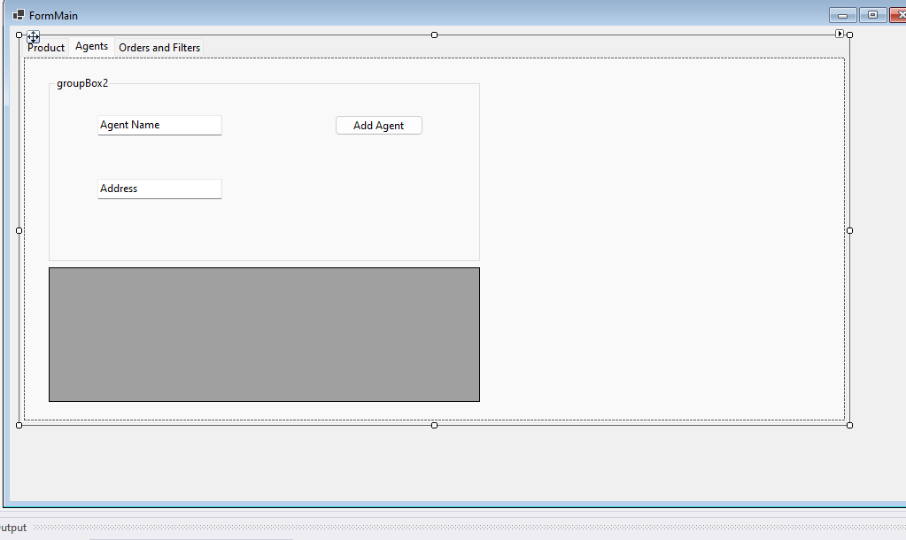

Developing the Filter Form

