Phạm Thái An Bình

522K0031

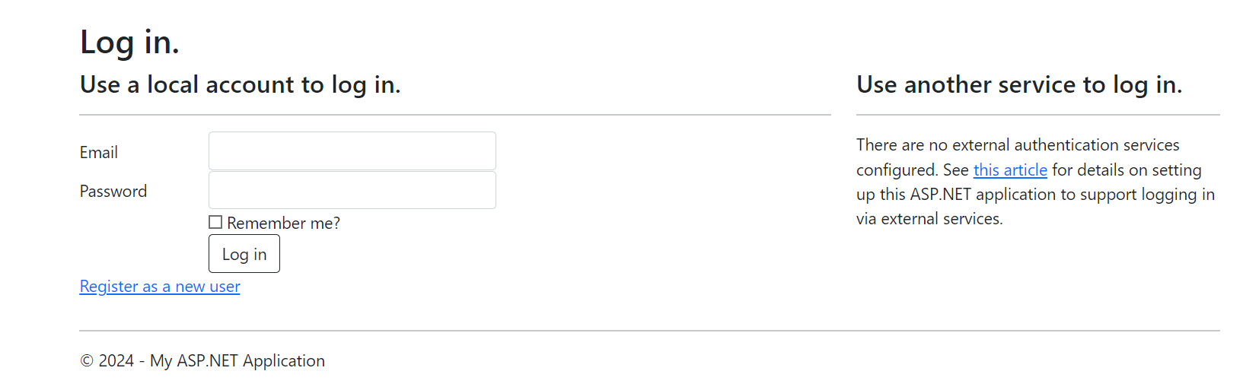

Key Files:

- Views/Account/Login.cshtml

- Controllers/AccountController.cs

- Models/AccountViewModels.cs

- Models/IdentityModels.cs

Implementation Details:

- Uses ASP.NET Identity for secure authentication

- Implements password hashing and security best practices

- Includes Remember Me functionality

- Redirects to last accessed page after login

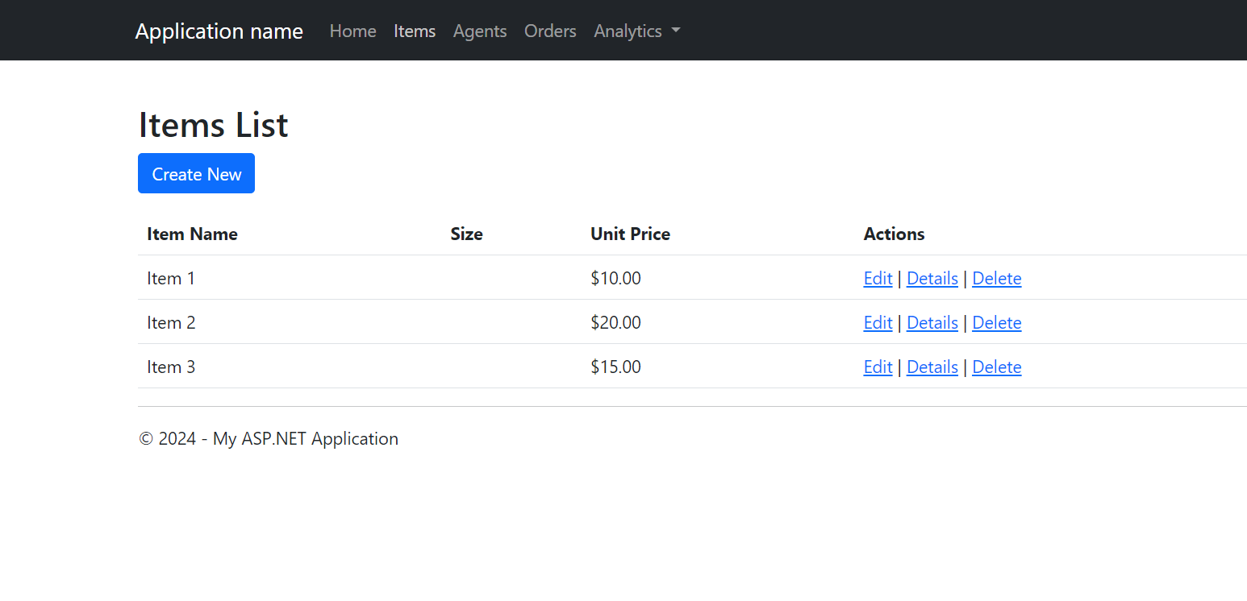

Key Files:

- Views/Items/Create.cshtml

- Controllers/ItemsController.cs

- Models/Item.cs

Implementation Details:

- CRUD operations for products

- Image upload capability

- Price validation

- Stock management

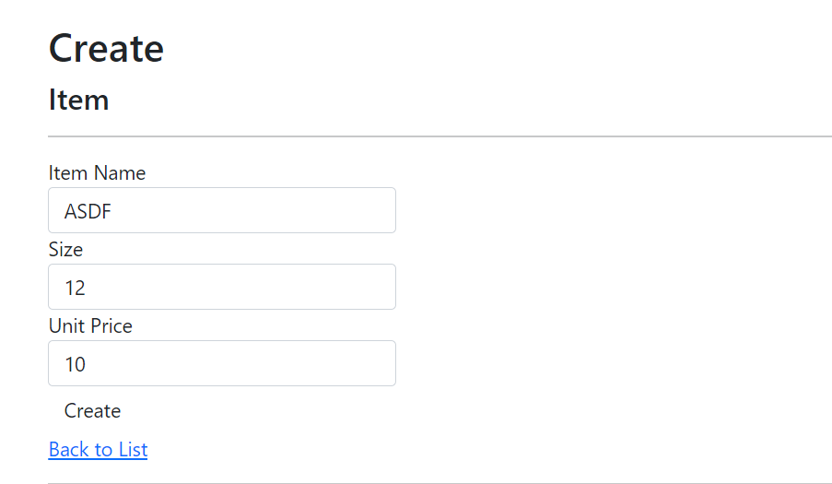

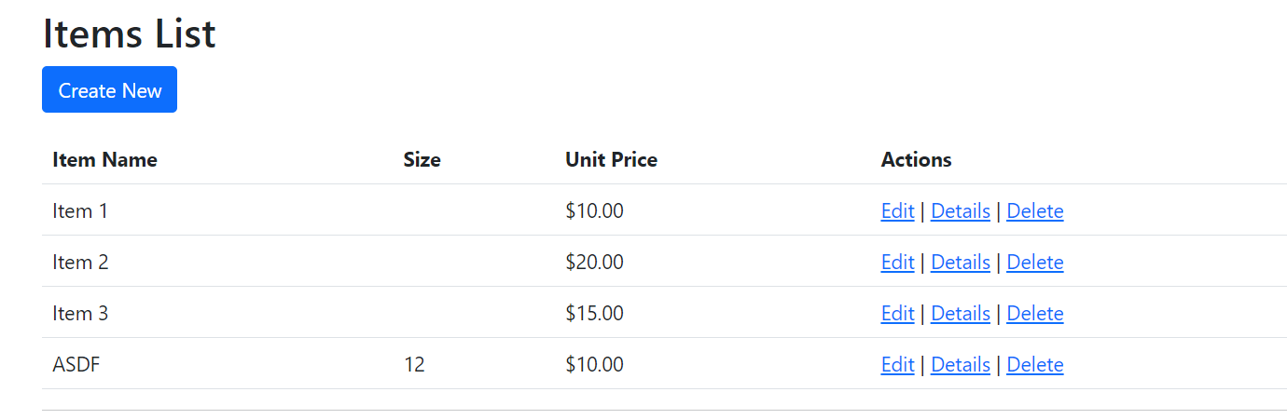

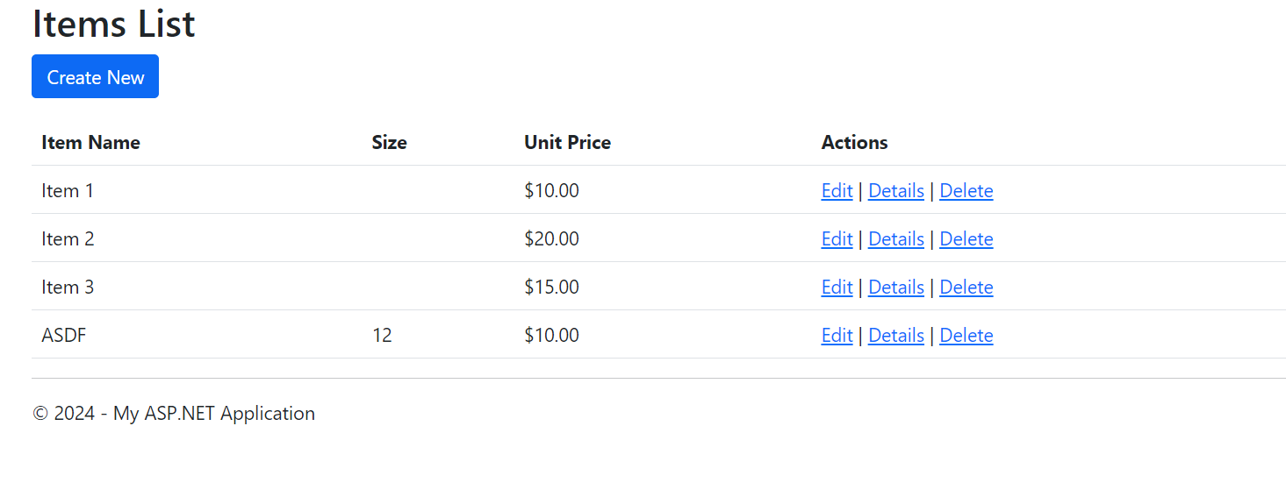

Agent Registration

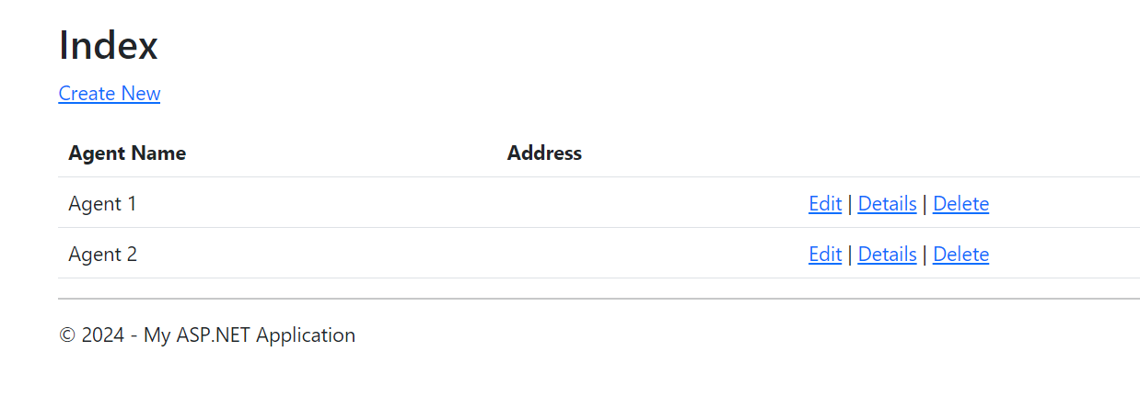

Key Files:

- Views/Agents/Create.cshtml

- Controllers/AgentsController.cs

- Models/Agent.cs

Implementation Details:

- Agent registration with validation

- Territory assignment

- Commission tracking

- Performance metrics

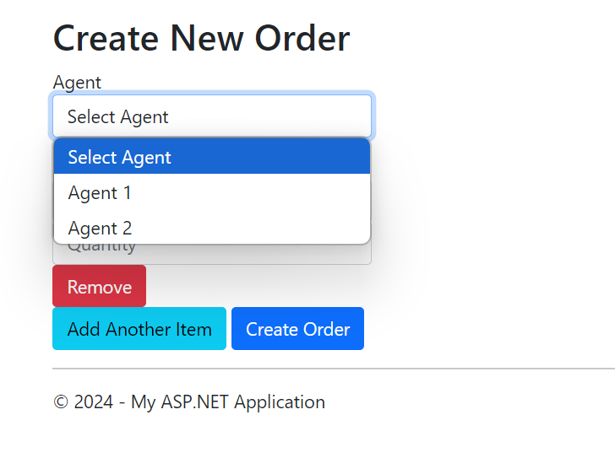

Key Files:

- Views/Orders/Create.cshtml

- Controllers/OrdersController.cs

- Models/Order.cs

- Models/OrderDetail.cs

Implementation Details:

- Master-detail form implementation

- Dynamic line item addition/removal

- Real-time total calculation

- Stock validation

Order Models:

