This report is for Lab 3 software engineer  
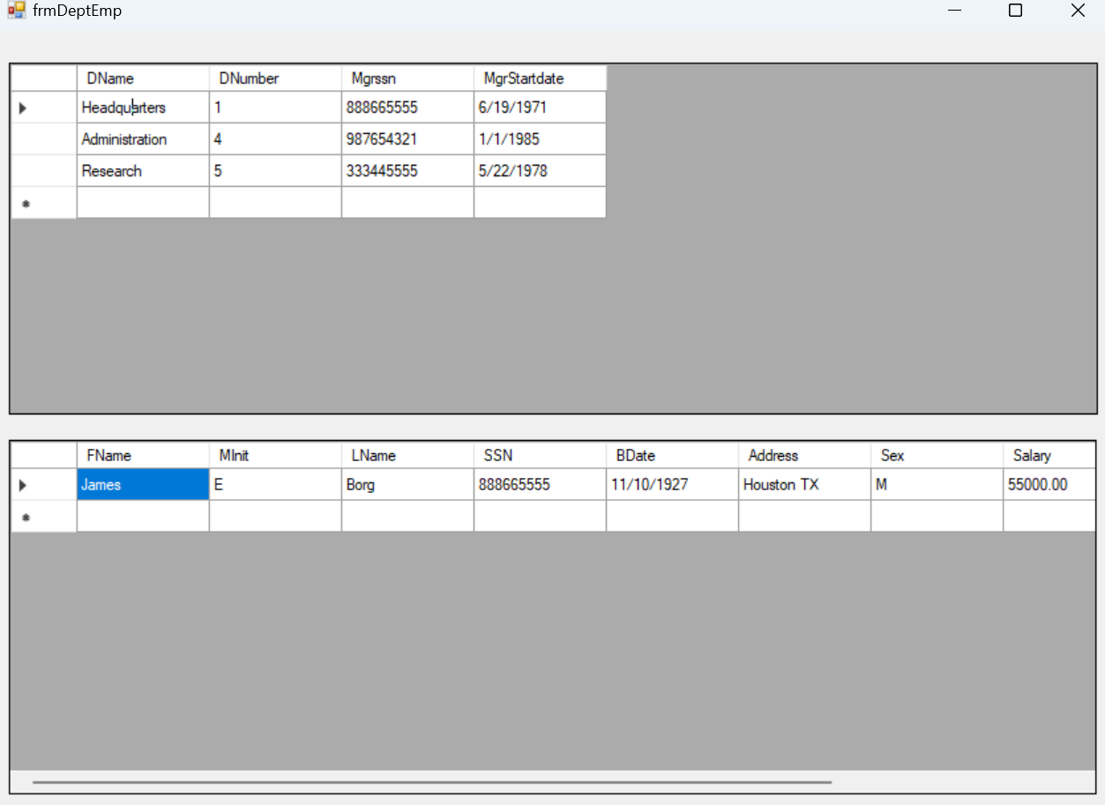

Like before, I will be using SQL Server Object Explorer for this lab exercises

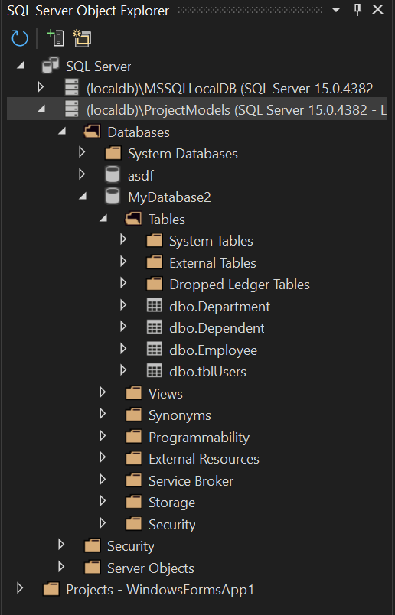

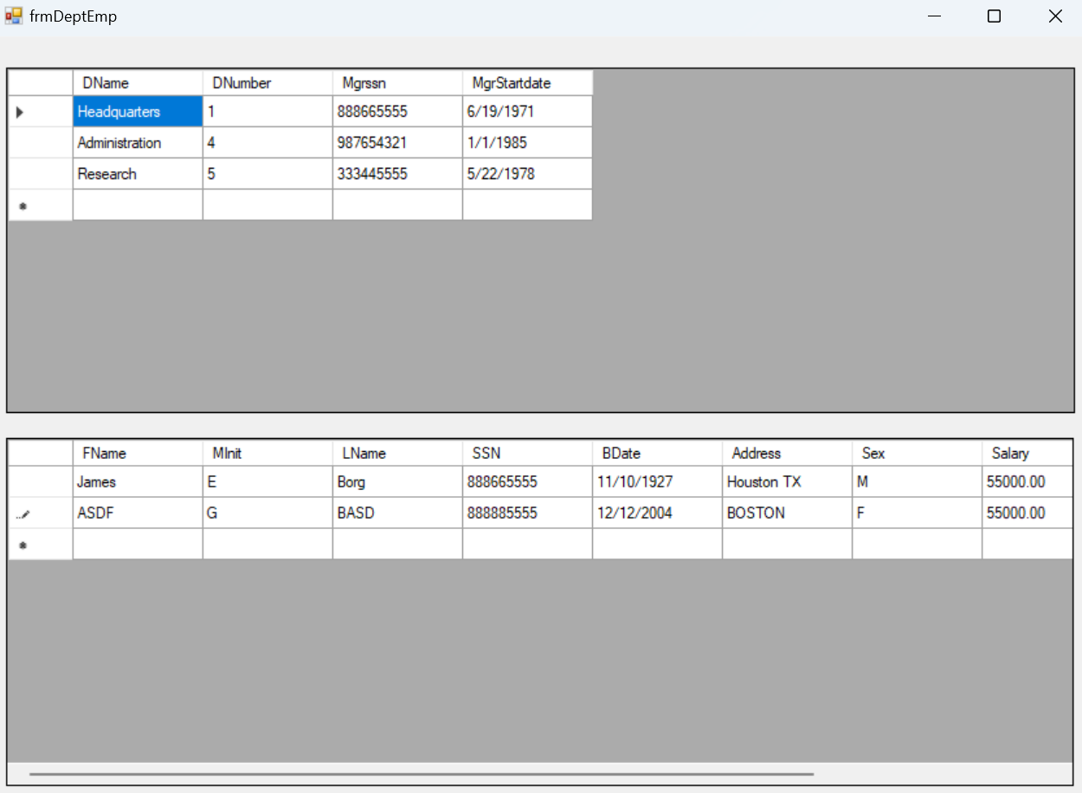

I managed to get the things I typed in the table to be saved in the database aswell