Game Design Document

Fill up the Following document

1. Write the title of your project.

Angry Gorilla King

1. What is the goal of the game?

The player should play as a gorilla and escape enemies(policemen, military forces ,etc.)

1. Write a brief story of your game?

A Gorilla King was kept in a prison for several years. It has now escaped

The prison and is on its way to home but the police and military forces are trying to stop the gorilla. The gorilla should defend it self

And reach its home

1. Which are the playing characters of this game?

* Playing characters are the ones which respond to the user based on the input from the user
* Cars, monkeys, dinos, wizards etc, are the playing characters in the game.

|  |  |  |
| --- | --- | --- |
| Number | Character Name | What can this character do? |
| 1 | Gorilla King | Punch Enemies, Throw Rocks and call other animals for a short period of time. |
| 2 |  |  |
| 3 |  |  |
| 4 |  |  |
| 5 |  |  |
| 6 |  |  |
| 7 |  |  |
| 8 |  |  |

1. Which are the Non Playing Characters of this game?

* Non Playing characters are the ones which don't have an action or a behavior when the user interacts with the game.
* Hurdles, stones, bananas, coins, etc. are non playing characters in the game.

|  |  |  |
| --- | --- | --- |
| Number | Character Name | What can this character do? |
| 1 | Military Force(group) | Shoot at the gorilla |
| 2 | Police(group) | Shoot At the gorilla |
| 3 | Heart | Refill the gorilla’s health |
| 4 | Animal helpers | Help the King Gorilla to defeat enemies for a short period of time |
| 5 | invulnerability | Make the Gorilla invulnerable for a short period of time |
| 6 | tanks | Shoot the gorilla |
| 7 |  |  |
| 8 |  |  |

Draw your imagination of this game. What does this game look like?

* Draw the game either on your computer or on paper,
* Add images of scenes of the game to show each of the playing and non-playing characters at least once.

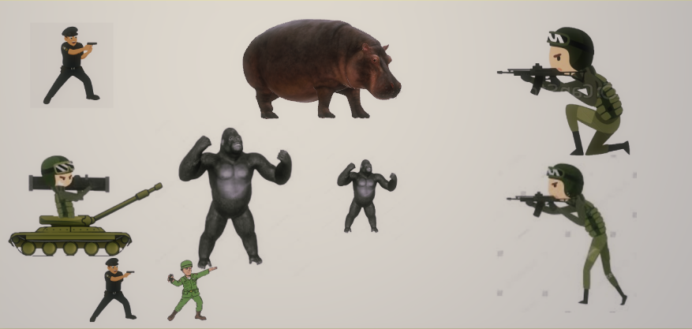

How do you plan to make your game engaging?

I will make the game engaging by giving equal opportunity. The player will health and also the enemies. enemies will keep spawning. The player will have three lives. When the third life is completed it is game over.