**Project Summary**

We are designing and developing a student forum mobile web application. The purpose of the project is to create a resource that provides a means of networking, help and support, and general educational news strictly for students. We will be using a database backend for data persistency so that students can be registered and be able to keep track of their posts, topics and conversations, as well as create a custom profile to represent themselves. When we are done the application will be accessible by the public and available for use by students. We hope to accomplish a working application by the end of the semester.

**Project Requirements**

* Be able to handle large numbers of users (hundreds/thousands)
* Be accessible any time of the day (early morning, afternoon, evening)
* Database backend for data and state persistency and user individuality
* The ability to create and edit topics/categories
* The ability to create and edit subtopics/subcategories
* The ability to create and edit posts
* A WSYWIG text editor for posts
* jQuery integration
* CSS/CSS3 for styling
* HTML/HTML5 for visual representation
* PHP for database access and backend architecture

**Users and Tasks**

1. Users & Tasks
   1. Users Must:
      1. Create Account
      2. Login/Logout
      3. Change Account Information
      4. View Categories
      5. View/Add Topics & Posts
2. Permission Levels
   1. 1 – Inactive
      1. Must be activated to login
   2. 2 – Active
      1. Can edit own personal information
      2. Can Edit/Delete their own Topics/Posts
   3. 3 – Moderator
      1. Can edit own personal information
      2. Can edit/delete all Topics/Posts
   4. 4 – Admin
      1. Can edit/delete all Users/Topics/Posts
3. Use Cases
   1. All users
      1. User creates account
         1. Problem: User tries to create account with incorrect formatting. Does not meet the requirements of Username/Password length or other invalid information.
      2. User logs in
         1. Problem: User enters a Username/Password combination that is not found in the database.
      3. User logs out
         1. Problem: User is not already logged in.
      4. User creates Topic
         1. Problem: User creates a Topic with an empty body, no title, or any other invalid format that may be used.
      5. User edits Topic
         1. Problem: User tries to edit Topic that is not in their permission level.
         2. Problem: User tries to use invalid input.
      6. User deletes Topic
         1. Problem: User tries to delete Topic that is not in their permission level.
      7. User creates Post
         1. Problem: User tries to create a Post with an empty body, or other invalid formats.
         2. Problem: User tries to use invalid input.
      8. User edits Post
         1. Problem: User tries to edit Post that is not in their permission level.
         2. Problem: User tries to use invalid input.
      9. User deletes Post
         1. Problem: User tries to delete Post that is not in their permission level.
      10. User edits personal information
          1. Problem: User edits personal information with incorrect formatting, such as changing their password to one with an invalid length or providing a false email address.
   2. Admin users
      1. User edits/activates/deactivates another user
         1. Problem: User account being altered might not exist.

**Activity Diagram**



**Architecture Framework**

We are using the CodeIgniter framework for our web application

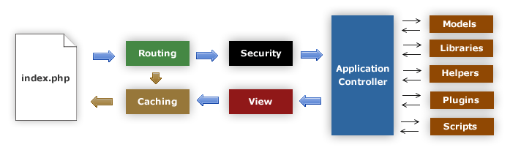

**Data Storage**

For data storage and persistency, our application will use a MySQL Database. This database will be located on the same server the webapp will be hosted on, so we will be able to access it via “localhost”. The classes that will be persisted in this database are: User, Category, Topic, and Post. Accordingly there will be a MySQL table for each persisted class.

**UI Mockups**

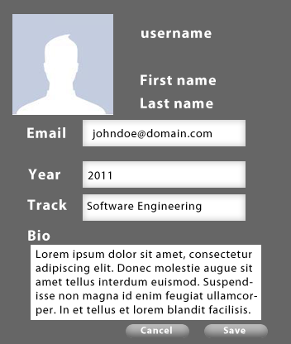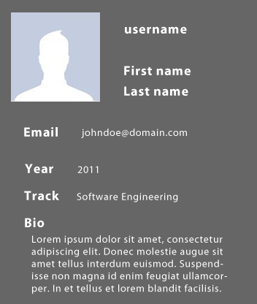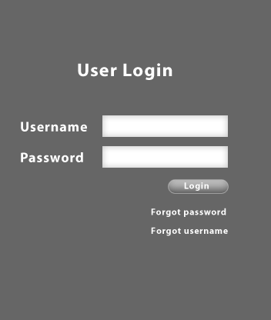

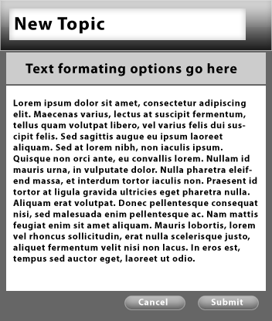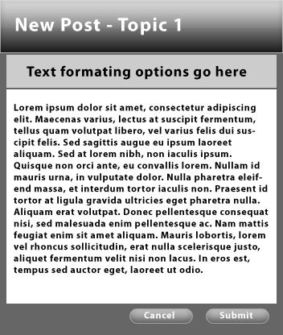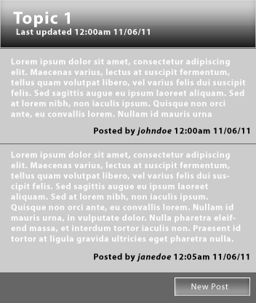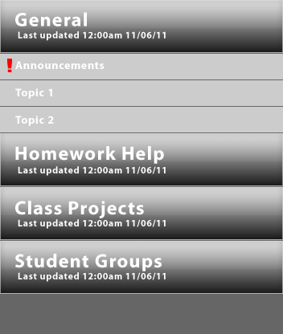

**User Interactions**

**Class Diagram**