音乐播放器
- 设计
播放器的功能有播放，暂停，停止，选择上一曲和下一曲。
- 双击歌曲名选择歌曲并播放，同时播放按钮变为暂停按钮；再点击暂停按钮，歌曲暂停播放；按钮显示播放，再次播放时歌曲从上次暂停的地方再次播放。
- 点击停止按钮，歌曲暂停播放，进度条置为0
- 上一曲则是播放当前歌曲的上一首歌曲
- 下一曲则是播放当前歌曲的下一首歌曲
- 程序结果
1、start.java文件开始运行程序，未添加歌曲文件前
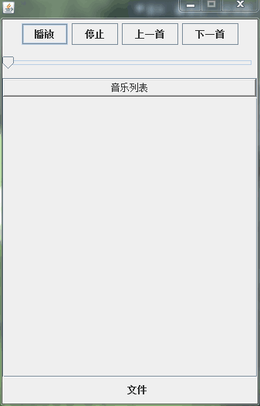

2、点击添加歌曲文件
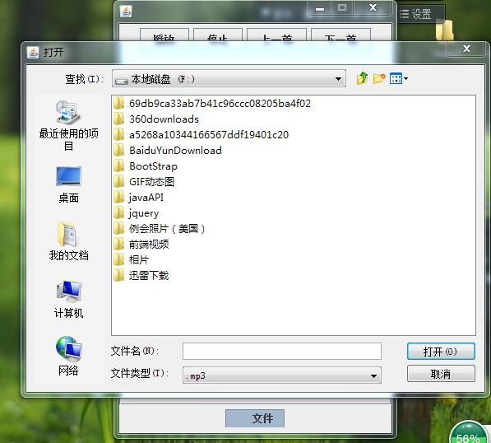
3、添加歌曲文件之后，歌曲名显示在歌曲列表上
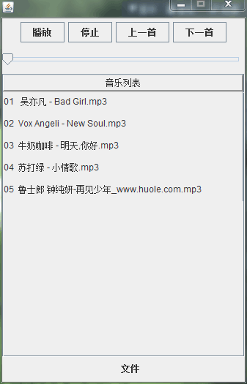

4、播放歌曲后，按钮变为暂停，进度值开始增加
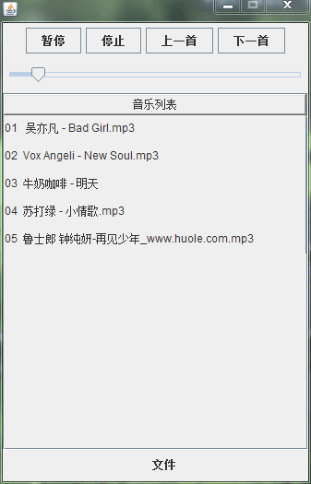
5、暂停后，按钮变为播放，进度值暂停增加
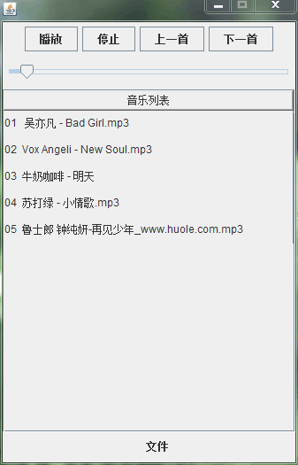

三、源代码
1.start.java 启动程序
package mymusic;

import javax.swing.UIManager;

import com.list.ViewList;
import com.view.View;

public class start {

public static void main(String[] args) {
if (ViewList.getList().size()==0) {

View v=new View();

ViewList.add(v);

//设置风格
try
{
//将外观设置为系统外观
UIManager.setLookAndFeel(UIManager.getSystemLookAndFeelClassName());
}catch(Exception exception){
exception.printStackTrace();
}
}
System.out.println("启动");
}
}
2.view.java 界面
package com.view;

import java.awt.BorderLayout;
import java.awt.Color;
import java.awt.Component;
import java.awt.Dimension;
import java.awt.GridLayout;
import java.awt.event.ActionEvent;
import java.awt.event.ActionListener;
import java.awt.event.MouseEvent;
import java.awt.event.MouseListener;
import java.awt.event.WindowEvent;
import java.awt.event.WindowListener;
import java.io.File;
import java.io.IOException;
import java.util.ArrayList;

import javax.swing.JButton;
import javax.swing.JComponent;
import javax.swing.JFrame;
import javax.swing.JLabel;
import javax.swing.JMenu;
import javax.swing.JMenuBar;
import javax.swing.JMenuItem;
import javax.swing.JOptionPane;
import javax.swing.JPanel;
import javax.swing.JRootPane;
import javax.swing.JScrollPane;
import javax.swing.JSlider;
import javax.swing.JTable;
import javax.swing.ListSelectionModel;
import javax.swing.SwingConstants;
import javax.swing.table.TableCellRenderer;

import com.list.MusicList;
import com.list.ThreadList;
import com.list.ViewList;
import com.model.Model;
import com.model.Music;
import com.service.Player;
//import com.util.DirInput;
import com.util.FileInput;
import com.util.FileList;
//import com.util.List_File;

public class View extends JFrame implements MouseListener,ActionListener,WindowListener {

private JButton stop, open,next,pre;
private Player p;
private JPanel[] jPanels;
private MusicList list;
private JScrollPane jsp;
private JTable jt;
private JRootPane j;
private Model model;
private JSlider jSliderPlayProgress;
private FileInput fileinput;
private JMenuBar jb;
private JMenuItem fm;

public View(){
System.out.println(ViewList.getList().size());
if (ViewList.getList().size()==0) {
Open();
}
}

private void Open() {

//菜单选项
jb=new JMenuBar();
fm=new JMenuItem("文件");
fm.addActionListener(this);

jb.add(fm);

JPanel p1=new JPanel();
JPanel p2=new JPanel();
JPanel p3=new JPanel();

//增加菜单选项
j=new JRootPane();
j.setJMenuBar(jb);
p2.add(j);

open=new JButton("播放");
stop=new JButton("停止");
open.addMouseListener(this);
stop.addMouseListener(this);
pre=new JButton("上一首");
next=new JButton("下一首");
pre.addMouseListener(this);
next.addMouseListener(this);
//网格布局，2行1列
p1.setLayout(new GridLayout(2,1));

JPanel jPanel2=new JPanel();
jPanel2.add(open);
jPanel2.add(stop);
jPanel2.add(pre);
jPanel2.add(next);

p1.add(jPanel2);

//播放进度条
jSliderPlayProgress = new JSlider();
jSliderPlayProgress.setValue(0);
jSliderPlayProgress.setEnabled(false);
jSliderPlayProgress.setPreferredSize(new Dimension(200, 20));
p1.add(jSliderPlayProgress);

jPanels=new JPanel[list.getList().size()];

for (int i = 0; i < list.getList().size(); i++) {
Music music=list.getList().get(i);
JPanel jPanel=new MyJPanel(music);
JLabel jLabel=new JLabel(music.getName(),SwingConstants.CENTER);
jLabel.setSize(300, 10);
jLabel.setHorizontalTextPosition(JLabel.CENTER);
jPanel.setBackground(Color.WHITE);

jPanels[i]=jPanel;
jPanel.addMouseListener(this);
jPanel.add(jLabel);
p3.add(jPanel);
}

p3.setBackground(Color.WHITE);
p3.setLayout(new GridLayout(10, 1));
p3.setSize(320, 500);

this.add(p1,BorderLayout.NORTH);
this.add(p2,BorderLayout.SOUTH);

//添加表
model=new Model();

jt=new JTable(model){ // 设置jtable的单元格为透明的
public Component prepareRenderer(TableCellRenderer renderer,
int row, int column) {
Component c = super.prepareRenderer(renderer, row, column);
if (c instanceof JComponent) {
((JComponent) c).setOpaque(false);
}
return c;
}
};;

jt.setOpaque(false);

jt.setRowHeight(30);
jt.setSelectionMode(ListSelectionModel.SINGLE_SELECTION );
jt.setShowHorizontalLines(false);
jt.setSelectionBackground(new Color(189,215,238));
jt.addMouseListener(this);

jsp = new JScrollPane(jt);

jsp.setOpaque(false);
jsp.getViewport().setOpaque(false);

this.add(jsp,BorderLayout.CENTER);
this.setDefaultCloseOperation(EXIT_ON_CLOSE);
this.addWindowListener(this);

this.getContentPane().add(jsp);
this.setLocation(400, 200);
this.setSize(337, 525);
this.setResizable(false);
this.setVisible(true);
}

@Override
public void mouseClicked(MouseEvent e) {

System.out.println("开始播放");

if (e.getSource()==open) {

if (p==null) {//开始
p=new Player(jSliderPlayProgress);
p.setMusic(MusicList.getList().get(0));
jt.setRowSelectionInterval(0,0);
ThreadList.add(p);
open.setText("暂停");
p.start();
}else{//继续
if (ThreadList.getList().size()!=0) {
p=ThreadList.getList().get(0);
}

String s=p.isPaused()?"暂停":"播放";
open.setText(s);
p.Pause();
}

}else if (e.getSource()==stop) {
if (ThreadList.getList().size()!=0) {
p=ThreadList.getList().get(0);
}
if (p!=null) {
p.stopplay();
p=null;
open.setText("播放");
}

}else if (e.getSource()==pre) {//上一首
premusic();

}else if (e.getSource()==next) {//下一首
nextmusic();
}else if (e.getSource()==jt&&e.getClickCount()==2) {//双击
clickmusic();
}
}

private void clickmusic() {
//双击Jtable
System.out.println("点击了");

int rowNum = this.jt.getSelectedRow();
// System.out.println(rowNum);
if(rowNum == -1) {
JOptionPane.showMessageDialog(this, "你没有选择一项");
return;
}

ArrayList<Player> list=ThreadList.getList();
// System.out.println(list.size()+"音乐文件数目");

if (list.size()==0) {

p=new Player(jSliderPlayProgress);
p.setMusic(MusicList.getList().get(rowNum));
ThreadList.add(p);
open.setText("暂停");
p.start();
}else{
// System.out.println("停止");
list.get(0).stopplay();
list.clear();
p=new Player(jSliderPlayProgress);
p.setMusic(MusicList.getList().get(rowNum));
open.setText("暂停");
list.add(p);
p.start();
}
}

public JTable getJt() {
return jt;
}

private void premusic() {
System.out.println("上一首");

ArrayList<Player> list=ThreadList.getList();

int id=Integer.parseInt(list.get(0).getMusic().getId());

if(id!=0){
if (id==1) {
jt.setRowSelectionInterval(0,0);
}else{
jt.setRowSelectionInterval(id-2,id-1);
}
System.out.println(id);

list.get(0).stopplay();
list.clear();

p=new Player(jSliderPlayProgress);

p.setMusic(MusicList.getList().get(id-1));
System.out.println(id-1);

open.setText("暂停");
list.add(p);
p.start();
}
}

private void nextmusic() {
System.out.println("下一首");
ArrayList<Player> list=ThreadList.getList();
int id=Integer.parseInt(list.get(0).getMusic().getId());

// System.out.println(id);
if(id!=MusicList.getList().size()-1){

jt.setRowSelectionInterval(id,id+1);

list.get(0).stopplay();
list.clear();

p=new Player(jSliderPlayProgress);

p.setMusic(MusicList.getList().get(id+1));
// System.out.println(id+1);

open.setText("暂停");
list.add(p);
p.start();
}
}

@Override
public void mouseEntered(MouseEvent e) {
// TODO Auto-generated method stub

}

@Override
public void mouseExited(MouseEvent e) {
// TODO Auto-generated method stub

}

@Override
public void mousePressed(MouseEvent e) {
// TODO Auto-generated method stub

}

@Override
public void mouseReleased(MouseEvent e) {
// TODO Auto-generated method stub

}

@Override
public void actionPerformed(ActionEvent e) {
if (e.getSource()==fm) {//添加mp3文件
if(fileinput==null) fileinput = new FileInput(this);
fileinput.open();
File[] s=fileinput.getFiles();
ArrayList<Music> musiclist=MusicList.getList();

if(s!=null){
for(int i=0;i<s.length;i++){
Music music= new Music();
music.setId(musiclist.size()+"");
music.setName(s[i].getName());
music.setPath(s[i].getAbsolutePath());
musiclist.add(music);
jt.setModel(new Model());
}
}
}
}

@Override
public void windowActivated(WindowEvent e) {
// TODO Auto-generated method stub

}

@Override
public void windowClosed(WindowEvent e) {
// TODO Auto-generated method stub
System.out.println("关闭kk");
}

@Override
public void windowClosing(WindowEvent e) {
// TODO Auto-generated method stub
System.out.println("close");

if (MusicList.getList().size()!=0) {
System.out.println("写入文件");
//清空之前的内容
FileList.clear("file/filelist.txt");
ArrayList<Music> list=MusicList.getList();
for (int i = 0; i < list.size(); i++) {
FileList.writeFile("file/filelist.txt",list.get(i).getId()+","+list.get(i).getName()+","
+list.get(i).getPath()+"\n");
}
}
}

@Override
public void windowDeactivated(WindowEvent e) {
// TODO Auto-generated method stub

}

@Override
public void windowDeiconified(WindowEvent e) {
// TODO Auto-generated method stub

}

@Override
public void windowIconified(WindowEvent e) {
// TODO Auto-generated method stub

}

@Override
public void windowOpened(WindowEvent e) {
// TODO Auto-generated method stub
System.out.println("open");

File file=new File("file/filelist.txt");

if (file.exists()==false) {
try {
file.createNewFile();
} catch (IOException e1) {
// TODO Auto-generated catch block
e1.printStackTrace();
}
}else {

FileList.readFileByLines("file/filelist.txt");
jt.setModel(new Model());
}
}
}
3.MyJPanel.java 提供音乐列表
package com.view;

import javax.swing.JPanel;

import com.model.Music;

public class MyJPanel extends JPanel {

private Music music;

public Music getMusic() {
return music;
}

public void setMusic(Music music) {
this.music = music;
}

public MyJPanel(Music music) {
super();
this.music = music;
}
}
4.FileList.java 文件列表
package com.util;

import java.io.BufferedReader;
import java.io.BufferedWriter;
import java.io.File;
import java.io.FileInputStream;
import java.io.FileOutputStream;
import java.io.FileReader;
import java.io.IOException;
import java.io.InputStreamReader;
import java.io.OutputStreamWriter;
import java.util.ArrayList;

import com.list.MusicList;
import com.model.Music;

public class FileList {

//写文件(防止中文乱码)
public static void writeFile(String filePathAndName, String fileContent) {
try {
File f = new File(filePathAndName);
if (!f.exists()) {
f.createNewFile();
}
OutputStreamWriter write = new OutputStreamWriter(new FileOutputStream(f,true),"UTF-8");
BufferedWriter writer=new BufferedWriter(write);
writer.write(fileContent);
writer.close();
} catch (Exception e) {
System.out.println("写文件内容操作出错");
e.printStackTrace();
}
}
//清空
public static void clear(String path){
try {
new FileOutputStream(path).write(new String("").getBytes());
} catch (Exception e) {
// TODO: handle exception
System.out.println("清空文件错误"+e.getMessage());
}

}

//读(防止中文乱码)

public static void readFileByLines(String fileName) {

File file = new File(fileName);
BufferedReader reader = null;
try {
reader=new BufferedReader(new InputStreamReader(new FileInputStream(fileName),"UTF-8"));

String tempString = null;
ArrayList<Music> list=MusicList.getList();
while ((tempString = reader.readLine()) != null) {
String[] s= tempString.split(",");
Music music= new Music();
music.setId(s[0]);//id
music.setName(s[1]);//名字
music.setPath(s[2]);//路径
list.add(music);
}
reader.close();
} catch (IOException e) {
e.printStackTrace();
} finally {
if (reader != null) {
try {
reader.close();
} catch (IOException e1) {
}
}
}
}

}
5.FileIuput.java 获得文件
package com.util;

import java.io.File;

import javax.swing.JFileChooser;
import javax.swing.JFrame;
import javax.swing.filechooser.FileFilter;

/**
*class FileInput 获得歌曲文件
*/
public class FileInput
{
private JFileChooser fdialog=null;
private File f[];
private String name[];
private JFrame jf;
public FileInput(JFrame jf)
{
this.jf=jf;
fdialog=new JFileChooser("F:");
fdialog.setFileFilter(new FileFilter() {

@Override
public String getDescription() {
// TODO Auto-generated method stub
return ".mp3";
}

@Override
public boolean accept(File f) {
// TODO Auto-generated method stub
if (f.isDirectory())return true;
return f.getName().endsWith(".mp3");
}

});
fdialog.setAcceptAllFileFilterUsed(false);

fdialog.setFileSelectionMode(JFileChooser.FILES_AND_DIRECTORIES);
fdialog.setMultiSelectionEnabled(true);

}
public void open()
{
f=null;
int result = fdialog.showOpenDialog(jf);
if(result == fdialog.APPROVE_OPTION){

f=fdialog.getSelectedFiles();

}
}
public String[] getFileNames()
{
name=null;
if(f!=null)
{
name=new String[f.length];
for(int i=0;i<f.length;i++)
name[i]=f[i].getPath();
}
return name;
}
public File[] getFiles()
{
return f;
}

}
6.Player.java 播放歌曲
package com.service;

import java.io.File;
import java.io.IOException;

import javax.sound.sampled.*;
import javax.swing.JSlider;
import javax.swing.JTable;

import com.list.MusicList;
import com.list.ThreadList;
import com.list.ViewList;
import com.model.Model;
import com.model.Music;

public class Player extends Thread{

public Player(JSlider jSliderPlayProgress) {
super();
this.jSliderPlayProgress=jSliderPlayProgress;
}

private Player p;
private long time = 0;

Object lock = new Object();//一个空的对象

private boolean paused = false;// 暂停 继续

public boolean isPaused() {
return paused;
}

public void setPaused(boolean paused) {
this.paused = paused;
}

private JSlider jSliderPlayProgress;//播放进度条
private boolean over = false;//开始 结束

//是否自动播放下一曲
private boolean isNext=true;

AudioInputStream din = null;
SourceDataLine line=null;

/*private FloatControl volume = null;
private JSlider jSliderVolume;

public JSlider getjSliderVolume() {
return jSliderVolume;
}

public void setjSliderVolume(JSlider jSliderVolume) {
this.jSliderVolume = jSliderVolume;

}*/

private Music music;

public Music getMusic() {
return music;
}

public void setMusic(Music music) {
this.music = music;
}

//播放音乐
public void run(){

AudioInputStream in=null;

try {

File file = new File(music.getPath());

//播放不了的歌曲，直接下一首
try {
in = AudioSystem.getAudioInputStream(file);
} catch (Exception e) {

ViewList.getList().get(0).getJt().setModel(new Model());

nextmusic();
}

AudioFormat baseFormat = in.getFormat();
AudioFormat decodedFormat = new AudioFormat(
AudioFormat.Encoding.PCM_SIGNED,
baseFormat.getSampleRate(), 16, baseFormat.getChannels(),
baseFormat.getChannels() * 2, baseFormat.getSampleRate(),
false);
if(baseFormat.getEncoding()==AudioFormat.Encoding.PCM_UNSIGNED || baseFormat.getEncoding()==AudioFormat.Encoding.ULAW ||
baseFormat.getEncoding()==AudioFormat.Encoding.ALAW || baseFormat.getEncoding()==AudioFormat.Encoding.PCM_SIGNED){
time=(file.length()*8000000)/((int)(decodedFormat.getSampleRate()*baseFormat.getSampleSizeInBits()));
}else{
int bitrate=0;
if(baseFormat.properties().get("bitrate")!=null){
//取得播放速度(单位位每秒)
bitrate=(int)((Integer)(baseFormat.properties().get("bitrate")));
if(bitrate!=0)
time=(file.length()*8000000)/bitrate;
}

}

//line 打开文件
din = AudioSystem.getAudioInputStream(decodedFormat, in);
DataLine.Info info = new DataLine.Info(SourceDataLine.class, decodedFormat);
line = (SourceDataLine) AudioSystem.getLine(info);
line.open();
//设置歌曲进度条的时间
jSliderPlayProgress.setMaximum((int)time);
jSliderPlayProgress.setValue(0);

if(line!=null){
line.open(decodedFormat);
byte[] data = new byte[4096];
int nBytesRead;

synchronized (lock) {
while ((nBytesRead = din.read(data, 0, data.length)) != -1) {
while (paused) {
if(line.isRunning()) {
line.stop();
System.out.println("暂停");
}
try {
lock.wait();
System.out.println("等待");
}
catch(InterruptedException e) {
}
}
if(!line.isRunning()&&!over) {
System.out.println("开始播放");
line.start();
}

if (over&&line.isRunning()) {
System.out.println("停止播放");
jSliderPlayProgress.setValue(0);
isNext=false;
line.drain();
line.stop();
line.close();
}

jSliderPlayProgress.setValue((int)line.getMicrosecondPosition());
line.write(data, 0, nBytesRead);
}

nextmusic();
}

}
}
catch(Exception e) {
e.printStackTrace();
}
finally {
if(din != null) {
try {
din.close();
} catch(IOException e) {

}
}
}
}

private void nextmusic() {
int currentid=Integer.parseInt(this.music.getId());
int nextid=0;//将要播放的id
if (isNext&&!(currentid==MusicList.getList().size()-1)){
nextid=currentid+1;
JTable jTable=ViewList.getList().get(0).getJt();
if(nextid==0){//第一个
jTable.setRowSelectionInterval(0,0);

}else {
jTable.setRowSelectionInterval(nextid-1,nextid);
}
this.stopplay();
ThreadList.getList().clear();
p=new Player(jSliderPlayProgress);
p.setMusic(MusicList.getList().get(nextid));
ThreadList.getList().add(p);
p.start();
}

}

//开始
public void startplay(){
over=false;
}

//停止

public void stopplay(){
over=true;
}

// 暂停
public void userPressedPause() {
paused = true;
}

//继续
public void userPressedPlay() {
synchronized(lock) {
paused = false;
lock.notifyAll();
}

}

public void Pause(){
if (paused) {
//保证在同一时刻最多只有一个线程执行
synchronized(lock) {
paused = false;
lock.notifyAll();
}
}else{
paused = true;
}
}
}
7.Music.java 歌曲信息
package com.model;

public class Music {

private String id;
private String name;
private String path;
public String getId() {
return id;
}
public String getName() {
return name;
}
public void setName(String name) {
this.name = name;
}
public void setId(String id) {
this.id = id;
}
public String getPath() {
return path;
}
public void setPath(String path) {
this.path = path;
}
}
8.Model.java 提供列表
package com.model;
import javax.swing.*;

import java.util.*;
import javax.swing.table.*;

import com.list.MusicList;

public class Model extends AbstractTableModel{

//初始化
Vector rowData, columnNames;
JTable jt = null;

JScrollPane jsp = null;

private MusicList list;

public Model() {
columnNames = new Vector();
//设置列名
columnNames.add("音乐列表");

rowData = new Vector();

for (int i = 0; i < list.getList().size(); i++) {
Vector hang=new Vector();
String num=i<10?"0"+(i+1):(i+1)+"";
hang.add(num+" "+list.getList().get(i).getName());
rowData.add(hang);
}
}
//设置列

@Override
public int getColumnCount() {
// TODO Auto-generated method stub
return this.columnNames.size();
}

@Override
public int getRowCount() {
// TODO Auto-generated method stub
return this.rowData.size();
}

@Override
public Object getValueAt(int rowIndex, int column) {
// TODO Auto-generated method stub
return ((Vector)this.rowData.get(rowIndex)).get(column);
}

@Override
public String getColumnName(int arg0) {
// TODO Auto-generated method stub
return (String) this.columnNames.get(arg0);
}
}
9.ViewList.java 界面
package com.list;

import java.util.ArrayList;

import com.view.View;

final public class ViewList {

private static ArrayList<View> list;

static{
if (list==null) {
System.out.println("启动页面成功");
list=new ArrayList<View>();
}
}

public static void add(View v){

list.add(v);
}

public static ArrayList<View> getList() {
return list;
}

}
10.ThreadList.java 线程
package com.list;

import java.util.ArrayList;

import com.service.Player;

final public class ThreadList {

private static ArrayList<Player> list;

static{
if (list==null) {
list=new ArrayList<Player>();
}
}

public static void add(Player player){

list.add(player);
}

public static ArrayList<Player> getList() {
return list;
}

}
11.MusicList.java 音乐列表
package com.list;

import java.util.ArrayList;

import com.model.Music;

final public class MusicList {

private static ArrayList<Music> list;

static{

if (list==null) {
System.out.println("创建列表");
list=new ArrayList<Music>();
}
}

public static void add(Music music){

list.add(music);
}

public static ArrayList<Music> getList() {
return list;
}

public static Music get(int id){
return list.get(id);
}

}

