

Sensor Web Community
User Guide
for
SOS Importer
version 0.1
Supports SOS Versions 1.0.0

Document Change Control
Revision | Date | Author(s) | Brief Description Of Changes
0.1 | 2011-09-13 | Eike Hinderk Jürens | initialized

Editors
Eike Hinderk Jürrens
Email: e.h.juerrens@52north.org

Licence
This document is part of 52°North
Copyright (C) 2011 by 52 North Initiative for Geospatial Open Source Software GmbH
Contact: Andreas Wytzisk,
52 North Initiative for Geospatial Open Source Software GmbH,
Martin-Luther-King-Weg 24,
48155 Muenster, Germany, info@52north.org
This program is free software; you can redistribute and/or modify it under the terms of the GNU General Public License version 2 as published by the Free Software Foundation.
This program is distributed WITHOUT ANY WARRANTY; even without the implied WARRANTY OF MERCHANTABILITY or FITNESS FOR A PARTICULAR PURPOSE. See the GNU General Public License for more details.
You should have received a copy of the GNU General Public License along with this program (see gnu-gpl v2.txt). If not, write to the Free Software Foundation, Inc., 59 Temple Place - Suite 330, Boston, MA 02111-1307, USA or visit the Free Software Foundation web page, http://www.fsf.org.

For more information, contact:
52°North Initiative for Geospatial Open Source Software GmbH
Martin-Luther-King-Weg 24
48155 Münster, Germany
52north.org

Table of Contents
Sensor Web Community User Guide for SOS Importer version 0.1 Supports SOS Versions 1.0.0 1
1 Document Change Control 2
2 Editors 3
3 Licence 4
4 Introduction 6
5 Requirements and Launching the Application 8
6 Steps 9
7 Troubleshooting 16

Introduction
The application makes use of the wizard design pattern which guides the user through different steps. These and their purposes are briefly characterized in the table below. Screenshots of all steps are shown below in Figure 1 to Figure 15.
Step | Function
Step 1 | Choose a CSV file from the file system to publish in a SOS instance
Step 2 | Provide a preview of the CSV file and select settings for parsing (e.g. which character is used for separating columns)
Step 3 | Display the CSV file in tabular format and assign metadata to each column (e.g. indicate that the second column consists of measured values). Offer customizable settings for parsing (e.g. for date/time patterns)
Step 4 | In case of more than one date/time, feature of interest, observed property, unit of measurement, sensor identifier or position has been identified in step 3, select the correct associations to the according measured value columns (e.g. state that date/time in column 1 belongs to the measured values in column 3 and date/time in column 2 belongs to the measured values in column 4). When there is exactly one appearance of a certain type, automatically assign this type to all measured values
Step 5 | Check available metadata for completeness and ask the user to add information in case something is missing (e.g. EPSG-code for positions)
Step 6 | When there is no metadata of a particular type present in the CSV file (e.g. sensor id), let the user provide this information (e.g. name and URI of this sensor)
Step 7 | Enter the URL of a Sensor Observation Service where measurements and sensor metadata in the CSV file shall be uploaded to
Step 8 | Assemble all information from previous steps and convert the CSV file into XML files according to OGC’s Observations & Measurements and SensorML specifications. Register sensors and insert observations at the given Sensor Observation Service using the Transactional Profile of the SOS specification. Show the progress and provide a report of errors and success

Note that steps 4 to 6 can sometimes be skipped for CSV files of a particular structure. Also, their functionality is split up in the application according to the type of metadata they represent (a – date/time, b – features of interest, observed properties, units of measurement, sensors, c – positions).

Requirements and Launching the Application
The 52°North SOS importer requires an actual Java Runtime Environment, network connection to running SOS instance.
To launch the application, please place the 52n-sensorweb-sos-importer.jar in a directory with write permission for the launching user and call:
java –jar 52n-sensorweb-sos-importer.jar

Steps
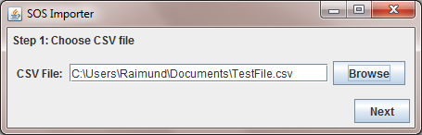
In the first step, the user selects the file (in this version a CSV file) which contains the observation data set that shall be published.
Figure 1: Choosing the CSV file containing the observation data
After this, the general settings for parsing the file need to be set (column separator, comment indicator and text qualifier).
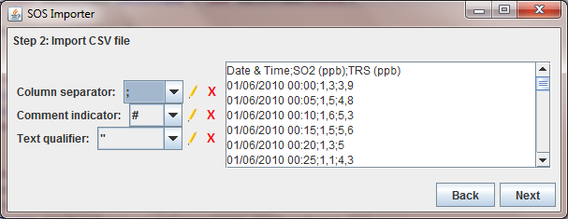
Figure 2: Selecting settings for parsing the CSV file
In the next steps the content of the different columns needs to be defined. Depending on the type of data contained in a column further information needs to be set by the user. For example:
- If a column contains data and time, the according format (e.g. dd/MM/yy HH:mm) needs to be described
- If a column contains observed values the data type (e.g. numeric, Boolean, category) need to be set and if applicable also thousands and decimal separators
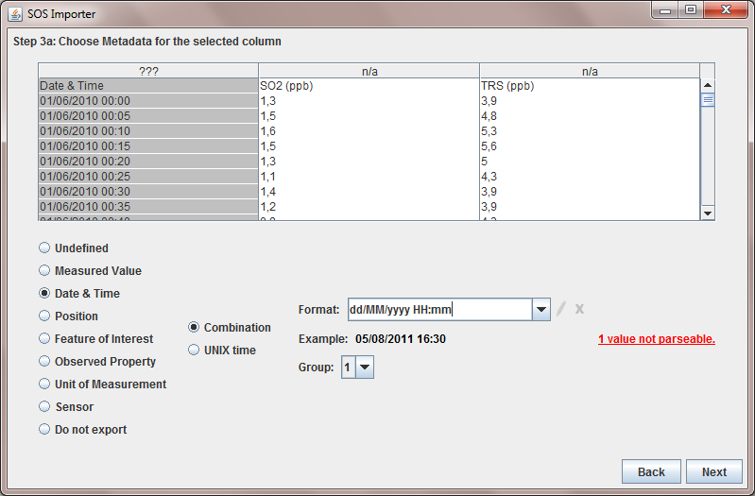
Figure 3: Describing the content of the columns (date and time)
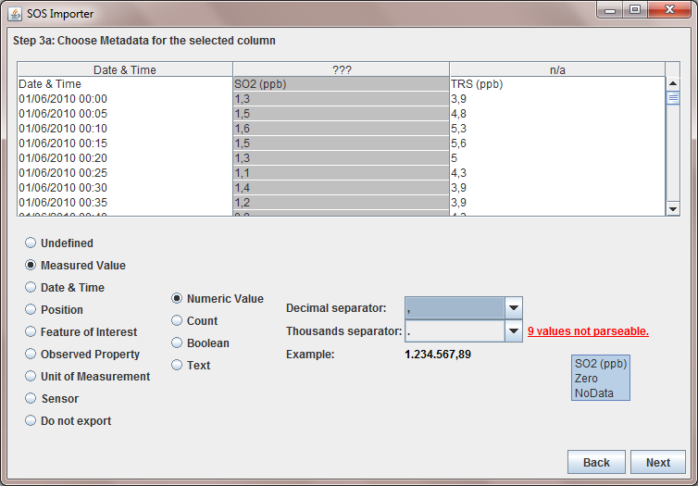
Figure 4: Describing the content of the columns (measured value)
If multiple columns with the same content type are present in a CSV file, according associations must be created, for example
- If there are multiple timestamp columns it must be defined which time stamp column belongs to which measured value column
- If there are multiple unit of measurement columns it must be defined which unit of measurement column belongs to which measured value column
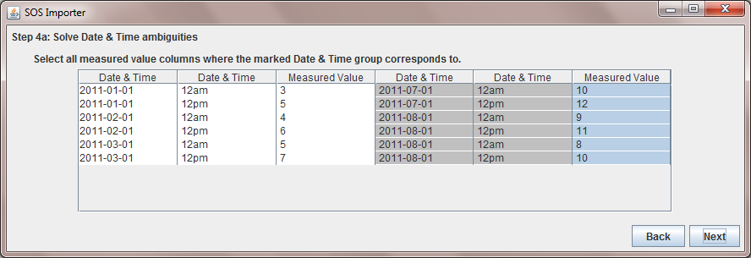
Figure 5: Creating associations between measured values and units of measurements
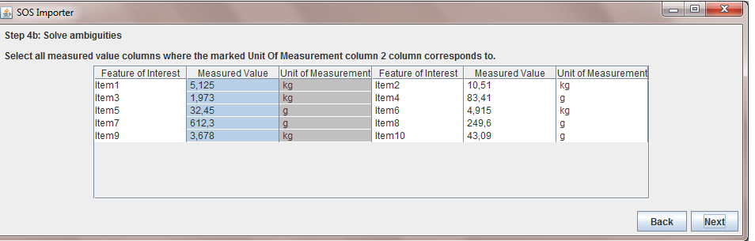
Figure 6: Creating associations between measured values and time stamps
If there is missing metadata for a time stamp column (e.g. time zone) the user has to provide this information in the next step.
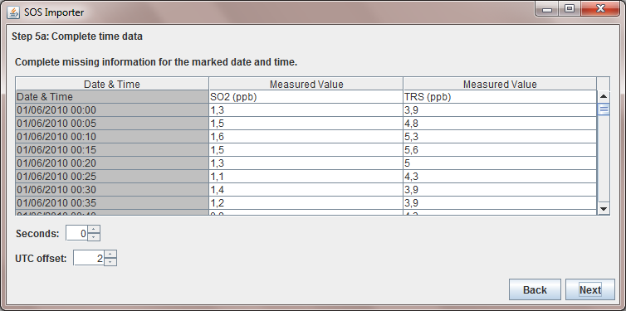
Figure 7: Adding missing metadata
In case certain metadata elements are missing within the positions of sensor observations, the next step can be used for inserting the according information (e.g. height, EPSG code of the reference system).
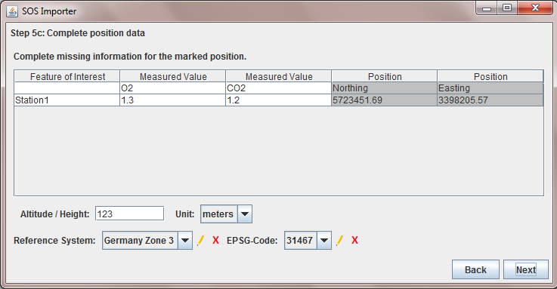
Figure 8: Adding missing position information
If no time stamps for the measured data are provided, the subsequent step requests the according input from the user.

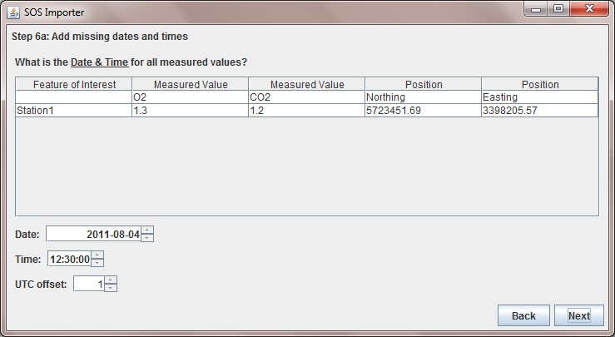
Figure 9: Setting a time for all measured values
If the CSV file does not contain information about the observed property, this can be inserted by the user as shown below.
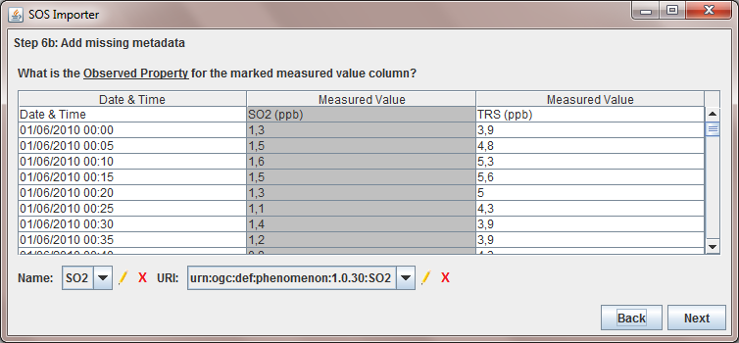
Figure 10: Creating associations between measured values and observed properties
Also, if no sensor identifiers are available in the CSV file, this can be described manually.

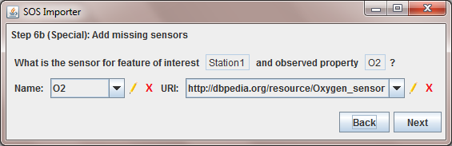
Figure 11: Creating associations between measured values and sensors
In case the CSV file doesn’t provide any spatial reference for the measured values, the menu below offers the possibility to enter positions manually.
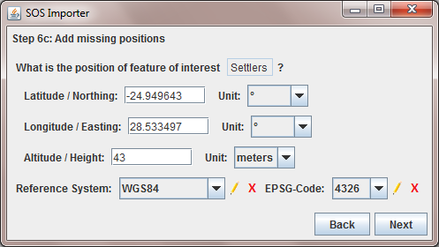
Figure 12: Setting the positions of the features of interest
After all necessary data and metadata elements are entered, the SOS instance to which the sensor observations shall be published must be entered.
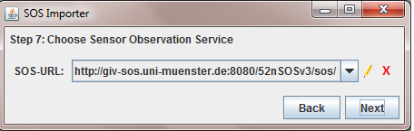
Figure 13: Setting the URL of a Sensor Observation Service
Finally, the publication process is started and the user is informed about the progress.

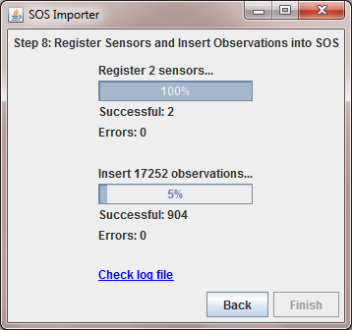
Figure 14: Registering sensors and inserting observations
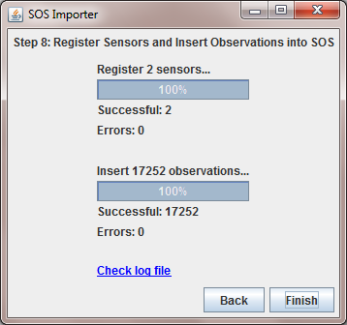
Figure 15: Import finished

Troubleshooting
In the case of having problems, different steps are possible:
- Check the “SOS importer” section of the issue tracking system of 52°North:
https://bugzilla.52north.org/buglist.cgi?product=52N%20Sensor%20Web& component=SOS%20CSV%20Importer
- Get in touch with the Sensor Web Community of 52°North:
  - Homepage: http://52north.org/sensorweb
  - Forum: http://sensorweb.forum.52north.org/
  - Mailinglist: http://list.52north.org/mailman/listinfo/swe
- Open your IDE and solve the issue by yourself and contribute to the 52°North Sensorweb Community:
  - ViewVC: https://svn.52north.org/cgi-bin/viewvc.cgi/incubation/SOS-importer/trunk/?root=sensorweb
  - SVN: https://svn.52north.org/svn/swe/incubation/SOS-importer/trunk/
  - Get Involved: http://52north.org/about/get-involved/

Go to http://java.com/download to check your version and get the latest one.

